Here come the Israelites
11-14-21

The fear of God is upon the people of the lands Joshua is moving into.

God, Joshua 2:9 and said to the men: “I know that the LORD has given you the land, that the terror of you has fallen on us, and that all the inhabitants of the land are fainthearted because of you. 10 “For we have heard how the LORD dried up the water of the Red Sea for you when you came out of Egypt, and what you did to the two kings of the Amorites who were on the other side of the Jordan, Sihon and Og, whom you utterly destroyed. 11 “And as soon as we heard these things, our hearts melted; neither did there remain any more courage in anyone because of you, for the LORD your God, He is God in heaven above and on earth beneath.
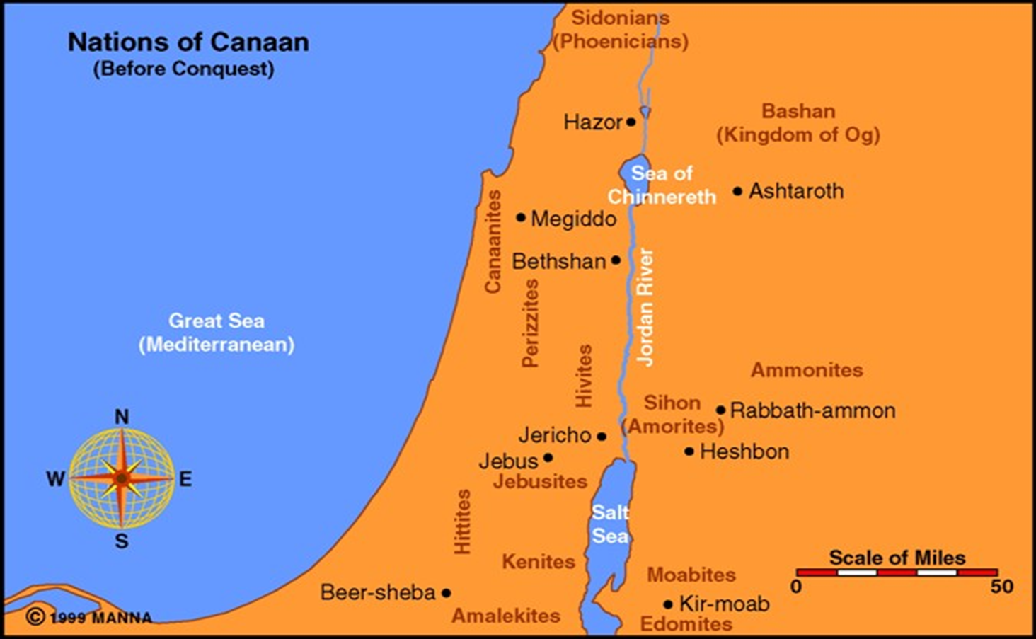

Joshua was to conquer and then divide up the land according to the tribal boundaries.

He conquered what he was told to do but the tribes were supposed to take the rest.

Joshua 11:15 As the LORD had commanded Moses his servant, so Moses commanded Joshua, and so Joshua did. He left nothing undone of all that the LORD had commanded Moses.

Then he divided the land according to tribes

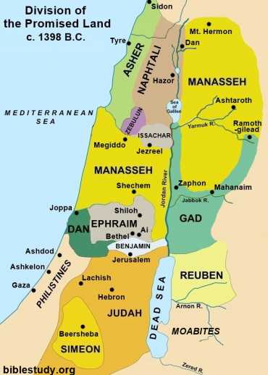

A word on the devastation Joshua brought to all the lands that he conquered.

Josh 6:21 And they utterly destroyed all that was in the city, both man and woman, young and old, ox and sheep and donkey, with the edge of the sword.

They did this repeatedly.

26 For Joshua did not draw back his hand, with which he stretched out the spear, until he had utterly destroyed all the inhabitants of Ai.

Joshua 11:19 There was not a city that made peace with the children of Israel, except the Hivites, the inhabitants of Gibeon. All the others they took in battle.

20 For it was of the LORD to harden their hearts, that they should come against Israel in battle, that He might utterly destroy them, and that they might receive no mercy, but that He might destroy them, as the LORD had commanded Moses.

So how does all this line up with this?

2 Peter 3:9 The Lord is not slack concerning His promise, as some count slackness, but is longsuffering toward us, not willing that any should perish but that all should come to repentance.

It’s not God’s fault it is ours!

Romans 1:18 For the wrath of God is revealed from heaven against all ungodliness and unrighteousness of men, who suppress the truth in unrighteousness, 19 because what may be known of God is manifest in them, for God has shown it to them.

20 For since the creation of the world His invisible attributes are clearly seen, being understood by the things that are made, even His eternal power and Godhead, so that they are without excuse,

21 because, although they knew God, they did not glorify Him as God, nor were thankful,

but became futile in their thoughts, and their foolish hearts were darkened. 22 Professing to be wise, they became fools,

23 and changed the glory of the incorruptible God into an image made like corruptible man–and birds and four-footed animals and creeping things.

Every single one of these nations had so corrupted themselves that they were sacrificing their children, practicing all forms of sexual perversion and were as corrupt as one can get.

As the rest of Romans 1 says, God simply lets them go the course they desire because they have not listened.

Eventually people become so bad that they destroy each other to extinction. And if God doesn’t intervene…

Mat 24:22 “And unless those days were shortened, no flesh would be saved; but for the elect’s sake those days will be shortened.

Wickedness is bad church; it will eventually lead to complete darkness. The Spirit of God restrains but imagine if all these were present in all their fullness on this planet at once:

Rom 1:29 being filled with all unrighteousness, sexual immorality, wickedness, covetousness, maliciousness; full of envy, murder, strife, deceit, evil-mindedness; they are whisperers, 30 backbiters, haters of God, violent, proud, boasters, inventors of evil things, disobedient to parents,

31 undiscerning, untrustworthy, unloving, unforgiving, unmerciful; 32 who, knowing the righteous judgment of God, that those who practice such things are deserving of death

not only do the same but also approve of those who practice them.

How bad can man get?

To the point that good is evil or weak, and wickedness is a virtue.

From Don Richardson The “Peace Child”

For the Sawi (saw-wee), the highest ideal was to “fatten a victim with friendship” before taking his head in treachery and feasting on him.

According to the Word of God those nation’s cups of sin had overflowed.

Gen 15:16 “But in the fourth generation they shall return here, for the iniquity of the Amorites is not yet complete.”

Deut 9:4 “Do not think in your heart, after the LORD your God has cast them out before you, saying, ‘Because of my righteousness the LORD has brought me in to possess this land’; but it is because of the wickedness of these nations that the LORD is driving them out from before you.

Deut 18:10 “There shall not be found among you anyone who makes his son or his daughter pass through the fire, or one who practices witchcraft, or a soothsayer, or one who interprets omens, or a sorcerer,

11 “or one who conjures spells, or a medium, or a spiritist, or one who calls up the dead. 12 “For all who do these things are an abomination to the LORD, and because of these abominations the LORD your God drives them out from before you.

13 “You shall be blameless before the LORD your God. 14 “For these nations which you will dispossess listened to soothsayers and diviners; but as for you, the LORD your God has not appointed such for you.

Because of wickedness, all the cities Joshua took were completely destroyed, and this is a foreshadowing of this:

Revelation 20:12 And I saw the dead, small and great, standing before God, and books were opened. And another book was opened, which is the Book of Life.

And the dead were judged according to their works, by the things which were written in the books. 13 The sea gave up the dead who were in it, and Death and Hades delivered up the dead who were in them. And they were judged, each one according to his works.

14 Then Death and Hades were cast into the lake of fire. This is the second death. 15 And anyone not found written in the Book of Life was cast into the lake of fire.

Next week: Rahab, the great foreshadowing of the mercy of God for individuals, and Gentiles!

