Jesus continues to reveal more of Himself!
October 16, 2025

Jesus’ 4-fold witness…

John 5:31 “If I bear witness of Myself, My witness is not true. 32 “There is another who bears witness of Me, and I know that the witness which He witnesses of Me is true. 33 “You have sent to John, and he has borne witness to the truth.

34 “Yet I do not receive testimony from man, but I say these things that you may be saved. 35 “He was the burning and shining lamp, and you were willing for a time to rejoice in his light. 36 “But I have a greater witness than John’s;

for the works which the Father has given Me to finish–the very works that I do–bear witness of Me, that the Father has sent Me. 37 “And the Father Himself, who sent Me, has testified of Me. You have neither heard His voice at any time, nor seen His form.

38 “But you do not have His word abiding in you, because whom He sent, Him you do not believe. 39 “You search the Scriptures, for in them you think you have eternal life; and these are they which testify of Me.

40“But you are not willing to come to Me that you may have life.

The True Law… Deut 19:15 “One witness shall not rise against a man concerning any iniquity or any sin that he commits; by the mouth of two or three witnesses the matter shall be established.

John the Baptist… but you will kill him!

The amazing works Jesus did that only Messiah could do… But they said He did them from the devil!

3. God the Father…

Mat 3:17 And suddenly a voice came from heaven, saying, “This is My beloved Son, in whom I am well pleased.”

4. The scriptures…

Luke 24:25 Then He said to them, “O foolish ones, and slow of heart to believe in all that the prophets have spoken! 26 “Ought not the Christ to have suffered these things and to enter into His glory?” 27 And beginning at Moses and all the Prophets, He expounded to them in all the Scriptures the things concerning Himself.

The testimony of their lost state from Moses!

John 5:45 “Do not think that I shall accuse you to the Father; there is one who accuses you–Moses, in whom you trust. 46 “For if you believed Moses, you would believe Me; for he wrote about Me. 47 “But if you do not believe his writings, how will you believe My words?”

They don’t believe Moses alone in the Tanakh’s Laws, instead they believe the Mishna. They studied the Mishna and today Talmud, which are the eyes of men.

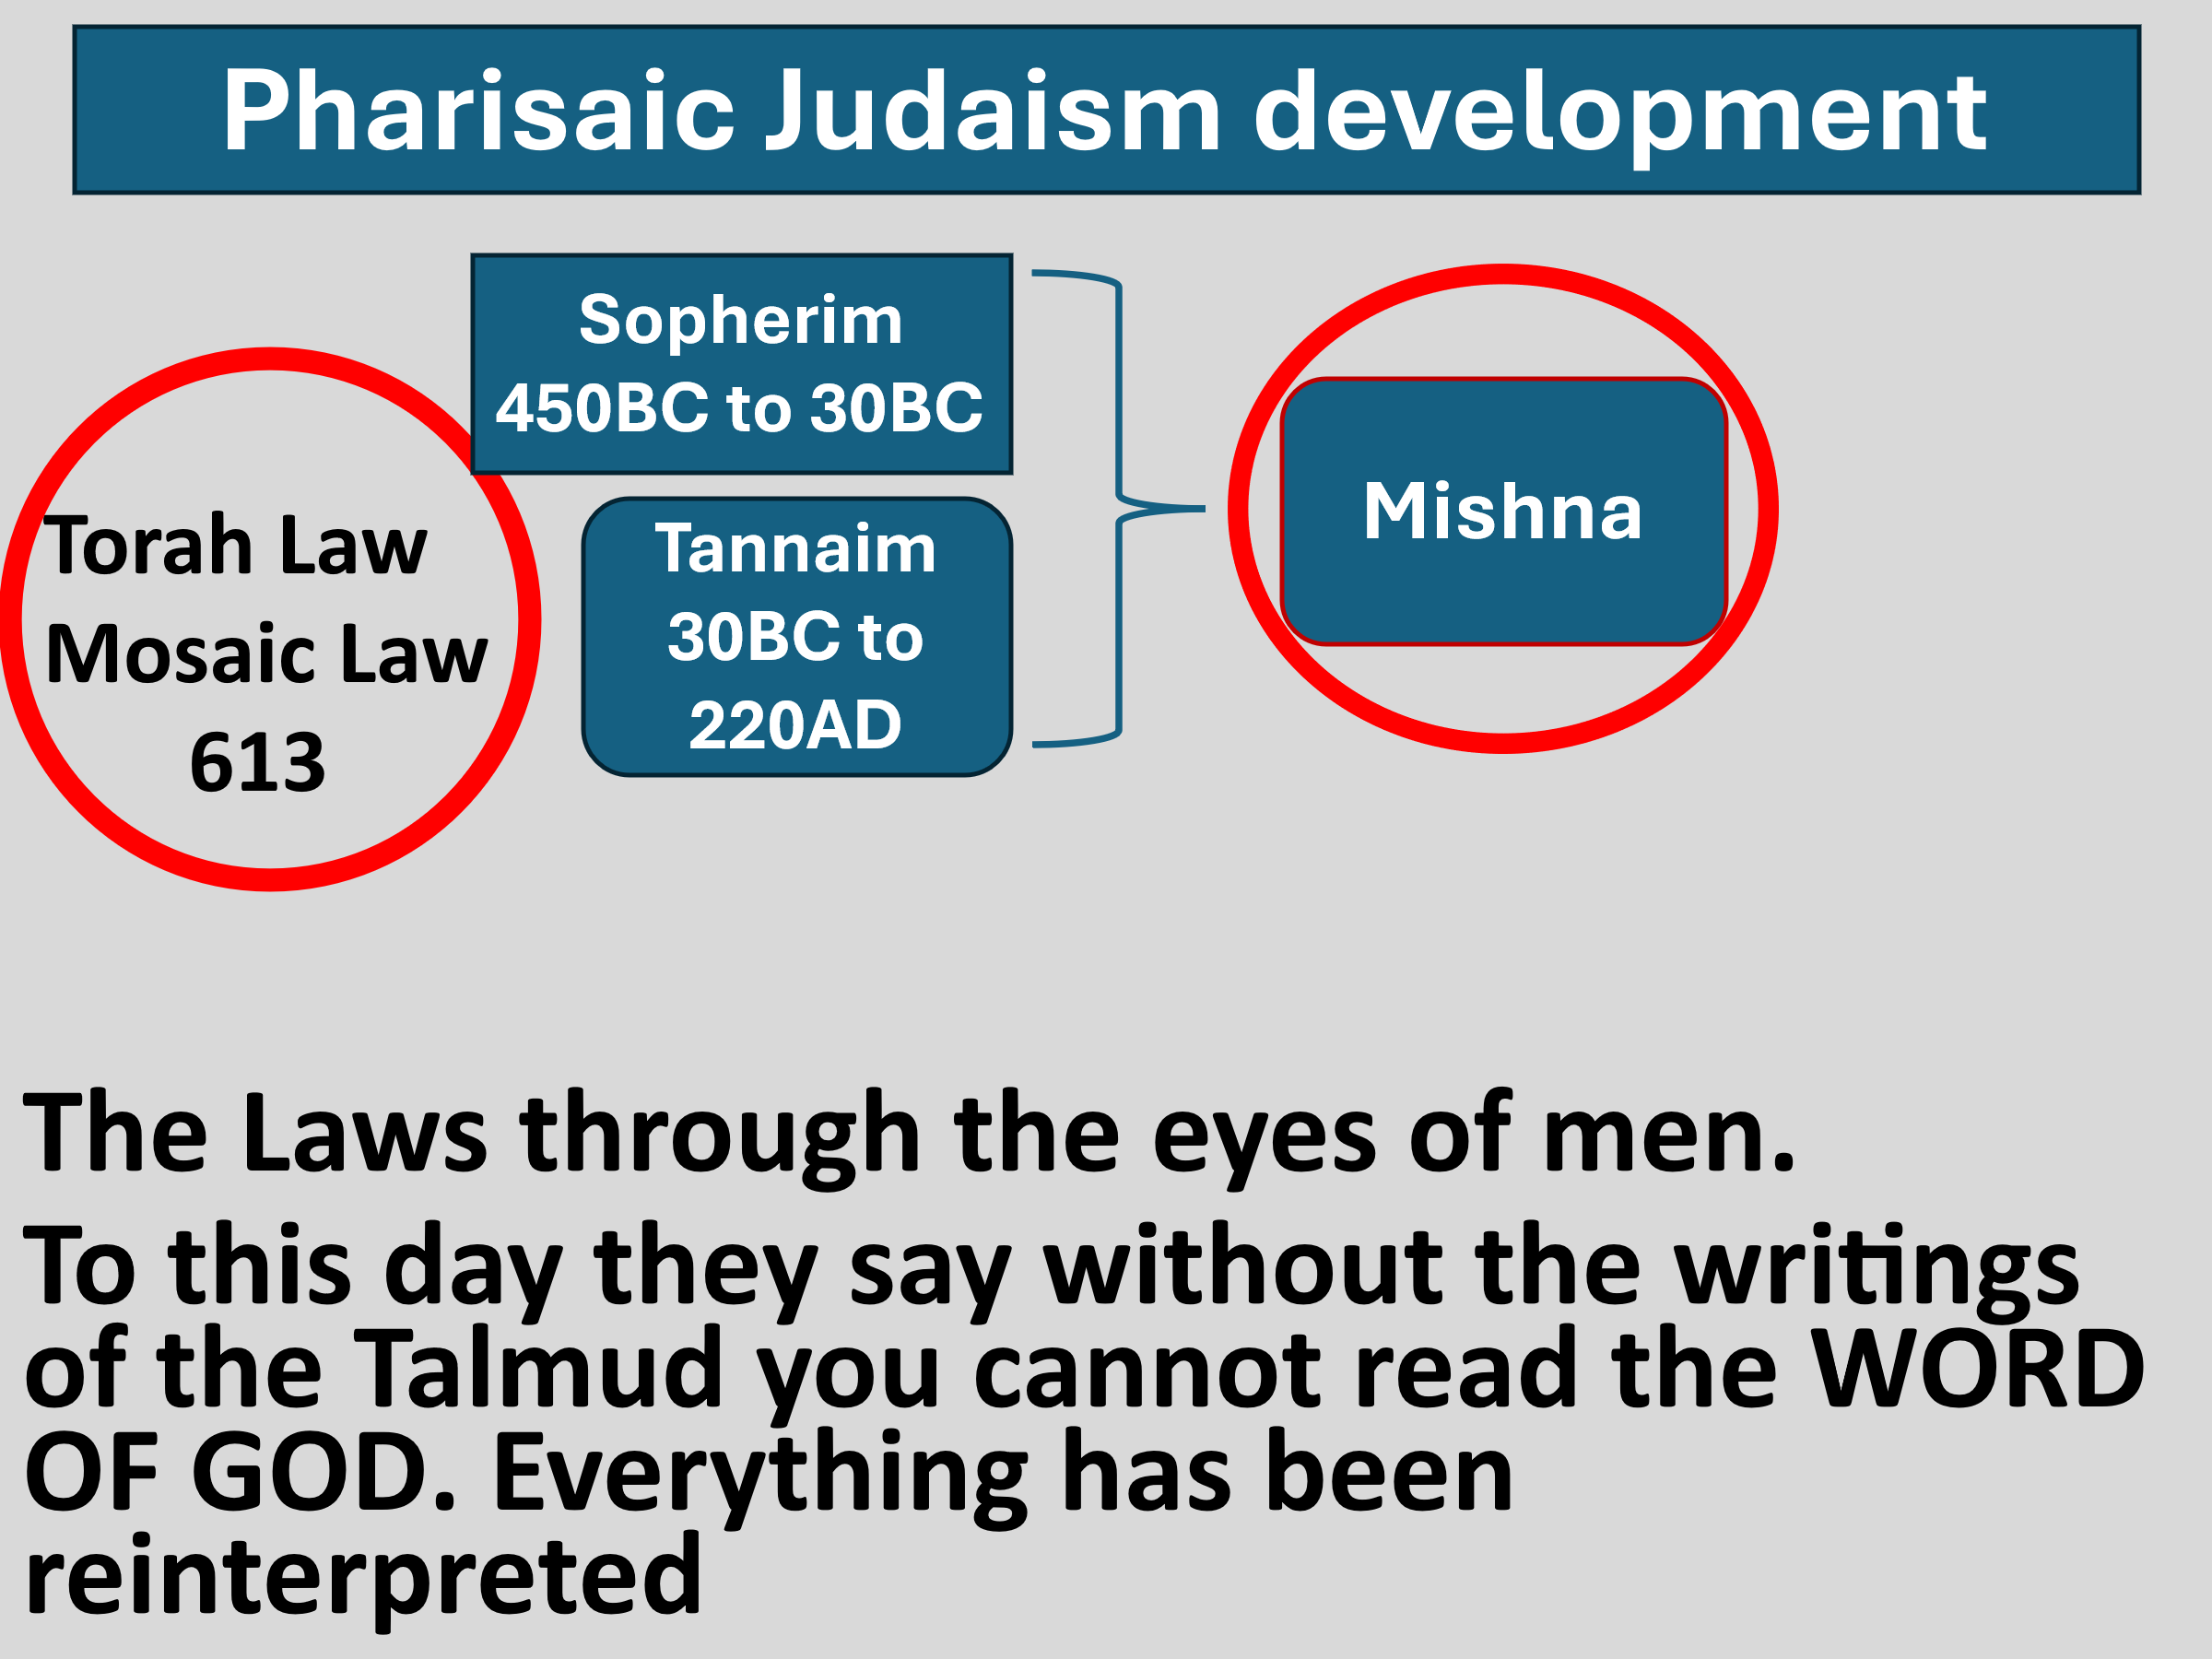

Video 1:26-7:17 https://youtu.be/_KAV5Y7tz9U?si=X8eq9X8kQ1nccll5

Messiah’s authority over the Sabbath!

Matt 12:1 At that time Jesus went through the grainfields on the Sabbath. And His disciples were hungry, and began to pluck heads of grain and to eat. 2 And when the Pharisees saw it, they said to Him, “Look, Your disciples are doing what is not lawful to do on the Sabbath!” 3 But He said to them, “Have you not read what David did when

he was hungry, he and those who were with him: 4 “how he entered the house of God and ate the showbread which was not lawful for him to eat, nor for those who were with him, but only for the priests?

5 “Or have you not read in the law that on the Sabbath the priests in the temple profane the Sabbath, and are blameless? 6 “Yet I say to you that in this place there is One greater than the temple.

7 “But if you had known what this means, ‘I desire mercy and not sacrifice,’ you would not have condemned the guiltless. 8 “For the Son of Man is Lord even of the Sabbath.”

1 Samuel 21:6 So the priest gave him holy bread; for there was no bread there but the showbread which had been taken from before the LORD, in order to put hot bread in its place on the day when it was taken away.

Pluck wheat guilty of reaping!

Rubbing in their hands guilty Threshing!

Blowing the chaff guilty winnowing!

Swallow wheat guilty of storing!

This is the reason they did not walk on the grass during the Sabbath!

That slavery to the Sabbath has not ended!

Mark 2:27 And He said to them, “The Sabbath was made for man, and not man for the Sabbath.

The Body of Christ, guilty of the same?????

“The church, too, has misconstrued the Sabbath, first by assuming that Sunday is the new Sabbath, and second, by insisting that it is still a mandatory day of worship. However, nowhere in Scripture is Sunday ever called the Sabbath. The Sabbath always was, is, and always will be from sundown Friday to sundown Saturday. The Bible never calls Sunday the Sabbath, nor does it call Sunday “the Lord’s Day.” That is a “Christian mishnah.” It is only by tradition that Sunday is referred to as “the Lord’s Day.”

In Scripture, Sunday is always called “the first day of the week,” which is a translation of the Hebrew Yom Rishon. Not only has the church defined Sunday as the new Sabbath, it has also begun to apply Sabbath rules and regulations to Sunday, and this is unwarranted.

As a result, in some circles, Sunday has become the obligatory day of congregational worship and rest. Limiting ourselves to the text of Scripture, believers are commanded to meet corporately on a regular basis.

This is not an option, but a biblical command. However, the day of the week is optional. Furthermore, the Scriptures do not teach that the Sabbath is a mandatory day of worship.

Those who condemn other denominations and churches for having corporate gatherings on Sunday and not on Saturday, base their convictions on a misunderstanding of the Mosaic purpose of the Sabbath. In the Mosaic Law, the Sabbath was to be a day of rest, not a day of corporate worship.

Moses said to stay home and rest on the Sabbath; he did not say to have corporate worship on the Sabbath. The Pharisees understood this, so as part of their building a fence around this law, they declared that it was forbidden for a person to walk more than a Sabbath day’s journey from home.

This was two thousand cubits, equal to approximately a kilometer, or three-quarters of a mile. Therefore, a person who gets up Saturday morning, starts his car engine, and drives to church is breaking the Sabbath every week.

Arnold G. Fruchtenbaum. baf-yes2 (Kindle Locations 4334-4348). Kindle Edition.

Next week: Withered hand healing

