Pharisaism;

What happened?
Sept 7, 2025

Last week we saw Jesus saying that you cannot put new wine in old wineskins

And why don’t His disciples fast according to the Jewish oral law?

This was their constant conflict with Jesus! That He rejected their man-made Law!!!!!

Over the last 400 years here is what happened:

The Mosaic Law had 613 commandments

There was a group that developed called the, “Sopherim”

3. Their thinking was this: Build a fence around the Law with other laws to keep the people from breaking the real Law and thus sending them into captivity!

We must remember this:

The 70-year captivity was awful everything was destroyed, and the Jews were taken captive by their enemies…

Daniel 9:3 Then I set my face toward the Lord God to make request by prayer and supplications, with fasting, sackcloth, and ashes. 4 And I prayed to the LORD my God, and made confession, and said,

“O Lord, great and awesome God, who keeps His covenant and mercy with those who love Him, and with those who keep His commandments,

5 “we have sinned and committed iniquity, we have done wickedly and rebelled, even by departing from Your precepts and Your judgments. 6 “Neither have we heeded Your servants the prophets, who spoke in Your name to our kings and our princes, to our fathers and all the people of the land.

7 “O Lord, righteousness belongs to You, but to us shame of face, as it is this day–to the men of Judah, to the inhabitants of Jerusalem and all Israel, those near and those far off in all the countries to which You have driven them, because of the unfaithfulness which they have committed against You.

8 “O Lord, to us belongs shame of face, to our kings, our princes, and our fathers, because we have sinned against You. 9 “To the Lord our God belong mercy and forgiveness, though we have rebelled

against Him. 10 “We have not obeyed the voice of the LORD our God, to walk in His laws, which He set before us by His servants the prophets. 11 “Yes, all Israel has transgressed Your law, and has departed so as not to obey Your voice; therefore the curse and the oath written in the Law of Moses the servant of God have been poured out on us, because we have sinned against Him.

12 “And He has confirmed His words, which He spoke against us and against our judges who judged us,

by bringing upon us a great disaster; for under the whole heaven such has never been done as what has been done to Jerusalem.

4. The Sopherim used Pilpulistic logic: How many laws can we derive from one law to make it impossible to break THE LAW.

Exodus 23:19 “The first of the firstfruits of your land you shall bring into the house of the LORD your God. You shall not boil a young goat in its mother’s milk.

… “this law was given to avoid a Canaanite practice. When a goat gave birth to its firstborn kid, the Canaanites would take the kid away from its mother, milk the mother, and then boil the meat of the kid in the milk of its mother as a firstfruits offering to Baal. Jews could not practice that kind of idolatry, and so they were not to seethe a kid in the milk of its mother. God gave that commandment to Moses around 1,400 B.C. A thousand years later, in 400 B.C., there were no

Canaanites around anymore. No one was boiling kids in the milk of the mother goat anymore, and so the original intent of that commandment had long been forgotten. In the school of the Sopherim, the question arose:

How do we make sure we never, never, never, ever, ever, ever boil a kid in the milk of its mother? That is when the pilpulistic logic began to work. Suppose you eat a piece of meat, and with the meat, you drink a glass of milk. It is possible that the meat is from the young of the animal

that produced the milk you are drinking. As you swallow both the meat and the milk, it mixes in your stomach, and you seethe a kid in the milk of its mother. Thus, a new law came into being: A Jew may not eat milk and meat products at the same time. After meat meals, one must wait about four hours before eating dairy.

Arnold G. Fruchtenbaum. baf-yes2 (Kindle Locations 3505-3514). Kindle Edition.

This, however, opens a rabbit hole:

…”the pilpulistic logic went even further. Suppose at noon you choose to eat a dairy meal. You take a plate, and from this, you eat some cheese.

After you eat the cheese, you may wash and scrub the plate thoroughly, but there just might be a tiny speck of cheese still left on the plate that you did not see. In the evening, you choose to eat meat, and you place the meat on the same plate from which you ate the cheese earlier in the day.

The meat then might pick up that tiny speck of cheese. No matter how remote, it just might be possible that the cheese you had at noon was made from the milk of the mother of the meat you are eating later in the day. As you swallow this tiny speck of cheese with the meat, you seethe the kid in the milk of its mother and again violate the Torah. Thus, another new law came into being: all Jews must have two sets of dishes; one is to be used for dairy products and one for meat products.

If one accidentally uses the wrong dish for the item eaten, the dish must either be destroyed or given to a Gentile, but no Jew may eat from that plate again! To each of the 613 commandments God gave to Moses, the Sopherim issued multiple new rules and regulations. The period of the Sopherim began about 400 B.C. and ended in 30 B.C. In rabbinic calculations, this period was not based on specific dates, but on key rabbis. This period is known as “From Ezra to Hillel.”
Arnold G. Fruchtenbaum. baf-yes (1) (Kindle Locations 1730-1747). Kindle Edition.

I can take it even further.

“We know cheese can have mold even to a small degree. Mold spores can go everywhere even to the plates used for meat, so in order to prevent this, the plates must be separated by at least another location outside of the house, or, you may seal them in a special airtight container. Then and only then can you truly know if they have been violated!

I can go further still: Separate plates are not enough “One must never have meat

and cheese together even on separate dishes. They really cannot be in the same house at any time. You need the meat in one location and the cheese in another. Restaurants are not allowed unless you bring your own tableware, because you cannot control meat and cheese crosses with their tableware. Therefore, eating out is only allowed with vegetarian orders with no meet or cheese…….

John 8:32 “And you shall know the truth, and the truth shall make you free.”

Matthew 23:4 “For they bind heavy burdens, hard to bear, and lay them on men’s shoulders; but they themselves will not move them with one of their fingers.

Torah 613 laws that were good! 1300 BC

School of the Sopherim 450BC to 30BC Need fences around the law!

School of the Tannaim 30 BC to 220 AD

Need MORE fences around the LAW!

3. The Amoriam 200 AD-500 AD Fences

The Problem…

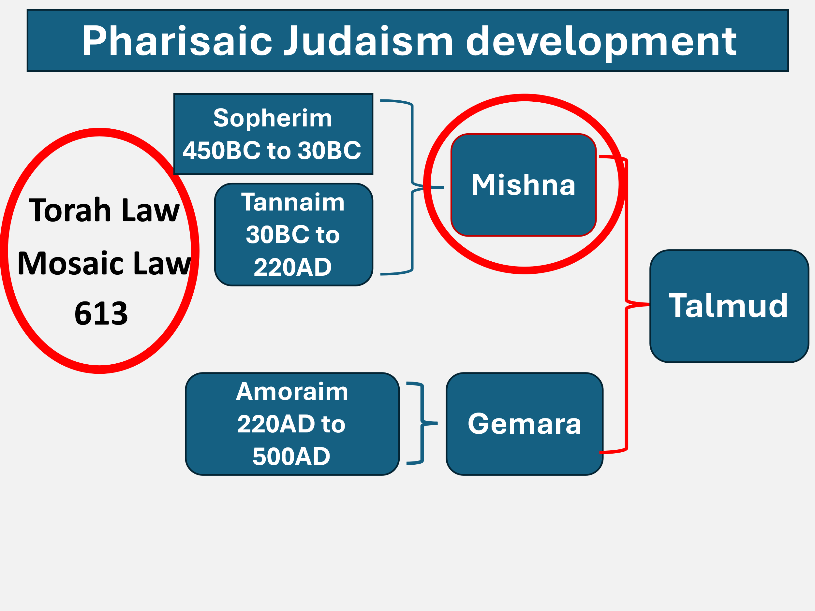

The reason we have taken so much time on this is to show Jesus Christ’s authenticity even more.

He was coming at the Pharisee’s corruption of the Law!

Jesus truly is the Messiah come to…

Luke 3:17 “His winnowing fan is in His hand, and He will thoroughly clean out His threshing floor, and gather the wheat into His barn; but the chaff He will burn with unquenchable fire.”

The Chaff did burn up just like He said it would back then!

Matthew 23:13 “But woe to you, scribes and Pharisees, hypocrites! For you shut up the kingdom of heaven against men; for you neither go in yourselves, nor do you allow those who are entering to go in.

Matt 24:1 Then Jesus went out and departed from the temple, and His disciples came up to show Him the buildings of the temple. 2 And Jesus said to them, “Do you not see all these things? Assuredly, I say to you, not one stone

shall be left here upon another, that shall not be thrown down.”

Just 40 years later, Jerusalem was burned to the ground and stayed that way till 1967 AD!

Next week: The 12 and Tradition!

