Old wineskins and the Pharisee’s Sabbath.
September 14, 2025

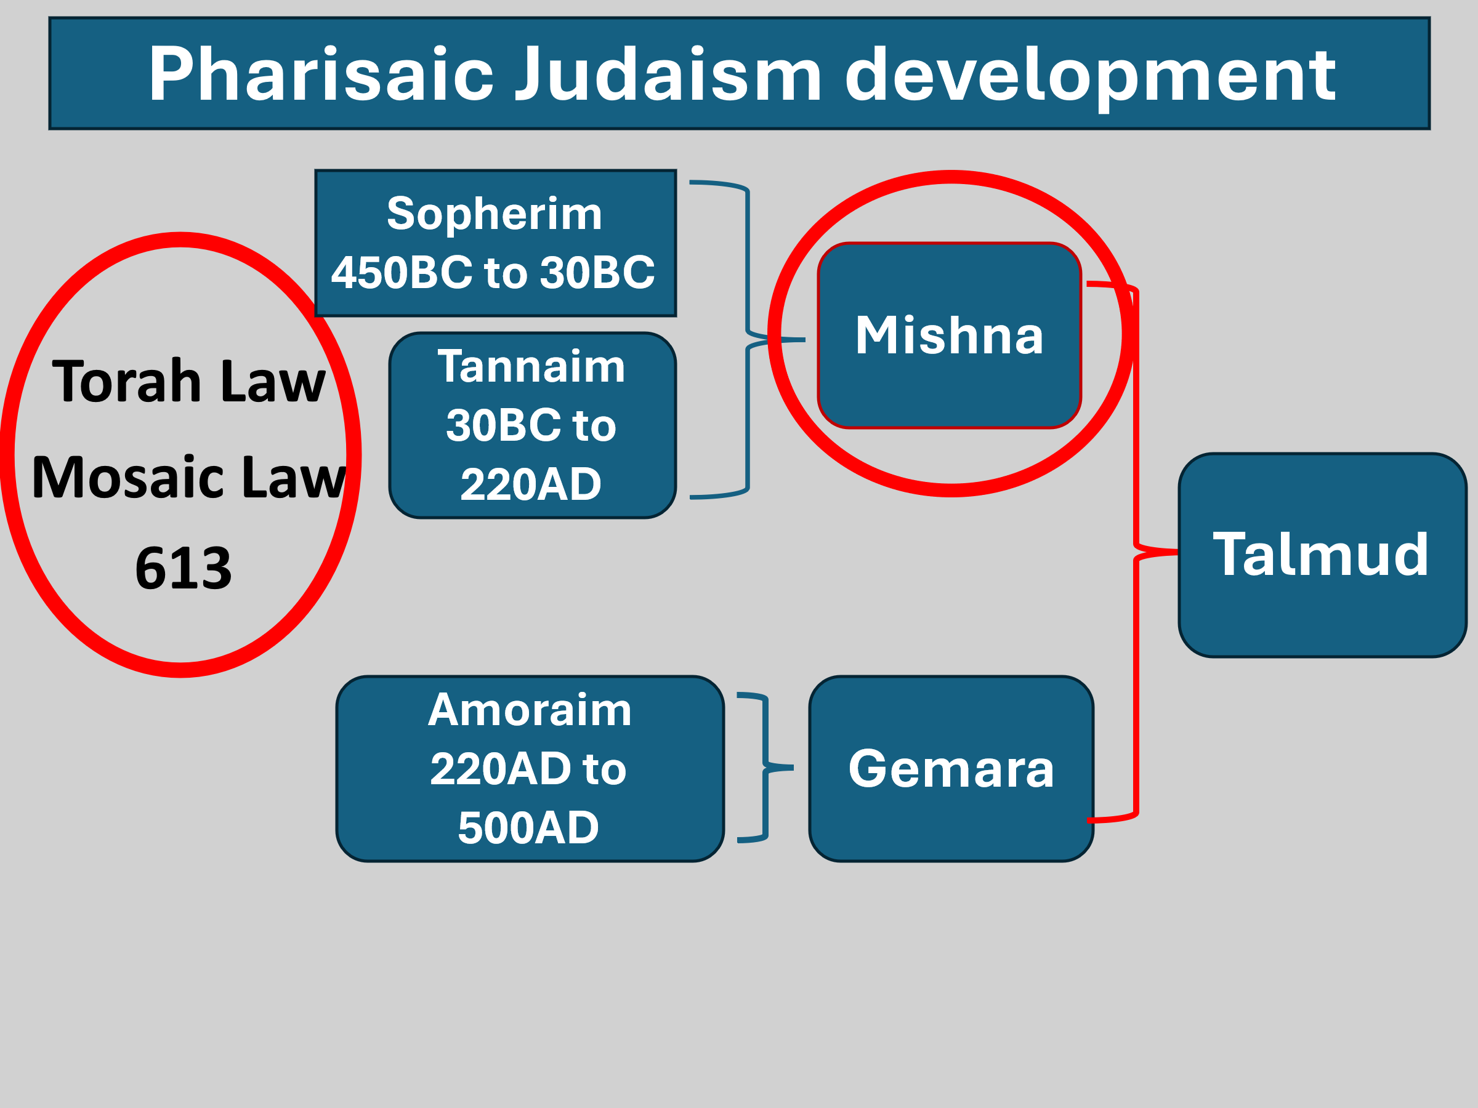

After the destruction of the Temple in 70AD the rabbis held the Sabbath and fasting as the ultimate holy acts! Note this quote:

“Rabbi Sheisheth, when he had fasted, said, after he had finished his prayer: “Lord of the world, it is evident before Thee, that at the time that the Sanctuary stood, a man sinned, and he brought an offering, nor did they offer of it anything but its fat and its blood, and he was forgiven. And now I have remained in fasting,

and my fat and my blood have been diminished, may it please Thee, that my fat and my blood which have been diminished be as if I had offered them upon the altar, and be merciful to me.”

[Edersheim, Sketches of Jewish Social Life, pp. 282-283.

Arnold G. Fruchtenbaum. baf-yes2 (Kindle Locations 12132-12133). Kindle Edition. (Kindle Locations 3604-3607). Kindle Edition.

This is offensive to Christ and probably why this was written here:

Hebrews 10:29 Of how much worse punishment, do you suppose, will he be

thought worthy who has trampled the Son of God underfoot, counted the blood of the covenant by which he was sanctified a common thing, and insulted the Spirit of grace?

From this point out, anytime in the scriptures we see, “the tradition of the Elders or the fathers” it is referring to the Mishnah.

Also, the Pharisees had in their teaching that when Messiah comes, He will follow the Mishna. This is where the wineskin teaching makes more sense…

Luke 5:37 “And no one puts new wine into old wineskins; or else the new wine will burst the wineskins and be spilled, and the wineskins will be ruined. 38 “But new wine must be put into new wineskins, and both are preserved. 39 “And no one, having drunk old wine, immediately desires new; for he says, ‘The old is better.’ ”

There are some things here we must remember…

Jesus is not in the business of supporting the Mishna/old.

Mat 15:7 “Hypocrites! Well did Isaiah prophesy about you, saying: 8 ‘These people draw near to Me with their mouth, And honor Me with their lips, But their heart is far from Me. 9 And in vain they worship Me, Teaching as doctrines the commandments of men.’ ” 14 “Let them alone. They are blind leaders of the blind. And if the blind leads the blind, both will fall into a ditch.”

So there are two ways that the last verse of Luke can be taken…

Luke 5:39 “And no one, having drunk old wine, immediately desires new; for he says, ‘The old is better.’ ”

Some see it has the old wine is better. The old representing the Mosiac Law. The new, “the Mishna”.

I must keep with the new/old context. The New here always represents the New which Christ brings, the old wineskins is the law of commandments of the Pharisees.’

And therefore in the end the religious leaders will stay with the old laws and traditions and reject Christ.

Even though Jeremiah says this:

Jeremiah 31:31 “Behold, the days are coming, says the LORD, when I will make a new covenant with the house of Israel and with the house of Judah– 32 “not according to the covenant that I made with their fathers in the day that I took them by the hand to lead them out of the land of Egypt,

My covenant which they broke, though I was a husband to them, says the LORD. 33 “But this is the covenant that I will make with the house of Israel after those days, says the LORD: I will put My law in their minds, and write it on their hearts; and I will be their God, and they shall be My people.

34 “No more shall every man teach his neighbor, and every man his brother, saying, ‘Know the LORD,’ for they all shall know Me, from the least of them to the

greatest of them, says the LORD. For I will forgive their iniquity, and their sin I will remember no more.”

Jesus is in the business of true worship and at this point, till the old covenant passes away, He is born under true Law.

Galatians 4:4 But when the fullness of the time had come, God sent forth His Son, born of a woman, born under the law, 5 to redeem those who were under the law, that we might receive the adoption as sons.

Matthew 5:17 “Do not think that I came to destroy the Law or the Prophets. I did not come to destroy but to fulfill.

20 “For I say to you, that unless your righteousness exceeds the righteousness of the scribes and Pharisees, you will by no means enter the kingdom of heaven.

Back to John and the Sabbath!

The Jewish leaders over the years had added over 1500 “fences” to the Sabbath Law. One was, “you cannot carry a burden from a public to private place and visa versa!

Another stated that the only healing allowed, was if a life depended on it!

John 5:1 After this there was a feast of the Jews, and Jesus went up to Jerusalem. 2 Now there is in Jerusalem by the Sheep Gate a pool, which is called in Hebrew, Bethesda, having five porches. 3 In these lay a great multitude of sick people, blind, lame, paralyzed, waiting for the moving of the water. 4 For an angel went down at a certain time into the pool and stirred up the water; then whoever stepped in first, after the stirring of the water,

was made well of whatever disease he had. 5 Now a certain man was there who had an infirmity thirty-eight years. 6 When Jesus saw him lying there, and knew that he already had been in that condition a long time, He said to him, “Do you want to be made well?”

7 The sick man answered Him, “Sir, I have no man to put me into the pool when the water is stirred up; but while I am coming, another steps down before me.” 8 Jesus said to him, “Rise, take up your bed and walk.” 9 And immediately the man was made well, took up his bed, and walked. And that day was the Sabbath.

38 years in that condition! Think of the muscles, bones and ligament atrophy!

Jesus sought him out and it did not require faith on his part because it is still in the period where these are shown to get Israel to believe!!!!

Jesus did this on the Sabbath to oppose the man-made laws of the Pharisees. Note what they focus on:

John 5:10 The Jews therefore said to him who was cured, “It is the Sabbath; it is not lawful for you to carry your bed.”

Jesus constantly has issue with them

Matthew 23:23 “Woe to you, scribes and Pharisees, hypocrites! For you pay tithe of mint and anise and cummin, and have neglected the weightier matters of the law: justice and mercy and faith. These you ought to have done, without leaving the others undone.

24 “Blind guides, who strain out a gnat and swallow a camel! 25 “Woe to you, scribes and Pharisees, hypocrites! For you cleanse the outside of the cup and dish,

but inside they are full of extortion and self-indulgence. 26 “Blind Pharisee, first cleanse the inside of the cup and dish, that the outside of them may be clean also.

This next one is Jesus the Lion!

Mark 3:1 And He entered the synagogue again, and a man was there who had a withered hand. 2 So they watched Him closely, whether He would heal him on the Sabbath, so that they might accuse Him. 3 And He said to the man who had the withered hand, “Step forward.”

4 Then He said to them, “Is it lawful on the Sabbath to do good or to do evil, to save life or to kill?” But they kept silent. 5 And when He had looked around at them with anger, being grieved by the hardness of their hearts, He said to the man, “Stretch out your hand.” And he stretched it out, and his hand was restored as whole as the other.

BEWARE CHURCH!

The Fence Built by the Church

“…the church has not escaped the temptation of trying to “build a fence around the law.” …What happened in Jewish history has also happened in church history

in that people felt that God’s law had to be protected by additional rules and regulations. …Rules and regulations differ from denomination to denomination and sometimes even within the same denomination. …but these lists cannot be found anywhere in Scripture, …Nevertheless, they are still treated as if they possess the same validity as Scripture, and often, a believer’s spiritual level is judged according to whether or not he conforms to these additional man-made rules and regulations. … The result is legalism. Legalism is when a believer chooses to live by a set of rules which goes beyond Scripture. …A person becomes a legalist when he or she expects all others to conform to their rules and judges their spirituality based on their level of conformity to these regulations. The point is that the church has no more authority to issue rules and regulations beyond Scripture than did the Pharisees”.

Arnold G. Fruchtenbaum. baf-yes2 (Kindle Locations 3657-3674). Kindle Edition.

Next week: Great promises!!!!

