Messiah’s Authority over Men!
August 31, 2025

Last time Jesus did a powerful climatic miracle by healing a man paralyzed and using the Jewish “easy to difficult” example, He healed the man (Harder). Your sins are forgiven (Easier).

Today: “calling the uncalled”

At this point, the Jewish leadership begins the interrogation phase!

They now will follow Him wherever He goes up till chapter 12 of Matthew.

Luke 5:27 After these things He went out and saw a tax collector named Levi,

sitting at the tax office. And He said to him, "Follow Me.” 28 So he left all, rose up, and followed Him. 29 Then Levi gave Him a great feast in his own house. And there were a great number of tax collectors and others who sat down with them.

30 And their scribes and the Pharisees complained against His disciples, saying, “Why do You eat and drink with tax collectors and sinners?” 31 Jesus answered and said to them, “Those who are well have no need of a physician, but those who are sick. 32 “I have not come to call the righteous, but sinners,

to repentance.”

Mat 9:9 As Jesus passed on from there, He saw a man named Matthew sitting at the tax office. And He said to him, “Follow Me.” So he arose and followed Him. 10 Now it happened, as Jesus sat at the table in the house, that behold, many tax collectors and sinners came and sat down with Him and His disciples.

11 And when the Pharisees saw it, they said to His disciples, “Why does your Teacher eat with tax collectors and sinners?”

12 When Jesus heard that, He said to them, “Those who are well have no need of a physician, but those who are sick. 13 “But go and learn what this means: ‘I desire mercy and not sacrifice.’ For I did not come to call the righteous, but sinners, to repentance.”

What are they to go and learn about what Jesus said?

Luke 18:10 “Two men went up to the temple to pray, one a Pharisee and the other a tax collector. 11 “The Pharisee stood and prayed thus with himself,

‘God, I thank You that I am not like other men–extortioners, unjust, adulterers, or even as this tax collector. 12 ‘I fast twice a week; I give tithes of all that I possess.’

13 “And the tax collector, standing afar off, would not so much as raise his eyes to heaven, but beat his breast, saying, ‘God, be merciful to me a sinner!’ 14 “I tell you, this man went down to his house justified rather than the other; for everyone who exalts himself will be humbled, and he who humbles himself will be exalted.”

Who was Matthew?

He is the seventh disciple

He was a tax collector and considered as bad as a prostitute!

Tax collectors were the utmost, despised people and considered treasonous to their own people because they extorted money from them.

The only people they would hang with were other tax collectors and prostitutes according to Jewish law, and they were unforgivable.

Income tax officials and the customs officials were the two types and Matthew was the customs official

WHICH WAS THE WORST KIND!

“the Pharisees were characterized by much sacrifice but little mercy, meaning they were very careful to keep the external demands of the Mosaic Law, but not as careful to keep its internal demands. Their lack of mercy was demonstrated by their many rules and regulations against the publicans.”

Arnold G. Fruchtenbaum. baf-yes2 (Kindle Locations 3431-3433). Kindle Edition.

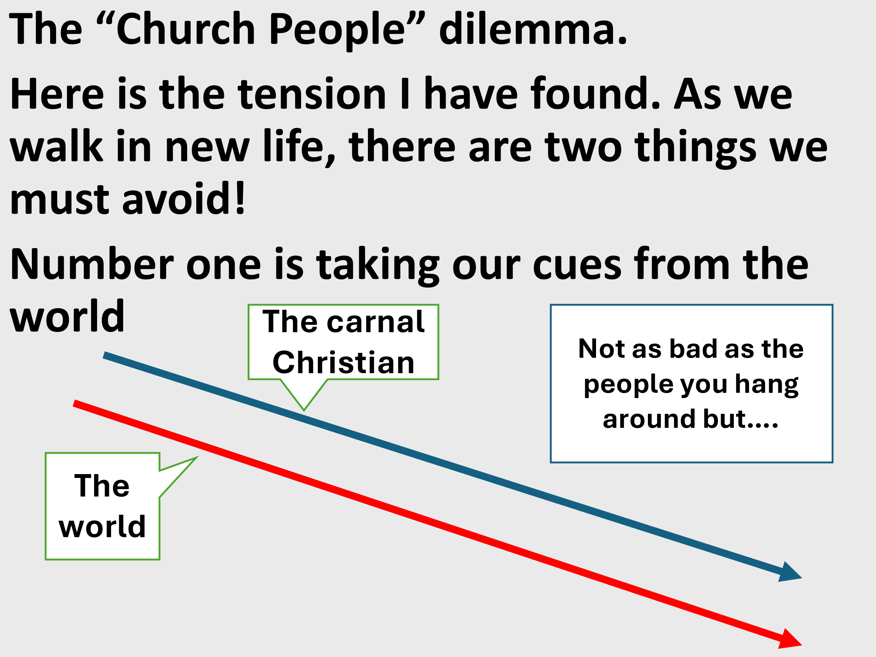

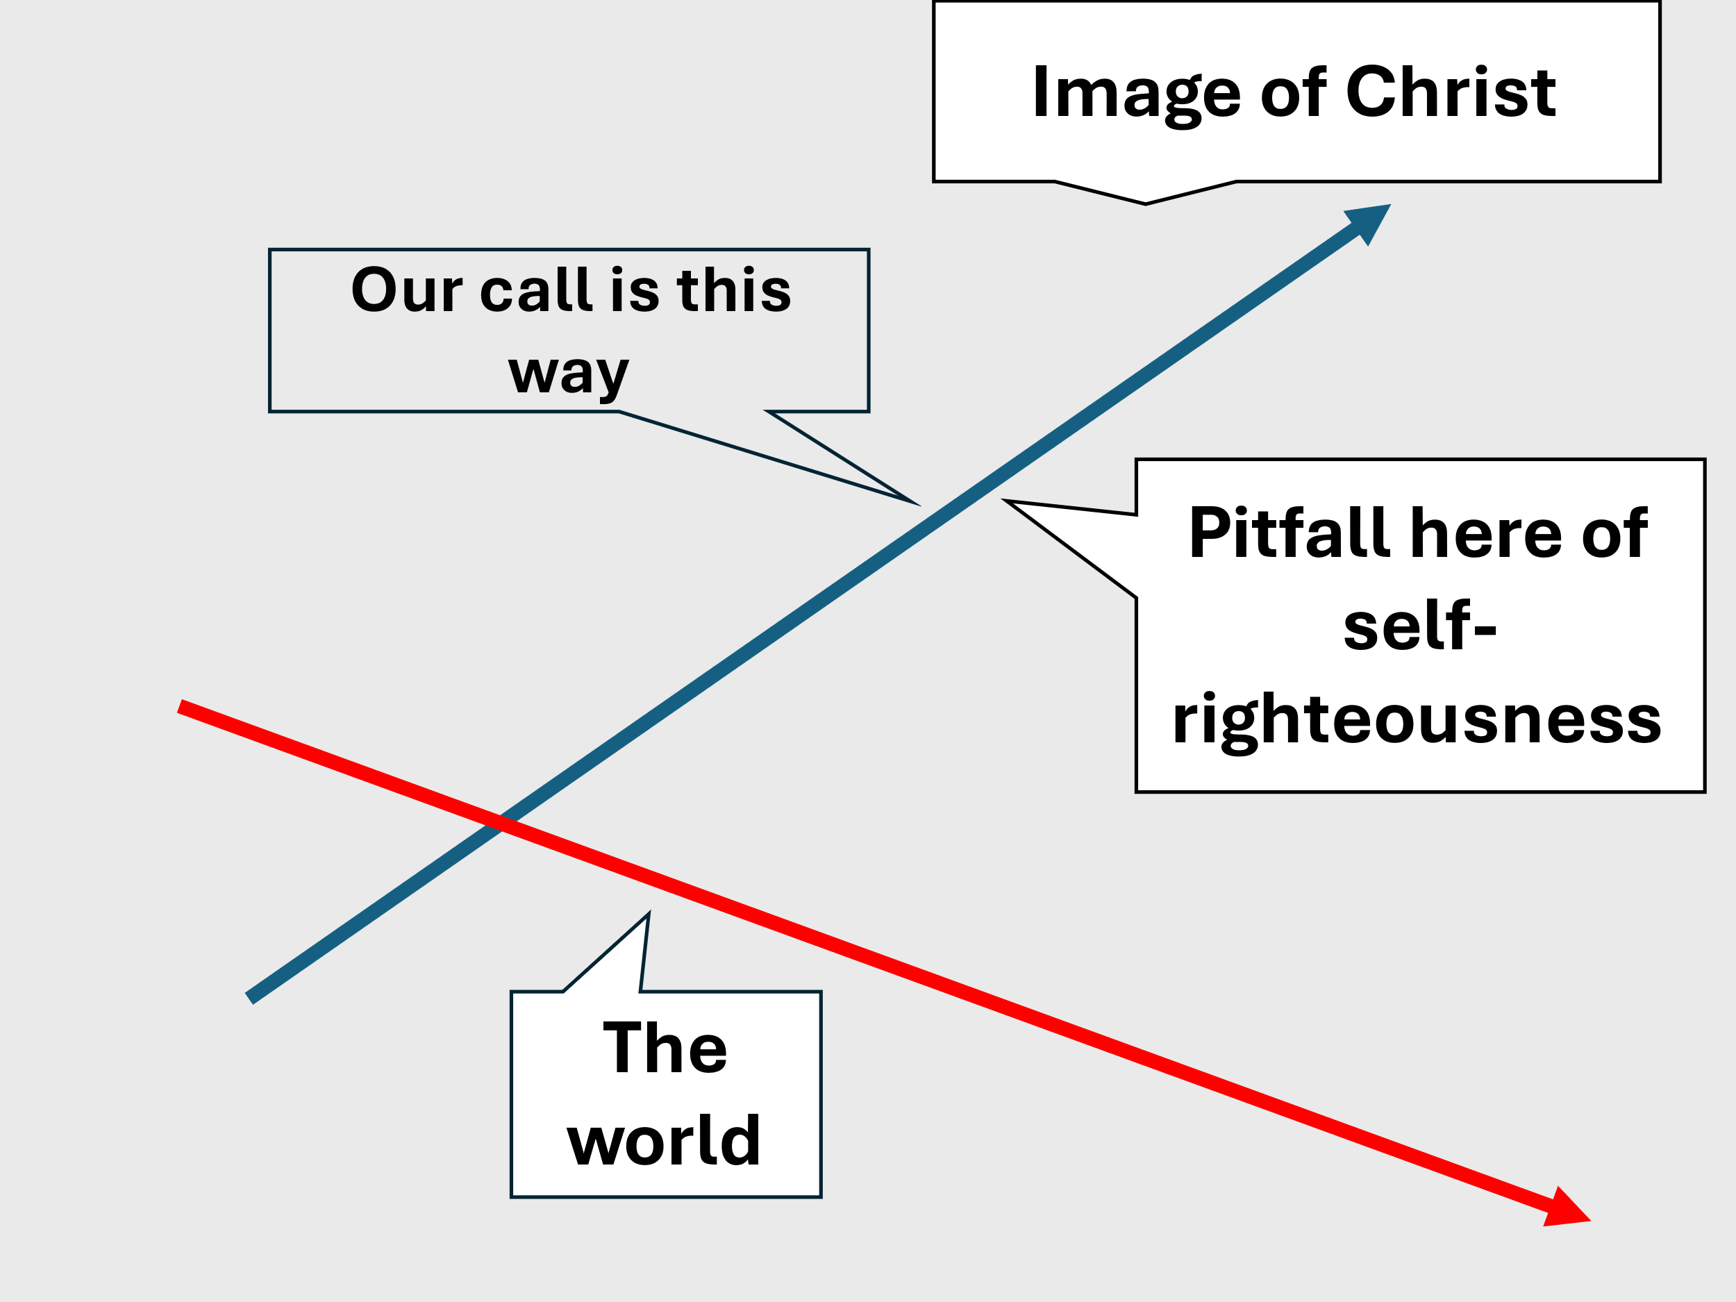

Preventing the two extremes!

We must REMEMBER!

Romans 5:6 For when we were still without strength, in due time Christ died for the ungodly. 7 For scarcely for a righteous man will one die; yet perhaps for a good man someone would even dare to die. 8 But God demonstrates His own love toward us, in that while we were still sinners, Christ died for us.

9 Much more then, having now been justified by His blood, we shall be saved from wrath through Him.

10 For if when we were enemies we were reconciled to God through the death of His Son, much more, having been reconciled, we shall be saved by His life. 11 And not only that, but we also rejoice in God through our Lord Jesus Christ, through whom we have now received the reconciliation.

Much questioning from here on out!

Luke 5:33 Then they said to Him, “Why do the disciples of John fast often and make prayers, and likewise those of the Pharisees, but Yours eat and drink?”

34 And He said to them, “Can you make the friends of the bridegroom fast while the bridegroom is with them? 35 “But the days will come when the bridegroom will be taken away from them; then they will fast in those days.”

36 Then He spoke a parable to them: “No one puts a piece from a new garment on an old one; otherwise the new makes a tear, and also the piece that was taken out of the new does not match the old.

37 “And no one puts new wine into old wineskins;. or else the new wine will burst the wineskins and be spilled, and the wineskins will be ruined. 38 “But new wine must be put into new wineskins, and both are preserved

39 “And no one, having drunk old wine, immediately desires new; for he says, ‘The old is better.’ ”

1. The wedding analogy: People don’t come to a wedding to fast and mourn but to celebrate JOYFULLY!!!!

Jesus is present with them! Messiah is here and the Kingdom is near!

Luke 10:9 “And heal the sick there, and say to them, ‘The kingdom of God has come near to you.’

Soon though, the bridegroom will be taken away!

Isaiah 53:8 He was taken from prison and from judgment, And who will declare His generation? For He was cut off from the land of the living; For the transgressions of My people He was stricken.

2. The garment, patch example: You cannot take the new to patch up the old which is passing away!

3. The wineskin example! You cannot take the new wine and pour it into the old which is passing away!

2Cor 3:7 But if the ministry of death, written and engraved on stones, was glorious, so that the children of Israel could not look steadily at the face of Moses because of the glory of his countenance, which glory was passing away,

8 how will the ministry of the Spirit not be more glorious? 9 For if the ministry of condemnation had glory, the ministry of righteousness exceeds much more in glory. 10 For even what was made glorious had no glory in this respect, because of the glory that excels. 11 For if what is passing away was glorious, what remains is much more glorious.

Pharisaic Judaism is dead! Mat 5:17 “Do not think that I came to destroy the Law or the Prophets.

I did not come to destroy but to fulfill. 18 “For assuredly, I say to you, till heaven and earth pass away, one jot or one tittle will by no means pass from the law till all is fulfilled.

JESUS SAID: IT IS FINISHED!!!!!!!!

