## **The appointment in Samaria July 13, 2025**

## ***John 4:1 Therefore, when the Lord knew that the Pharisees had heard that Jesus made and baptized more disciples than John 2 (though Jesus Himself did not baptize, but His disciples), 3 He left Judea and departed again to Galilee. 4 But He needed to go through Samaria.***

## ***5 So He came to a city of Samaria which is called Sychar, near the plot of ground that Jacob gave to his son Joseph. 6 Now Jacob’s well was there. Jesus therefore, being wearied from His journey, sat thus***

## ***by the well. It was about the sixth hour.***

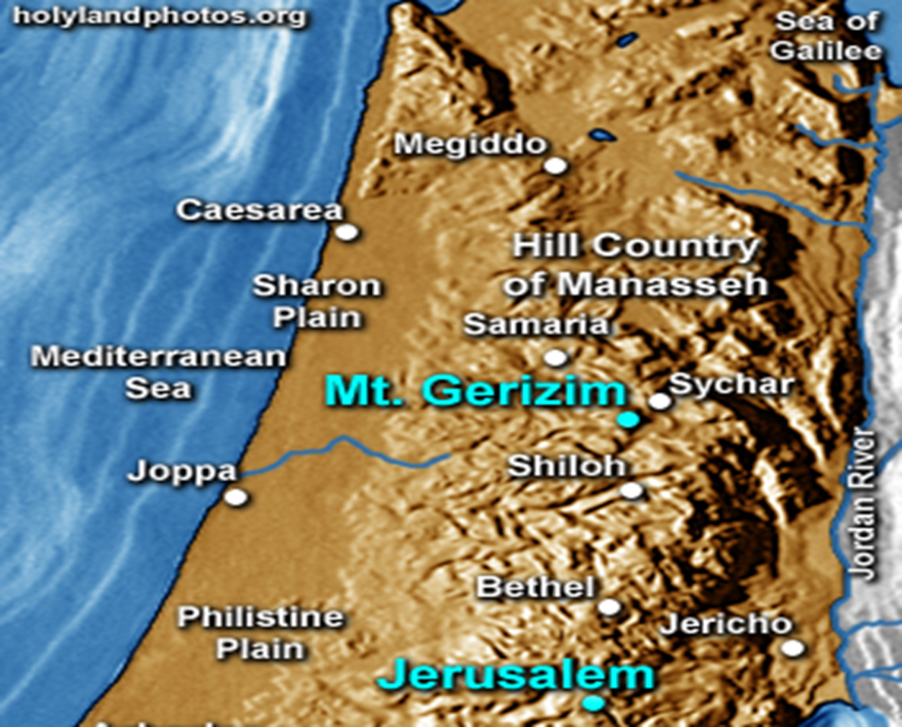



## **Samaritans were a mixed race**

## **They followed first five books of the Bible but no others. Everything to them happened on Mt Gerizim and not Mt Moriah in Jerusalem.**

## **They were also awaiting Messiah.**

## **The Jews taught this about them:**

## **They were a corruption of the true faith**



## **Contact was to be limited**



## **Accepted no free things from them**



## **Samaritans on the other hand would not let Jews pass through towards Jerusalem but would allow it from Jerusalem.**

## ***John 4:7 A woman of Samaria came to draw water. Jesus said to her, “Give Me a drink.” 8 For His disciples had gone away into the city to buy food. 9 Then the woman of Samaria said to Him, “How is it that You, being a Jew, ask a drink from me, a Samaritan woman?” For Jews have no dealings with Samaritans. 10 Jesus answered and said to her,***

## ***“If you knew the gift of God, and who it is who says to you, ‘Give Me a drink,’ you would have asked Him, and He would have given you living water.”***

## **First Jesus breaks with man-made tradition.**



## **He sits by a well without a way to draw anything and asks a woman who is an untouchable to do something for Him.**

## **Then He talks about a water that she is not familiar with.**

## **He then takes this special Jacobian well, gives the truth concerning it and this earthly water. And gives her the same teaching that He gave Nicodemus**

## **IT’S NOT ABOOUT EARTHLY THINGS!!!!!**

## **This is something Jesus will always do, take something normal and natural and turn it into a life saving truth!**

## **Why does He keep doing this?**

## ***Col 1:15 He is the image of the invisible God, the firstborn over all creation.***

## ***16 For by Him all things were created that are in heaven and that are on earth, visible and invisible, whether thrones or dominions or principalities or powers. All things were created through Him and for Him. 17 And He is before all things, and in Him all things consist.***



## **He also takes incredible difficult truths to understand and makes them simple truth! Unlike many who take the simple and make it so complex that no one can understand it.**

## **She keeps following the trail…**

## **Then He gives her another angle of the born-again truth!**

## ***John 4:13 Jesus answered and said to her, “Whoever drinks of this water will thirst again, 14 “but whoever drinks of the water that I shall give him will never thirst. But the water that I shall give him***

## ***will become in him***

## ***a fountain of water***

## ***springing up into everlasting life.”***

## **She gets that it is a different water, but she is still thinking physically not spiritually.**

## ***John 4:15 The woman said to Him, “Sir, give me this water, that I may not thirst, nor come here to draw.”***

## **The unsaved cannot think in Spiritual realities! Note:**

## ***1 Corinthians 2:14 But the natural man does not receive the things of the Spirit of God, for they are foolishness to him; nor can he know them, because they are spiritually discerned.***

## **Note to Those of us who know and understand by the Holy Spirit**

## **If you drink of earth’s water, you'll have to drink again.**

## **If you drink from the Living water, YOU WILL NEVER THIRST AGAIN!**

## **In fact, it will fountain up forever once it starts!**

## **Think about it: If Spiritual life could be lost why say this???**

## **She realizes that once you drink this water you will never need anymore because it becomes eternal in you!!!!!**

## **That’s a great deal so she asks for some…**

## ***John 4:15 The woman said to Him, “Sir, give me this water, that I may not thirst, nor come here to draw.”***

## **Now note she first called Him, “A Jew”**

## **Now she calls Him, “Sir”**

## **The next name will be, “prophet”**

## **Lastly, “The Messiah”**

## **Jesus is now revealing the spiritual mission that He is on!!!! To save us from ourselves!**

## ***Romans 3:10 As it is written: “There is none righteous, no, not one; 11 There is none who understands; There is none who seeks after God. 12 They have all turned aside; They have together become unprofitable; There is none who does good, no, not one.” 13 “Their throat is an open tomb; With their tongues they have practiced deceit”; “The poison of asps is under their lips”;***

## ***14 “Whose mouth is full of cursing and bitterness.” 15 “Their feet are swift to shed blood; 16 Destruction and misery are in their ways; 17 And the way of peace they have not known.” 18 “There is no fear of God before their eyes.”***

## ***19 Now we know that whatever the law says, it says to those who are under the law, that every mouth may be stopped, and all the world may become guilty before God. 20 Therefore by the deeds of the law no flesh will be justified in His sight, for by the law is the knowledge of sin.***

## **And this is what Jesus does with her!!!!!**

## ***John 4:16 Jesus said to her, “Go, call your husband, and come here.” 17 The woman answered and said, “I have no husband.” Jesus said to her, “You have well said, ‘I have no husband,’ 18 “for you have had five husbands, and the one whom you now have is not your husband; in that you spoke truly.”***

## **Sometimes it takes a bit for us to realize our awful lost state. Hanging out dirty laundry is embarrassing and revealing.**

## **Many times, we first deflect!**

## ***4:19 The woman said to Him, “Sir, I perceive that You are a prophet. 20 “Our fathers worshiped on this mountain, and you Jews say that in Jerusalem is the place where one ought to worship.”***

## **Don’t get derailed!**

## ***John 4:21 Jesus said to her, “Woman, believe Me, the hour is coming when you will neither on this mountain, nor in Jerusalem, worship the Father. 22 “You worship what you do not know; we know what we worship,***

## ***for salvation is of the Jews. 23 “But the hour is coming, and now is, when the true worshipers will worship the Father in spirit and truth; for the Father is seeking such to worship Him. 24 “God is Spirit, and those who worship Him must worship in spirit and truth.”***

## **She doesn’t disagree with the statement but basically says: You say, we say but when Messiah comes, He’ll fix what we can’t agree on right now, but for now who knows?**

## ***4:25 The woman said to Him, “I know that Messiah is coming” (who is called Christ). “When He comes, He will tell us all things.”***

## ***26 Jesus said to her, “I who speak to you am He.”***

## **Next week: Hey who gave Him food, who gave Jesus some food?**