## **The second sign and beyond! July 27, 2025**



## ***John 4:43 Now after the two days He departed from there and went to Galilee. 44 For Jesus Himself testified that a prophet has no honor in his own country. 45 So when He came to Galilee, the Galileans received Him, having seen all the things He did in Jerusalem at the feast; for they also had gone to the feast.***

## ***46 So Jesus came again to Cana of Galilee where He had made the water wine. And there was a certain nobleman whose son was sick at Capernaum.***

## ***47 When he heard that Jesus had come out of Judea into Galilee, he went to Him and implored Him to come down and heal his son, for he was at the point of death. 48 Then Jesus said to him, “Unless you people see signs and wonders, you will by no means believe.”***

## ***49 The nobleman said to Him, “Sir, come down before my child dies!” 50 Jesus said to him, “Go your way; your son lives.” So the man believed the word that Jesus spoke to him, and he went his way.***



## ***51 And as he was now going down, his servants met him and told him, saying, “Your son lives!” 52 Then he inquired of them the hour when he got better. And they said to him, “Yesterday at the seventh hour the fever left him.”***

## ***53 So the father knew that it was at the same hour in which Jesus said to him, “Your son lives.” And he himself believed, and his whole household. 54 This again is the second sign Jesus did when He had come out of Judea into Galilee.***

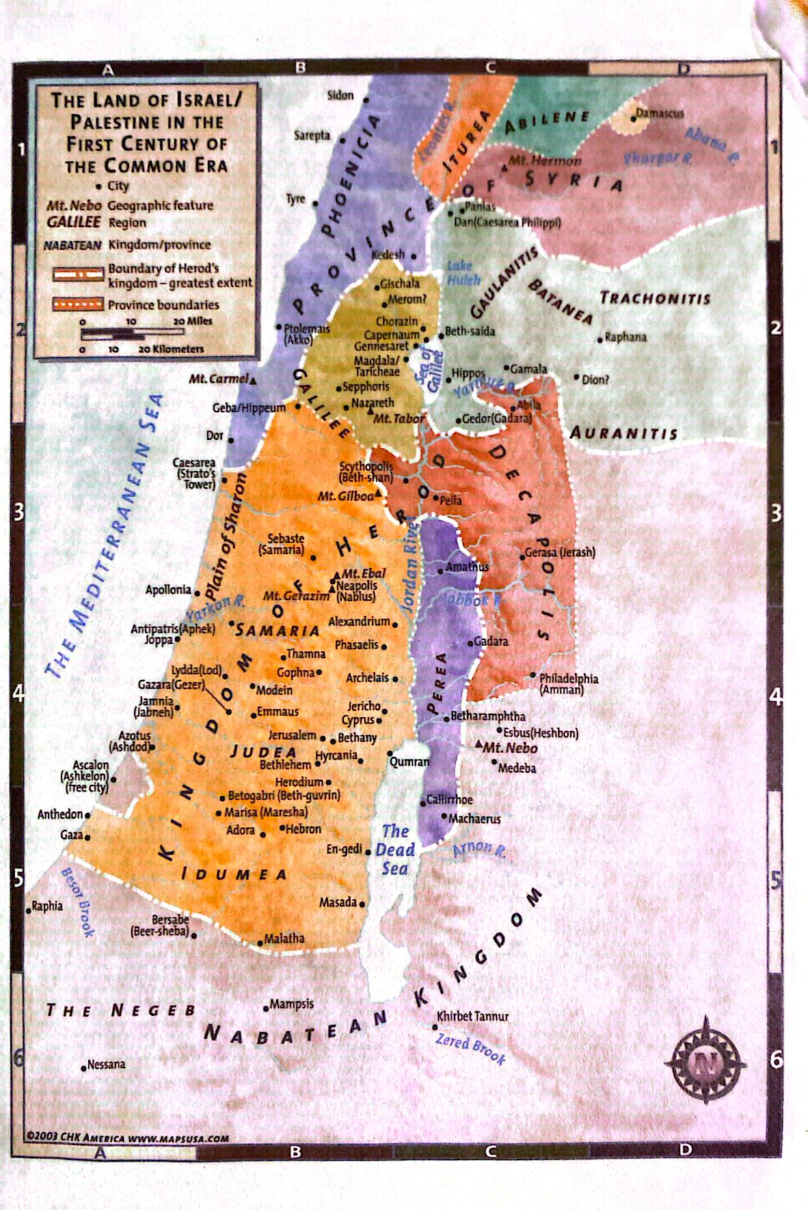

## **It is at this time that Jesus begins to preach this:**

## ***Matthew 4:12 Now when Jesus heard that John had been put in prison, He departed to Galilee. 13 And leaving Nazareth, He came and dwelt in Capernaum, which is by the sea, in the regions of Zebulun and Naphtali,***

## ***14 that it might be fulfilled which was spoken by Isaiah the prophet, saying: 15 “The land of Zebulun and the land of, Naphtali By the way of the sea,***

## ***beyond the Jordan, Galilee of the Gentiles: 16 The people who sat in darkness have seen a great light, And upon those who sat in the region and shadow of death Light has dawned.” 17 From that time Jesus began to preach and to say, “Repent, for the kingdom of heaven is at hand.”***

## **This is Isaiah 9 prophecy fulfilled. The very people whom darkness descended back in**

## **2 Kings 15:29 when the cruel Assyrians took them away, will be visited with a GREAT LIGHT!**

## **This is literally the light of MESSIAH THE SAVIOR!!! This comes to two tribes in the Galilee area Zebulun and Napthali.**

## **What is the great light?**



## ***Romans 5:17 For if by the one man’s offense death reigned through the one, much more those who receive abundance of grace and of the gift of righteousness will reign in life through the One, Jesus Christ.) 18 Therefore, as through one man’s offense judgment came to all men, resulting in condemnation,***

## ***even so through one Man’s righteous act the free gift came to all men, resulting in justification of life. 19 For as by one man’s disobedience many were made sinners, so also by one Man’s obedience many will be made righteous.***

## ***20 Moreover the law entered that the offense might abound. But where sin abounded, grace abounded much more, 21 so that as sin reigned in death, even so grace might reign through righteousness to eternal life through Jesus Christ our Lord.***



## **The healing of the noble man’s son is significant because here this official walked uphill 30 miles, asked for no sign, instead simply trusts in what Jesus said…**

## ***John 4:50 Jesus said to him, “Go your way; your son lives.” So the man believed the word that Jesus spoke to him, and he went his way. 51 And as he was now going down, his servants met him and told him, saying, “Your son lives!”***

## ***52 Then he inquired of them the hour when he got better. And they said to him,***

## ***“Yesterday at the seventh hour the fever left him.” 53 So the father knew that it was at the same hour in which Jesus said to him, “Your son lives.” And he himself believed, and his whole household. 54 This again is the second sign Jesus did when He had come out of Judea into Galilee.***

## **This is all the Spirit’s doing, note as He enters the Galilee region…**

## ***14 Then Jesus returned in the power of the Spirit to Galilee, and news of Him went out through all the surrounding region.***



## ***15 And He taught in their synagogues, being glorified by all.***

## **Incoming Prophecy!!!!!! Isaiah 61:1-2a**

## ***Luke 4:16 So He came to Nazareth, where He had been brought up. And as His custom was, He went into the synagogue on the Sabbath day, and stood up to read. 17 And He was handed the book of the prophet Isaiah. And when He had opened the book, He found the place where it was written: 18 “The Spirit of the LORD*** *is* ***upon Me,***

## ***Because He has anointed Me To preach the gospel to the poor; He has sent Me to heal the brokenhearted, To proclaim liberty to the captives And recovery of sight to the blind, To set at liberty those who are oppressed; 19 To proclaim the acceptable year of the LORD.”***

## ***20 Then He closed the book, and gave it back to the attendant and sat down. And the eyes of all who were in the synagogue were fixed on Him.***

## ***21 And He began to say to them, “Today this Scripture is fulfilled in your hearing.” 22 So all bore witness to Him, and marveled at the gracious words which proceeded out of His mouth. And they said, “Is this not Joseph’s son?”***

## **There are some things He does here that we miss:**

## **1. He goes against Rabbinic teaching and reads only half of what was to be read in the synagogue.**

## **2. They know He’s reading a Messianic text and is applying it to Himself.**

## **3. They were impressed by His reading BUT their unbelief is exposed in this statement “Is this not Joseph’s son?” This implies normal human and from Nazareth! This is why this is said…**



## ***Luke 4:23 He said to them, “You will surely say this proverb to Me, ‘Physician, heal yourself! Whatever we have heard done in Capernaum, do also here in Your country.’ ” 24 Then He said, “Assuredly, I say to you, no prophet is accepted in his own country.***

## ***25 “But I tell you truly, many widows were in Israel in the days of Elijah, when the heaven was shut up three years and six months, and there was a great famine throughout all the land;***

## ***26 “but to none of them was Elijah sent except to Zarephath, in the region of Sidon, to a woman who was a widow. 27 “And many lepers were in Israel in the time of Elisha the prophet, and none of them was cleansed except Naaman the Syrian.”***



## **Jesus is showing them what is in their hearts**

## **They will not believe and in fact God will allow Gentiles to see while they will be blind!!!!! This does not cause repentance but anger instead!**



## ***Luke 6:11 But they were filled with rage, and discussed with one another what they might do to Jesus.***



## ***Luke 4:28 So all those in the synagogue, when they heard these things, were filled with wrath,***



## ***29 and rose up and thrust Him out of the city; and they led Him to the brow of the hill on which their city was built, that they might throw Him down over the cliff. 30 Then passing through the midst of them, He went His way.***



## **Next week: More Zebulun and Naphtali!**