Food and farming
July 20, 2025

John 4:27 And at this point His disciples came, and they marveled that He talked with a woman; yet no one said, “What do You seek?” or, “Why are You talking with her?” 28 The woman then left her waterpot, went her way into the city, and said to the men,

29 “Come, see a Man who told me all things that I ever did. Could this be the Christ?” 30 Then they went out of the city and came to Him. 31 In the meantime His disciples urged Him, saying, “Rabbi, eat.”

32 But He said to them, “I have food to eat of which you do not know.” 33 Therefore the disciples said to one another, “Has anyone brought Him anything to eat?”

34 Jesus said to them, “My food is to do the will of Him who sent Me, and to finish His work. 35 “Do you not say, ‘There are still four months and then comes the harvest’? Behold, I say to you, lift up your eyes and look at the fields, for they are already white for harvest!

36 “And he who reaps receives wages, and gathers fruit for eternal life, that both he who sows and he who reaps may rejoice together. 37 “For in this the saying is true: ‘One sows and another reaps.’ 38 “I sent you to reap that for which you have not labored; others have labored, and you have entered into their labors.”

39 And many of the Samaritans of that city believed in Him because of the word of the woman who testified, “He told me all that I ever did.”

40 So when the Samaritans had come to Him, they urged Him to stay with them; and He stayed there two days.

41 And many more believed because of His own word. 42 Then they said to the woman, “Now we believe, not because of what you said, for we ourselves have heard Him and we know that this is indeed the Christ, the Savior of the world.”

Jesus takes food and farming to show His mission here for all.

The disciples were thinking physical food and Jesus made it spiritual!

John 4:32 But He said to them, “I have food to eat of which you do not know.” Spiritual

33 Therefore the disciples said to one another, “Has anyone brought Him anything to eat?” Physical

34 Jesus said to them, “My food is to do the will of Him who sent Me, and to finish His work. Spiritual

The result of the eternal food was this:

John 4:42 Then they said to the woman, “Now we believe, not because of what you said, for we ourselves have heard Him and we know that this is indeed the Christ, the Savior of the world.”

Though we live here in the physical our mindset is not physical but eternal!!!

1 Corinthians 15:42 So also is the resurrection of the dead. The body is sown in corruption, it is raised in incorruption.

43 It is sown in dishonor, it is raised in glory. It is sown in weakness, it is raised in power. 44 It is sown a natural body, it is raised a spiritual body. There is a natural body, and there is a spiritual body. 45 And so it is written, “The first man Adam became a living being.” The last Adam became a life-giving spirit.

REMEMBER!

Psalm 39:4 “LORD, make me to know my end, And what is the measure of my days, That I may know how frail I am. 5 Indeed……

You have made my days as handbreadths, And my age is as nothing before You; Certainly every man at his best state is but vapor. ​Selah

6 Surely every man walks about like a shadow; Surely they busy themselves in vain; He heaps up riches, And does not know who will gather them. 7 “And now, Lord, what do I wait for?

My hope is in You.

The true reality of this life is this…

Romans 8:22 For we know that the whole creation groans and labors with birth pangs together until now.

23 Not only that, but we also who have the firstfruits of the Spirit, even we ourselves groan within ourselves, eagerly waiting for the adoption, the redemption of our body. 24 For we were saved in this hope,…

Since we know the reality of this life we need to have a Farmer’s mindset.

John 4:35 “Do you not say, ‘There are still four months and then comes the harvest’? Behold, I say to you, lift up your eyes and look at the fields, for they are already white for harvest! 36 “And he who reaps receives wages, and gathers fruit for eternal life, that both he who sows and he who reaps may rejoice together.

37 “For in this the saying is true: ‘One sows and another reaps.’ 38 “I sent you to reap that for which you have not labored; others have labored, and you have entered into their labors.”

The period we live in is the days of the Harvest, the days of the Church! Between the four Spring feasts.

Passover

Unleavened Bread

Feast Of First fruits

Feast of Weeks/Pentecost

Then the four-month period awaiting the Harvest. The church age, however, is the time for sowing and reaping getting ready for the Gathering Up and the fall feasts.

Feast of Trumpets

Day of Atonement

Feast Of Tabernacles

The Fall Is coming! Be Reapers and Sowers and receive wages and gather in the fruit!!!!!

Remember our mission here….

Rom 12:1 I beseech you therefore, brethren, by the mercies of God, that you present your bodies a living sacrifice, holy, acceptable to God, which is your reasonable service.

2 And do not be conformed to this world, but be transformed by the renewing of your mind, that you may prove what is that good and acceptable and perfect will of God.

Matthew 28:18 And Jesus came and spoke to them, saying, “All authority has been given to Me in heaven and on earth. 19 “Go therefore and make disciples of all the nations, baptizing them in the name of the Father and of the Son and of the Holy Spirit, 20 “teaching them to observe

all things that I have commanded you; and lo, I am with you always, even to the end of the age.” Amen.

Now Jesus will leave Samaria and head North

John 4:43 Now after the two days He departed from there and went to Galilee. 44 For Jesus Himself testified that a prophet has no honor in his own country.

45 So when He came to Galilee, the Galileans received Him, having seen all the things He did in Jerusalem at the feast; for they also had gone to the feast.

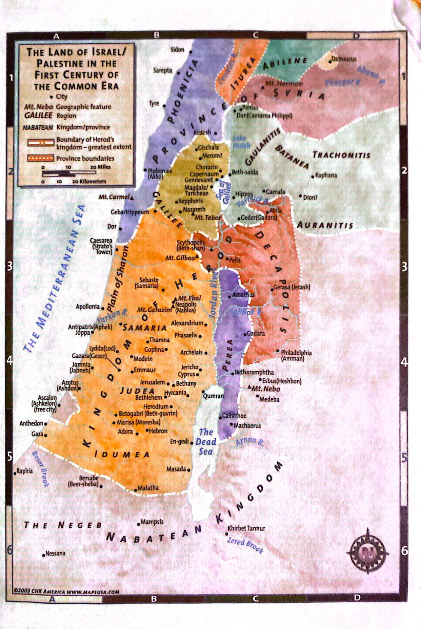

Next week: The Faith of a Royal Official and the Unbelief of the Religious establishment!

