The beginning of the seven signs of the book of John.
June 8, 1015

John = 7 Signs, 7 discourses, and 7 “IAM” statements.

John 2:1 On the third day there was a wedding in Cana of Galilee, and the mother of Jesus was there. 2 Now both Jesus and His disciples were invited to the wedding. 3 And when they ran out of wine, the mother of Jesus said to Him, “They have no wine.” 4 Jesus said to her, “Woman, what does your concern have to do with Me? My hour has not yet come.” 5 His mother said to the servants, “Whatever He says to you, do it.”

6 Now there were set there six waterpots of stone, according to the manner of purification of the Jews, containing twenty or thirty gallons apiece. 7 Jesus said to them, “Fill the waterpots with water.” And they filled them up to the brim. 8 And He said to them, “Draw some out now, and take it to the master of the feast.” And they took it.

9 When the master of the feast had tasted the water that was made wine, and did not know where it came from (but the servants who had drawn the water knew),

the master of the feast called the bridegroom. 10 And he said to him, “Every man at the beginning sets out the good wine, and when the guests have well drunk, then the inferior. You have kept the good wine until now!”

11 This beginning of signs Jesus did in Cana of Galilee, and manifested His glory; and His disciples believed in Him.

First: This was actual wine, not grape juice or something else. JESUS MADE IT FROM WATER!!!!!

Why this one?

John 1:3 All things were made through Him, and without Him nothing was made that was made.

Jesus is the WORD, HE CREATES!

Col 1:16 For by Him all things were created that are in heaven and that are on earth, visible and invisible, whether thrones or dominions or principalities or powers. All things were created through Him and for Him. 17 And He is before all things, and in Him all things consist.

Wine is made from grapes and there is a time factor. This however, was water, changed into GOOD wine instantly!

From here they head down to Galilee

John 2:12 After this He went down to Capernaum, He, His mother, His brothers, and His disciples; and they did not stay there many days. 13 Now the Passover of the Jews was at hand, and Jesus went up to Jerusalem.

It’s possible that one million or more people could be there at this time during Passover!

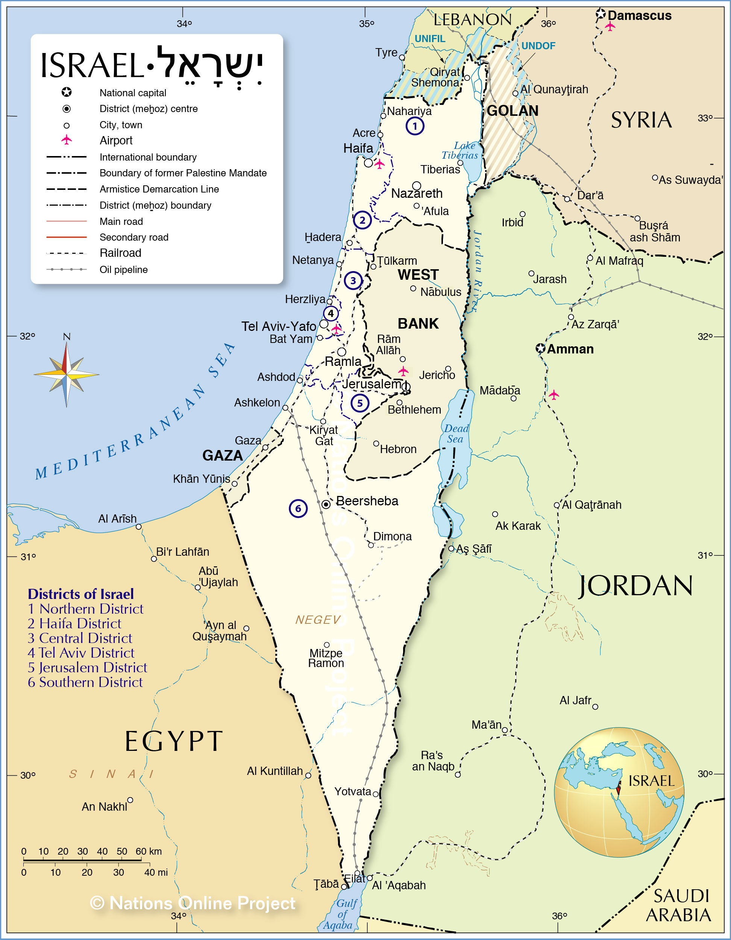

There is a BIG problem in the Temple.

John 2:13 Now the Passover of the Jews was at hand, and Jesus went up to Jerusalem. 14 And He found in the temple those who sold oxen and sheep and doves, and the money changers doing business.

15 When He had made a whip of cords, He drove them all out of the temple, with the sheep and the oxen, and poured out the changers’ money and overturned the tables. 16 And He said to those who sold doves,

“Take these things away! Do not make My Father’s house a house of merchandise!” 17 Then His disciples remembered that it was written, “Zeal for Your house has eaten Me up.” 18 So the Jews answered and said to Him, “What sign do You show to us, since You do these things?”

19 Jesus answered and said to them, “Destroy this temple, and in three days I will raise it up.” 20 Then the Jews said, “It has taken forty-six years to build this temple, and will You raise it up in three days?” 21 But He was speaking of the temple of His body.

The Temple was controlled by the Sadducees. Which meant they controlled who was High Priest. The High Priest was Caiaphas, Annas was his father-in-law. Both would be involved in Christ’s trial.

Annas was removed by the Romans way earlier, however he still had power and sway over Israel.

This whole Passover was a money-making scheme for them. The Pharisees hated it and called it, “The Bazaar of the sons of Annas”

Each sacrifice was to be examined for blemishes many were disqualified due to a “found imperfection”. Choice was to go home and find another OR buy one from the handy dandy Sacrifice Shop.

Oh, and they weren’t cheap.

The money changers changed Roman coinage into Temple coinage. The exchange rate was very one sided. Annas pocketed all this money. This was a money-making scam and all knew it.

John the Baptist had already addressed this corruption…

Luke 3:12 Then tax collectors also came to be baptized, and said to him, “Teacher, what shall we do?” 13 And he said to them, “Collect no more than what is appointed for you.”

In 67AD the people mobbed and overran all this because of the corruption. In 70AD the temple was burned up and Jerusalem was destroyed.

Annas hates Jesus because of this temple cleansing and it is this incident that fulfills the prophecy and parables.

Psalm 69:9 Because zeal for Your house has eaten me up, And the reproaches of those who reproach You have fallen on me.

Mat 21:37 “Then last of all he sent his son to them, saying, ‘They will respect my son.’ 38 “But when the vinedressers saw the son, they said among themselves, This is the heir. Come, let us kill him and seize

his inheritance.’ 39 “So they took him and cast him out of the vineyard and killed him. 40 “Therefore, when the owner of the vineyard comes, what will he do to those vinedressers?”

41 They said to Him, “He will destroy those wicked men miserably, and lease his vineyard to other vinedressers who will render to him the fruits in their seasons.” 42 Jesus said to them, “Have you never read in the Scriptures: ‘The stone which the builders rejected

Has become the chief cornerstone. This was the LORD’s doing, And it is marvelous in our eyes’ ? 43 “Therefore I say to you, the kingdom of God will be taken from you and given to a nation bearing the fruits of it.

44 “And whoever falls on this stone will be broken; but on whomever it falls, it will grind him to powder.” 45 Now when the chief priests and Pharisees heard His parables, they perceived that He was speaking of them. 46 But when they sought to lay hands on Him,

they feared the multitudes, because they took Him for a prophet.

For Jesus to do what he did says He is Lord over the Temple.

Mal 3:1 “Behold, I send My messenger, And he will prepare the way before Me. And the Lord, whom you seek, Will suddenly come to His temple, Even the Messenger of the covenant, In whom you delight. Behold, He is coming,” Says the LORD of hosts. 2 “But who can endure the day of His coming? And who can stand when He appears?

For He is like a refiner’s fire And like launderers’ soap. 3 He will sit as a refiner and a purifier of silver; He will purify the sons of Levi, And purge them as gold and silver, That they may offer to the LORD An offering in righteousness.

Because right now the temple is a house of Merchandise, a den of thieves.

Mat 21:13 And He said to them, “It is written, ‘My house shall be called a house of prayer,’ but you have made it a ‘den of thieves.’ ”

Who does this sound like?

Jer 7:8 “Behold, you trust in lying words that cannot profit. 9 “Will you steal, murder, commit adultery, swear falsely, burn incense to Baal, and walk after other gods whom you do not know,

10 “and then come and stand before Me in this house which is called by My name, and say, ‘We are delivered to do all these abominations’? 11 “Has this house, which is called by My name, become a den of thieves in your eyes? Behold, I, even I, have seen it,” says the LORD.

Messiah has come during a very dry and Spiritually empty time in Israel.

Isaiah 53:2 For He shall grow up before Him as a tender plant, And as a root out of dry ground. He has no form or comeliness; And when we see Him, There is no beauty that we should desire Him.

After this and many other teachings to a hard people, this is beginning to be fulfilled.

53:3 He is despised and rejected by men, A Man of sorrows and acquainted with grief. And we hid, as it were, our faces from Him; He was despised, and we did not esteem Him.

Next week: Signs and wonders!

