Jesus’ only boyhood writings and John the Baptist begins his ministry!
April 6, 2025

Jesus gets lost?

Luke 2:41 His parents went to Jerusalem every year at the Feast of the Passover. 42 And when He was twelve years old, they went up to Jerusalem according to the custom of the feast.

43 When they had finished the days, as they returned, the Boy Jesus lingered behind in Jerusalem. And Joseph and His mother did not know it; 44 but supposing Him to have been in the company,

they went a day’s journey, and sought Him among their relatives and acquaintances. 45 So when they did not find Him, they returned to Jerusalem, seeking Him. 46 Now so it was that after three days they found Him in the temple, sitting in the midst of the teachers, both listening to them and asking them questions.

47 And all who heard Him were astonished at His understanding and answers. 48 So when they saw Him, they were amazed; and His mother said to Him,

“Son, why have You done this to us? Look, Your father and I have sought You anxiously.” 49 And He said to them, “Why did you seek Me? Did you not know that I must be about My Father’s business?” 50 But they did not understand the statement which He spoke to them.

51 Then He went down with them and came to Nazareth, and was subject to them, but His mother kept all these things in her heart. 52 And Jesus increased in wisdom and stature, and in favor with God and men.

Did you not know that I must be about My Father’s business?”

Jesus is 12 and apprenticeships began with Jewish boys, Mary should have known this. He is with His Father GOD!

Age 5 they studied the Torah

Age 10 They studied the oral Law/ Rabbinic tradition

Age 12 They began their apprenticeships,

Age 16-20 they would marry.

If they were in rabbinical studies, they finished at thirty.

Humility on display!!! Subject to them!

John 1:1 IN the beginning was the Word, and the Word was with God, and the Word was God. 2 He was in the beginning with God. 3 All things were made through Him, and without Him nothing was made that was made.

Yet we get upset when we must submit to anything.

Believers with the church

Wives with husbands

Children with parents

MEN with God’s commands and authorities placed by God.

We pride ourselves in submitting to no one!

Yet Jesus, who is one with God, God in the flesh remained in submission to earthly parents.

This JESUS!...

Revelations 5:11 Then I looked, and I heard the voice of many angels around the throne,

the living creatures, and the elders; and the number of them was ten thousand times ten thousand, and thousands of thousands, 12 saying with a loud voice: “Worthy is the Lamb who was slain To receive power and riches and wisdom, And strength and honor and glory and blessing!”

13 And every creature which is in heaven and on the earth and under the earth and such as are in the sea, and all that are in them, I heard saying:

“Blessing and honor and glory and power Be to Him who sits on the throne, And to the Lamb, forever and ever!” 14 Then the four living creatures said, “Amen!” And the twenty-four elders fell down and worshiped Him who lives forever and ever.

Calling out pride will be a major cornerstone of Jesus’ ministry!!!

But first John the Baptist

Mal 3:1 “Behold, I send My messenger, And he will prepare the way before Me. And the Lord, whom you seek, Will suddenly come to His temple,

Even the Messenger of the covenant, In whom you delight. Behold, He is coming,” Says the LORD of hosts.

Isa 40:3 The voice of one crying in the wilderness: “Prepare the way of the LORD; Make straight in the desert A highway for our God.

His message was …

Mat 3:2 and saying, “Repent, for the kingdom of heaven is at hand!”

The King is coming BE READY!!!!!!

We have the same thing today, as believers we are to:

2Cor 5:9 Therefore we make it our aim, whether present or absent, to be well pleasing to Him. 10 For we must all appear before the judgment seat of Christ, that each one may receive the things done in the body, according to what he has done, whether good or bad.

Romans 14:12 So then each of us shall give account of himself to God.

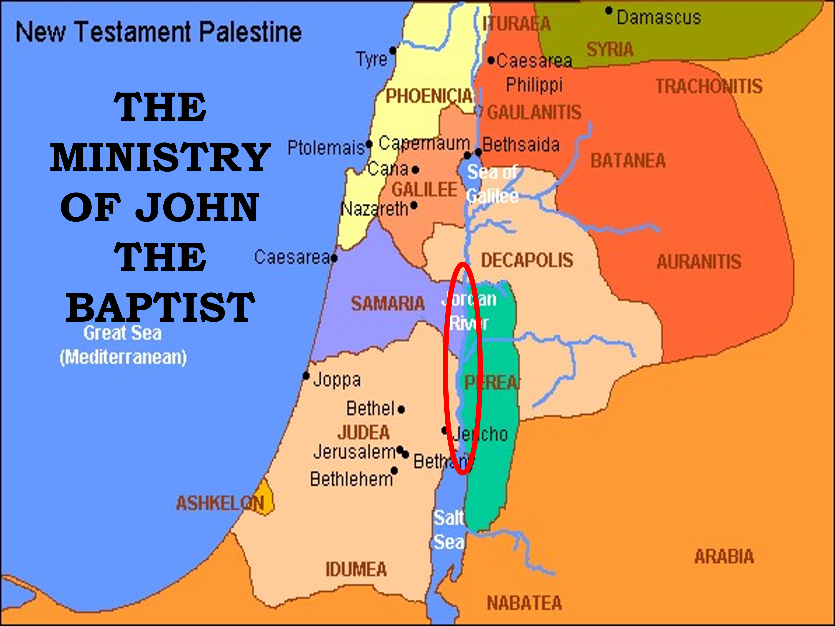

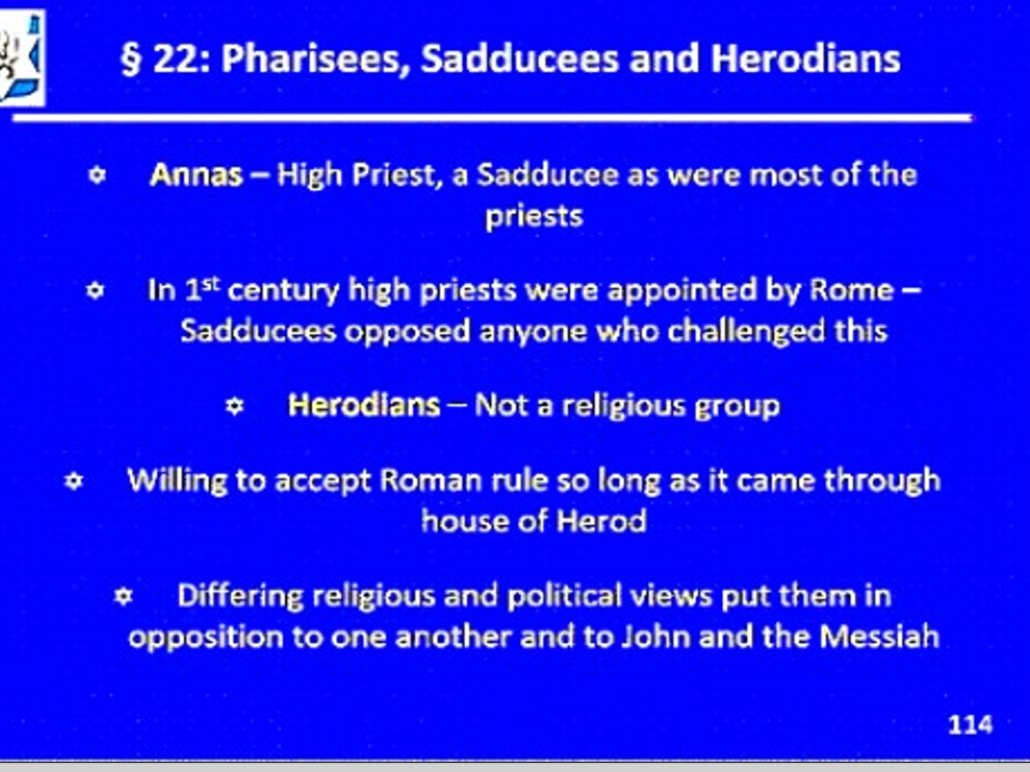

John was very popular at first and many came.

Mat 3:5 Then Jerusalem, all Judea, and all the region around the Jordan went out to him 6 and were baptized by him in the Jordan, confessing their sins.

Anything with Messianic overtones however, would be investigated by the Sanhedrin. First by only observing, second by interrogation.

This is what John is condemning; this is not a show to observe, but to be a part of!

Mat 3:7 But when he saw many of the Pharisees and Sadducees coming to his baptism, he said to them, “Brood of vipers! Who warned you to flee from the wrath to come? 8 “Therefore bear fruits worthy of repentance,

9 “and do not think to say to yourselves, ‘We have Abraham as our father.’ For I say to you that God is able to raise up children to Abraham from these stones. 10 “And even now the ax is laid to the root of the trees.

Therefore every tree which does not bear good fruit is cut down and thrown into the fire. 11 “I indeed baptize you with water unto repentance, but He who is coming after me is mightier than I, whose sandals I am not worthy to carry. He will baptize you with the Holy Spirit and fire.

12 “His winnowing fan is in His hand, and He will thoroughly clean out His threshing floor, and gather His wheat into the barn; but He will burn up the chaff with unquenchable fire.”

The wrath to come?

The Day of the Lord, the Great Tribulation the time of Jacobs Trouble!

John’s message to Israel :

Acts 19:4 Then Paul said, “John indeed baptized with a baptism of repentance, saying to the people that they should believe on Him who would come after him, that is, on Christ Jesus.”

This is what is to be believed!

This is how to walk….

Luke 3:10 So the people asked him, saying, “What shall we do then?” 11 He answered and said to them, “He who has two tunics, let him give to him who has none; and he who has food, let him do likewise.”

12 Then tax collectors also came to be baptized, and said to him, “Teacher, what shall we do?” 13 And he said to them, “Collect no more than what is appointed for you.” 14 Likewise the soldiers asked him, saying, “And what shall we do?”

So he said to them, “Do not intimidate anyone or accuse falsely, and be content with your wages.” 18 And with many other exhortations he preached to the people.

Next week: Jesus begins the Ministry!

