Life of Messiah
Jan 5, 2025

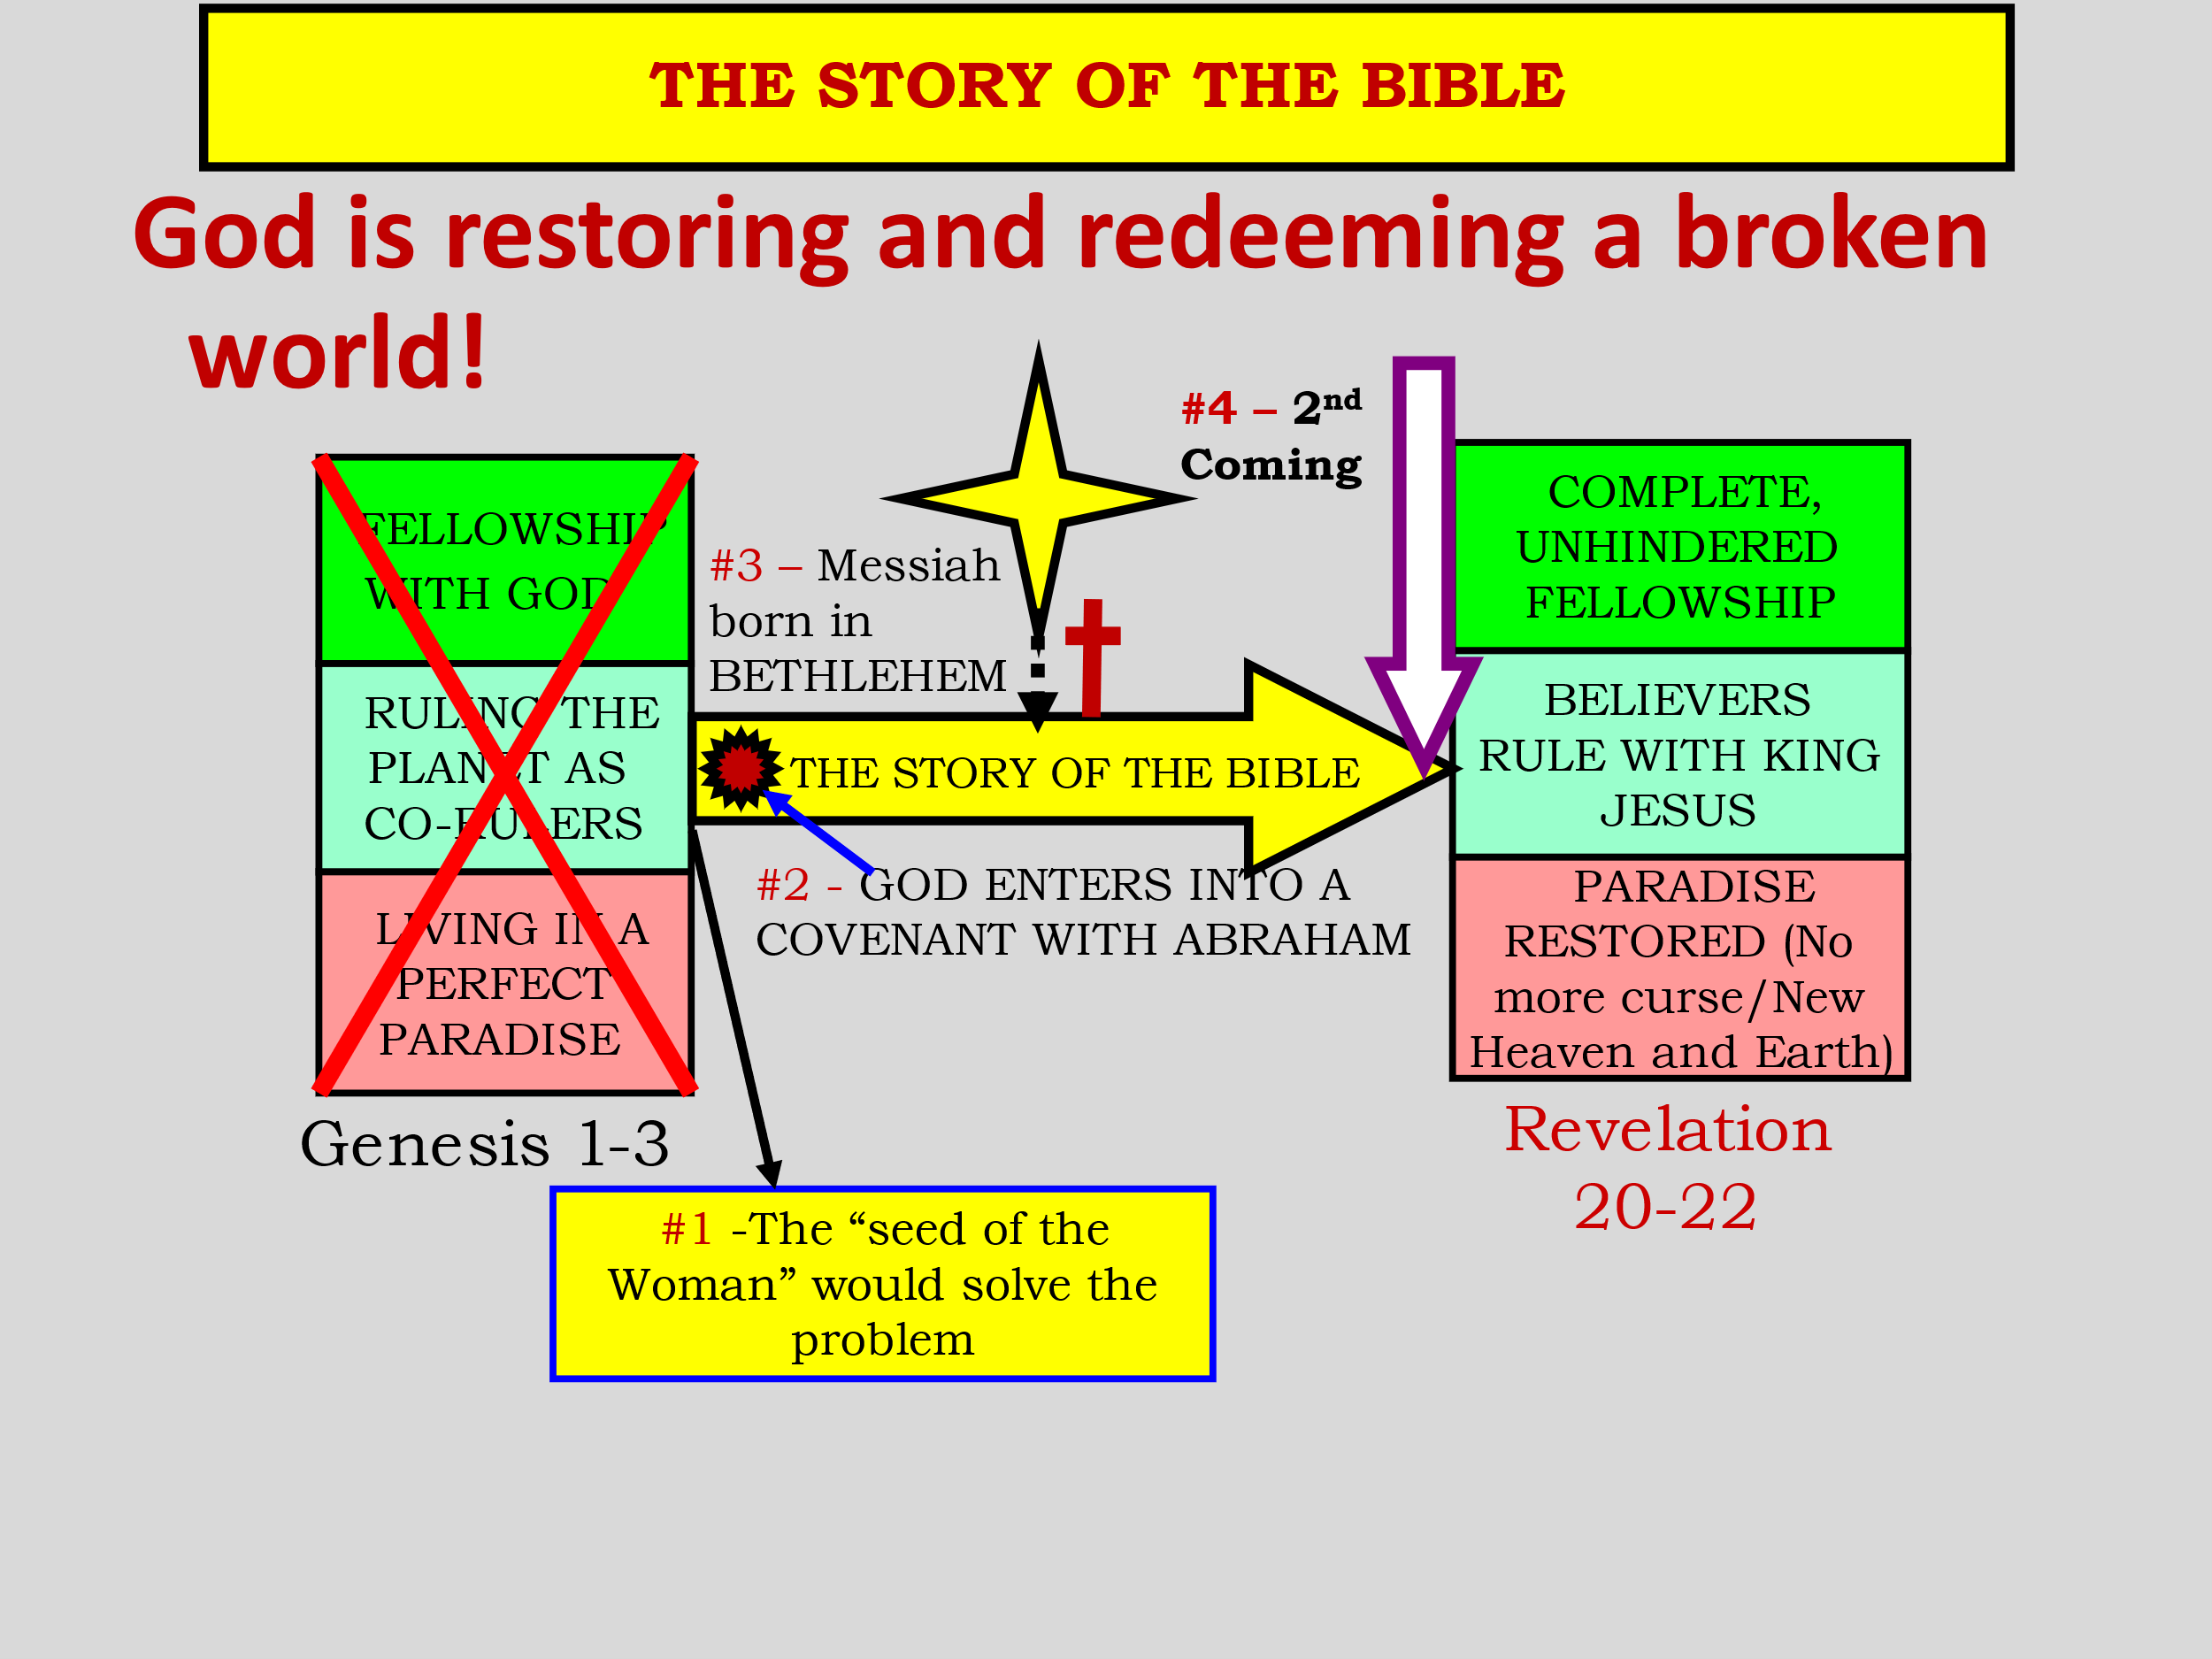

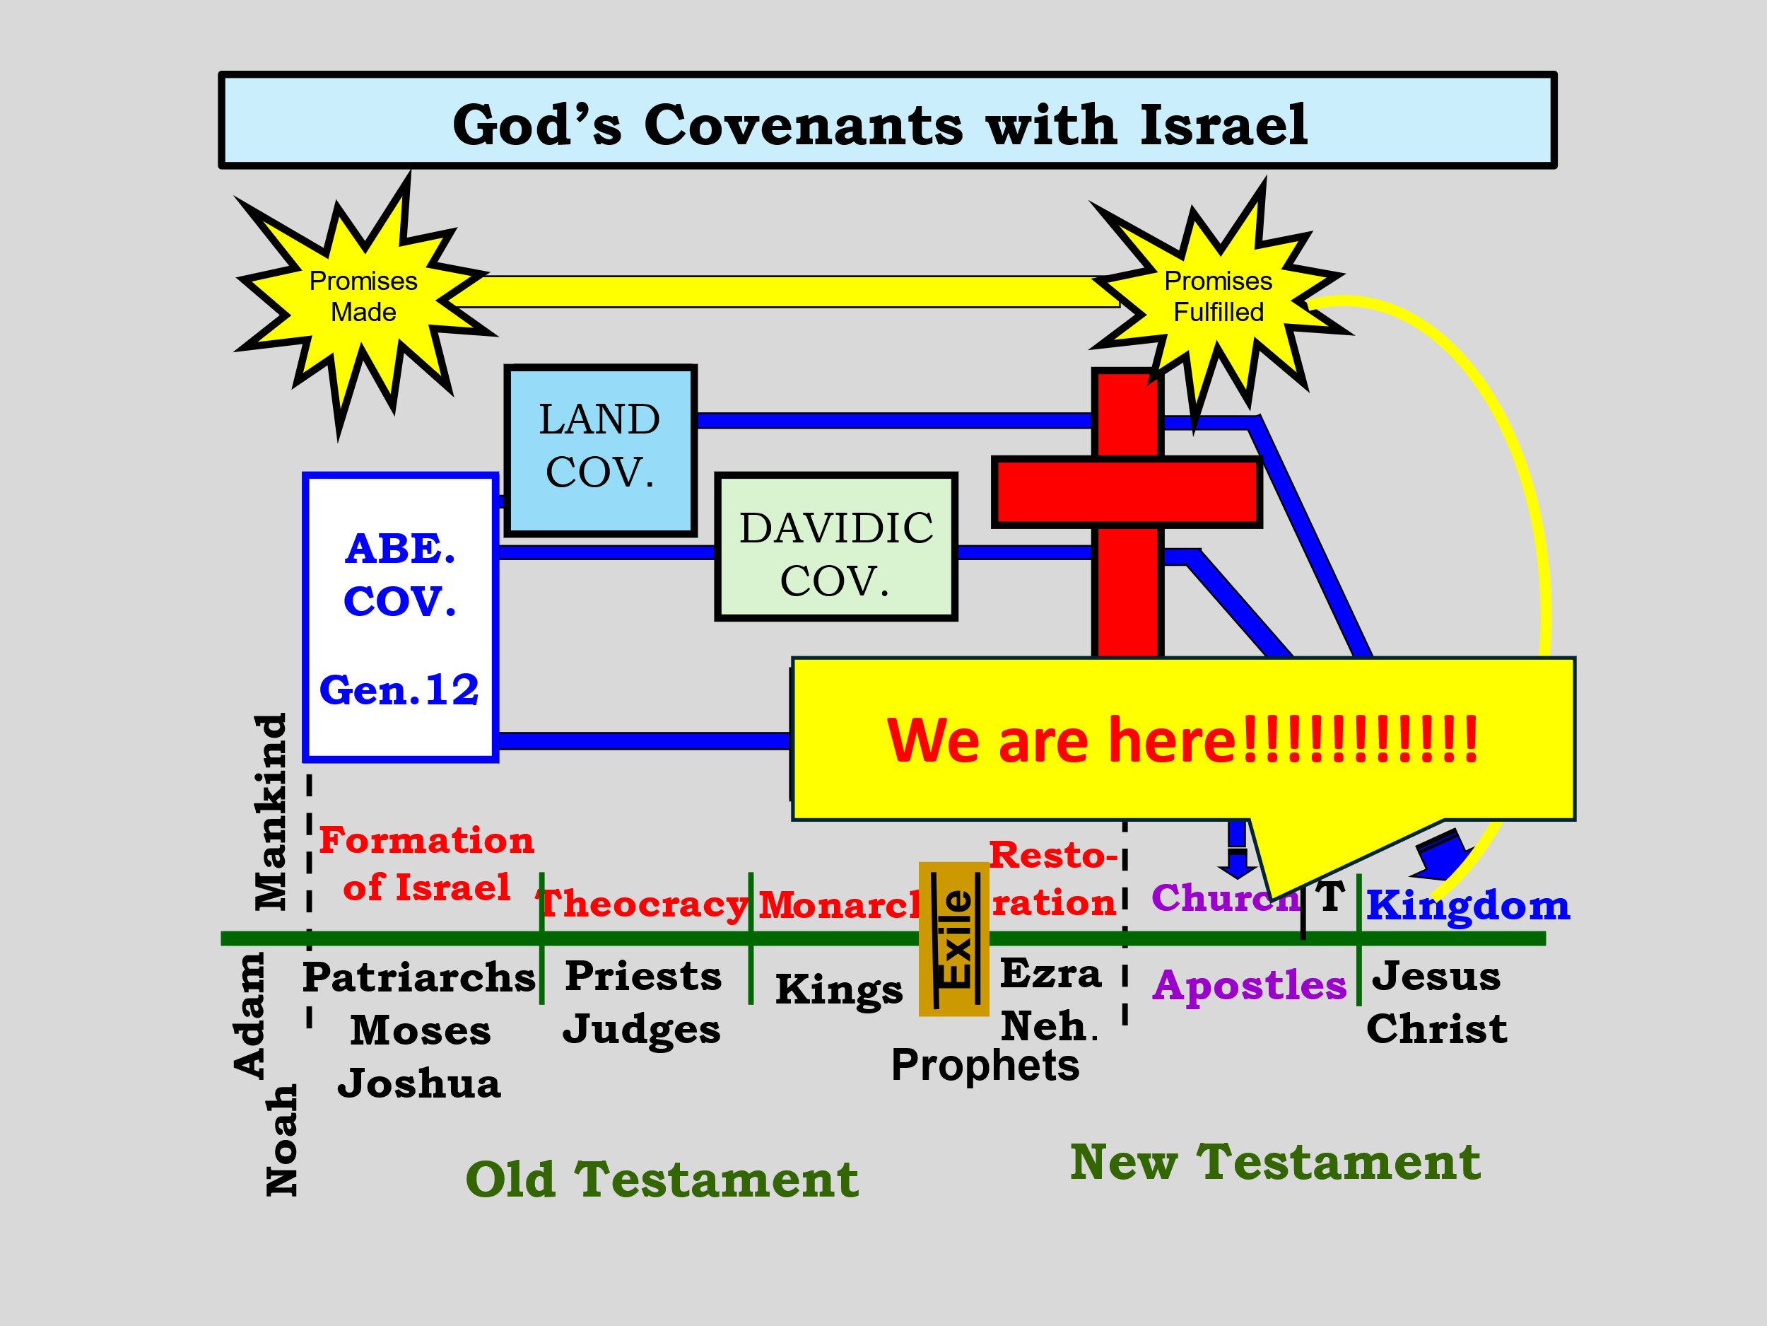

How far down the Biblical timeline are we?

Heb 1:1 GOD, who at various times and in various ways spoke in time past to the fathers by the prophets, 2 has in these last days spoken to us by His Son, whom He has appointed heir of all things, through whom also He made the worlds;

3 who being the brightness of His glory and the express image of His person, and upholding all things by the word of His power,

when He had by Himself purged our sins, sat down at the right hand of the Majesty on high, (Short term Prophecy 33AD)

Matt 24:1 Then Jesus went out and departed from the temple, and His disciples came up to show Him the buildings of the temple. 2 And Jesus said to them, “Do you not see all these things? Assuredly, I say to you, not one stone shall be left here upon another, that shall not be thrown down.”

(Short term prophecy 70AD, to validate the others)

But before the Temple is destroyed and nation against nation, the book of Acts must happen 33AD-70AD.

Luke 21:12 “But before all these things, they will lay their hands on you and persecute you, delivering you up to the synagogues and prisons. You will be brought before kings and rulers for My name’s sake. 13 “But it will turn out for you as an occasion for testimony.

14 “Therefore settle it in your hearts not to meditate beforehand on what you will answer;

15 “for I will give you a mouth and wisdom which all your adversaries will not be able to contradict or resist. 16 “You will be betrayed even by parents and brothers, relatives and friends; and they will put some of you to death.

17 “And you will be hated by all for My name’s sake. 18 “But not a hair of your head shall be lost. 19 “By your patience possess your souls.

Then comes the destruction of the Temple 70AD

Luke 21:20 “But when you see Jerusalem surrounded by armies, then know that its desolation is near. 21 “Then let those who are in Judea flee to the mountains, let those who are in the midst of her depart, and let not those who are in the country enter her. 22 “For these are the days of vengeance, that all things which are written may be fulfilled.

23 “But woe to those who are pregnant and to those who are nursing babies in those days! For there will be great distress in the land and wrath upon this people.

24 “And they will fall by the edge of the sword, and be led away captive into all nations. And Jerusalem will be trampled by Gentiles until the times of the Gentiles are fulfilled.

From the destruction of Jerusalem and the scattering of the Jewish people 70AD, till the first sign 1914AD world war…

Luke 21:8 And He said: “Take heed that you not be deceived. For many will come in My name, saying, ‘I am He,’ and, ‘The time has drawn near.’ Therefore do not go after them.

9 “But when you hear of wars and commotions, do not be terrified; for these things must come to pass first, but the end will not come immediately.”

What are the signs of the last days?

Mat 24:7 “For nation will rise against nation, and kingdom against kingdom. And there will be famines, pestilences, and earthquakes in various places. 8 “All these are the beginning of sorrows.

All these happened just as He said validating Him as the Prophet like unto Moses!

Acts 7:37 “This is that Moses who said to the children of Israel, ‘The LORD your God will raise up for you a Prophet like me from your brethren. Him you shall hear.’

All these Jesus predicted and ALL of them came to pass exactly as prophesized.

John 1:1 IN the beginning was the Word, and the Word was with God, and the Word was God. 2 He was in the beginning with God. 3 All things were made through Him, and without Him nothing was made that was made.

4 In Him was life, and the life was the light of men. 5 And the light shines in the darkness, and the darkness did not comprehend it.

John 1:14 And the Word became flesh and dwelt among us, and we beheld His glory, the glory as of the only begotten of the Father, full of grace and truth.

The ARRIVAL Of the Shekinah Glory of God…

“LET THERE BE LIGHT!”

Gen 1:1 IN the beginning God created the heavens and the earth. 2 The earth was without form, and void; and darkness was on the face of the deep. And the Spirit of God was hovering over the face of the waters. 3 Then God said, “Let there be light”; and there was light.

Luke 2:8 Now there were in the same country shepherds living out in the fields, keeping watch over their flock by night. 9 And behold, an angel of the Lord stood before them,

and the glory of the Lord shone around them, and they were greatly afraid. 10 Then the angel said to them, “Do not be afraid, for behold, I bring you good tidings of great joy which will be to all people.

11 “For there is born to you this day in the city of David a Savior, who is Christ the Lord. 12 “And this will be the sign to you: You will find a Babe wrapped in swaddling cloths, lying in a manger.” 13 And suddenly there was with the angel a multitude of the heavenly host praising God and saying:

14 “Glory to God in the highest, And on earth peace, goodwill toward men!”

1 John 4:9 In this the love of God was manifested toward us, that God has sent His only begotten Son into the world, that we might live through Him. 10 In this is love, not that we loved God, but that He loved us and sent His Son to be the propitiation for our sins. 11 Beloved, if God so loved us, we also ought to love one another.

Next week: In the beginning was the WORD!

