Setting the foundations for Messiah Jesus
Jan 19, 2025

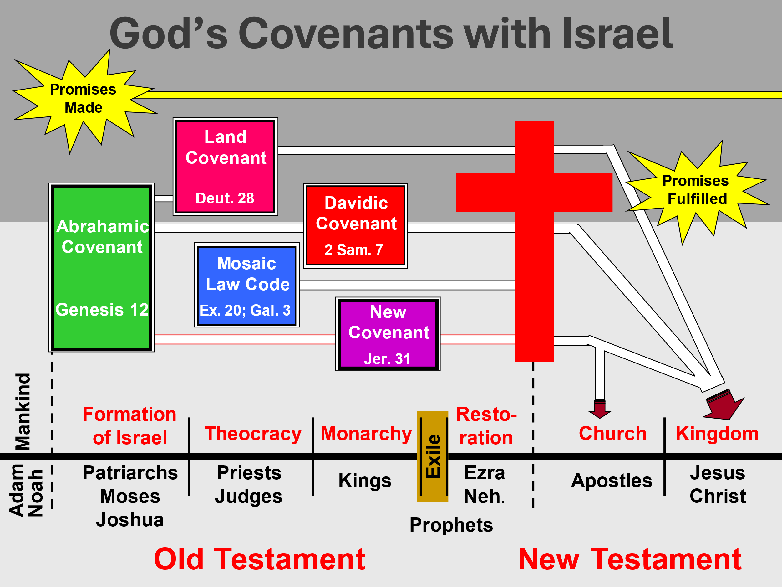

Mosaic Law code:

Ends with Christ!

Hebrews 8:6 But now He has obtained a more excellent ministry, inasmuch as He is also Mediator of a better covenant, which was established on better promises. 7 For if that first covenant had been faultless, then no place would have been sought for a second. 8 Because finding fault with them, He says: “Behold, the days are coming, says the LORD, when I will make a new covenant with the house of Israel

and with the house of Judah– 9 “not according to the covenant that I made with their fathers in the day when I took them by the hand to lead them out of the land of Egypt; because they did not continue in My covenant, and I disregarded them, says the LORD.

10 “For this is the covenant that I will make with the house of Israel after those days, says the LORD: I will put My laws in their mind and write them on their hearts; and I will be their God, and they shall be My people.

11 “None of them shall teach his neighbor, and none his brother, saying, ‘Know the LORD,’ for all shall know Me, from the least of them to the greatest of them.

12 “For I will be merciful to their unrighteousness, and their sins and their lawless deeds I will remember no more.” 13 In that He says, “A new covenant,” He has made the first obsolete. Now what is becoming obsolete and growing old is ready to vanish away.

Galatians 3:19 What purpose then does the law serve? It was added because of transgressions, till the Seed should come to whom the promise was made; and it was appointed through angels by the hand of a mediator.

20 Now a mediator does not mediate for one only, but God is one. 21 Is the law then against the promises of God? Certainly not! For if there had been a law given which could have given life, truly righteousness would have been by the law.

22 But the Scripture has confined all under sin, that the promise by faith in Jesus Christ might be given to those who believe. 23 But before faith came, we were kept under guard by the law, kept for the faith which would afterward be revealed.

24 Therefore the law was our tutor to bring us to Christ, that we might be justified by faith. 25 But after faith has come, we are no longer under a tutor.

Davidic Covenant:

2 Sam 7:18 Then King David went in and sat before the LORD; and he said: “Who am I, O Lord GOD?

And what is my house, that You have brought me this far? 19 “And yet this was a small thing in Your sight, O Lord GOD; and You have also spoken of Your servant’s house for a great while to come. Is this the manner of man, O Lord GOD? 20 “Now what more can David say to You? For You, Lord GOD, know Your servant.

21 “For Your word’s sake, and according to Your own heart, You have done all these great things, to make Your servant know them. 22 “Therefore You are great, O Lord GOD. For there is none like You, nor is there any God besides You, according to all that we have heard with our ears.

23 “And who is like Your people, like Israel, the one nation on the earth whom God went to redeem for Himself as a people, to make for Himself a name–

and to do for Yourself great and awesome deeds for Your land–before Your people whom You redeemed for Yourself from Egypt, the nations, and their gods? 24 “For You have made Your people Israel Your very own people forever; and You, LORD, have become their God.

25 “Now, O LORD God, the word which You have spoken concerning Your servant and concerning his house, establish it forever and do as You have said. The New Covenant

Hebrews 8:7 For if that first covenant had been faultless, then no place would have been sought for a second. 8 Because finding fault with them, He says: “Behold, the days are coming, says the LORD, when I will make a new covenant with the house of Israel and with the house of Judah–

9 “not according to the covenant that I made with their fathers in the day when I took them by the hand to lead them out of the land of Egypt; because they did not continue in My covenant, and I disregarded them, says the LORD.

10 “For this is the covenant that I will make with the house of Israel after those days, says the LORD: I will put My laws in their mind and write them on their hearts; and I will be their God, and they shall be My people.

11 “ None of them shall teach his neighbor, and none his brother, saying, ‘Know the LORD,’ for all shall know Me, from the least of them to the greatest of them. 12 “For I will be merciful to their unrighteousness, and their sins and their lawless deeds I will remember no more.”

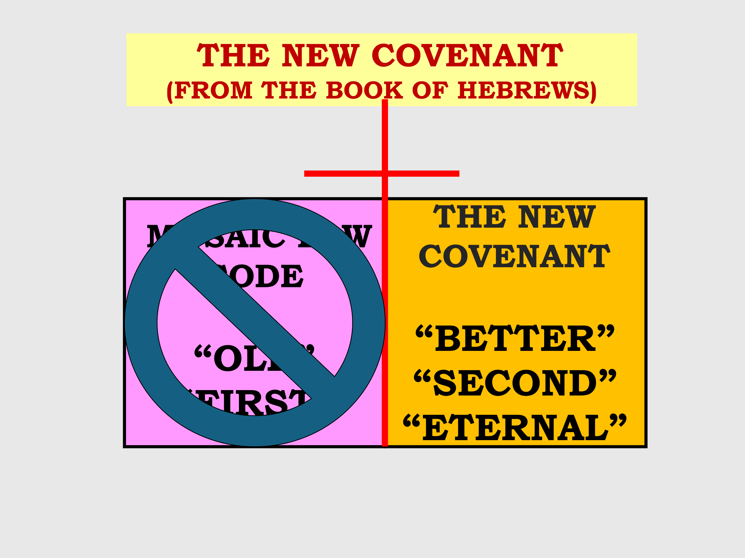

CONSIDERING THE NEW COVENANT

BASIS: The New Covenant is based on the death of Christ (Luke 22:20; Hebrews 10:10-13).

PARTIES OF THE COVENANT: It was made between God and the House of JUDAH and Israel and not the Church. (The Church is not Israel). Jeremiah 31:31-35

THE FINAL FULLFILMENT OF THE COVENANT: In the future, (Rom. 11:25-29). This is the primary purpose of the “Tribulation.” The Church is a “PARTAKER” of the covenant

This is one continuous last day's timeline. Once the clock has started; all will be fulfilled!

Heb 1:1 GOD, who at various times and in various ways spoke in time past to the fathers by the prophets, 2 has in these last days spoken to us by His Son, whom He has appointed heir of all things, through whom also He made the worlds;

Mat 16:18 “And I also say to you that you are Peter, and on this rock I will build My church, and the gates of Hades shall not prevail against it.

1 Cor 15:51 Behold, I tell you a mystery: We shall not all sleep, but we shall all be changed– 52 in a moment, in the twinkling of an eye, at the last trumpet. For the trumpet will sound, and the dead will be raised incorruptible, and we shall be changed.

Mat 24:21 “For then there will be great tribulation, such as has not been since the beginning of the world until this time, no, nor ever shall be. 22 “And unless those days were shortened, no flesh would be saved; but for the elect’s sake

those days will be shortened.

23 “Then if anyone says to you, ‘Look, here is the Christ!’ or ‘There!’ do not believe it. 24 “For false christs and false prophets will rise and show great signs and wonders to deceive, if possible, even the elect.

2 Thess 2:8 And then the lawless one will be revealed, whom the Lord will consume with the breath of His mouth and destroy with the brightness of His coming.

9 The coming of the lawless one is according to the working of Satan, with all power, signs, and lying wonders, 10 and with all unrighteous deception among those who perish, because they did not receive the love of the truth, that they might be saved.

Rev 19:11 Now I saw heaven opened, and behold, a white horse. And He who sat on him was called Faithful and True, and in righteousness He judges and makes war. 12 His eyes were like a flame of fire, and on His head were many crowns. He had a name written that no one knew except Himself.

13 He was clothed with a robe dipped in blood, and His name is called The Word of God. 14 And the armies in heaven, clothed in fine linen, white and clean, followed Him on white horses.

15 Now out of His mouth goes a sharp sword, that with it He should strike the nations. And He Himself will rule them with a rod of iron. He Himself treads the winepress of the fierceness and wrath of Almighty God. 16 And He has on His robe and on His thigh a name written: KING OF KINGS AND LORD OF LORDS.

Rev 19:20 Then the beast was captured, and with him the false prophet who worked signs in his presence, by which he deceived those who received the mark of the beast and those who worshiped his image. These two were cast alive into the lake of fire burning with brimstone.

Rev 20:7 Now when the thousand years have expired, Satan will be released from his prison 8 and will go out to deceive the nations which are in the four corners of the earth, Gog and Magog, to gather them together to battle, whose number is as the sand of the sea.

9 They went up on the breadth of the earth and surrounded the camp of the saints and the beloved city. And fire came down from God out of heaven and devoured them. 10 The devil, who deceived them, was cast into the lake of fire and brimstone where the beast and the false prophet are. And they will be tormented day and night forever and ever.

Rev 21:1 Now I saw a new heaven and a new earth, for the first heaven and the first earth had passed away. Also there was no more sea. 2 Then I, John, saw

the holy city, New Jerusalem, coming down out of heaven from God, prepared as a bride adorned for her husband. 3 And I heard a loud voice from heaven saying, “Behold, the tabernacle of God is with men, and He will dwell with them, and they shall be His people. God Himself will be with them and be their God.

4 “And God will wipe away every tear from their eyes; there shall be no more death, nor sorrow, nor crying. There shall be no more pain, for the former things have passed away.”

21:5 Then He who sat on the throne said, “Behold, I make all things new.” And He said to me, “Write, for these words are true and faithful.”

6 And He said to me, “It is done! I am the Alpha and the Omega, the Beginning and the End. I will give of the fountain of the water of life freely to him who thirsts….

IT IS GOOD!!!!!!!!!!!!!!

