## **The earthly life of Messiah Jesus! Dec 28 2024**

# 

## **Introduction of the KING**

## **The arrival of the King is long anticipated.**

## **(The Fall) destroyed life and rule for man!**

## **Man is hopeless because of it and needs God to fix everything, because men are not able.**



## ***Gen 3:7 Then the eyes of both of them were opened, and they knew that they were naked; and they sewed fig leaves together and made themselves coverings. 8 And they heard the sound of the LORD***

## ***God walking in the garden in the cool of the day, and Adam and his wife hid themselves from the presence of the LORD God among the trees of the garden. 9 Then the LORD God called to Adam and said to him, “Where are you?” 10 So he said, “I heard Your voice in the garden, and I was afraid because I was naked; and I hid myself.”***



## **All we can do now is, unsuccessfully hide ourselves from the PRESENCE of the Lord.**



## **We were fundamentally changed so that now, this is the reality!**

## ***Luke 16:26 ‘And besides all this, between us and you there is a great gulf fixed, so that those who want to pass from here to you cannot, nor can those from there pass to us.’***

## ***1Cor 15:50 Now this I say, brethren, that flesh and blood cannot inherit the kingdom of God; nor does corruption inherit incorruption.***



## ***1 Cor 15:42 So also is the resurrection of the dead. The body is sown in corruption, it is raised in incorruption. 43 It is sown in dishonor, it is raised in glory. It is sown in weakness, it is raised in power.***



## **We now needed a redeemer and God promised it:**



## ***Gen 3:15 And I will put enmity Between you and the woman, And between your seed and her Seed; He shall bruise your head, And you shall bruise His heel.”***

## **Adam and Eve knew what God Promised.**

## **And so did satan!**

## ***Gen 4:1 Now Adam knew Eve his wife, and she conceived and bore Cain, and said, “I have acquired a man from the LORD.”***

## **The actual Hebrew meaning is, “*I have gotten a man: Jehovah”***

## **Eve understood that the Savior would be the God-man.**

## **When Abel is born his name means VANITY.**

## **The devil also knew the prophecy!**

## **So, he tempted Cain to kill Abel.**

## **But Seth would be born**

## **So, then he corrupted the race from whom Messiah would come**

## ***Gen 6:1 Now it came to pass, when men began to multiply on the face of the earth, and daughters were born to them, 2 that the sons of God saw the daughters of men, that they were beautiful; and they took wives for themselves of all whom they chose. 3 And the LORD said, “My Spirit shall not strive with man forever, for he is indeed flesh;***

## ***yet his days shall be one hundred and twenty years.” 4 There were giants on the earth in those days, and also afterward, when the sons of God came in to the daughters of men and they bore children to them. Those were the mighty men who were of old, men of renown.***



## ***5 Then the LORD saw that the wickedness of man was great in the earth, and that every intent of the thoughts of his heart was only evil continually.***



## **So, God destroyed everything with a flood, But Noah found grace! Noah’s great grandpa Enoch was a preacher of righteousness, and a prophet. He only lives 365 years and disappears, for God took him!!!!! Before this though he has a son, he names Methuselah.**



## **His name means “when he dies, he/it will come”. Lamech picks up on this and names his son NOAH… *Gen 5:29 And he called his name Noah, saying,***



## ***“This one will comfort us concerning our work and the toil of our hands, because of the ground which the LORD has cursed.”***



## **Noah was righteous but not the promised redeemer. But He, his wife and three sons and their wives repopulate the destroyed earth.**



## **Messiah would be a man from the human race.**

## **Now narrowed down to a certain people, when God calls Abraham and makes a covenant with him!**

## ***Gen 12:1 Now the LORD had said to Abram: “Get out of your country, From your family And from your father’s house, To a land that I will show you. 2 I will make you a great nation; I will bless you And make your name great; And you shall be a blessing.***



## ***3 I will bless those who bless you, And I will curse him who curses you;* From a great people to all the people of earth!**



## ***And in you all the families of the earth shall be blessed.”***

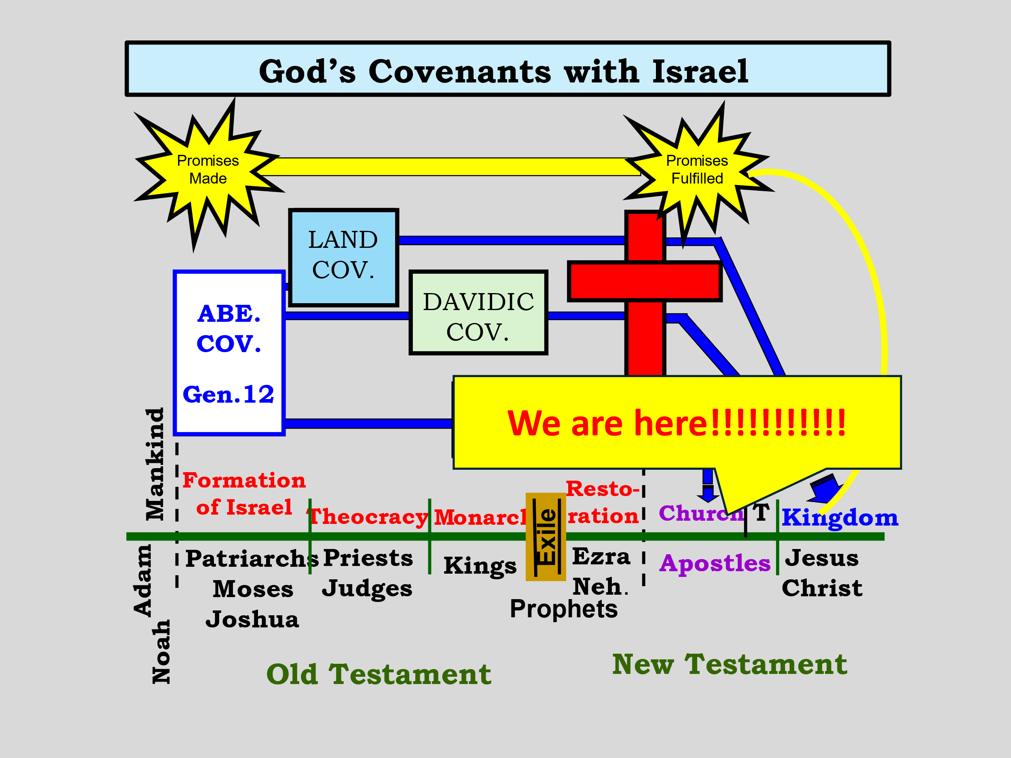

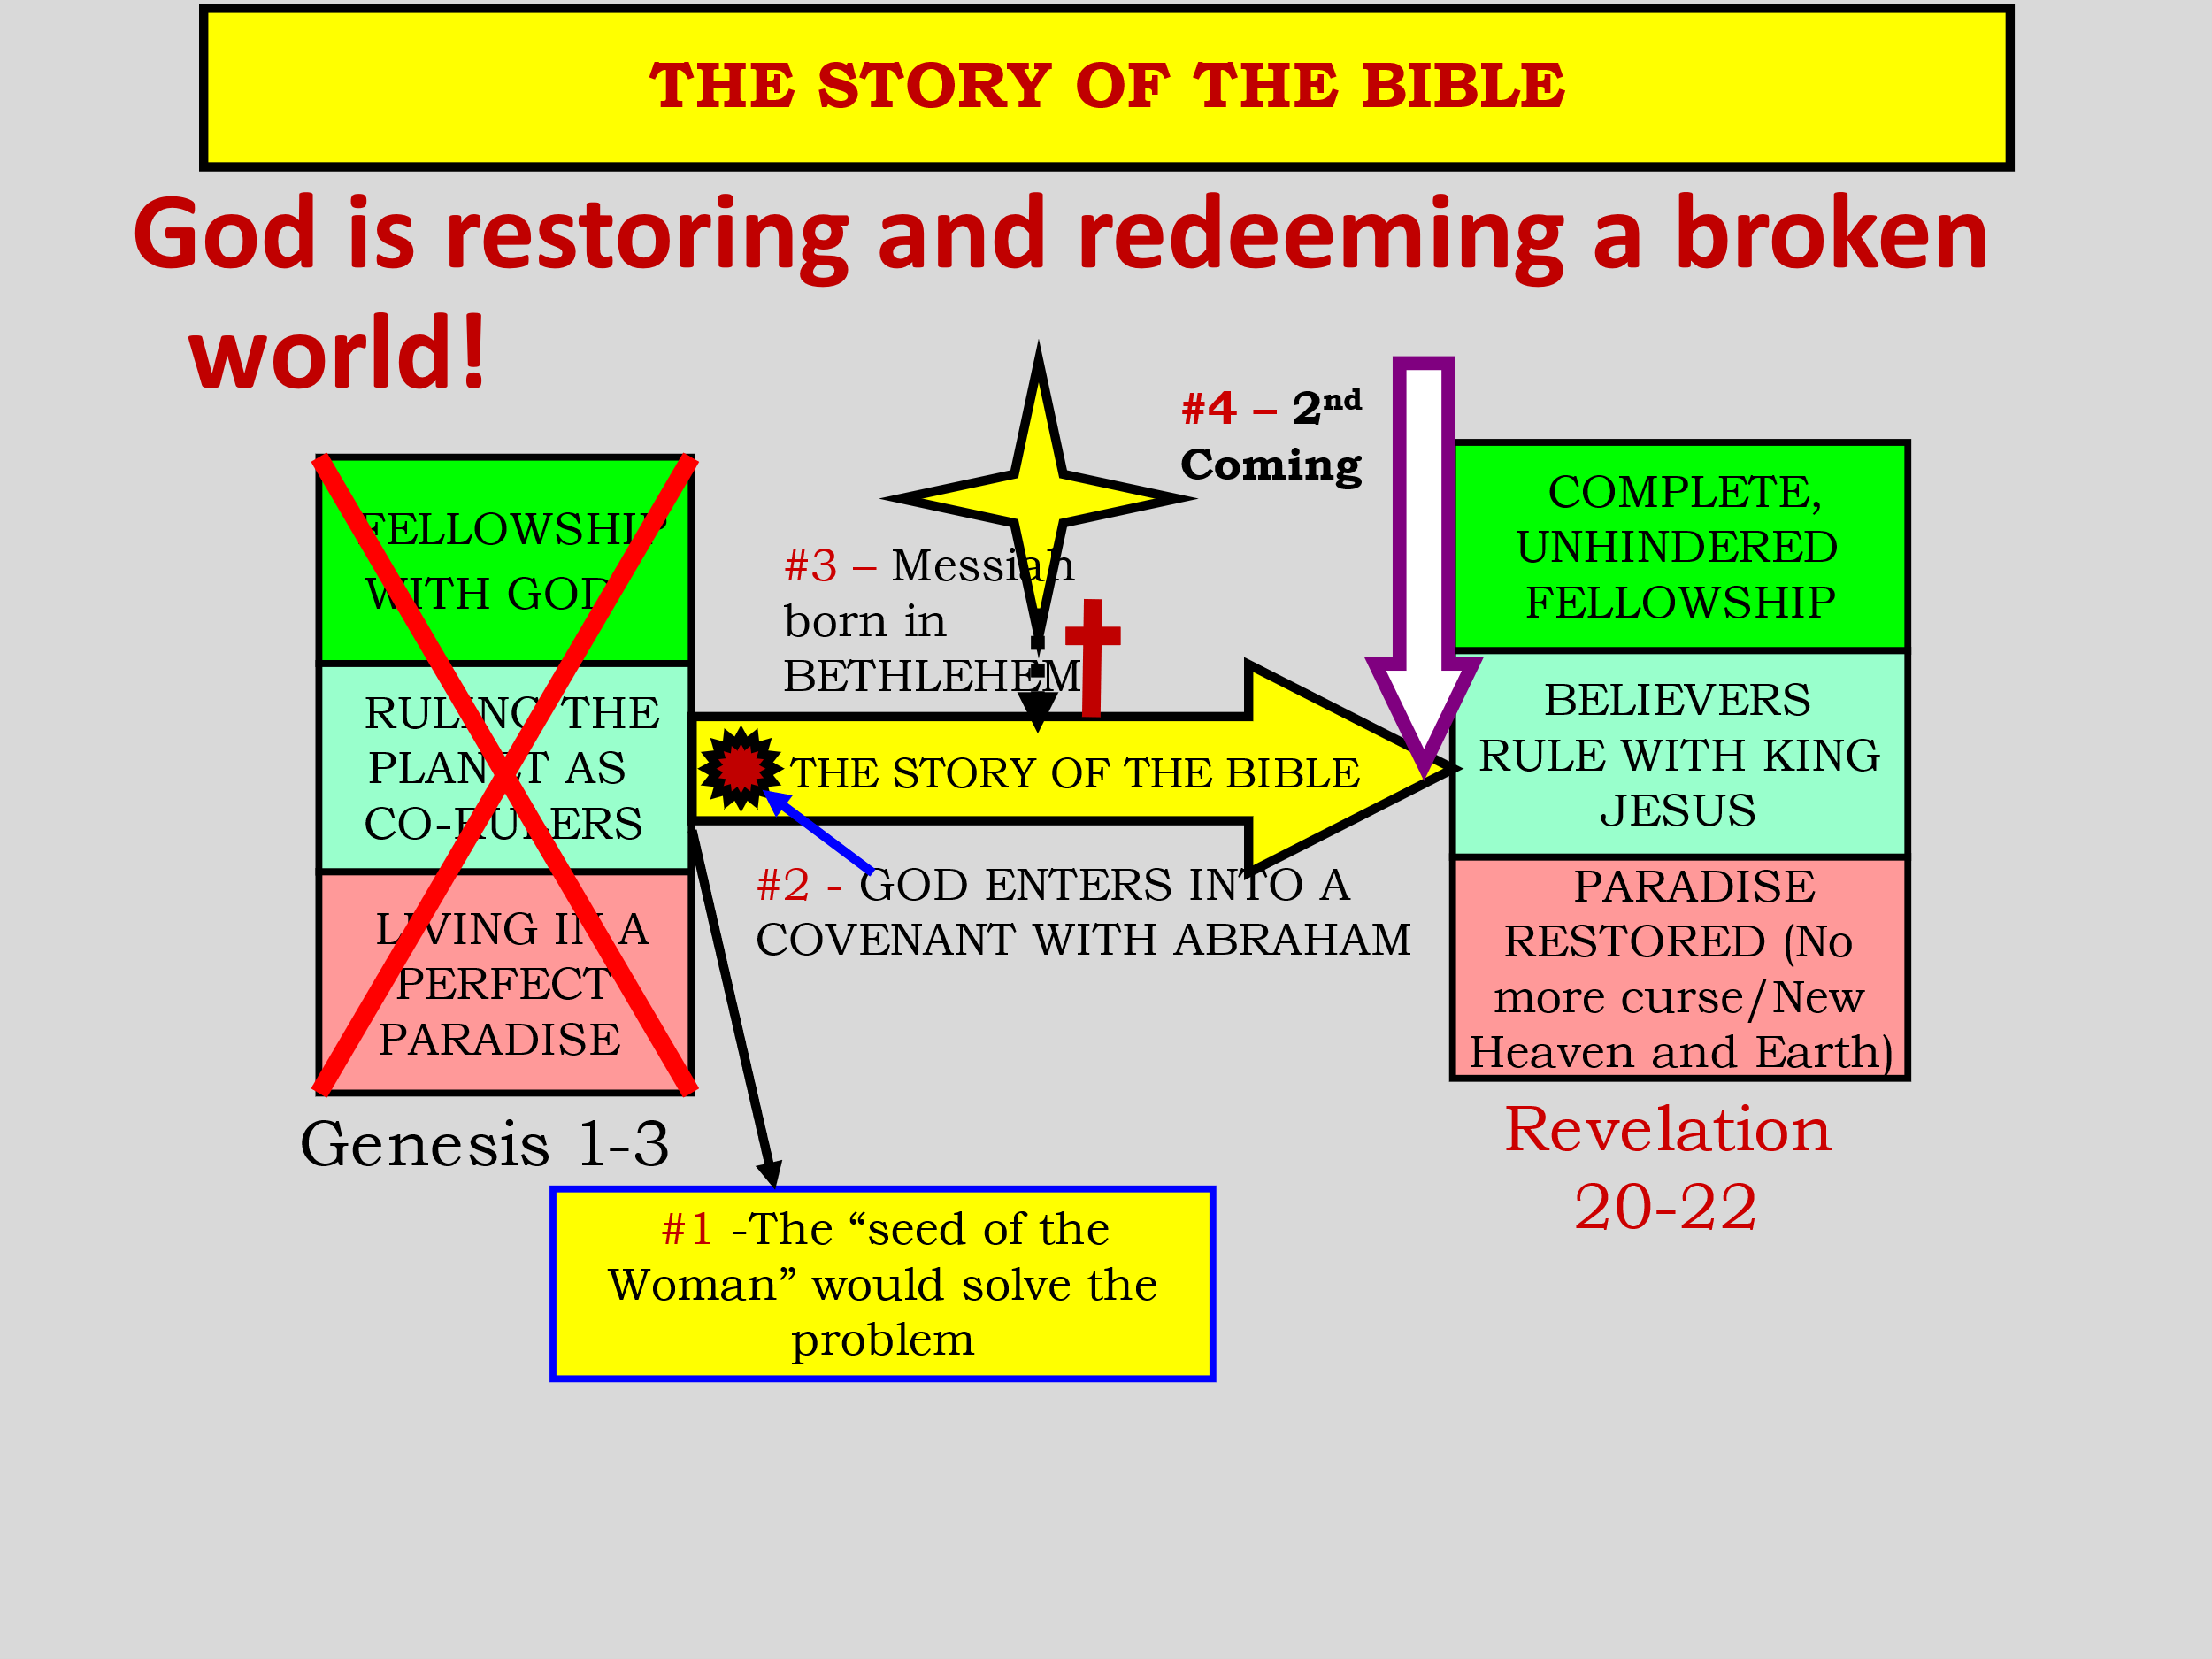



## **The ARRIVAL Of the Shekinah Glory of God “LET THERE BE LIGHT!”**

## ***Gen 1:1 IN the beginning God created the heavens and the earth. 2 The earth was without form, and void; and darkness was on the face of the deep. And the Spirit of God was hovering over the face of the waters. 3 Then God said, “Let there be light”; and there was light.***

## ***Luke 2:8 Now there were in the same country shepherds living out in the fields, keeping watch over their flock by night.***



## ***9 And behold, an angel of the Lord stood before them, and the glory of the Lord shone around them, and they were greatly afraid. 10 Then the angel said to them, “Do not be afraid, for behold, I bring you good tidings of great joy which will be to all people.***

## ***11 “For there is born to you this day in the city of David a Savior, who is Christ the Lord. 12 “And this will be the sign to you: You will find a Babe wrapped in swaddling cloths, lying in a manger.”***

## ***13 And suddenly there was with the angel a multitude of the heavenly host praising God and saying: 14 “Glory to God in the highest, And on earth peace, goodwill toward men!”***

## ***1 John 4:9 In this the love of God was manifested toward us, that God has sent His only begotten Son into the world, that we might live through Him. 10 In this is love, not that we loved God, but that He loved us and sent His Son to be the propitiation for our sins.***

## ***11 Beloved, if God so loved us, we also ought to love one another.***

## **Next week: In the beginning was the WORD!**