The campaign of Armageddon
20 October, 2024

Zech 12:1 The burden of the word of the LORD against (for) Israel. Thus says the LORD, who stretches out the heavens, lays the foundation of the earth, and forms the spirit of man within him:

2 “Behold, I will make Jerusalem a cup of drunkenness to all the surrounding peoples, when they lay siege against Judah and Jerusalem. 3 “And it shall happen in that day that I will make Jerusalem a very heavy stone for all peoples;

all who would heave it away will surely be cut in pieces, though all nations of the earth are gathered against it. 4 “In that day,” says the LORD, “I will strike every horse with confusion, and its rider with madness; I will open My eyes on the house of Judah, and will strike every horse of the peoples with blindness.

5 “And the governors of Judah shall say in their heart, ‘The inhabitants of Jerusalem are my strength in the LORD of hosts, their God.’

6 “In that day I will make the governors of Judah like a firepan in the woodpile, and like a fiery torch in the sheaves; they shall devour all the surrounding peoples on the right hand and on the left, but Jerusalem shall be inhabited again in her own place–Jerusalem.

7 “The LORD will save the tents of Judah first, so that the glory of the house of David and the glory of the inhabitants of Jerusalem shall not become greater than that of Judah.

8 “In that day the LORD will defend the inhabitants of Jerusalem; the one who is feeble among them in that day shall be like David, and the house of David shall be like God, like the Angel of the LORD before them. 9 “It shall be in that day that I will seek to destroy all the nations that come against Jerusalem.

TIDBIT….

Thus says the LORD, who stretches out the heavens, lays the foundation of the earth, and forms the spirit of man within him:

The continuous expansion of the universe won't have a direct impact on Earth. This is because the expansion of the universe is happening on a cosmic scale, affecting galaxies and clusters of galaxies, but not individual stars, solar systems, or planets. https://math.ucr.edu/home

Really? How does that happen?

Heb 1:3 ….upholding all things by the word of His power, …

God is beyond our comprehension!

Eight times in nine verses God deals out the REAL “I WILL,” as opposed to man’s will or satan’s will. Every time God says I WILL, it happens. All other I wills are futile!

Isaiah 14:13 For you have said in your heart: ‘I will ascend into heaven, I will exalt my throne above the stars of God; I will also sit on the mount of the congregation On the farthest sides of the north; 14 I will ascend above the heights of the clouds, I will be like the Most High.’ 15 Yet you shall be brought down to Sheol,

To the lowest depths of the Pit.

God is against ALL self will!

Romans 1:18 For the wrath of God is revealed from heaven against all ungodliness and unrighteousness of men, who suppress the truth in unrighteousness, 19 because what may be known of God is manifest in them, for God has shown it to them. 20 For since the creation of the world His invisible attributes are clearly seen, being understood by the things that are made,

even His eternal power and Godhead, so that they are without excuse,

God has been merciful; man has been foolish and stubborn and now IT IS THE DAY!

This teaching in Zech 12 is the last burden!

THE INTRODUCTION, 1:1-6

THE 8 NIGHT VISIONS, 1:7-6:8

THE FOUR MESSAGES, 7:1-8:23

THE TWO BURDENS, 9:1-14:21

This is the burden of the Word of Jehovah for Israel.

The campaign of Armageddon is not one battle but eight battles total.

The valley of Megiddo is simply where all the nations gather

Revelation 16:12 Then the sixth angel poured out his bowl on the great river Euphrates, and its water was dried up, so that the way of the kings from the east might be prepared. 13 And I saw three unclean spirits like frogs coming out of the mouth of the dragon, out of the mouth of the beast, and out of the mouth of the false prophet.

14 For they are spirits of demons, performing signs, which go out to the kings of the earth and of the whole world, to gather them to the battle of that great day of God Almighty.

“Megiddo stands on the southern edge of the Jezreel Valley and is probably the most famous battlefield in the world. In biblical times, Megiddo was one of three cities that guarded the Via Maris trade route. Standing near a critical mountain pass, it was the most strategic location on the well-traveled road.

Controlling Megiddo meant having enormous influence over the ancient world, and people often vied for its control. Archaeologists have discovered seventy-seven layers in Tel Megiddo, each representing a time when the city was battled for, destroyed, and rebuilt.

Later, King Josiah foolishly fought Pharaoh-Neco and was killed (2 Chron. 35:20-24). https://www.thattheworldmayknow.com/megiddo

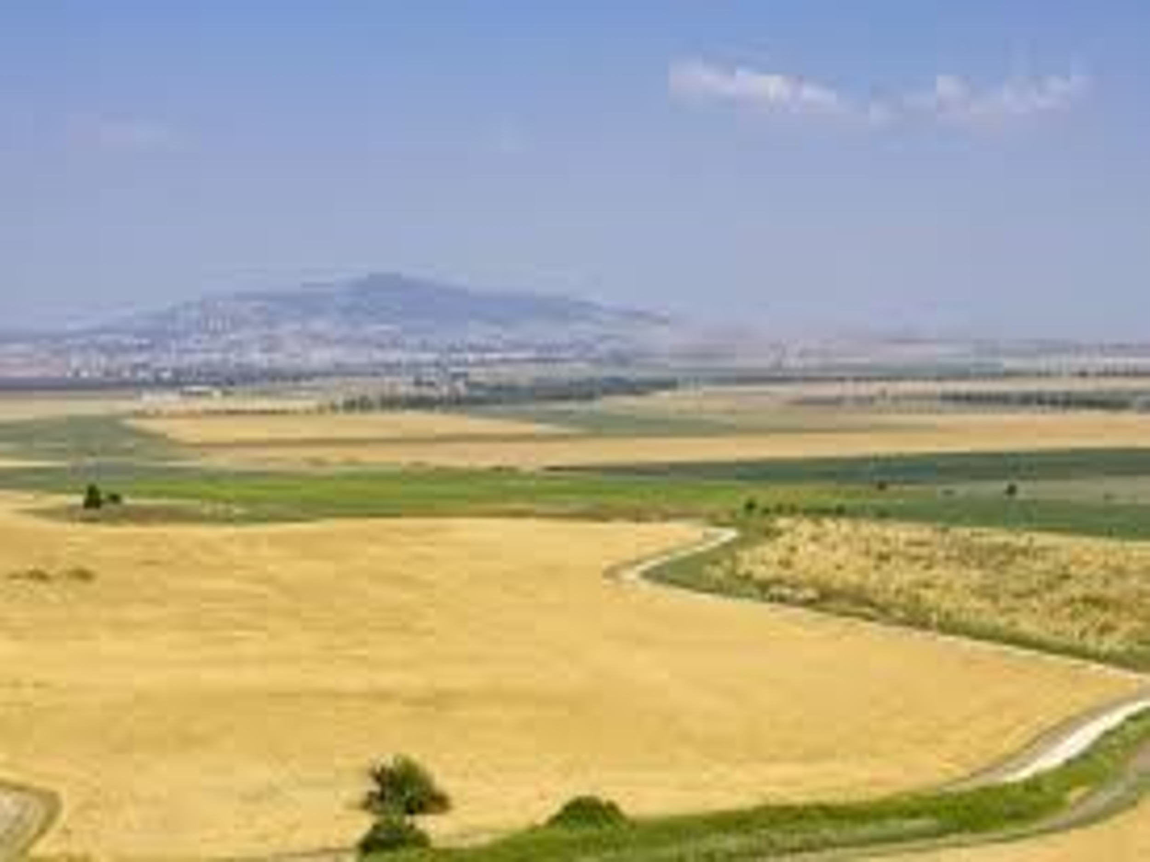

Before the armies can gather, the Battle for Jerusalem must happen.

12:1 establishes WHO the nations are coming against!

Psalms 2:1 WHY do the nations rage, And the people plot a vain thing? 2 The kings of the earth set themselves, And the rulers take counsel together, Against the LORD and against His Anointed, saying,

3 “Let us break Their bonds in pieces And cast away Their cords from us.”

4 He who sits in the heavens shall laugh; The LORD shall hold them in derision.

The antichrists plan is to systematically kill all the Jewish people.

Israel is attacked and 12-14 is one giant battle.

Though they are attacked God makes them cut the enemy bad while it is casting away the stone.

So whether Israel attacks or defends the enemy is dying by the millions

Their weapons aren’t working, in fact they are fighting against their own weapons and people. Israel though they are taking casualties, their enemies are dropping like flies.

Zech 12:5 “And the governors of Judah shall say in their heart, ‘The inhabitants of Jerusalem are my strength in the LORD of hosts, their God.’

6 “In that day I will make the governors of Judah like a firepan in the woodpile, and like a fiery torch in the sheaves; they shall devour all the surrounding peoples on the right hand and on the left,

but Jerusalem shall be inhabited again in her own place–Jerusalem.

7 “The LORD will save the tents of Judah first, so that the glory of the house of David and the glory of the inhabitants of Jerusalem shall not become greater than that of Judah. 8 “In that day the LORD will defend the inhabitants of Jerusalem; the one who is feeble among them in that day shall be like David, and the house of David shall be like God, like the Angel of the LORD before them.

9 “It shall be in that day that I will seek to destroy all the nations that come against Jerusalem.

The order of deliverance is, Judah first or Petra then Jerusalem!

Next week: Israel repents of their wicked act.

