The great promises!!!
8 Sept 2024

Zechariah

Intro 1:1-6

8 visions 1:7-6:8

4 messages 7:1-8:23

2 burdens 9:1-14:21

Now the people are returning from Babylon after 70 years Zechariah is reminding them how to be a blessing.

The temple is being rebuilt they are to look up BUT…

If you have never had a temple Zerubbabel's temple would be great!

If you remembered Solomon’s temple this new one would be sad.

Look UP! For the promises of God will be fulfilled!

Zech 8:1 Again the word of the LORD of hosts came, saying, 2 “Thus says the LORD of hosts: ‘I am zealous for Zion with great zeal; With great fervor I am zealous for her.’ 3 “Thus says the LORD: ‘I will return to Zion, And dwell in the midst of Jerusalem.

Jerusalem shall be called the City of Truth, The Mountain of the LORD of hosts, The Holy Mountain.’ 4 “Thus says the LORD of hosts: ‘Old men and old women shall again sit In the streets of Jerusalem, Each one with his staff in his hand Because of great age.

5 The streets of the city Shall be full of boys and girls Playing in its streets.’ 6 “Thus says the LORD of hosts: ‘If it is marvelous in the eyes of the remnant of this people in these days, Will it also be marvelous in My eyes?’ Says the LORD of hosts.

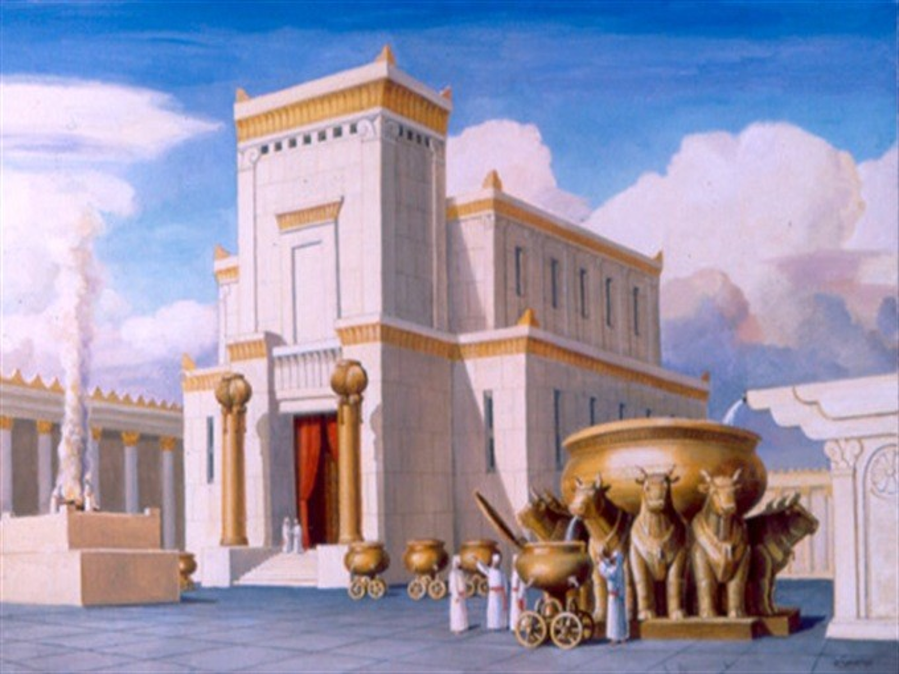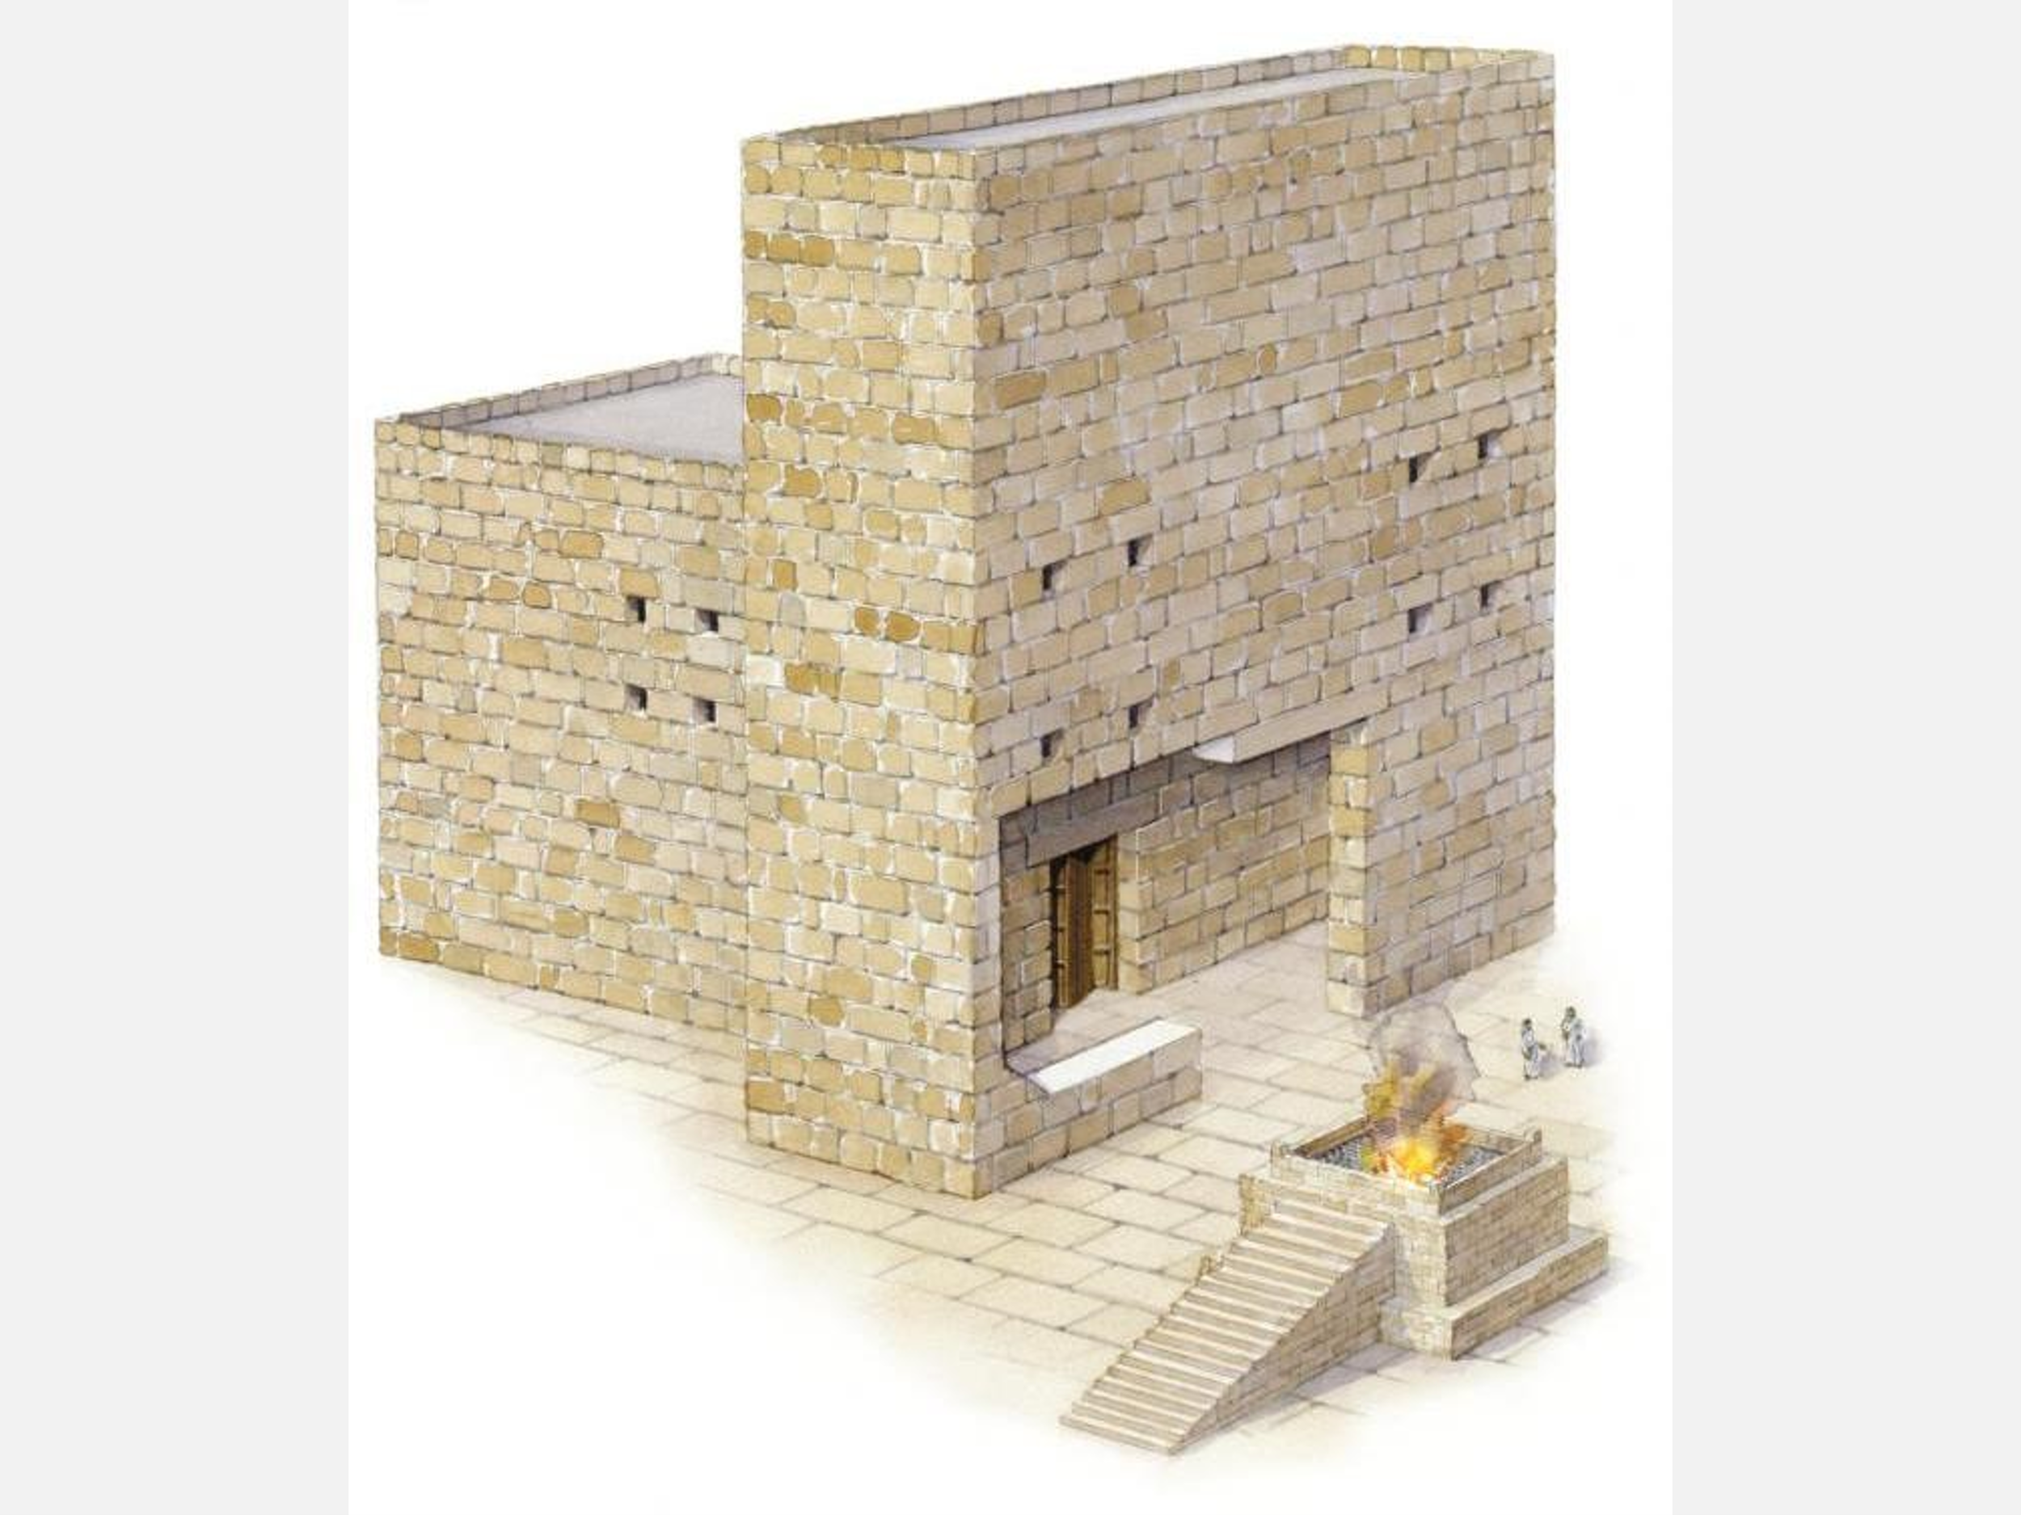

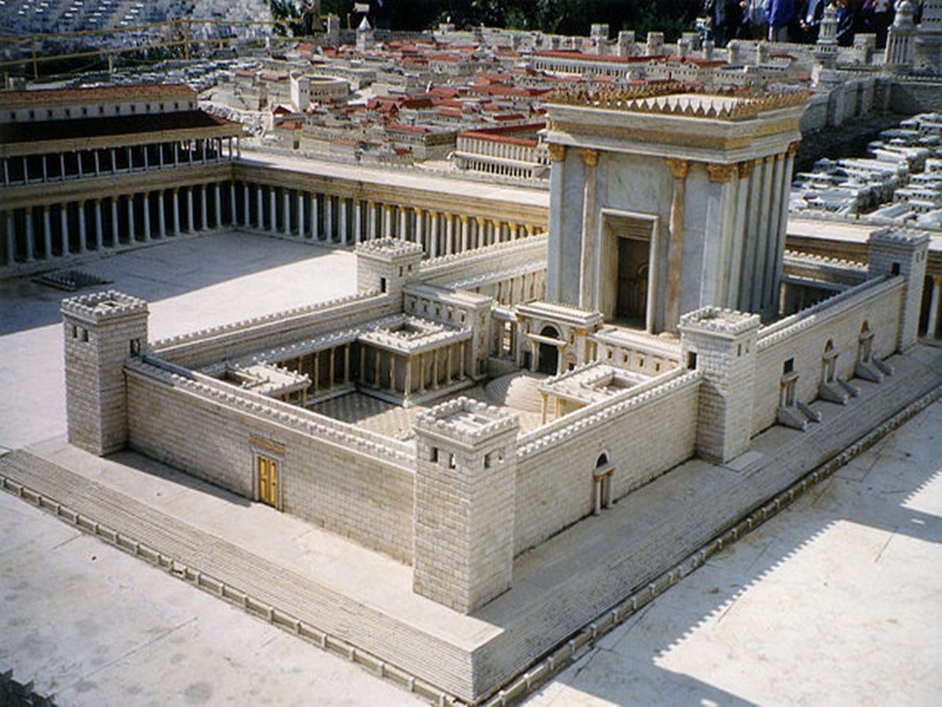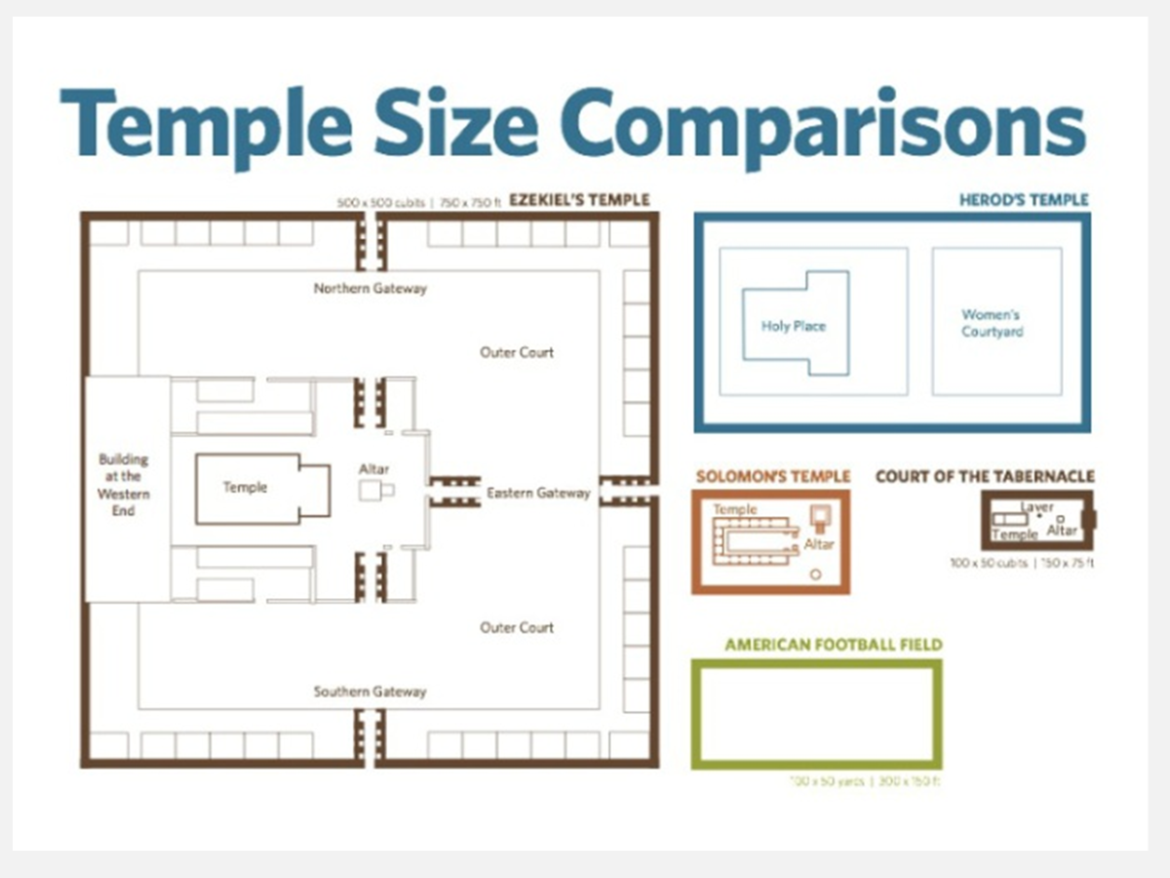

The regathering of Israel back to the land and Zerubbabel’s rebuilding the temple, is evidence that one day God will do all that he has said!

Isaiah 2:2 Now it shall come to pass in the latter days That the mountain of the LORD’s house Shall be established on the top of the mountains, And shall be exalted above the hills; And all nations shall flow to it. 3 Many people shall come and say, “Come, and let us go up to the mountain of the LORD, To the house of the God of Jacob;

He will teach us His ways, And we shall walk in His paths.” For out of Zion shall go forth the law, And the word of the LORD from Jerusalem.

4 He shall judge between the nations, And rebuke many people; They shall beat their swords into plowshares, And their spears into pruning hooks; Nation shall not lift up sword against nation, Neither shall they learn war anymore.

When HE dwells and returns this will happen too!

Zech 8:4 “Thus says the LORD of hosts: ‘Old men and old women shall again sit In the streets of Jerusalem, Each one with his staff in his hand Because of great age. 5 The streets of the city Shall be full of boys and girls Playing in its streets.’

Isa 65:22 They shall not build and another inhabit; They shall not plant and another eat; For as the days of a tree, so shall be the days of My people,

And My elect shall long enjoy the work of their hands.

23 They shall not labor in vain, Nor bring forth children for trouble; For they shall be the descendants of the blessed of the LORD, And their offspring with them.

And this!

Zech 8:7 “Thus says the LORD of hosts: ‘Behold, I will save My people from the land of the east And from the land of the west; 8 I will bring them back, And they shall dwell in the midst of Jerusalem.

They shall be My people And I will be their God, In truth and righteousness.’

Zech 14:16 And it shall come to pass that everyone who is left of all the nations which came against Jerusalem shall go up from year to year to worship the King, the LORD of hosts, and to keep the Feast of Tabernacles.

17 And it shall be that whichever of the families of the earth do not come up to Jerusalem to worship the King, the LORD of hosts, on them there will be no rain.

18 If the family of Egypt will not come up and enter in, they shall have no rain; they shall receive the plague with which the LORD strikes the nations who do not come up to keep the Feast of Tabernacles.

19 This shall be the punishment of Egypt and the punishment of all the nations that do not come up to keep the Feast of Tabernacles. 20 In that day “HOLINESS TO THE LORD” shall be engraved on the bells of the horses.

The pots in the LORD’s house shall be like the bowls before the altar. 21 Yes, every pot in Jerusalem and Judah shall be holiness to the LORD of hosts. Everyone who sacrifices shall come and take them and cook in them. In that day there shall no longer be a Canaanite in the house of the LORD of hosts.

Much of the curse is removed

Isa 11:6 “The wolf also shall dwell with the lamb, The leopard shall lie down with the young goat,

The calf and the young lion and the fatling together; And a little child shall lead them. 7 The cow and the bear shall graze; Their young ones shall lie down together; And the lion shall eat straw like the ox.

8 The nursing child shall play by the cobra’s hole, And the weaned child shall put his hand in the viper’s den. 9 They shall not hurt nor destroy in all My holy mountain, For the earth shall be full of the knowledge of the LORD As the waters cover the sea.

Jer 32:17 ‘Ah, Lord GOD! Behold, You have made the heavens and the earth by Your great power and outstretched arm. There is nothing too hard for You.

The removal of antisemitism!

Zech 8:20 “Thus says the LORD of hosts: ‘Peoples shall yet come, Inhabitants of many cities; 21 The inhabitants of one city shall go to another, saying, “Let us continue to go and pray before the LORD, And seek the LORD of hosts. I myself will go also.”

22 Yes, many peoples and strong nations Shall come to seek the LORD of hosts in Jerusalem, And to pray before the LORD.’ 23 “Thus says the LORD of hosts: ‘In those days ten men from every language of the nations shall grasp the sleeve of a Jewish man, saying, “Let us go with you, for we have heard that God is with you.” ’ ”

Romans 8:23… eagerly waiting for the adoption, the redemption of our body. 24 …For we were saved in this hope,!!!!!!!!!

