Zechariah 9

The coming King
Sept 15 2024

God’s Prophet Zechariah

THE INTRODUCTION, 1:1-6

The Lord was very angry with the fathers for their sinning.

Their sins eventually caught up with them and they were judged.

Don’t be like your fathers!

THE 8 NIGHT VISIONS, 1:7-6:8

#1 – The vision describes Israel’s subjection in the times of the gentiles. (“angel of Lord” = Jesus) Horses back and forth on the earth

#2 – This vision shows the flow of gentile world power (similar to Daniel 2 and 7)

#3 – Takes a look at the future when Israel would be delivered and restored.

#4 – This vision answers the question, “how can God restore and deliver a backslidden people?” (God’s grace)

#5 – Israel was chosen to be a LIGHT TO THE GENTILES. They will be empowered by the Spirit to do so.

#6 – A scroll with curses on it…before Messiah establishes His kingdom He will cut off the rebels in Israel.

#7 – A picture of the removal of evil from the land.

#8 – A picture of God’s judgment falling on the world

God’s Prophet Zechariah

THE FOUR MESSAGES, 7:1-8:23

#1 – Don’t fast in remembrance of events but mourn over the sin that caused the events.

#2 – Obedience is better than sacrifice.

#3 – Great blessing is coming and a universal return of Israel to the land.

#4 – In Messiah’s kingdom, days of fasting will be turned into days of joy.

THE TWO BURDENS, 9:1-14:21

FIRST BURDEN: Messiah’s appearances; but He will be rejected.

SECOND BURDEN: A focus on the “Second Coming” of the Messiah. Discusses what will take place in “THAT DAY” (i.e. the day of the Lord). Israel’s repentance, salvation and deliverance.

The first Burden 9:1-11:17!

Zech 9:1 The burden of the word of the LORD Against the land of Hadrach, And Damascus its resting place (For the eyes of men And all the tribes of Israel Are on the LORD); 2 Also against Hamath, which borders on it, And against Tyre and Sidon, though they are very wise.

3 For Tyre built herself a tower, Heaped up silver like the dust, And gold like the mire of the streets. 4 Behold, the LORD will cast her out; He will destroy her power in the sea, And she will be devoured by fire.

5 Ashkelon shall see it and fear; Gaza also shall be very sorrowful; And Ekron, for He dried up her expectation. The king shall perish from Gaza, And Ashkelon shall not be inhabited. 6 “A mixed race shall settle in Ashdod, And I will cut off the pride of the Philistines.

7 I will take away the blood from his mouth, And the abominations from between his teeth. But he who remains, even he shall be for our God, And shall be like a leader in Judah, And Ekron like a Jebusite.

8 I will camp around My house Because of the army, Because of him who passes by and him who returns. No more shall an oppressor pass through them, For now I have seen with My eyes.

Everything in this prophecy was fulfilled exactly, due to the Greek empire destroying and scraping it to the ground.

Ezek 26:14 ‘I will make you like the top of a rock; you shall be a place for spreading nets, and you shall never be rebuilt, for I the LORD have spoken,’ says the Lord GOD.

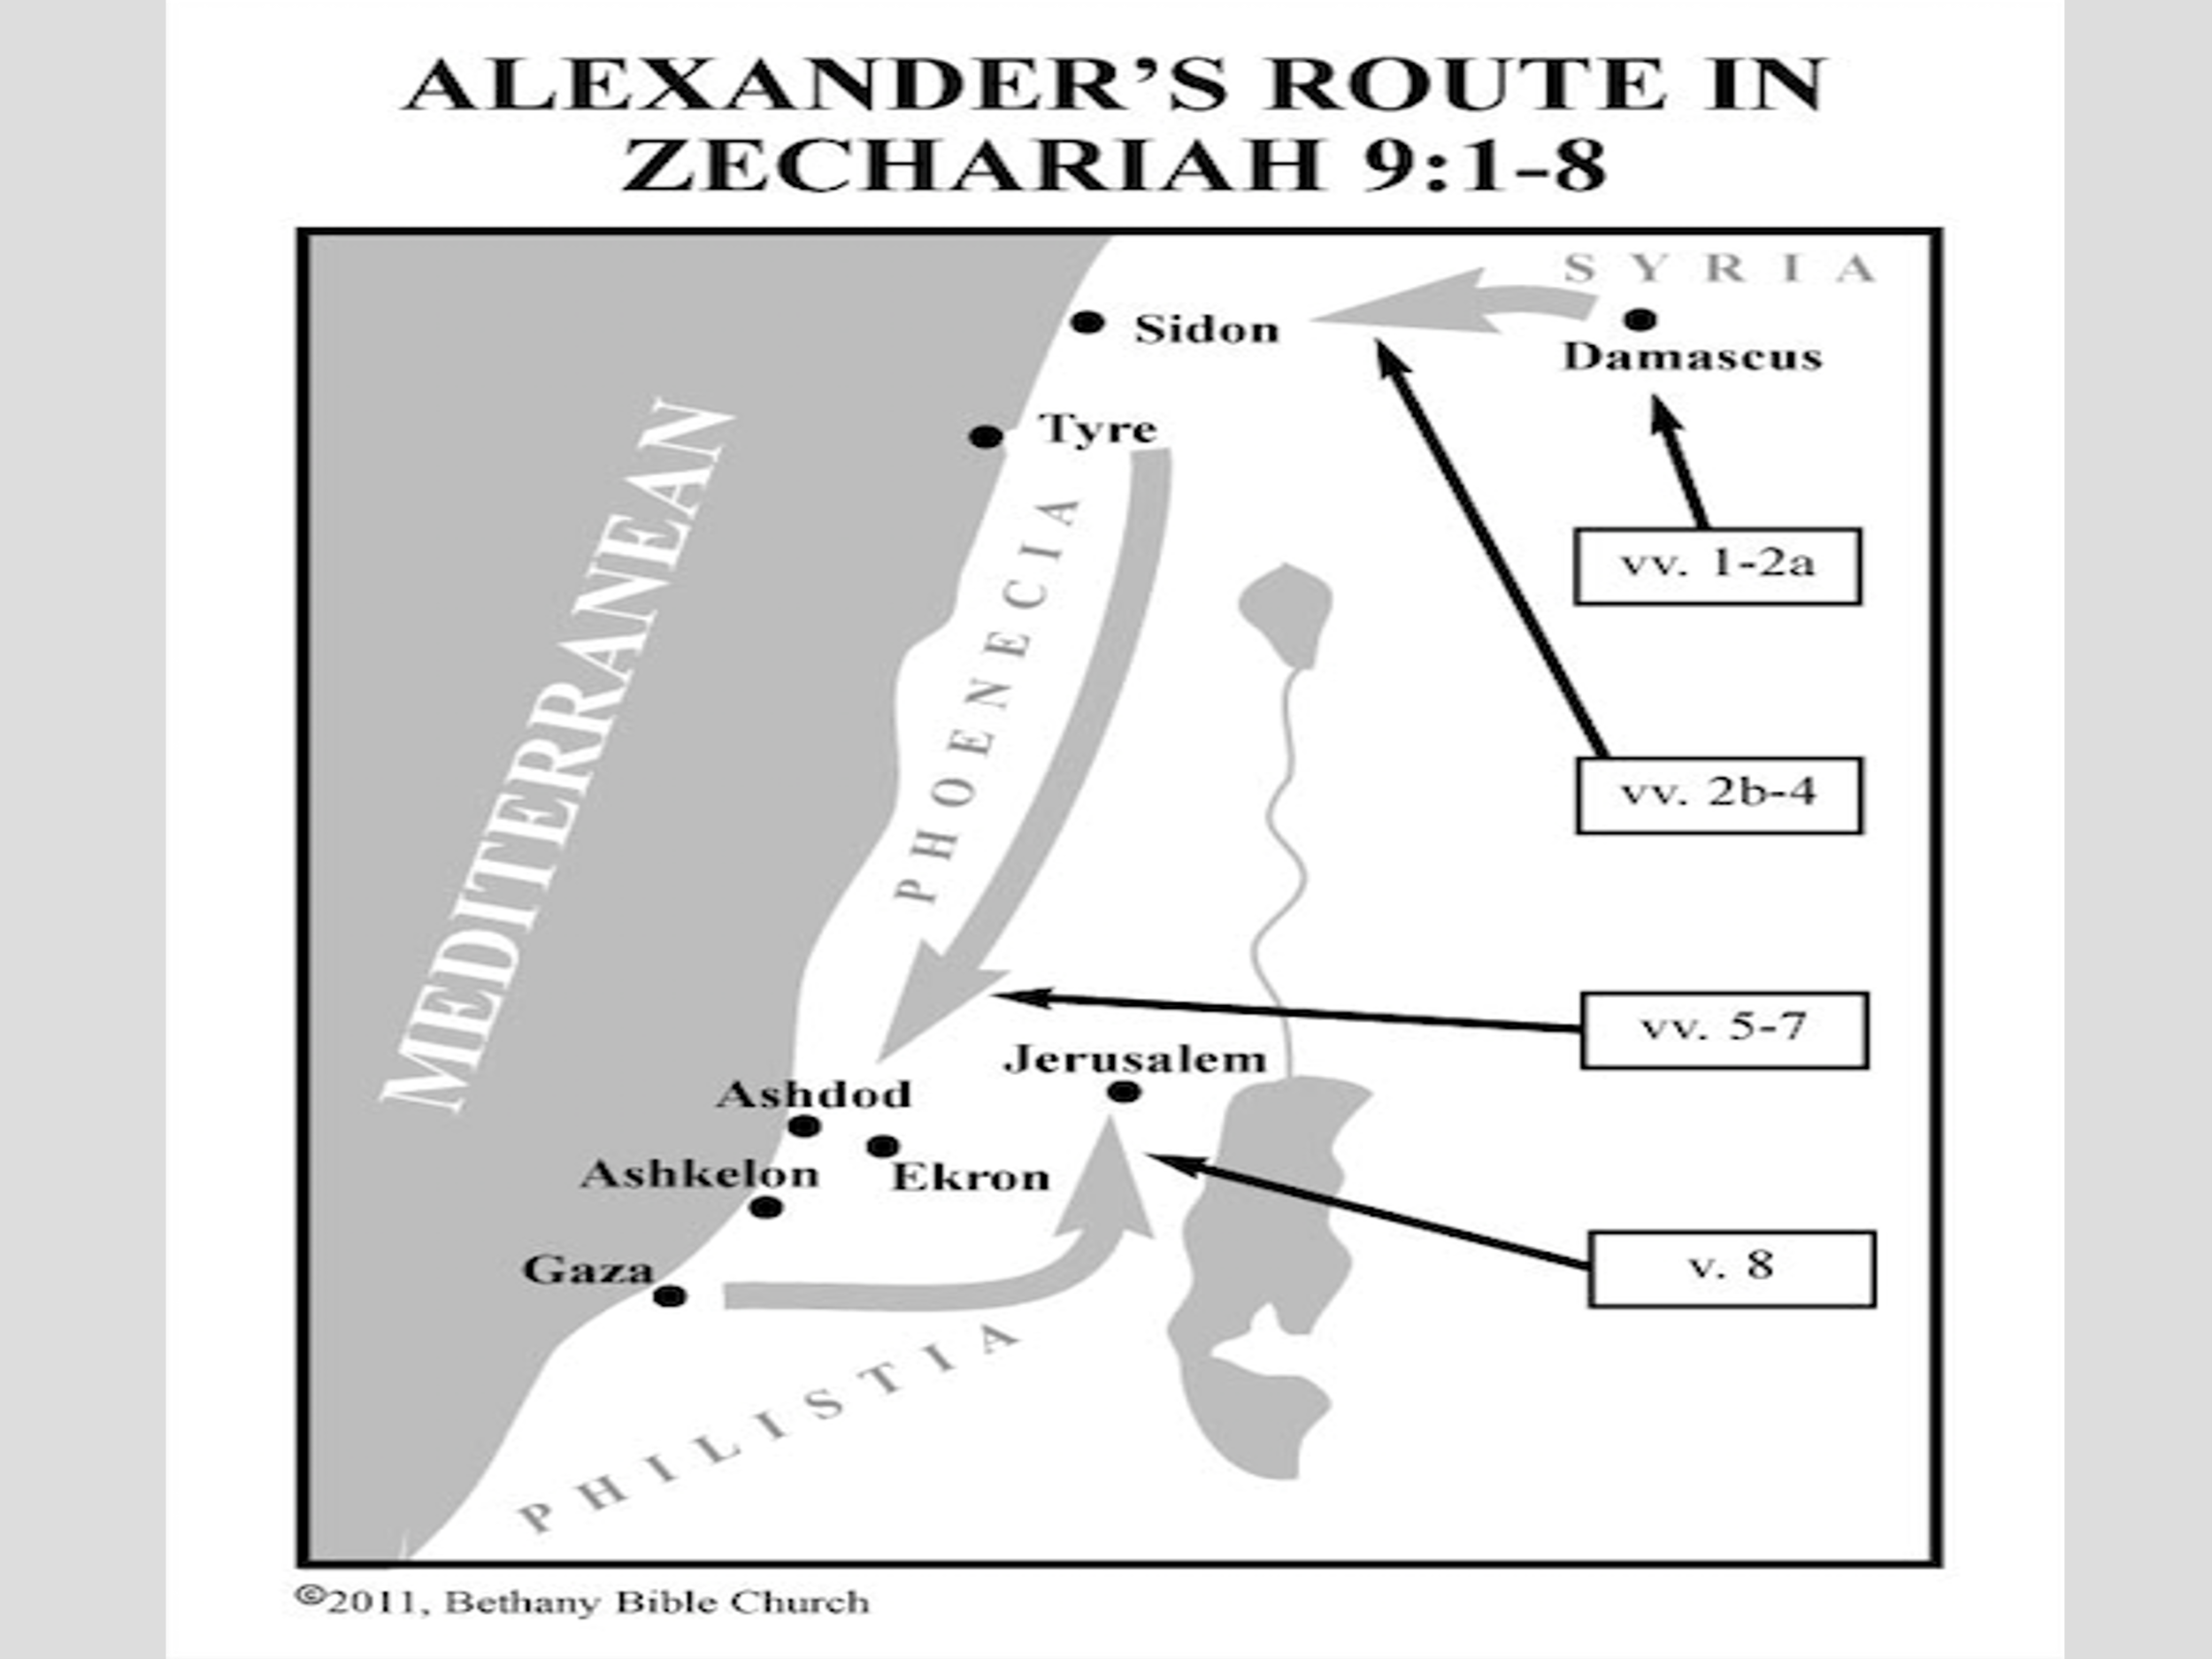

Alexander made a land bridge out to Tyre with all the debris 8000 were killed 200 were crucified 13,000 into slavery and Tyre was burned to the ground.

Short term prophecy

Zech 9:8 I will camp around My house Because of the army, Because of him who passes by and him who returns.

Alexander left Jerusalem alone!!!!!

Long term prophecy

Zech 9:8 No more shall an oppressor pass through them,

For now I have seen with My eyes.

Ezekiel 28:25 ‘Thus says the Lord GOD: “When I have gathered the house of Israel from the peoples among whom they are scattered, and am hallowed in them in the sight of the Gentiles, then they will dwell in their own land which I gave to My servant Jacob.

26 “And they will dwell safely there, build houses, and plant vineyards; yes, they will dwell securely, when I execute judgments on all those around them who despise them.

Then they shall know that I am the LORD their God.” ’ ”

Short term prophecy

Zech 9:9 “Rejoice greatly, O daughter of Zion! Shout, O daughter of Jerusalem! Behold, your King is coming to you; He is just and having salvation, Lowly and riding on a donkey, A colt, the foal of a donkey.

Long Term Prophecy 10 I will cut off the chariot from Ephraim And the horse from Jerusalem;

The battle bow shall be cut off. He shall speak peace to the nations; His dominion shall be ‘from sea to sea, And from the River to the ends of the earth.’

The Jewish rabbis and scholars thought for many years there were two Messiahs that would accomplish all the passages.

“Interestingly, the Jewish Scriptures paint seemingly two different pictures about the Messiah to come. For one, they talk about the Messiah who will come as the reigning King, who will usher in a period of unprecedented peace on earth.

But many verses talk about the Mashiach who will be a suffering servant, who will suffer and die for the sins of the people. For many hundreds of years the rabbis believed that there would be two Messiahs, the King Mashiach ben David, and the suffering servant Mashiach ben Joseph. The rabbis, unfortunately, were not able to see that one Messiah would accomplish both missions.
https://www.gotquestions.org/Jewish-Christian.html

Psalms 110:1:THE LORD said to my Lord,

“Sit at My right hand, Till I make Your enemies Your footstool.”

Isaiah 9:6: For unto us a Child is born,Unto us a Son is given; And the government will be upon His shoulder. And His name will be called Wonderful, Counselor, Mighty God, Everlasting Father, Prince of Peace.

Isaiah 9:7 Of the increase of His government and peace There will be no end, Upon the throne of David and over His kingdom,

to order it and establish it with judgment and justice From that time forward, even forever. The zeal of the LORD of hosts will perform this.

Jeremiah 23:5 “Behold, the days are coming,” says the LORD,“That I will raise to David a Branch of righteousness; A King shall reign and prosper, And execute judgment and righteousness in the earth.

Jeremiah 23:6: In His days Judah will be saved, And Israel will dwell safely;

Now this is His name by which He will be called: THE LORD OUR RIGHTEOUSNESS.

Matthew 21:5 “Tell the daughter of Zion,

‘Behold, your King is coming to you,

Lowly, and sitting on a donkey, A colt, the foal of a donkey.’ ”

Mark 11:7 Then they brought the colt to Jesus and threw their clothes on it, and He sat on it.

Mark 11:9 Then those who went before and those who followed cried out, saying: Hosanna! ‘Blessed is He who comes in the name of the LORD!’

Luke 19:38 saying:“ ‘Blessed is the King who comes in the name of the LORD!’ Peace in heaven and glory in the highest!”

John 12:15 “Fear not, daughter of Zion; Behold, your King is coming, Sitting on a donkey’s colt.”

Luke 18:31 Then He took the twelve aside and said to them, “Behold, we are going up to Jerusalem, and all things that are written by the prophets concerning the Son of Man will be accomplished.

KING STUFF RIGHT? NO NOT YET, SUFFERFING SERVANT STUFF!

32 “For He will be delivered to the Gentiles and will be mocked and insulted and spit upon. 33 “They will scourge Him and kill Him. And the third day He will rise again.”

34 But they understood none of these things; this saying was hidden from them, and they did not know the things which were spoken.

Next week: Oh! the things they longed to see that we see!!!!!!

