## **The book of Zechariah May 19, 2024**



# **God’s Prophet Zechariah**

## **TIME: Two months after Haggai began his ministry, Zechariah began his.**

## **THE MAN: He was a priest who was chosen by God to be a prophet as well. He came in the first return under Zerubbabel. (Note Ezra 5 and 6)**

## **HIS MESSAGE: Zechariah’s message is like the “major prophets” in that his message is broad in scope and does not just focus on one or two matters.**

## **OUTLINE:**

## **INTRODUCTION, 1:1-6**

## **THE 8 NIGHT VISIONS, 1:7-6:15**

## **THE 4 MESSAGES, 7:1-8:23**

## **THE 2 BURDENS, 9:1-14:21**

## **Focus: 8 visions, 4 messages, 2 burdens**

## **God’s Prophet Zechariah**

## **The introduction, 1:1-6**

## **The Lord was very angry with the fathers for their sinning.**



## ***Zech 1:3 “Therefore say to them, ‘Thus says the LORD of hosts: “Return to Me,” says the LORD of hosts, “and I will return to you,” says the LORD of hosts. 4 “Do not be like your fathers, to whom the former prophets preached, saying, ‘Thus says the LORD of hosts: “Turn now from your evil ways and your evil deeds.” ’ But they did not hear nor heed Me,” says the LORD.***

## **Their sins eventually caught up with them and they were judged.**

## ***5 “Your fathers, where are they? And the prophets, do they live forever?***



## ***6 Yet surely My words and My statutes, Which I commanded My servants the prophets, Did they not overtake your fathers?***

## **Don’t be like your fathers!**

## ***…“So they returned and said: ‘Just as the LORD of hosts determined to do to us, According to our ways and according to our deeds, So He has dealt with us.’ ” ’ ”***

## **Confess it,**

## **leave it, and move on.**



## ***Romans 6:6 knowing this, that our old man was crucified with Him, that the body of sin might be done away with, that we should no longer be slaves of sin. 7 For he who has died has been freed from sin.***



## **1. Confess it! Because of this great position we have;**

## ***Rom 6:12 Therefore do not let sin reign in your mortal body, that you should obey it in its lusts. 13 And do not present your members as instruments of unrighteousness to sin, but present yourselves to God***



## ***as being alive from the dead, and your members as instruments of righteousness to God.***

## **2. Leave IT and FORGET IT!**



## ***Phil 3:13 Brethren, I do not count myself to have apprehended; but one thing I do, forgetting those things which are behind and reaching forward to those things which are ahead, 14 I press toward the goal for the prize of the upward call of God in Christ Jesus.***

## **Note this about God:**

## **Zechariah = Jehovah remembers**

## **Family of Berechiah = Jehovah blesses**

## **Son of Iddo = His time**

## **Jehovah remembers, and Jehovah blesses in His time.**

## **God is all knowing and all encompassing, He wastes nothing, and needs nothing. He is the uncaused cause!**



## **He is all in all!**



## **Daniel theme; “the times of the Gentiles”**

## **Zechariah theme; “Israel during the times of the Gentiles”**

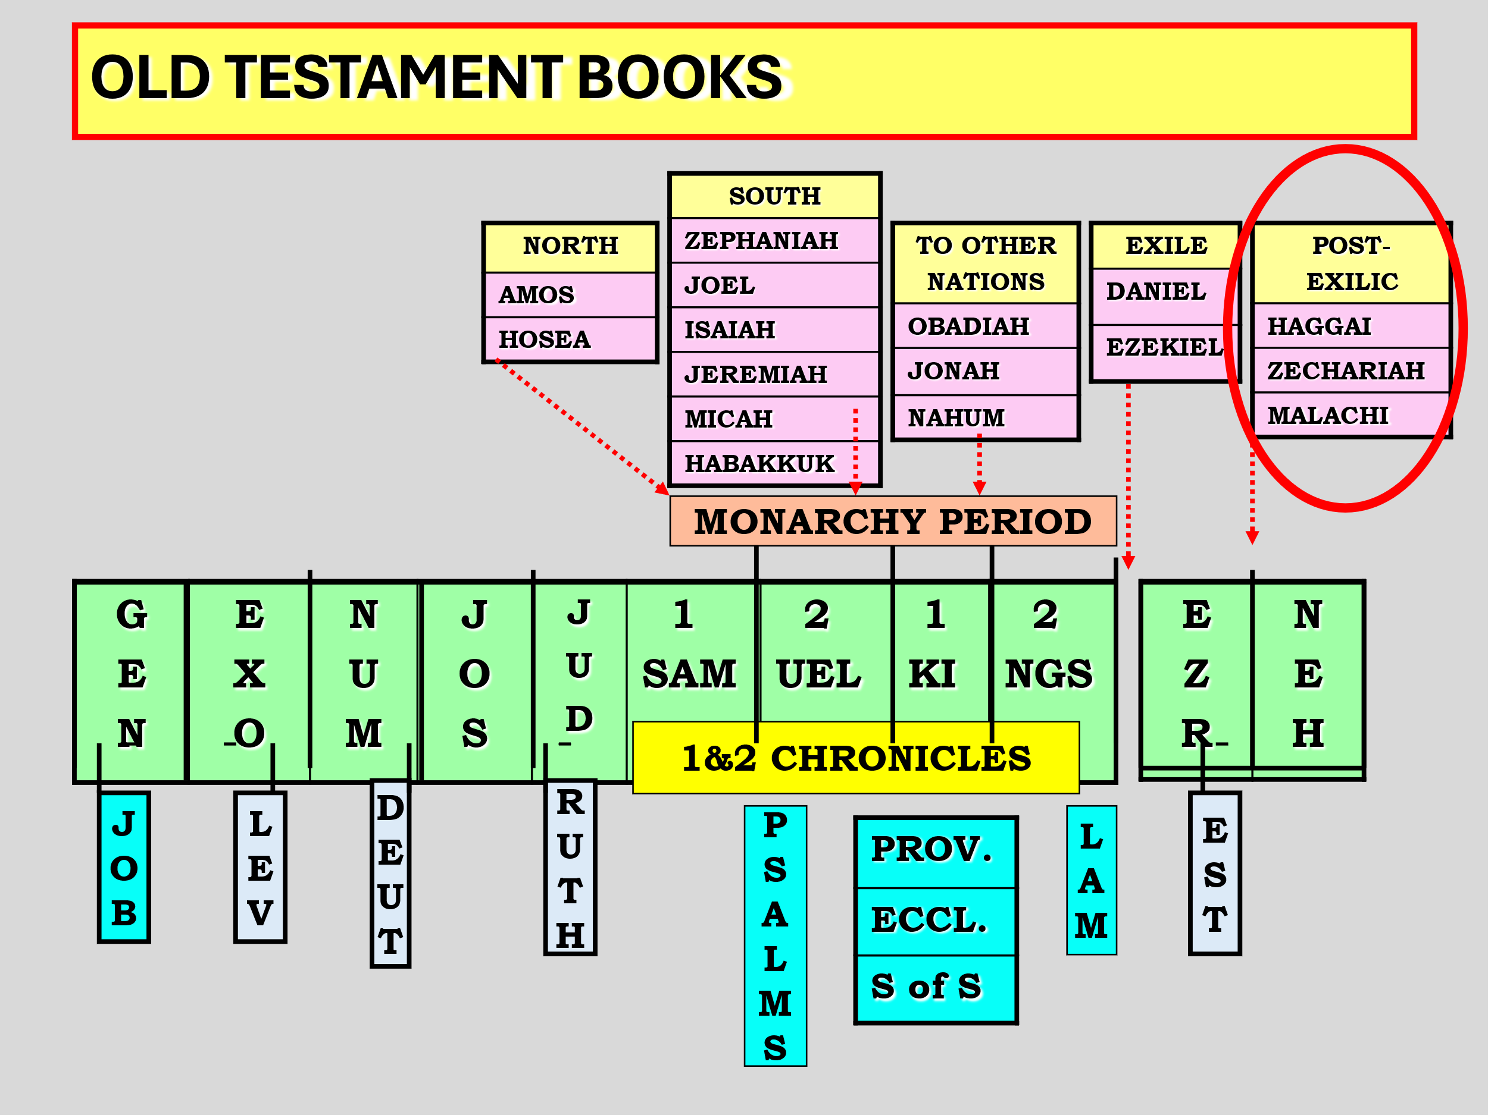

## **Israel by this time after the 70 years captivity …**

## **Idolatry forsaken**



## **Rise of the synagogue**

## **Spiritual conditions still poor**

## **THE 8 NIGHT VISIONS, 1:7-6:8**

## **#1 – The vision describes Israel’s subjection in the times of the gentiles. (“angel of Lord” = Jesus)**



## **Vision of the Horses!**

## ***Zech 1:7 On the twenty-fourth day of the eleventh month, which is the month Shebat, in the second year of Darius, the word of the LORD came to Zechariah the son of Berechiah, the son of Iddo the prophet:***

## ***8 I saw by night, and behold, a man riding on a red horse, and it stood among the myrtle trees in the hollow; and behind him were horses: red, sorrel, and white. 9 Then I said, “My lord, what are these?” So the angel who talked with me said to me, “I will show you what they are.”***

## ***10 And the man who stood among the myrtle trees answered and said, “These are the ones whom the LORD has sent to walk to and fro throughout the earth.”***

## ***11 So they answered the Angel of the LORD, who stood among the myrtle trees, and said, “We have walked to and fro throughout the earth, and behold, all the earth is resting quietly.”***

## **This is not a good report because nothing is happening with Israel and the forward move of prophetic future seems stalled.**



## **The ANGEL OF THE LORD (Christ before His first coming, the intercessor of Israel)**

## ***Zech 1:12 Then the Angel of the LORD answered and said, “O LORD of hosts, how long will You not have mercy on Jerusalem and on the cities of Judah, against which You were angry these seventy years?”***

## **He will do this in chapter 3**

## ***Zech 3:1 Then he showed me Joshua the high priest standing before the Angel of the LORD, and Satan standing at his right hand to oppose him. 2 And the LORD said to Satan, “The LORD rebuke you, Satan!***

## ***The LORD who has chosen Jerusalem rebuke you! Is this not a brand plucked from the fire?”***

## **The Father always answers the SON!**

## ***Zech 1:13 And the LORD answered the angel who talked to me, with good and comforting words. 14 So the angel who spoke with me said to me, “Proclaim, saying, ‘Thus says the LORD of hosts: “I am zealous for Jerusalem And for Zion with great zeal.***

## ***15 I am exceedingly angry with the nations at ease;***

## ***For I was a little angry, And they helped–but with evil intent.” 16 ‘Therefore thus says the LORD: “I am returning to Jerusalem with mercy; My house shall be built in it,” says the LORD of hosts, “And a surveyor’s line shall be stretched out over Jerusalem.” ’***

## ***17 “Again proclaim, saying, ‘Thus says the LORD of hosts: “My cities shall again spread out through prosperity; The LORD will again comfort Zion, And will again choose Jerusalem.” ’ ”***

## **Do not mess with God’s people!!!!**

## ***Zech 2:8 For thus says the LORD of hosts: “He sent Me after glory, to the nations which plunder you; for he who touches you touches the apple of His eye.***

## **(Warning)**

## **This can be in physical violence OR in bad Theology!**



## **Woe to those attacking Israel, as we will see.**



## **Woe to those who teach God is done with Israel.**



## ***9 “For surely I will shake My hand against them, and they shall become spoil for their servants. Then you will know that the LORD of hosts has sent Me.***

## ***10 “Sing and rejoice, O daughter of Zion! For behold, I am coming and I will dwell in your midst,” says the LORD.***

## ***11 “Many nations shall be joined to the LORD in that day, and they shall become My people. And I will dwell in your midst. Then you will know that the LORD of hosts has sent Me to you.***



## ***12 “And the LORD will take possession of Judah as His inheritance in the Holy Land, and will again choose Jerusalem. 13 “Be silent, all flesh, before the LORD, for He is aroused from His holy habitation!”***

## ***Hebrews 10:31 It is a fearful thing to fall into the hands of the living God.***

## **Next week: More visions!**