Zephaniah Chapter 3
May 21, 2024

This last chapter of Zephaniah needs to be started with these. First as we shall see God is not the one at fault.

Question? Is God ever at fault?

Whether its Job, or Jonah, or you and whoever;

God is always loving, always fair, and always right!

The problem is always the curse and what flows out of that. Even if we don’t understand or comprehend, GOD IS NOT AT FAULT!

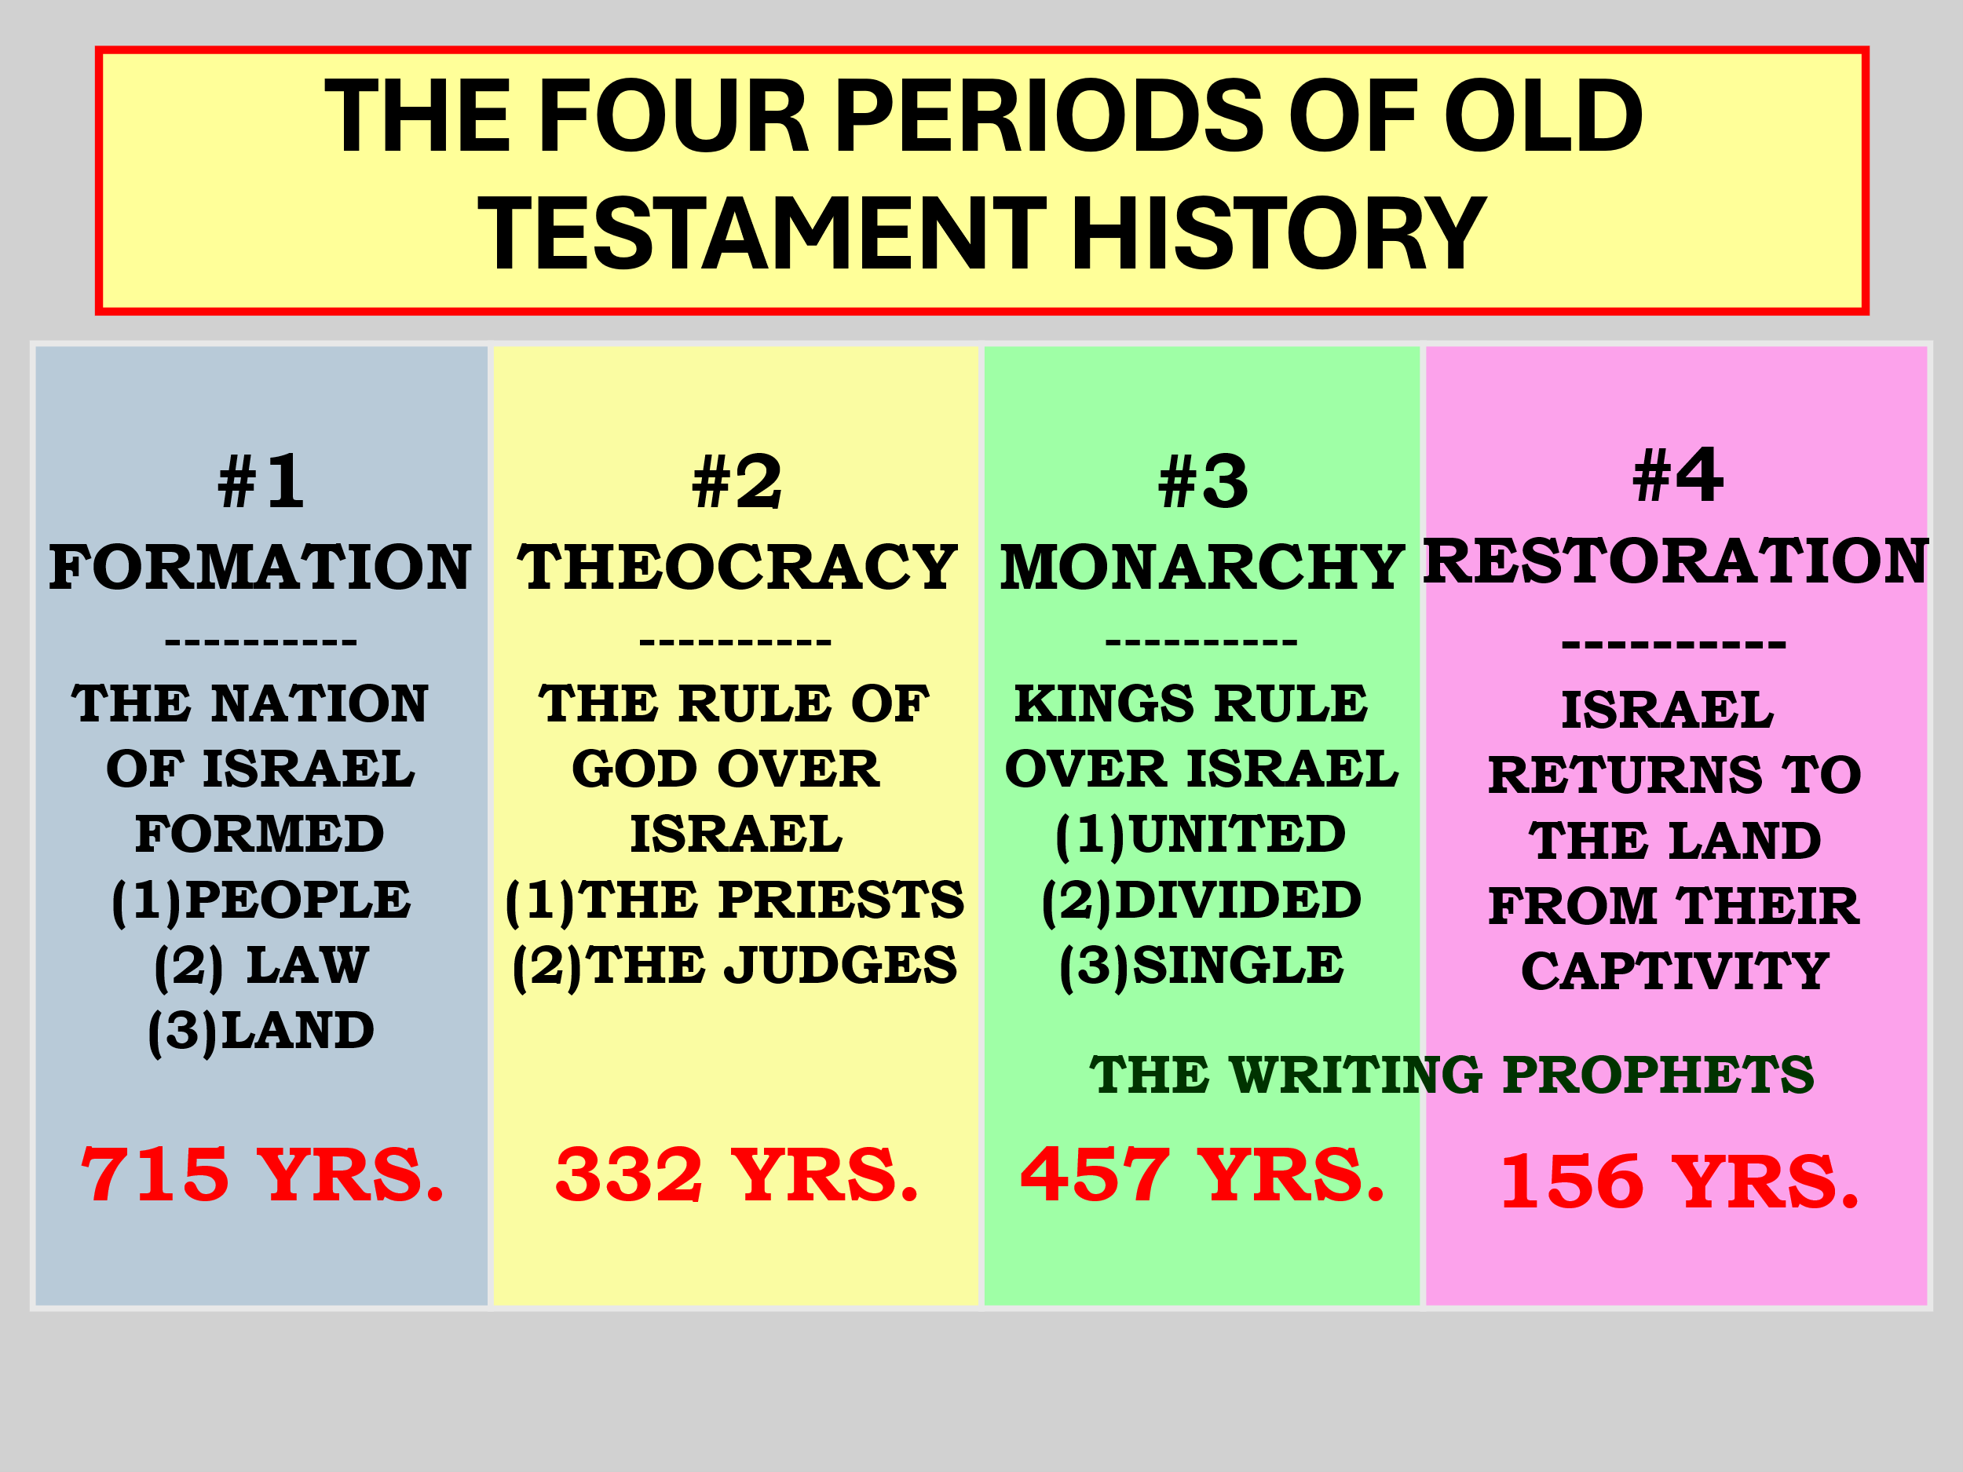

1504 yrs. God in His mercy called and was patient with a people.For 6000 yrs. God has had to endure this with all people.(First world, 1Pet 3:5-6) Gen 6:5 Then the LORD saw that the wickedness of man was great in the earth, and that every intent of the thoughts of his heart was only evil continually. (Second world) Romans 3:15 “Their feet are swift to shed blood; 16 Destruction and misery are in their ways; 17 And the way of peace they have not known.”

18 “There is no fear of God before their eyes.”

Let’s Read Nehemiah 9:1-38

This is the end of the matter with God and man.

So…..

Zeph 3:1 Woe to her who is rebellious and polluted, To the oppressing city! 2 She has not obeyed His voice, She has not received correction; She has not trusted in the LORD, She has not drawn near to her God.

3 Her princes in her midst are roaring lions; Her judges are evening wolves That leave not a bone till morning. 4 Her prophets are insolent, treacherous people; Her priests have polluted the sanctuary, They have done violence to the law.

All the leaders are corrupt because of this:

They have not obeyed God’s voice/WORD.

They have not received correction. God’s solution is ignored!

3. They have not trusted in God but…

Judges 21:25 In those days there was no king in Israel; everyone did what was right in his own eyes.

4. They have not come to reason with God, to draw close!

Isa 1:18 “Come now, and let us reason together,” Says the LORD, “Though your sins are like scarlet, They shall be as white as snow; Though they are red like crimson, They shall be as wool.

Come let us have a chat over your matters!

Satan only steals, kills and destroys.

God knows the best way for your life. Sit down reason with Him.

Mat 11:28 “Come to Me, all you who labor and are heavy laden, and I will give you rest. 29 “Take My yoke upon you and learn from Me, for I am gentle and lowly in heart, and you will find rest for your souls. 30 “For My yoke is easy and My burden is light.”

What evil does to nations:

3 Her princes in her midst are roaring lions;

They tear the land apart with greed, power, and high-level corruption.

Her judges are evening wolves That leave not a bone till morning.

They use their power to only benefit themselves more and more.

4 Her prophets are insolent, treacherous people;

Her priests have polluted the sanctuary, They have done violence to the law.

They have nothing to say because nothing is being said by God.

They are blind guides, corrupt with sacrifices, money and the people.

God now must remind them all of some things

Zeph 3:5 The LORD is righteous in her midst, He will do no unrighteousness. Every morning He brings His justice to light;

He never fails, But the unjust knows no shame. 6 “I have cut off nations, Their fortresses are devastated;

I have made their streets desolate, With none passing by. Their cities are destroyed; There is no one, no inhabitant. 7 I said, ‘Surely you will fear Me, You will receive instruction’– So that her dwelling would not be cut off, Despite everything for which I punished her.

But they rose early and corrupted all their deeds.

Is there hope?

Next week finish chap 3!!!

