## **Zephaniah and Prophetic review minor prophets**

## **4-14-24**

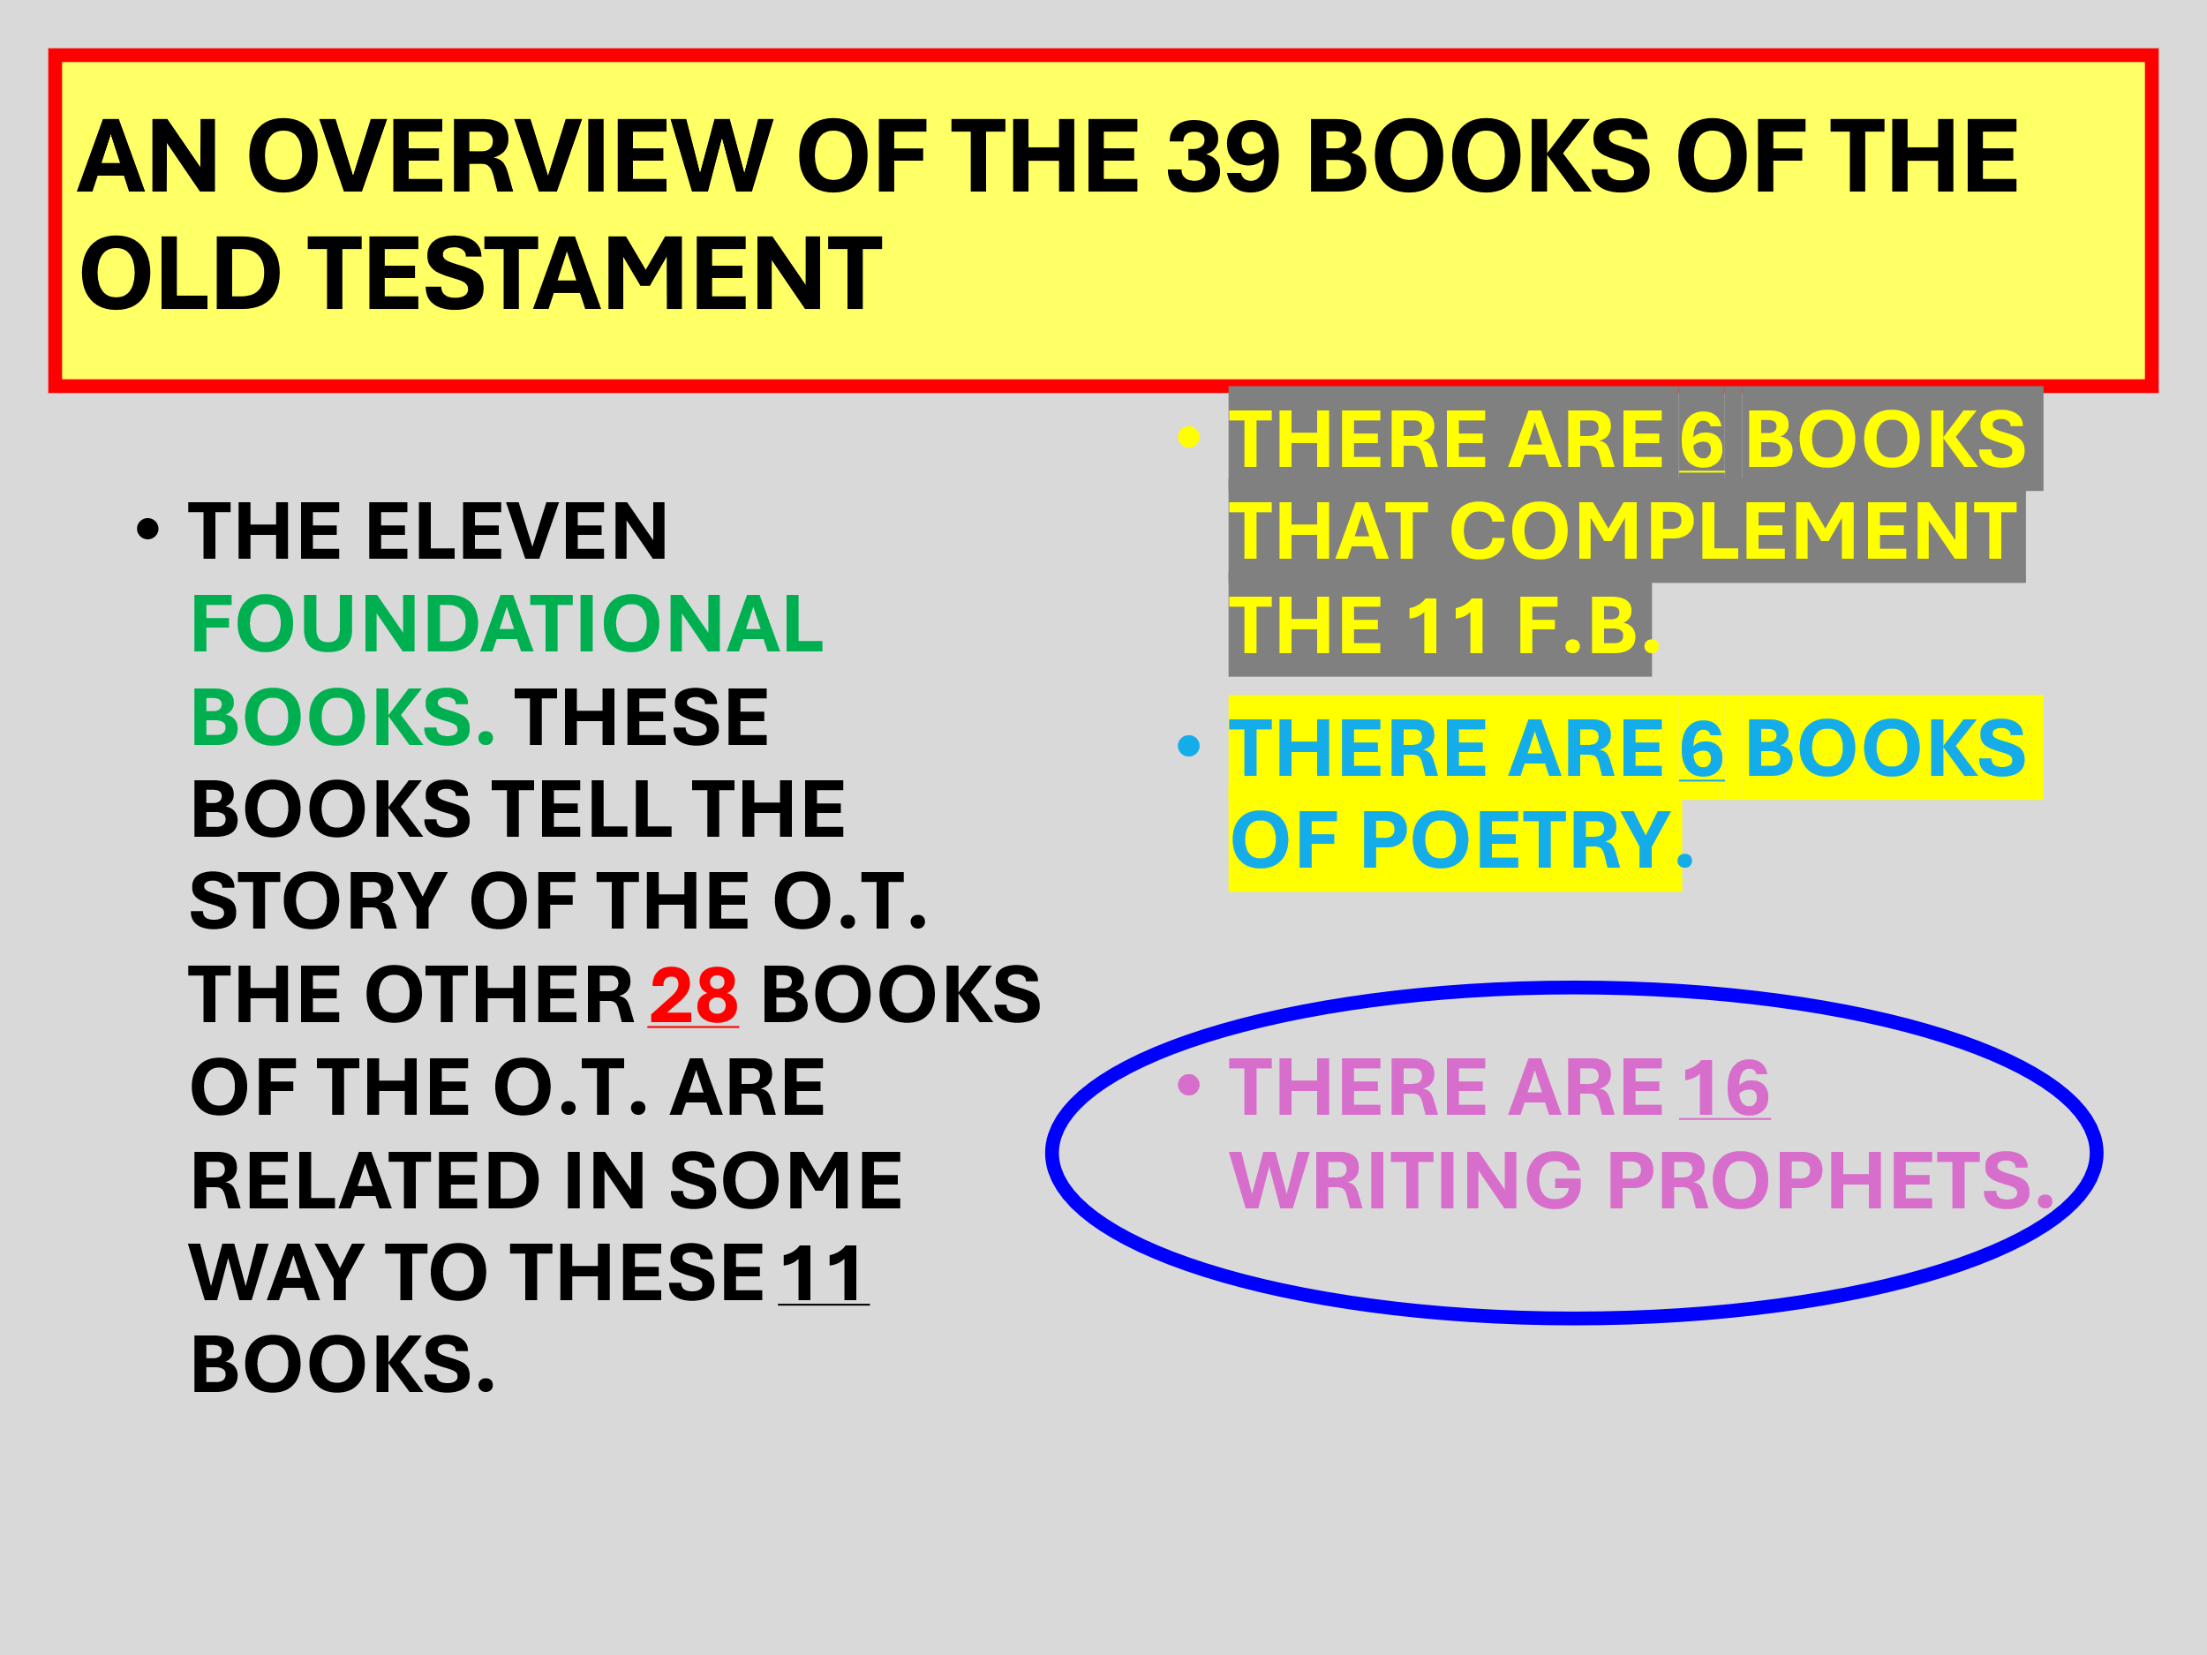  
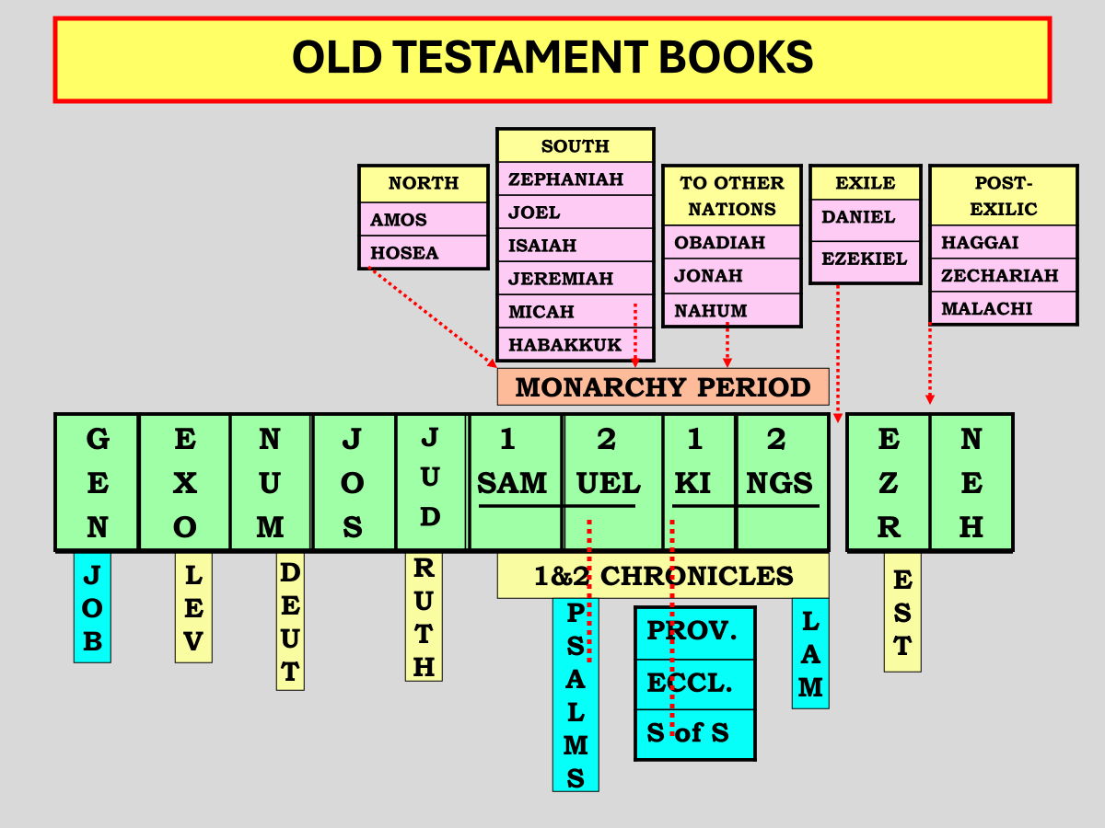  
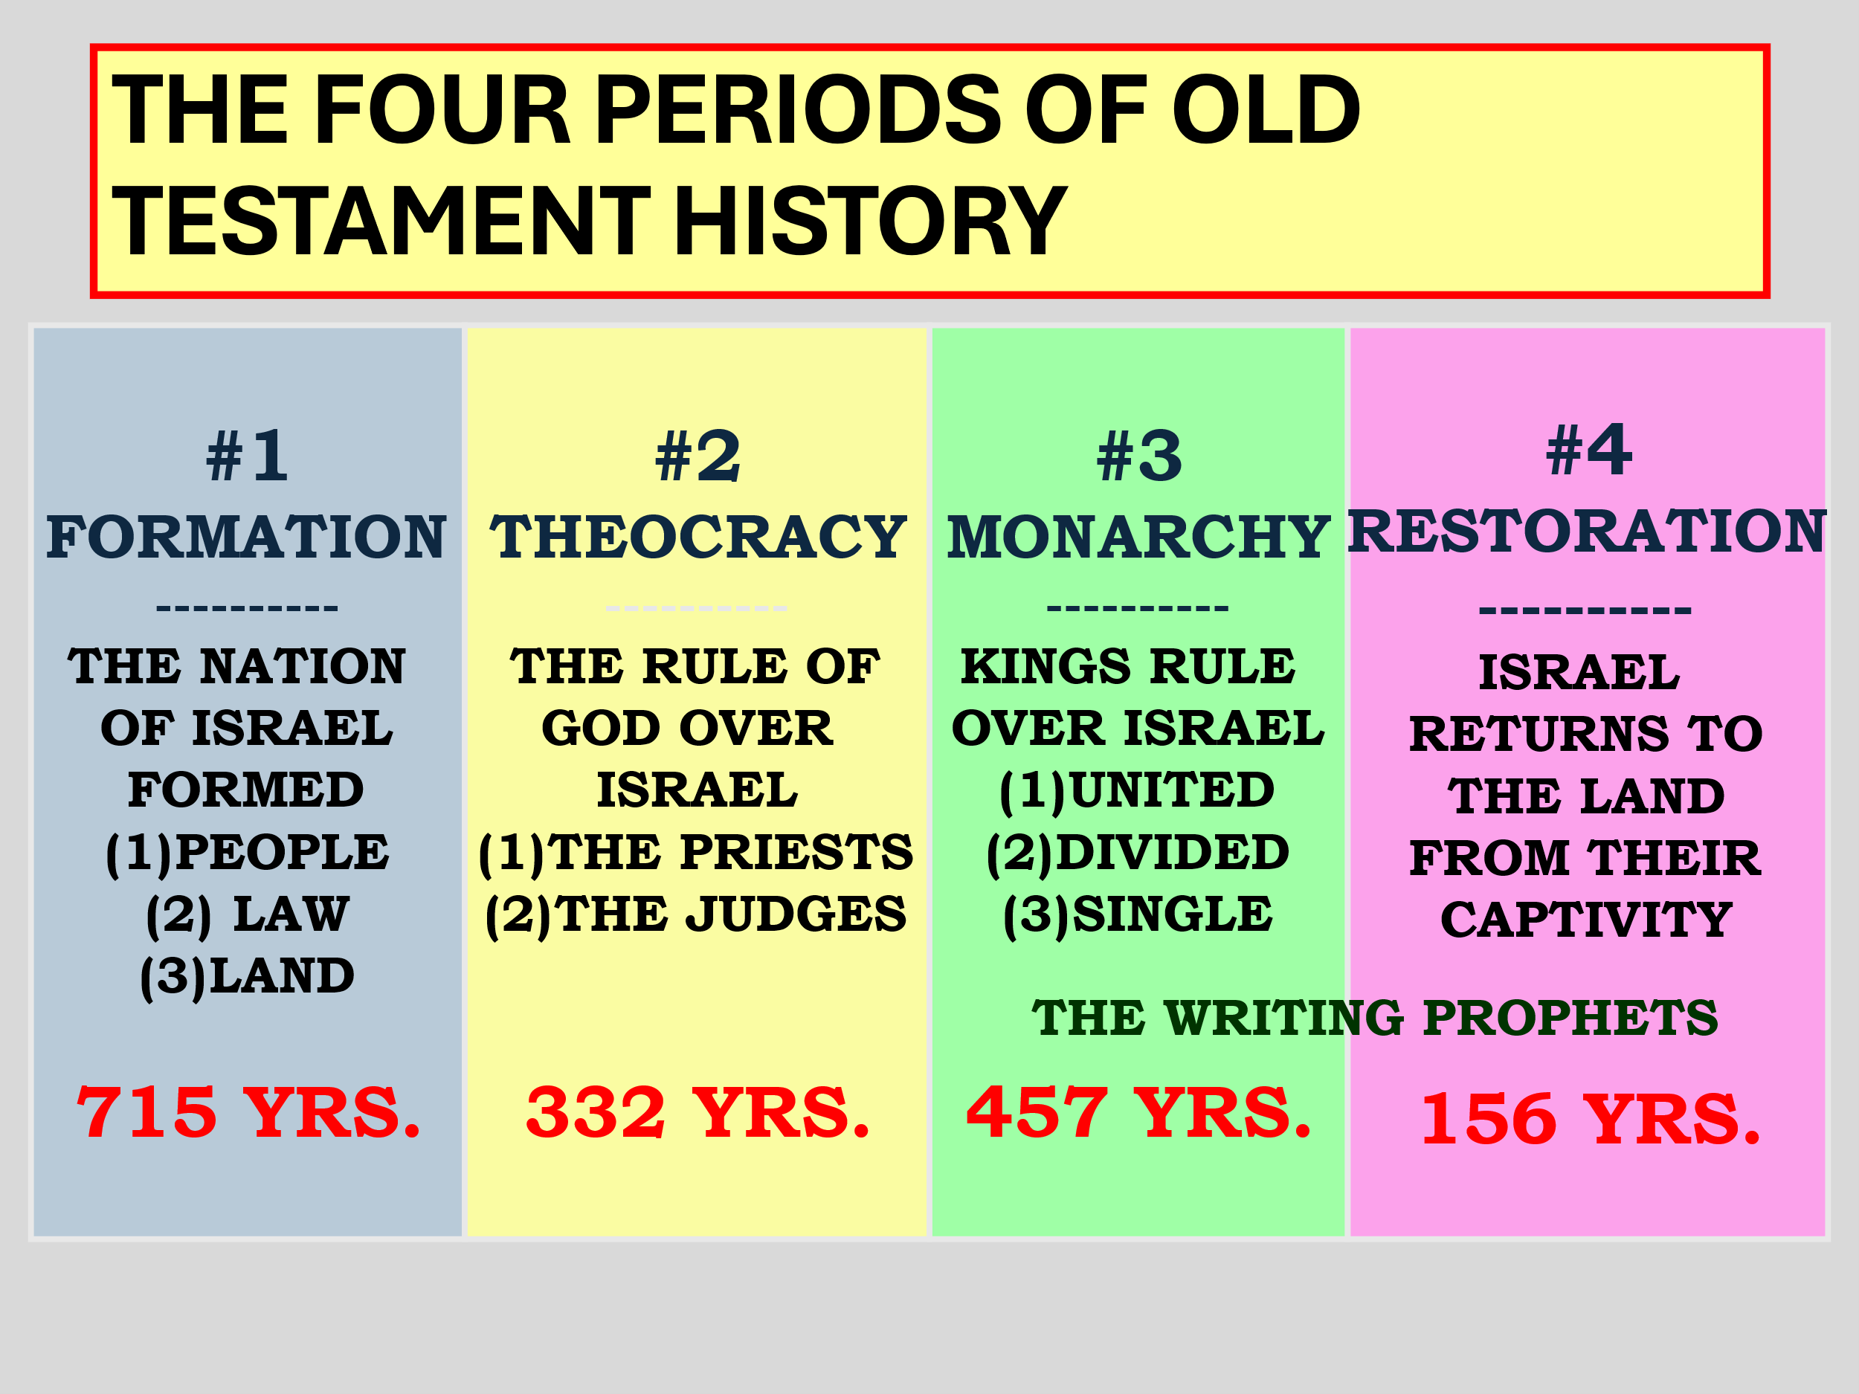  
  
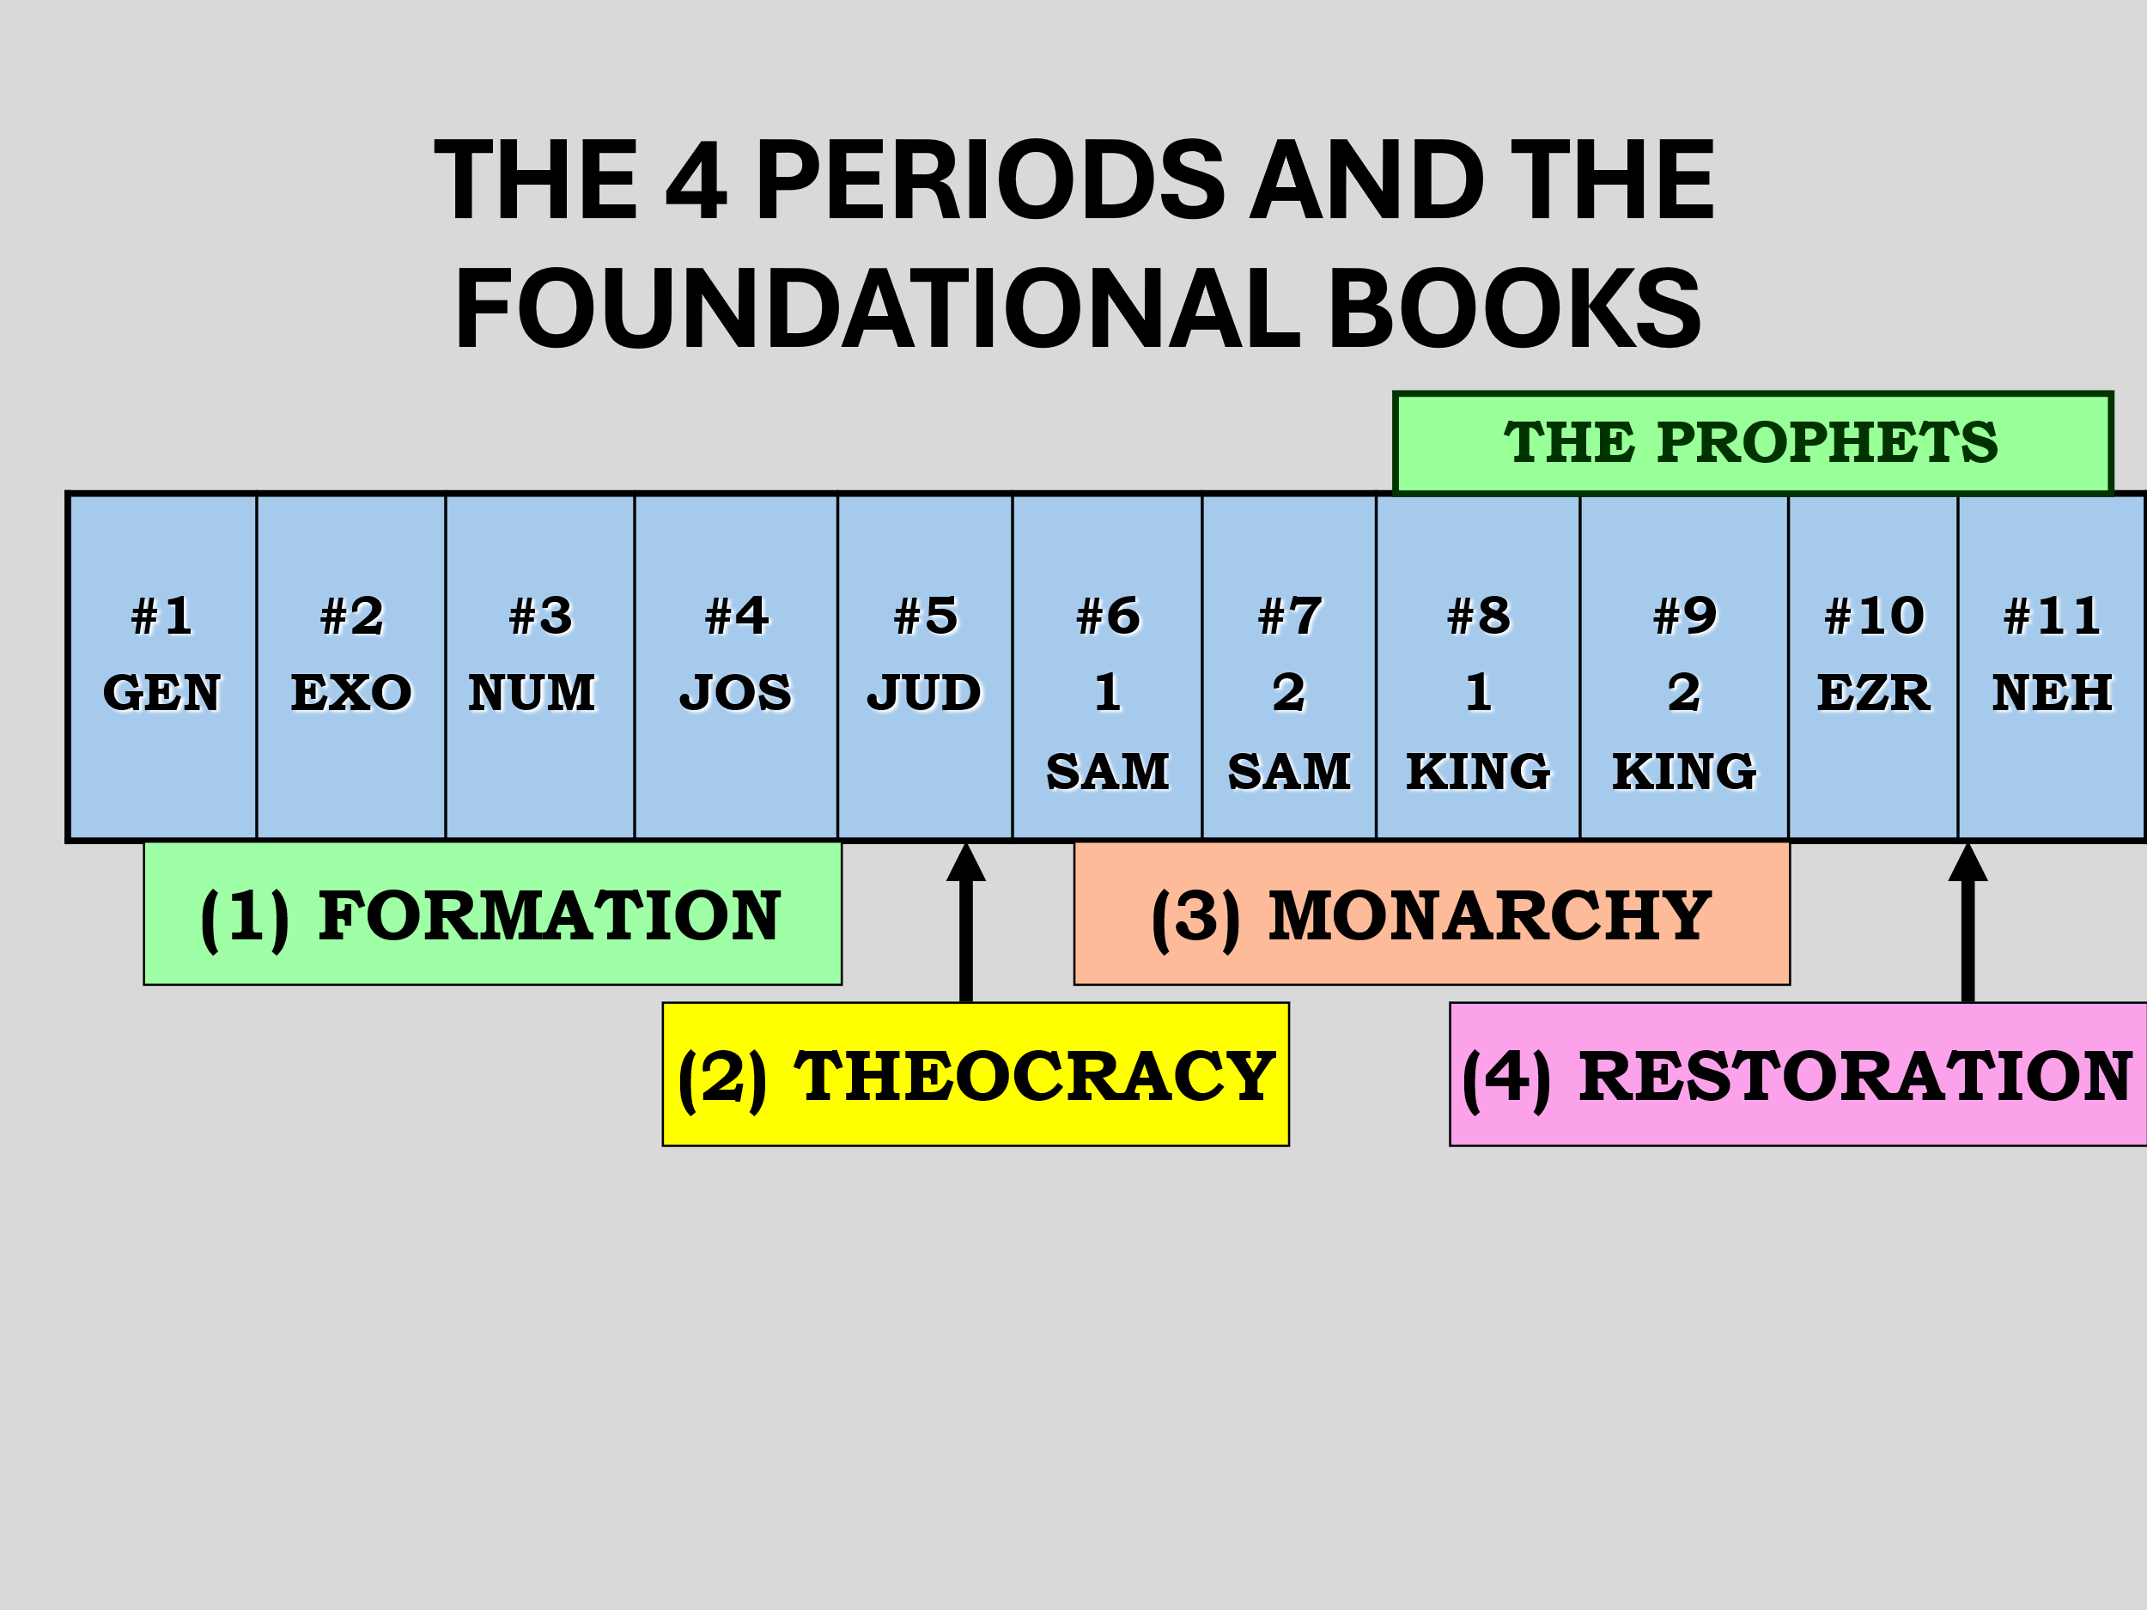

# 

# 

## **Why is this also an end times prophecy?**

## **The wording used!**

## ***Zeph 1:14 The great day of the LORD is near; It is near and hastens quickly. The noise of the day of the LORD is bitter; There the mighty men shall cry out. 15 That day is a day of wrath, A day of trouble and distress, A day of devastation and desolation, A day of darkness and gloominess, A day of clouds and thick darkness, 16 A day of trumpet and alarm Against the fortified cities And against the high towers.***



## ***17 “I will bring distress upon men, And they shall walk like blind men, Because they have sinned against the LORD; Their blood shall be poured out like dust, And their flesh like refuse.”***

## ***18 Neither their silver nor their gold Shall be able to deliver them In the day of the LORD’s wrath; But the whole land shall be devoured By the fire of His jealousy, For He will make speedy riddance Of all those who dwell in the land.***

## ***Joel 2:1 Blow the trumpet in Zion, And sound an alarm in My holy mountain! Let all the inhabitants of the land tremble; For the day of the LORD is coming, For it is at hand:***



## ***2 A day of darkness and gloominess, A day of clouds and thick darkness, Like the morning clouds spread over the mountains. A people come, great and strong, The like of whom has never been; Nor will there ever be any such after them, Even for many successive generations.***

## **Poured out?**

## ***Zech 14:12 And this shall be the plague with which the LORD will strike all the people who fought against Jerusalem: Their flesh shall dissolve while they stand on their feet, Their eyes shall dissolve in their sockets, And their tongues shall dissolve in their mouths.***



## **Israel is to gather together before!**

## **Before what?**

## ***Zeph 2:1 Gather yourselves together, yes, gather together, O undesirable nation, 2 Before the decree is issued, Or the day passes like chaff, Before the LORD’s fierce anger comes upon you, Before the day of the LORD’s anger comes upon you!***

## **Judgement on the nations surrounding Israel!**

## ***Zeph 2:4 For Gaza shall be forsaken, And Ashkelon desolate; They shall drive out Ashdod at noonday, And Ekron shall be uprooted.***

## ***5 Woe to the inhabitants of the seacoast, The nation of the Cherethites! The word of the LORD is against you, O Canaan, land of the Philistines: “I will destroy you; So there shall be no inhabitant.” 6 The seacoast shall be pastures, With shelters for shepherds and folds for flocks.***

## ***7 The coast shall be for the remnant of the house of Judah; They shall feed their flocks there; In the houses of Ashkelon they shall lie down at evening. For the LORD their God will intervene for them, And return their captives.***

## **Judgement on Jordan**

## ***2:8 “I have heard the reproach of Moab, And the insults of the people of Ammon, With which they have reproached My people, And made arrogant threats against their borders.***

## ***9 Therefore, as I live,” Says the LORD of hosts, the God of Israel, “Surely Moab shall be like Sodom, And the people of Ammon like Gomorrah– Overrun with weeds and saltpits, And a perpetual desolation. The residue of My people shall plunder them,***



## ***And the remnant of My people shall possess them.” 10 This they shall have for their pride, Because they have reproached and made arrogant threats Against the people of the LORD of hosts.***

## ***Zeph 2:11 The LORD will be awesome to them, For He will reduce to nothing all the gods of the earth; People shall worship Him, Each one from his place, Indeed all the shores of the nations.***

## **Next week: Chapter 3**