## **The book of Nahum Feb 10, 2024**

# **PROPHETS OF THE SINGLE KINGDOM PERIOD**

## **NAHUM**

## **ZEPHANIAH**

## **HABAKKUK**

## **JEREMIAH**



## **Nahum is a book to Gentiles living in Ninevah under the Assyrian Empire; 100 years earlier Ninevah had repented under Jonah’s preaching.**



## **Now generations later they are back to their old ways. The Assyrian Empire had conquered the Northern Kingdom and had taken them captive, however remember the Word of God!**



## ***Genesis 12:3 I will bless those who bless you, And I will curse him who curses you;***

## ***And in you all the families of the earth shall be blessed.”***

## **This is a solemn oath and is always true!**

## **God allowed Assyria to punish Israel but now He will punish Assyria.**



## ***Dan 4:35 All the inhabitants of the earth are reputed as nothing; He does according to His will in the army of heaven And among the inhabitants of the earth. No one can restrain His hand Or say to Him, “What have You done?”***

## **Let this sink in:**

## ***Nah 1:2 God is jealous, and the LORD avenges; The LORD avenges and is furious. The LORD will take vengeance on His adversaries, And He reserves wrath for His enemies;***



## ***6 Who can stand before His indignation? And who can endure the fierceness of His anger? His fury is poured out like fire, And the rocks are thrown down by Him.***



## **God used Assyria to punish Israel but now He will punish Assyria/Ninevah severely!**

## **All these armies AND NATIONS gathered against Israel today need to heed this:**

## ***Nah 1:10 For while tangled like thorns, And while drunken like drunkards, They shall be devoured like stubble fully dried.***

## **Every nation/organization gathered against Israel right now needs to tremble with fear, for the wrath of God will come!**



## **It will come in like kind, “curse for a curse”**

## **We are literally witnessing this now!**

## **Note these facts involving the Jewish people:**

## **Russia is a major superpower why are they having so much difficulty in the Ukraine? Is it because of NATO? Or is it someone else?**

## ***“Of particular note is the situation in Russia and Ukraine, where 2022 marked a turning point. If current migration rates persist for the next seven years, it is projected that 80% to 90% of Ukraine's 2021 Jewish population and 50% to 60% of Russia's 2021 Jewish population will have emigrated. https://www.jpost.com/diaspora/article-748995***

## ***Ezek 20:32 “What you have in your mind shall never be, when you say, ‘We will be like the Gentiles, like the families in other countries, serving wood and stone.’ 33 “As I live,” says the Lord GOD, “surely with a mighty hand, with an outstretched arm, and with fury poured out, I will rule over you.***



## ***34 “I will bring you out from the peoples and gather you out of the countries where you are scattered, with a mighty hand, with an outstretched arm, and with fury poured out.***



## **Who caused Hamas to jump the gun in pride and attack Israel without the rest of the Iranian planned coalition?**



## **Who exposed the plan of a mass attack and the tunnel strategy. What Israel learned in Gaza will be used against the rest. This enabled them to practice as to what works best.**

## **Who caused all of this?**

## **Who set the timing for the Jewish exodus from Russia and the Ukraine?**



## ***Nah 1:4 He rebukes the sea and makes it dry, And dries up all the rivers. Bashan and Carmel wither, And the flower of Lebanon wilts. 5 The mountains quake before Him, The hills melt, And the earth heaves at His presence, Yes, the world and all who dwell in it.***

## ***6 Who can stand before His indignation? And who can endure the fierceness of His anger? His fury is poured out like fire, And the rocks are thrown down by Him.***

## **This Prophetic truth remains, no matter what some misguided theologians believe:**

## ***Gen 12:3 I will bless those who bless you, And I will curse him who curses you; And in you all the families of the earth shall be blessed.”***



## **In this very short book Nahum looks like this:**



## **The doom of destruction 1:2-15**

## **The description of their doom 2:1-13**

## **The reasons for their doom 3:1-19**



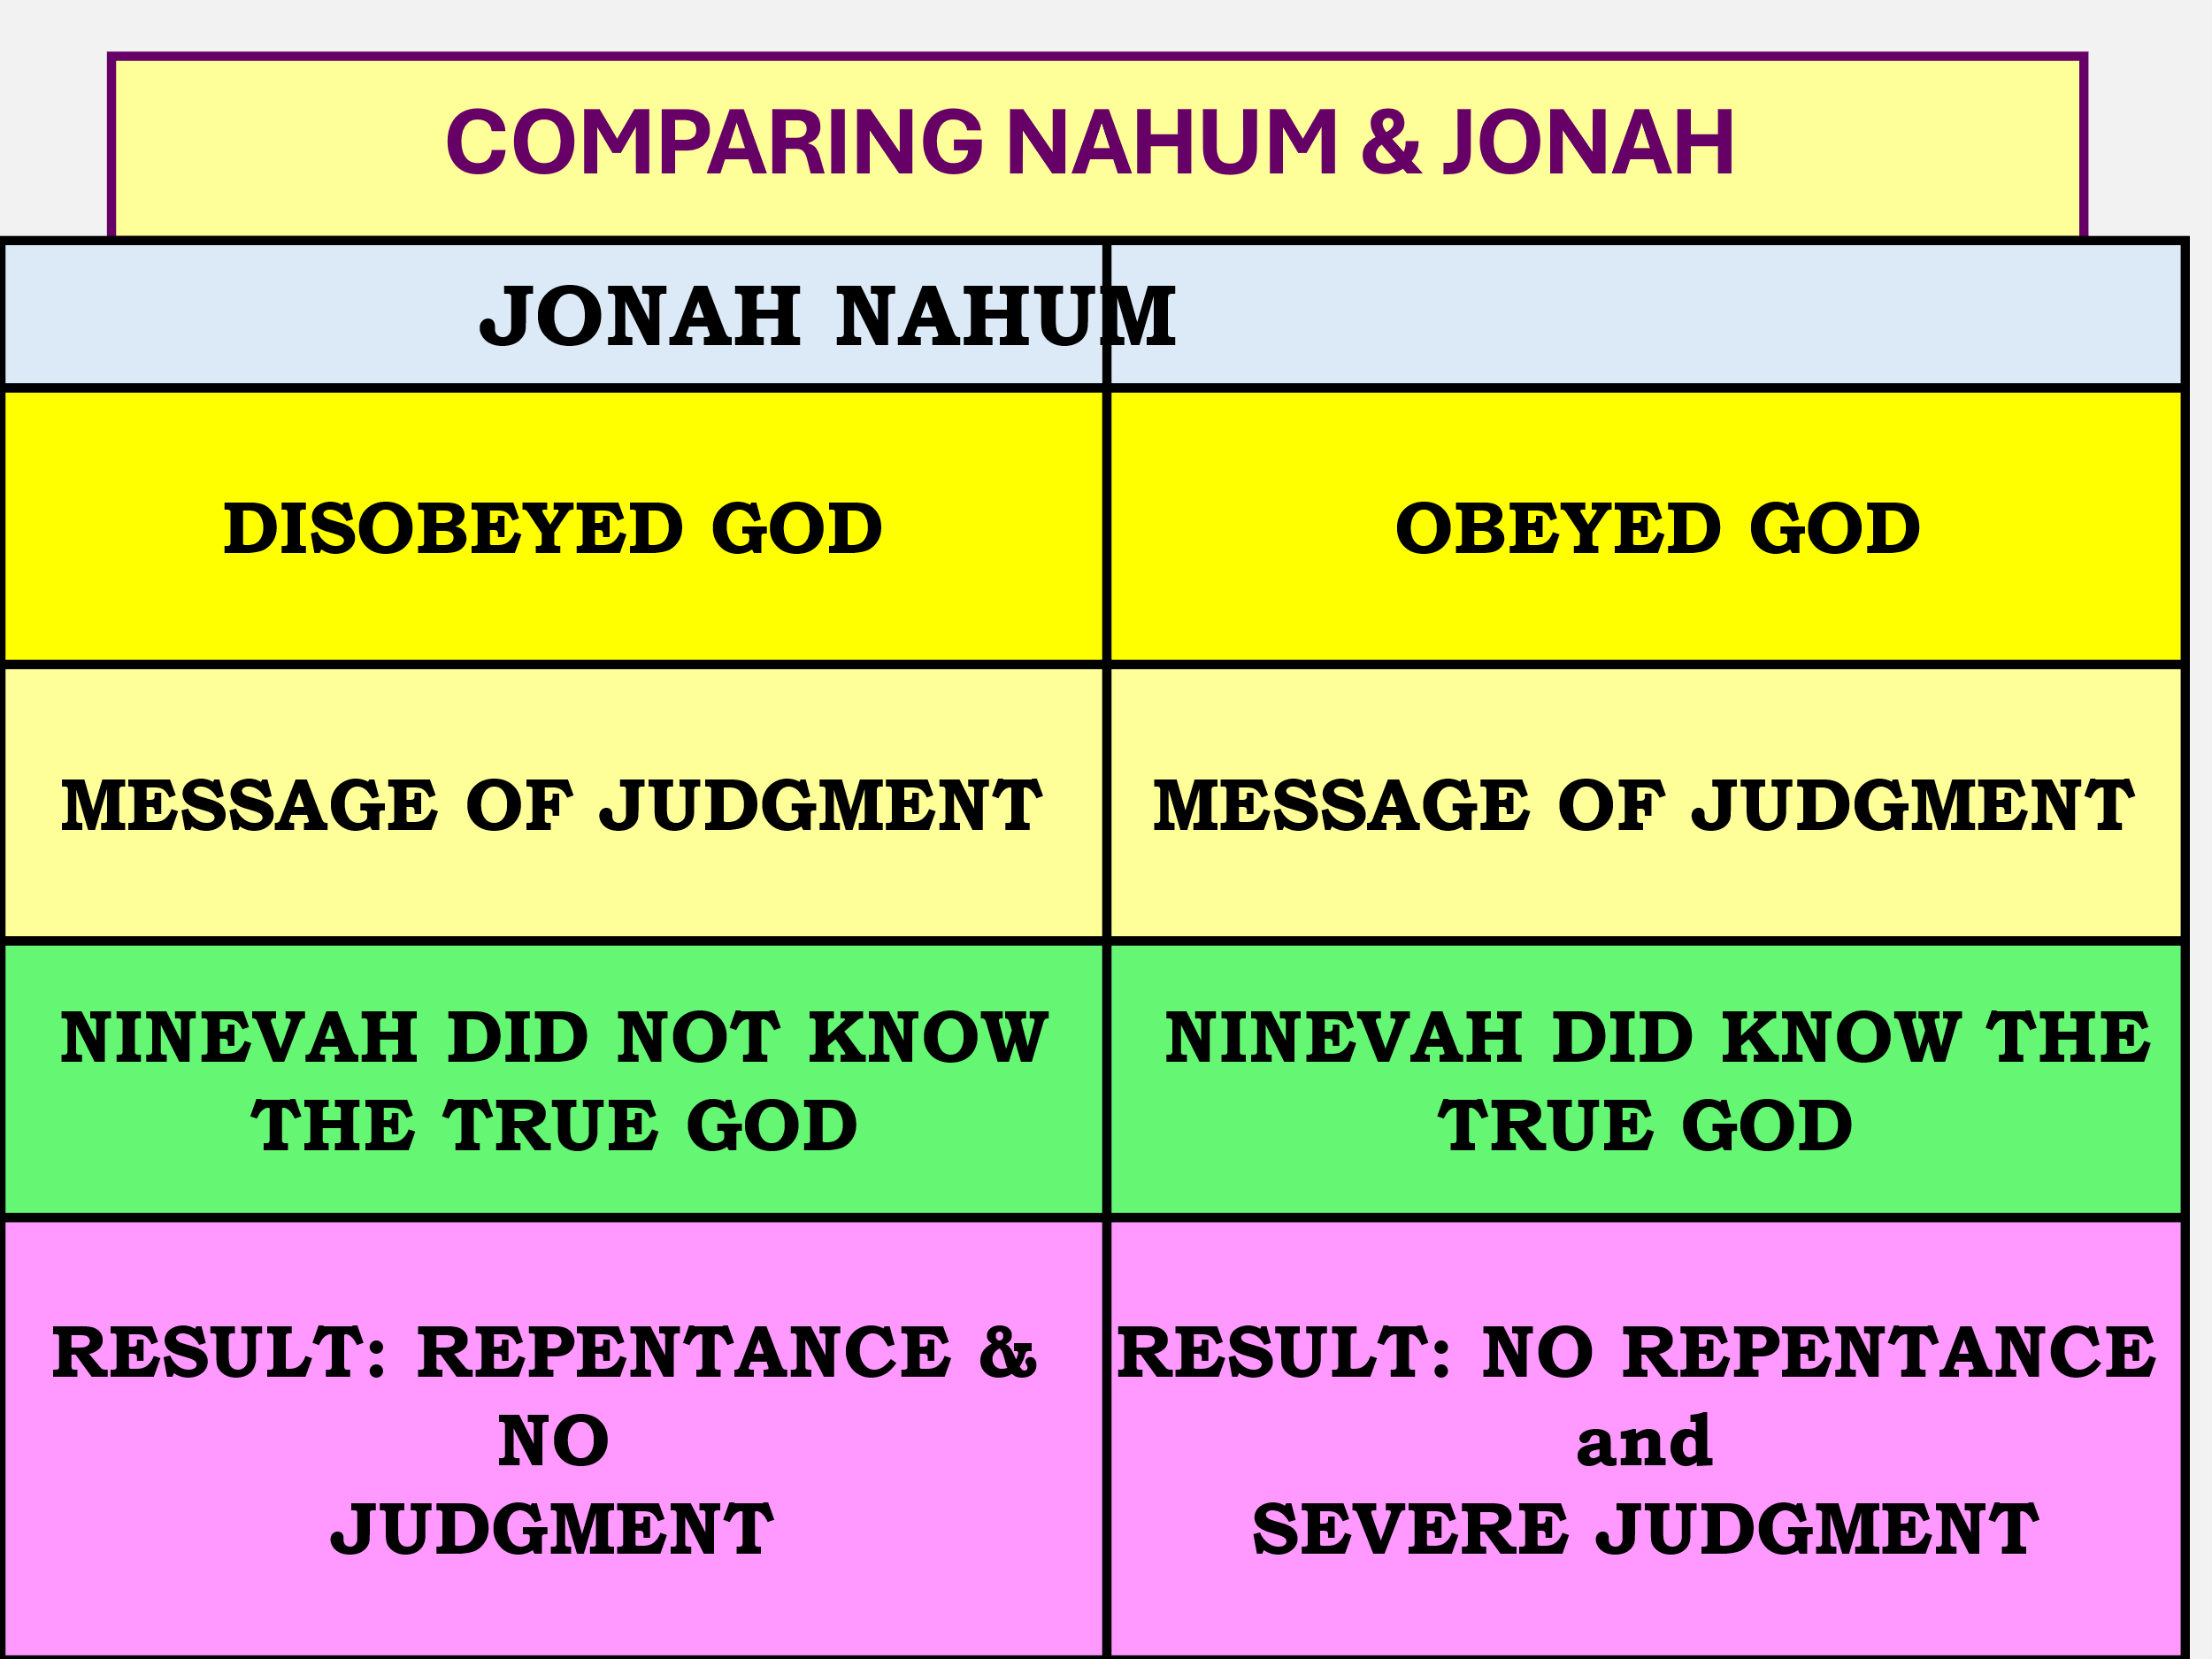



## **Nineveh was quite large, and it was founded by Nimrod Gen 10**

## **They destroyed Israel and really beat up Judah. (Days of Hezekiah)**

## **It was a complex of 4 cities surrounded by 2 walls, the outer wall was 52 miles perimeter the inner wall 6.2 miles!**

## **It was 175 square miles surrounded by the outer wall.**

## **The Quad Cities is 170 square miles!**

## **The walls were 50 feet thick at it’s base 12 feet thick at the top 100 feet high!**

## **It was fortified by 150 towers all 200 feet tall.**

## **It had an armory that took 6 years to stock up.**

## **However, God judges and God has His timeframe.**

## **Two armies attack them, Babylon and the Medes and for three battles they are repelled.**



## **Ninevah has a “party” for the victories, and it is then when the outer defenses are routed. Babylon will someday suffer the same fate with the Medes and Persians.**



## **The inner wall of Nineveh is just as difficult but not for God.**

## **This area of the Middle East gets all it’s rainfall October through April. This year, 612 BC the rains came early in July and August and are unexpectantly heavy! Two miles of the inner wall washes away.**



## **That’s the end! Coincidence?**

## **God said it would happen and that means it is so! This is #1 the doom of destruction.**

## **God has been patient with Nineveh, but they are wicked.**



## ***Nah 1:5 The mountains quake before Him, The hills melt, And the earth heaves at His presence, Yes, the world and all who dwell in it. 6 Who can stand before His indignation? And who can endure the fierceness of His anger? His fury is poured out like fire, And the rocks are thrown down by Him.***

## **No one can stand before the WRATH OF GOD!**



## **Unwise imbalance!!!!!**

## **God is love and He won’t punish or send anyone to hell.**

## **God just can’t wait for you to slip up, so He can crack you in the head!**

## **Balance:**

## ***1:7 The LORD is good, A stronghold in the day of trouble; And He knows those who trust in Him.***

## ***1:8 But with an overflowing flood He will make an utter end of its place, And darkness will pursue His enemies.***

## **Next week: They will be destroyed and how they are destroyed.**