## **The book of Micah 13 December 2023**

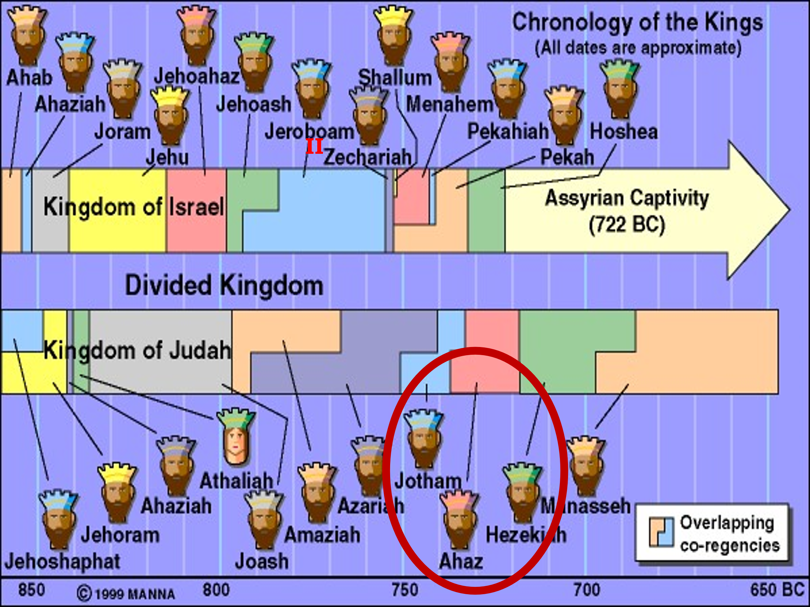

## **4 major points of Micah**

## **God will punish both Israel and Judah.**

## **The Jewish LEADERS are guilty of leading the nation astray.**

## **There is a survival of the remnant.**



## **Israel’s redemption will come by Messiah!!**

## **Main message of Micah is that wrath is coming to Judah/Jerusalem**

## **and**

## **Samaria/Israel.**

## **There are 3 sections to this book and each one begins with:**

## ***Mic 1:2 Hear, all you peoples! Listen, O earth, and all that is in it! Let the Lord GOD be a witness against you, The Lord from His holy temple.***



## ***Mic 3:1 And I said: “Hear now, O heads of Jacob, And you rulers of the house of Israel: Is it not for you to know justice?***



## ***Mic 6:1 Hear now what the LORD says: “Arise, plead your case before the mountains, And let the hills hear your voice.***



## **Micah also has great prophesies of Messiah!**

## ***Micah 5:2 “But you, Bethlehem Ephrathah, Though you are little among the thousands of Judah, Yet out of you shall come forth to Me The One to be Ruler in Israel, Whose goings forth are from of old, From everlasting.”* Mat 2:5-6**

## ***Micah 7:6 For son dishonors father, Daughter rises against her mother, Daughter-in-law against her mother-in-law; A man’s enemies are the men of his own household.* Mat 10:35-36**



## **God’s case against both houses!**



## ***Micah 1:5 All this is for the transgression of Jacob And for the sins of the house of Israel. What is the transgression of Jacob? Is it not Samaria? And what are the high places of Judah? Are they not Jerusalem?***

## **For Israel it is all out idolatry, which is the worship of false gods.**



## **For Judah it is the high places because people did not want to make a trip to Jerusalem, so they built many of these…**

# 

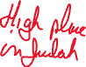

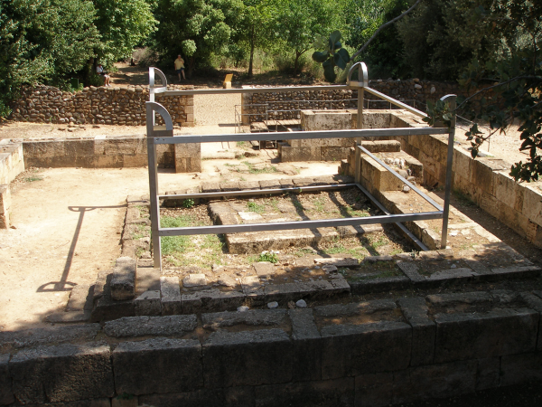



## **What is going to happen?**

## ***Micah 1:6 “Therefore I will make Samaria a heap of ruins in the field, Places for planting a vineyard; I will pour down her stones into the valley, And I will uncover her foundations.***



## ***7 All her carved images shall be beaten to pieces, And all her pay as a harlot shall be burned with the fire; All her idols I will lay desolate, For she gathered it from the pay of a harlot, And they shall return to the pay of a harlot.”***



## **Israel will be overrun and destroyed, and 47 of the fortresses of Judah will be burned. Because of Manasseh, Judah will be overrun not by Assyria but by Babylon.**

## ***Micah 1:9 For her wounds are incurable. For it has come to Judah; It has come to the gate of My people– To Jerusalem.***



## **But Assyria will not take Jerusalem!**

## ***2 Kings 18:13 And in the fourteenth year of King Hezekiah, Sennacherib king of Assyria came up against all the fortified cities of Judah and took them.***



## ***28 Then the Rabshakeh stood and called out with a loud voice in Hebrew, and spoke, saying, “Hear the word of the great king, the king of Assyria!***

## ***29 “Thus says the king: ‘Do not let Hezekiah deceive you, for he shall not be able to deliver you from his hand; 30 ‘nor let Hezekiah make you trust in the LORD, saying, “The LORD will surely deliver us; this city shall not be given into the hand of the king of Assyria.” ’***

## **Then the king of Assyria makes a fateful error that so many have made:**

## ***2 Kings 18:33 ‘Has any of the gods of the nations at all delivered its land from the hand of the king of Assyria? 35 ‘Who among all the gods of the lands have delivered their countries from my hand, that the LORD should deliver Jerusalem from my hand?’ ”***

## ***2 Kings 19:35 And it came to pass on a certain night that the angel of the LORD went out,***

## ***and killed in the camp of the Assyrians one hundred and eighty-five thousand; and when people arose early in the morning, there were the corpses–all dead.***

## **The very false gods that Sennacherib was worshiping and believed were the true gods, could not deliver him out of his own son's hands!**



## ***2 Kings 19:37 Now it came to pass, as he was worshiping in the temple of Nisroch his god, that his sons Adrammelech and Sharezer struck him down with the sword;***

## ***and they escaped into the land of Ararat. Then Esarhaddon his son reigned in his place.***

## **You don’t mess with God!**



## **You don’t take Him lightly!**

## **You don’t mock Him!**

## **You don’t consider Him impotent!**

## ***Job 38:1 Then the LORD answered Job out of the whirlwind, and said: 2 “Who is this who darkens counsel By words without knowledge?***



## ***3 Now prepare yourself like a man; I will question you, and you shall answer Me.***

## ***4 “Where were you when I laid the foundations of the earth? Tell Me, if you have understanding. 5 Who determined its measurements? Surely you know! Or who stretched the line upon it? 6 To what were its foundations fastened? Or who laid its cornerstone, 7 When the morning stars sang together, And all the sons of God shouted for joy?***

## ***Ps 2:1 WHY do the nations rage, And the people plot a vain thing? 2 The kings of the earth set themselves, And the rulers take counsel together, Against the LORD and against His Anointed, saying, 3 “Let us break Their bonds in pieces And cast away Their cords from us.”***

## ***4 He who sits in the heavens shall laugh; The LORD shall hold them in derision. 5 Then He shall speak to them in His wrath, And distress them in His deep displeasure:***

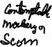

## ***6 “Yet I have set My King On My holy hill of Zion.” 7 “I will declare the decree: The LORD has said to Me, ‘You are My Son, Today I have begotten You. 8 Ask of Me, and I will give You The nations for Your inheritance, And the ends of the earth for Your possession.***

## ***9 You shall break them with a rod of iron; You shall dash them to pieces like a potter’s vessel.’ ” 10 Now therefore, be wise, O kings; Be instructed, you judges of the earth.***

## ***11 Serve the LORD with fear, And rejoice with trembling. 12 Kiss the Son, lest He be angry, And you perish in the way, When His wrath is kindled but a little. Blessed are all those who put their trust in Him.***

## Next week: Religious leaders held responsible!