God does not forget!
11 November 2023

Can you be that far gone?

Hosea 7:7 They are all hot, like an oven, And have devoured their judges; All their kings have fallen. None among them calls upon Me.

Last kings of Israel are all assassinated

It is chaos and they are like a cake unturned; burnt on the bottom and doughy on top. (7:8)

Their foreign policy is a disaster and there is only one solution for them.

Hosea 7:11 “Ephraim also is like a silly dove, without sense– They call to Egypt, They go to Assyria.

They make their alliance with king Jareb!

Hosea 5:13 “When Ephraim saw his sickness, And Judah saw his wound, Then Ephraim went to Assyria And sent to King Jareb; Yet he cannot cure you, Nor heal you of your wound.

They are sick and weak, and they do not even know it!

Hosea 7:9 Aliens have devoured his strength, But he does not know it; Yes, gray hairs are here and there on him, Yet he does not know it. 10 And the pride of Israel testifies to his face, But they do not return to the LORD their God, Nor seek Him for all this.

They continue to call upon the false gods who neither hear nor speak

They looked to Egypt to help, and it is a huge failure!

Here comes the trumpets of judgement

Five things are against them

They broke the Law (vs 8:1)

They put in Illegitimate kings (vs 8:4)

Judgement against Idolatry (vs 8:5)

Hosea 8:5 Your calf is rejected, O Samaria! My anger is aroused against them– How long until they attain to innocence?

6 For from Israel is even this: A workman made it, and it is not God; But the calf of Samaria shall be broken to pieces.

This has been going on since Jeroboam!

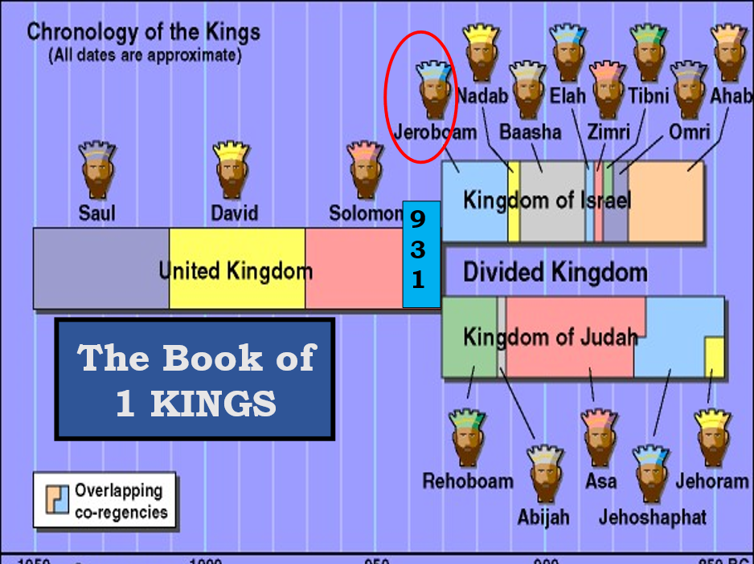

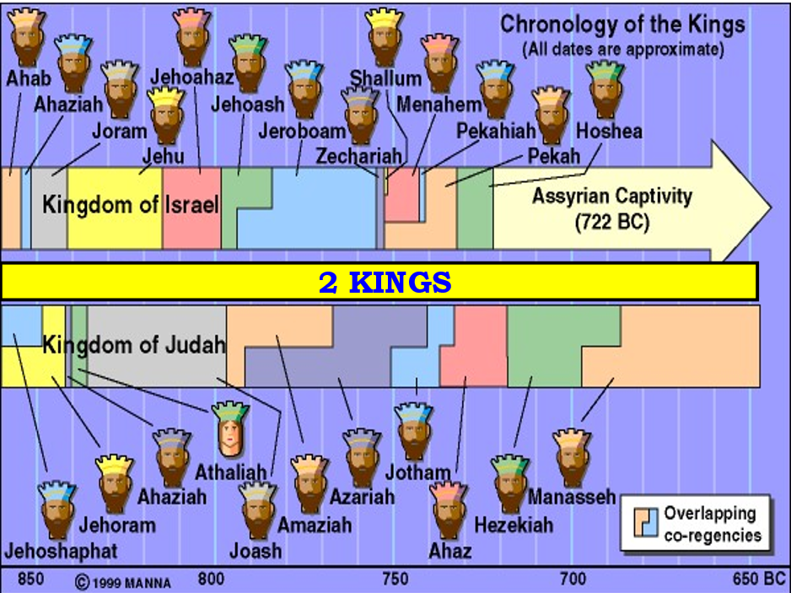

4. Their alliance with Egypt against Assyria (7:11)

Hos 8:8 Israel is swallowed up; Now they are among the Gentiles Like a vessel in which is no pleasure. 9 For they have gone up to Assyria, Like a wild donkey alone by itself; Ephraim has hired lovers.

10 Yes, though they have hired among the nations, Now I will gather them; And they shall sorrow a little, Because of the burden of the king of princes.

5. Against the altars of sin

8:11 “Because Ephraim has made many altars for sin, They have become for him altars for sinning. 12 I have written for him the great things of My law, But they were considered a strange thing.

God has put down precepts for man, but the world sees them as strange.

Marriage

babies

Sexes

Israel

Jihadists, those who wish war.

Remember, the Antichrist will hate everything that God has created.

Daniel 7:25 He shall speak pompous words against the Most High, Shall persecute the saints of the Most High, And shall intend to change times and law. Then the saints shall be given into his hand For a time and times and half a time.

Good becomes evil and evil good, just like northern kingdom

Hosea 9:9 They are deeply corrupted, As in the days of Gibeah. He will remember their iniquity; He will punish their sins.

GIBEAH?

Judges 19:22 As they were enjoying themselves, suddenly certain men of the city, perverted men, surrounded the house and beat on the door. They spoke to the master of the house, the old man, saying, “Bring out the man who came to your house, that we may know him carnally!”

This led to a bad tribal war, with the tribe of Benjamin almost being exterminated.

But that was then, this is now!

Hos 8:14 “For Israel has forgotten his Maker, And has built temples; Judah also has multiplied fortified cities; But I will send fire upon his cities, And it shall devour his palaces.”

This happened to Judah during King Hezekiah!

2 Kings 18:13 And in the fourteenth year of King Hezekiah,

Sennacherib king of Assyria came up against all the fortified cities of Judah and took them.

But God didn’t let them take Jerusalem!

Not so with the North though…

Ebrahim means “double fruitfulness” but now it will be fruitlessness!

Hos 9:11 As for Ephraim, their glory shall fly away like a bird– No birth, no pregnancy, and no conception!

12 Though they bring up their children, Yet I will bereave them to the last man.

Yes, woe to them when I depart from them!

And just like the unfaithful wife Gomer, Israel is will suffer 5 things:

(16) Ephraim is stricken, Their root is dried up;

They shall bear no fruit.

Yes, were they to bear children, I would kill the darlings of their womb.”

4. (17) My God will cast them away, Because they did not obey Him;

5. And they shall be wanderers among the nations.

Israel will go into Egypt and Assyria.

