Hosea

The prophet to the north
14 Oct 23

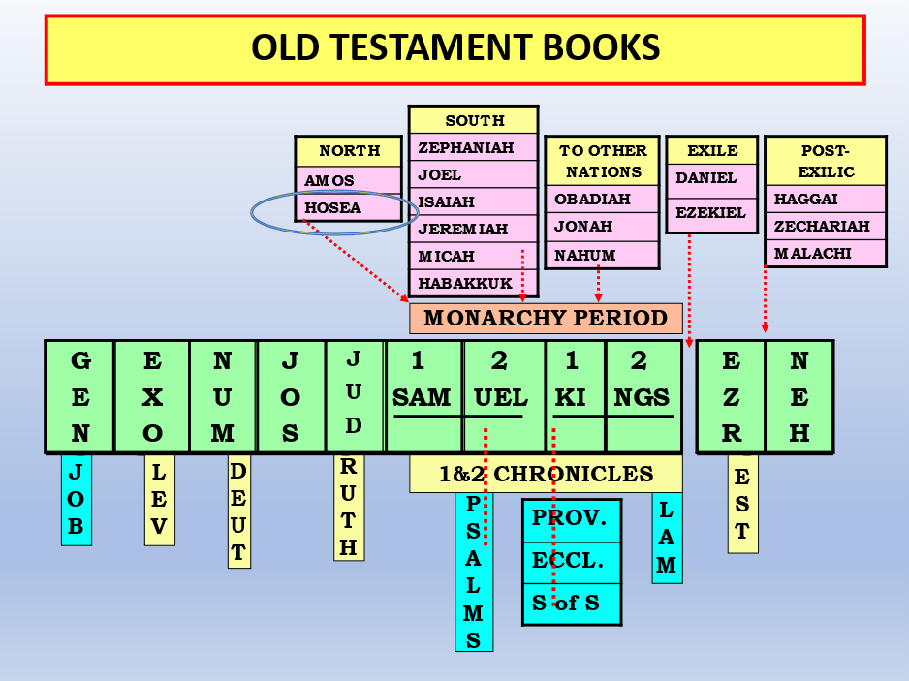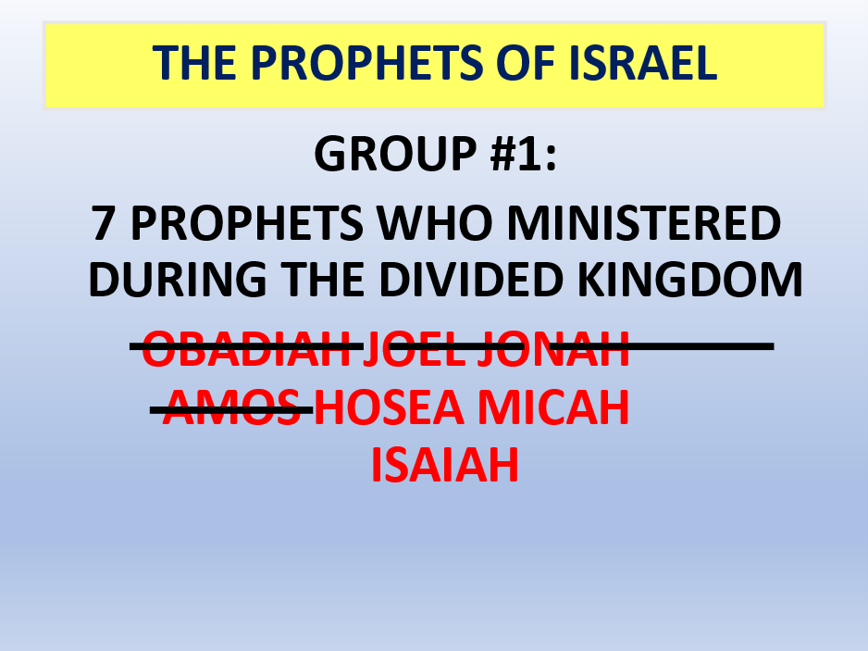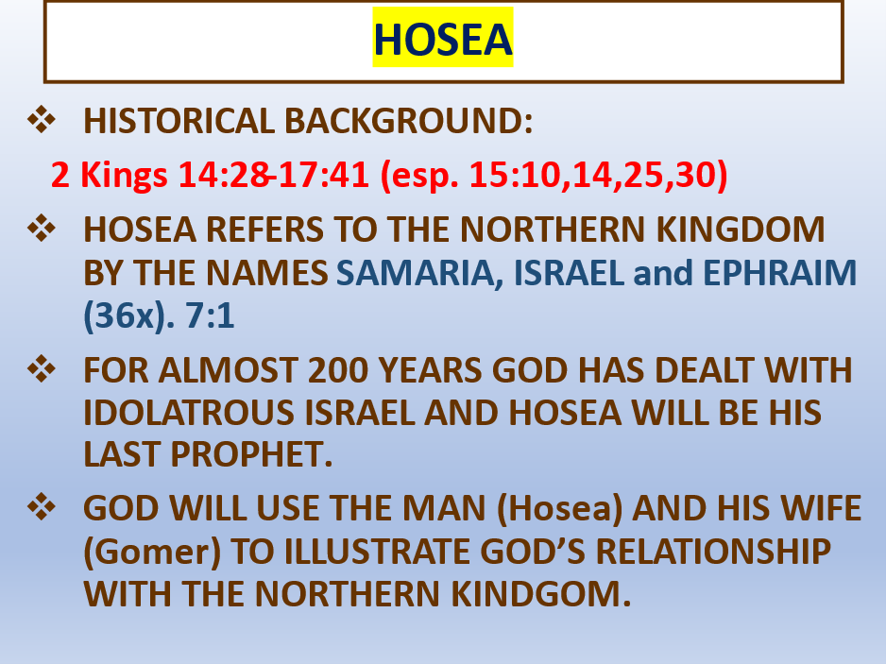

2 Kings 17:7 For so it was that the children of Israel had sinned against the LORD their God, who had brought them up out of the land of Egypt, from under the hand of Pharaoh king of Egypt; and they had feared other gods,

8 and had walked in the statutes of the nations whom the LORD had cast out from before the children of Israel, and of the kings of Israel, which they had made. 9 Also the children of Israel secretly did against the LORD their God

things that were not right, and they built for themselves high places in all their cities, from watchtower to fortified city.

10 They set up for themselves sacred pillars and wooden images on every high hill and under every green tree. 11 There they burned incense on all the high places, like the nations whom the LORD had carried away before them; and they did wicked things to provoke the LORD to anger,

12 for they served idols, of which the LORD had said to them, “You shall not do this thing.” 13 Yet the LORD testified against Israel and against Judah, by all of His prophets, every seer, saying, “Turn from your evil ways, and keep My commandments and My statutes, according to all the law which I commanded your fathers, and which I sent to you by My servants the prophets.”

14 Nevertheless they would not hear, but stiffened their necks, like the necks of their fathers, who did not believe in the LORD their God.

15 And they rejected His statutes and His covenant that He had made with their fathers, and His testimonies which He had testified against them; they followed idols, became idolaters, and went after the nations who were all around them, concerning whom the LORD had charged them that they should not do like them.

16 So they left all the commandments of the LORD their God, made for themselves a molded image and two calves, made a wooden image and worshiped all the host of heaven, and served Baal.

17 And they caused their sons and daughters to pass through the fire, practiced witchcraft and soothsaying, and sold themselves to do evil in the sight of the LORD, to provoke Him to anger. 18 Therefore the LORD was very angry with Israel, and removed them from His sight; there was none left but the tribe of Judah alone.

FOR ALMOST 200 YEARS GOD HAS DEALT WITH IDOLATROUS ISRAEL AND HOSEA WILL BE HIS LAST PROPHET TO THE NORTH.
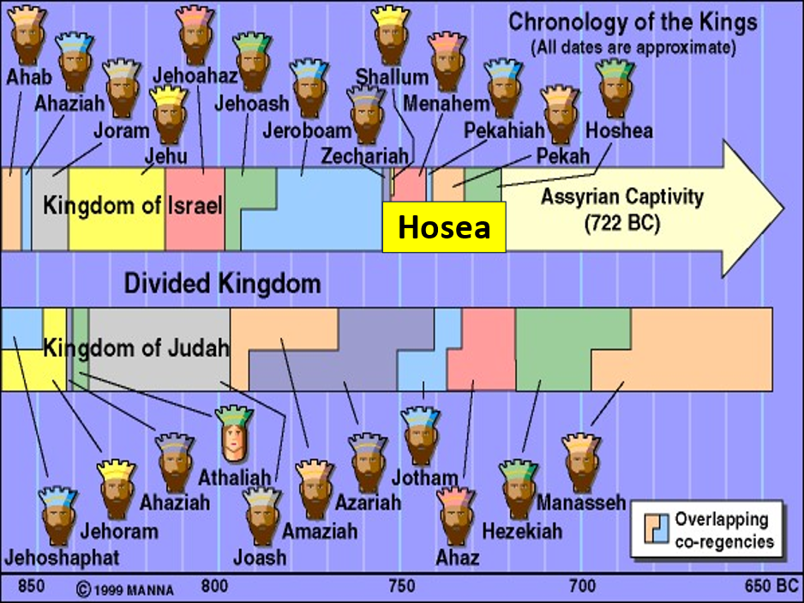

Hosea 5:4 “They do not direct their deeds Toward turning to their God, For the spirit of harlotry is in their midst, And they do not know the LORD. 5 The pride of Israel testifies to his face; Therefore Israel and Ephraim stumble in their iniquity; Judah also stumbles with them.

Hosea 9:9 They are deeply corrupted, As in the days of Gibeah. He will remember their iniquity; He will punish their sins.

According to the https://www.jewishvirtuallibrary.org/latest-population-statistics-for-israel#ultra

Of the Jewish population aged 20 and over, 44% of Jews self-identify as secular, 21% as traditional but not very observant, 12% as traditional and observant, 12% as religious, and 11% as ultra-Orthodox.

So, 65% of Israel is basically not interested in God.

Hos 4:1 Hear the word of the LORD, You children of Israel, For the LORD brings a charge against the inhabitants of the land: “There is no truth or mercy Or knowledge of God in the land.

HOSEA

THE AMAZING COMMAND: 1:2

2 When the LORD began to speak by Hosea, the LORD said to Hosea: “Go, take yourself a wife of harlotry And children of harlotry, For the land has committed great harlotry By departing from the LORD.”

THE FAMILY:

GOMER = Israel

HOSEA = The Lord God

THE CHILDREN = Each one has a name which symbolizes Israel’s spiritual situation and future.

1:4 Then the LORD said to him: “Call his name Jezreel, For in a little while I will avenge the bloodshed of Jezreel on the house of Jehu, And bring an end to the kingdom of the house of Israel. 5 It shall come to pass in that day That I will break the bow of Israel in the Valley of Jezreel.”

6 And she conceived again and bore a daughter. Then God said to him: “Call her name Lo-Ruhamah, For I will no longer have mercy on the house of Israel, But I will utterly take them away.

7 Yet I will have mercy on the house of Judah, Will save them by the LORD their God, And will not save them by bow, Nor by sword or battle, By horses or horsemen.” 8 Now when she had weaned Lo-Ruhamah, she conceived and bore a son.

9 Then God said: “Call his name Lo-Ammi, For you are not My people, And I will not be your God.

Gomer is terribly unfaithful while Hosea remains faithful and provides for her.1:6-9; 2:2-8

Israel’s idolatry (harlotry) will be judged.2:6-13

Israel will eventually repent and be restored because God is gracious and merciful. 1:10-2:1; 2:14-23

This is pictured by Hosea’s purchasing of his prodigal wife. 3:1-5

THE END OF ISRAEL, THE NORTHERN KINGDOM
2 Kings (17)

Hoshea is the last king of Israel and is not quite as evil as the others.

Israel is taken over by the Assyrians completely in 721 BC.

17:7-18 gives the reasons for their captivity. (Lev. 26!!!)

17:24 the Assyrian policy of relocation; the origin of the Samaritans.

Gomer/Israel Chapter 2

She will be judged

Adulterous vs2

Chasing other lovers thinking they provide for her

Striped naked left to die

God brings her back

Hos 3:5 Afterward the children of Israel shall return and seek the LORD their God and David their king. They shall fear the LORD and His goodness in the latter days.

Next week: HOW LONG?

Hos 14:1 O Israel, return to the LORD your God, For you have stumbled because of your iniquity;

