The final battle
2 September 2023

In Joel Chapter 3 we have a description of a final battle which we discussed some last week. The Jewish repentance will lead to their deliverance.

This battle described is in Joel 3:2-17

Joel 3:2 I will also gather all nations, And bring them down to the Valley of Jehoshaphat; And I will enter into judgment with them there On account of My people, My heritage Israel, Whom they have scattered among the nations;

They have also divided up My land.

3:12 “Let the nations be wakened, and come up to the Valley of Jehoshaphat; For there I will sit to judge all the surrounding nations. 13 Put in the sickle, for the harvest is ripe. Come, go down; For the winepress is full, The vats overflow– For their wickedness is great.”

14 Multitudes, multitudes in the valley of decision! For the day of the LORD is near in the valley of decision. 15 The sun and moon will grow dark, And the stars will diminish their brightness.

It is also in these Passages:

Rev 16:12 Then the sixth angel poured out his bowl on the great river Euphrates, and its water was dried up, so that the way of the kings from the east might be prepared.

13 And I saw three unclean spirits like frogs coming out of the mouth of the dragon, out of the mouth of the beast, and out of the mouth of the false prophet. 14 For they are spirits of demons, performing signs, which go out to the kings of the earth

and of the whole world, to gather them to the battle of that great day of God Almighty.

15 “Behold, I am coming as a thief. Blessed is he who watches, and keeps his garments, lest he walk naked and they see his shame.” 16 And they gathered them together to the place called in Hebrew, Armageddon.

Megiddo = Jezreel valley

Valley of decision = Valley of Jehoshaphat

Also called Kidron valley

Petra= Bozrah

This battle is also in Isaiah 63

2 Why is Your apparel red, And Your garments like one who treads in the winepress? 3 “I have trodden the winepress alone, And from the peoples no one was with Me. For I have trodden them in My anger, And trampled them in My fury; Their blood is sprinkled upon My garments, And I have stained all My robes.

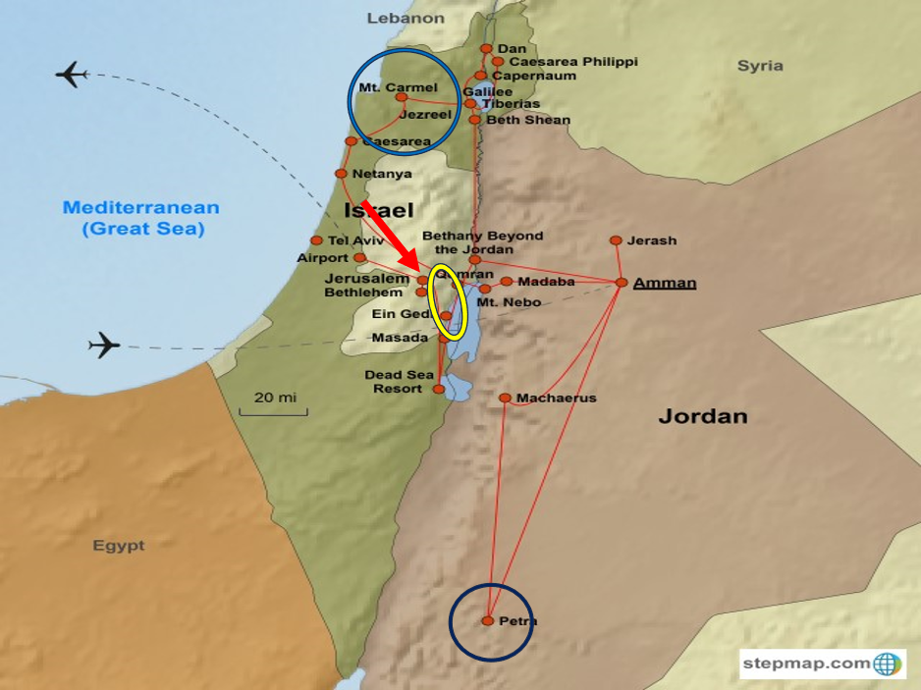

Also, in Zechariah 14

1 Behold, the day of the LORD is coming, And your spoil will be divided in your midst. 2 For I will gather all the nations to battle against Jerusalem; The city shall be taken, The houses rifled, And the women ravished. Half of the city shall go into captivity, But the remnant of the people shall not be cut off from the city. 3 Then the LORD will go forth And fight against those nations, As He fights in the day of battle.

4 And in that day His feet will stand on the Mount of Olives, Which faces Jerusalem on the east. And the Mount of Olives shall be split in two, From east to west, Making a very large valley; Half of the mountain shall move toward the north And half of it toward the south.

5 Then you shall flee through My mountain valley, For the mountain valley shall reach to Azal. Yes, you shall flee As you fled from the earthquake In the days of Uzziah king of Judah.

Thus the LORD my God will come, And all the saints with You. 6 It shall come to pass in that day That there will be no light; The lights will diminish. 7 It shall be one day Which is known to the LORD– Neither day nor night. But at evening time it shall happen That it will be light…

12 And this shall be the plague with which the LORD will strike all the people who fought against Jerusalem: Their flesh shall dissolve while they stand on their feet,

Their eyes shall dissolve in their sockets, And their tongues shall dissolve in their mouths. 13 It shall come to pass in that day That a great panic from the LORD will be among them. Everyone will seize the hand of his neighbor, And raise his hand against his neighbor’s hand;

15 Such also shall be the plague On the horse and the mule, On the camel and the donkey, And on all the cattle that will be in those camps. So shall this plague be.

Then after all this, healing comes:

Joel 3:17 “So you shall know that I am the LORD your God, Dwelling in Zion My holy mountain. Then Jerusalem shall be holy, And no aliens shall ever pass through her again.”

18 And it will come to pass in that day That the mountains shall drip with new wine, The hills shall flow with milk, And all the brooks of Judah shall be flooded with water; A fountain shall flow from the house of the LORD And water the Valley of Acacias.

Zech 14:16 And it shall come to pass that everyone who is left of all the nations which came against Jerusalem shall go up from year to year to worship the King, the LORD of hosts, and to keep the Feast of Tabernacles.

Even in this great time, men still have a sin nature, and this warning is needed:

Zech 14:18 If the family of Egypt will not come up and enter in, they shall have no rain; they shall receive the plague with which the LORD strikes the nations who do not come up to keep the Feast of

Tabernacles. 19 This shall be the punishment of Egypt and the punishment of all the nations that do not come up to keep the Feast of Tabernacles.

20 In that day “HOLINESS TO THE LORD” shall be engraved on the bells of the horses. The pots in the LORD’s house shall be like the bowls before the altar.

Rom 11:26 And so all Israel will be saved, as it is written: “The Deliverer will come out of Zion, And He will turn away ungodliness from Jacob; 27 For this is My covenant with them, When I take away

their sins.”

The Oath of God:

Jer 31:35 Thus says the LORD, Who gives the sun for a light by day, The ordinances of the moon and the stars for a light by night, Who disturbs the sea, And its waves roar (The LORD of hosts is His name):

36 “If those ordinances depart From before Me, says the LORD, Then the seed of Israel shall also cease From being a nation before Me forever.”

37 Thus says the LORD:“If heaven above can be measured, And the foundations of the earth searched out beneath, I will also cast off all the seed of Israel For all that they have done, says the LORD.

Joel 3:20 But Judah shall abide forever, And Jerusalem from generation to generation. 21 For I will acquit them of the guilt of bloodshed, whom I had not acquitted; For the LORD dwells in Zion.”

Next week: Amos

