AMOS
17 September 2023

AMOS

DATE:

Some time around 760 BC (King Uzziah (787-735) and Jeroboam II (790-749) set the boundaries. Amos 1:1

Two years before “the earthquake”. See Zechariah 14:5.

MINISTRY:

Amos was not trained in the school of the prophets. See 7:14.

He was from the South (Judah), but ministered for the Lord to the North (Israel).

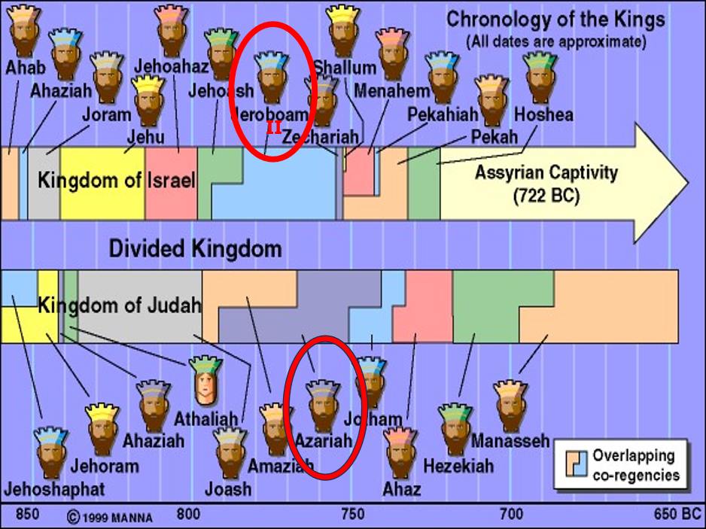
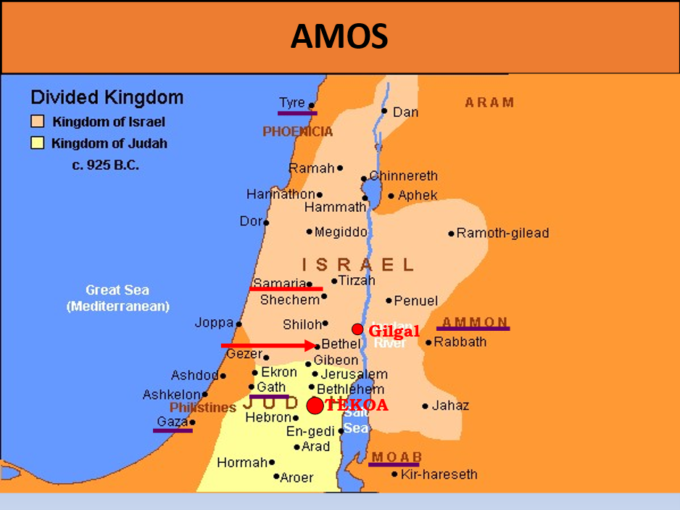

AMOS

Why mention coming judgment on foreign nations? (1:3-2:3)

To reveal that God is aware of the sins of the gentile nations.

To remind everyone of God’s sovereignty over all the earth.

To remind everyone that the Abrahamic Covenant is still in force.

Judgment will also come on Judah, but the focus is judgment on ISRAEL. (2:4-16)

THREE DISCOURSES: (3:1-6:15)

#1 – Cause and effect.

#2 – God’s disciplines were not responded to.

#3 – Repent or great destruction will come.

God reminds them of His goodness!

Amos 3:1 Hear this word that the LORD has spoken against you, O children of Israel, against the whole family which I brought up from the land of Egypt, saying:

2 “You only have I known of all the families of the earth;

Therefore I will punish you for all your iniquities.”

Whom much is given much is required!

Luke 12:48 “But he who did not know, yet committed things deserving of stripes, shall be beaten with few. For everyone to whom much is given, from him much will be required; and to whom much has been committed, of him they will ask the more.

#2 – God’s disciplines were not responded to.

Amos 3:7 Surely the Lord GOD does nothing, Unless He reveals His secret to His servants the prophets. 8 A lion has roared! Who will not fear? The Lord GOD has spoken! Who can but prophesy?

#3 – Repent or great destruction will come.

Amos 3:11 Therefore thus says the Lord GOD: “An adversary shall be all around the land;

He shall sap your strength from you, And your palaces shall be plundered.” 12 Thus says the LORD: “As a shepherd takes from the mouth of a lion Two legs or a piece of an ear, So shall the children of Israel be taken out Who dwell in Samaria– In the corner of a bed and on the edge of a couch!

Idolatrous Bethel will be destroyed! Why?

Wrong place to worship, this was set up by Jeroboam (The man who made Israel ______! )

They are going into captivity!

They are just as bad as the other nations around them, do they really think they will escape judgment?

The answer:

Amos 6:1 Woe to you who are at ease in Zion, And trust in Mount Samaria, Notable persons in the chief nation, To whom the house of Israel comes! 2 Go over to Calneh and see; And from there go to Hamath the great; Then go down to Gath of the Philistines. Are you better than these kingdoms?

Or is their territory greater than your territory? 3 Woe to you who put far off the day of doom, Who cause the seat of violence to come near; 4 Who lie on beds of ivory, Stretch out on your couches, Eat lambs from the flock And calves from the midst of the stall; 5 Who sing idly to the sound of stringed instruments, And invent for yourselves musical instruments like David;

6 Who drink wine from bowls, And anoint yourselves with the best ointments, But are not grieved for the affliction of Joseph.

7 Therefore they shall now go captive as the first of the captives, And those who recline at banquets shall be removed. 8 The Lord GOD has sworn by Himself, The LORD God of hosts says: “I abhor the pride of Jacob, And hate his palaces; Therefore I will deliver up the city And all that is in it.”

9 Then it shall come to pass, that if ten men remain in one house, they shall die. 10 And when a relative of the dead, with one who will burn the bodies, picks up the bodies to take them out of the house,

he will say to one inside the house, “Are there any more with you?” Then someone will say, “None.” And he will say, “Hold your tongue! For we dare not mention the name of the LORD.” 11 For behold, the LORD gives a command: He will break the great house into bits, And the little house into pieces.

12 Do horses run on rocks? Does one plow there with oxen? Yet you have turned justice into gall, And the fruit of righteousness into wormwood,

13 You who rejoice over Lo Debar, Who say, “Have we not taken Karnaim for ourselves By our own strength?”

14 “But, behold, I will raise up a nation against you, O house of Israel,” Says the LORD God of hosts; “And they will afflict you from the entrance of Hamath To the Valley of the Arabah.”

Image worship, false god worship, false priest service, completely unjust and unclean! This Is the cause of this destruction!!!

The warning now becomes URGENT!!

The Five visions of destruction Chap 7

Locust/Amos pleads God relents

Fire/Amos pleads God relents

Plumb line/they will suffer this!

They are not straight they are crooked!

God is showing Amos now and the people why this is coming!

Do they listen?

NO!

7:10 Then Amaziah the priest of Bethel sent to Jeroboam king of Israel, saying, “Amos has conspired against you in the midst of the house of Israel. The land is not able to bear all his words. 11 “For thus Amos has said: ‘Jeroboam shall die by the sword, And Israel shall surely be led away captive From their own land.’ ”

12 Then Amaziah said to Amos: “Go, you seer! Flee to the land of Judah. There eat bread, And there prophesy. 13 But never again prophesy at Bethel, For it is the king’s sanctuary,

And it is the royal residence.”

Those who were supposed to lead the people in righteousness, lead them into unrighteousness! And ultimately to destruction.

17 “Therefore thus says the LORD: ‘Your wife shall be a harlot in the city; Your sons and daughters shall fall by the sword; Your land shall be divided by survey line; You shall die in a defiled land; And Israel shall surely be led away captive From his own land.’ ”

Next week: God’s severity and His grace and Mercy! Amos/Jonah

