## **Amos 10 September 23**

# **AMOS**

## **DATE:**

## **Some time around 760 BC (King Uzziah (787-735) and Jeroboam II (790-749) set the boundaries. Amos 1:1**

## **Two years before “the earthquake”. See Zechariah 14:5.**

## **MINISTRY:**

## **Amos was not trained in the school of the prophets. See 7:14.**

## **He was from the South (Judah), but ministered for the Lord to the North (Israel).**

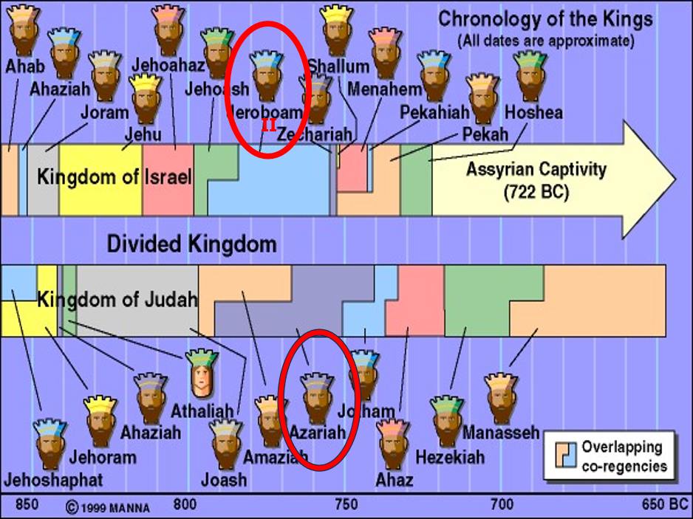

## **What was the earthquake?**

## ***So great is the amount of evidence spread throughout the Levant, in fact, that scientists have determined that the epicenter was likely in Lebanon and that its strength was probably around a magnitude 8.2 (at very least a 7.8), 4***

## ***with a Modified Mercalli intensity in Israel of 9. Dr. Steven Austin continues: “[This event] appears to be the largest yet documented on the Dead Sea Transform fault zone during the last four millennia.***

## ***The Dead Sea Transform fault likely ruptured along more than 400 kilometers as the ground shook violently for over 90 seconds! The urban panic created by this earthquake would have been legendary.”***

## ***The long duration of the earthquake—90 seconds—helps explain the Prophet Zechariah’s statement that people were “fleeing” while the earth was still rumbling.*** [***https://armstronginstitute.org***](https://armstronginstitute.org)

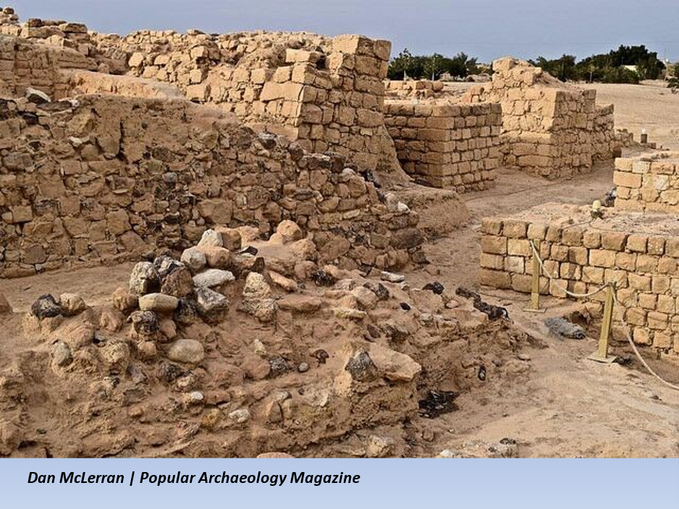

## ***Zech 14:5 Then you shall flee through My mountain valley, For the mountain valley shall reach to Azal. Yes, you shall flee As you fled from the earthquake In the days of Uzziah king of Judah. Thus the LORD my God will come, And all the saints with You.***

## ***Amos 1:3 Thus says the LORD: “For three transgressions of Damascus, and for four, I will not turn away its punishment, Because they have threshed Gilead with implements of iron.***

## **This Phrase repeats.**

## **The phrase means, “enough is enough, it’s the last straw, and times up”!**

## **Amos goes from the most distant by blood, to the bullseye which is Israel!**

## **Unrelated: Syria (Aramea), Philistia, Phoenicia (Lebanon).**

## **Distantly related: Edom, Ammon, Moab**

## **Closely related: Judah**

## **Bullseye: Israel**

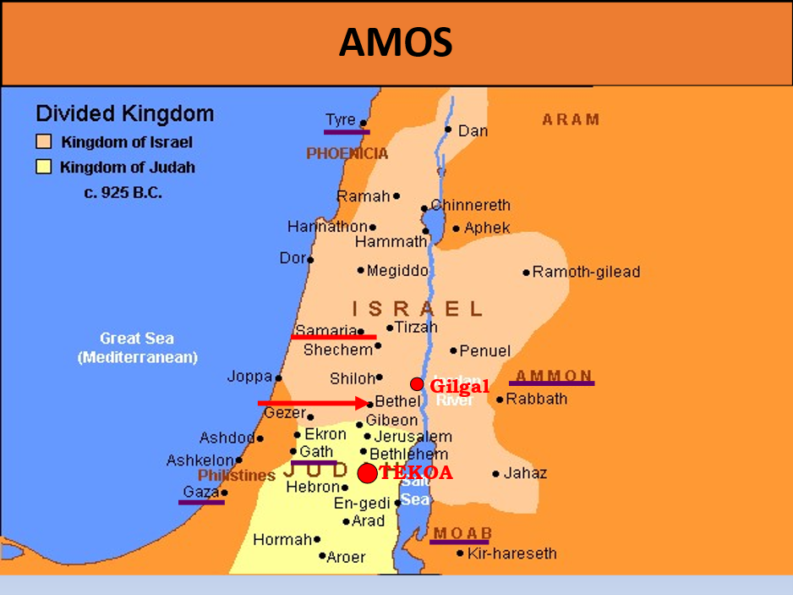

# **AMOS**

## **Why mention coming judgment on foreign nations? (1:3-2:3)**

## **To reveal that God is aware of the sins of the gentile nations.**

## **To remind everyone of God’s sovereignty over all the earth.**

## **To remind everyone that the Abrahamic Covenant is still in force.**

## **Judgment will also come on Judah, but the focus is judgment on ISRAEL. (2:4-16)**

## **1. *Revelation 14:6 Then I saw another angel flying in the midst of heaven, having the everlasting gospel to preach to those who dwell on the earth–to every nation, tribe, tongue, and people–***

## ***7 saying with a loud voice, “Fear God and give glory to Him, for the hour of His judgment has come; and worship Him who made heaven and earth, the sea and springs of water.”***

## **2.** ***Romans 14:11 For it is written: “As I live, says the LORD, Every knee shall bow to Me, And every tongue shall confess to God.”***

## **3.** ***Gen 12:3 I will bless those who bless you, And I will curse him who curses you; And in you all the families of the earth shall be blessed.”***

## ***Jeremiah 30:16 ‘Therefore all those who devour you shall be devoured; And all your adversaries, every one of them, shall go into captivity;***

## ***Those who plunder you shall become plunder, And all who prey upon you I will make a prey.***

## ***Ezekiel 39:3 “Then I will knock the bow out of your left hand, and cause the arrows to fall out of your right hand.***

## ***4 “You shall fall upon the mountains of Israel, you and all your troops and the peoples who are with you; I will give you to birds of prey of every sort and to the beasts of the field to be devoured.***

## **Judgment will come on Judah too, but for now it is the Northern Kingdom.**

## ***Amos 2:4 Thus says the LORD: “For three transgressions of Judah, and for four, I will not turn away its punishment, Because they have despised the law of the LORD, And have not kept His commandments. Their lies lead them astray, Lies which their fathers followed. 5 But I will send a fire upon Judah, And it shall devour the palaces of Jerusalem.”***

## ***6 Thus says the LORD: “For three transgressions of Israel, and for four, I will not turn away its punishment, Because they sell the righteous for silver, And the poor for a pair of sandals.***

## ***7 They pant (trample) after the dust of the earth which is on the head of the poor, And pervert the way of the humble. A man and his father go in to the same girl, To defile My holy name. 8 They lie down by every altar on clothes taken in pledge, And drink the wine of the condemned in the house***

## ***of their god. 9 “Yet it was I who destroyed the Amorite before them, Whose height was like the height of the cedars, And he was as strong as the oaks; Yet I destroyed his fruit above And his roots beneath.***

## ***10 Also it was I who brought you up from the land of Egypt, And led you forty years through the wilderness, To possess the land of the Amorite.* 11 I raised up some of your sons as prophets, And some of your young men as Nazirites. *Is it* not so, O you children of Israel?” Says the LORD.**

## **12 “But you gave the Nazirites wine to drink, And commanded the prophets saying, ‘Do not prophesy!’ 13 “Behold, I am weighed down by you, As a cart full of sheaves is weighed down.**

## **14 Therefore flight shall perish from the swift, The strong shall not strengthen his power, Nor shall the mighty deliver himself; 15 He shall not stand who handles the bow, The swift of foot shall not escape, Nor shall he who rides a horse deliver himself.**

## **16 The most courageous men of might Shall flee naked in that day,” Says the LORD.**

## **Next week: Amos**