## **The Prophets of Israel July 30, 2023**



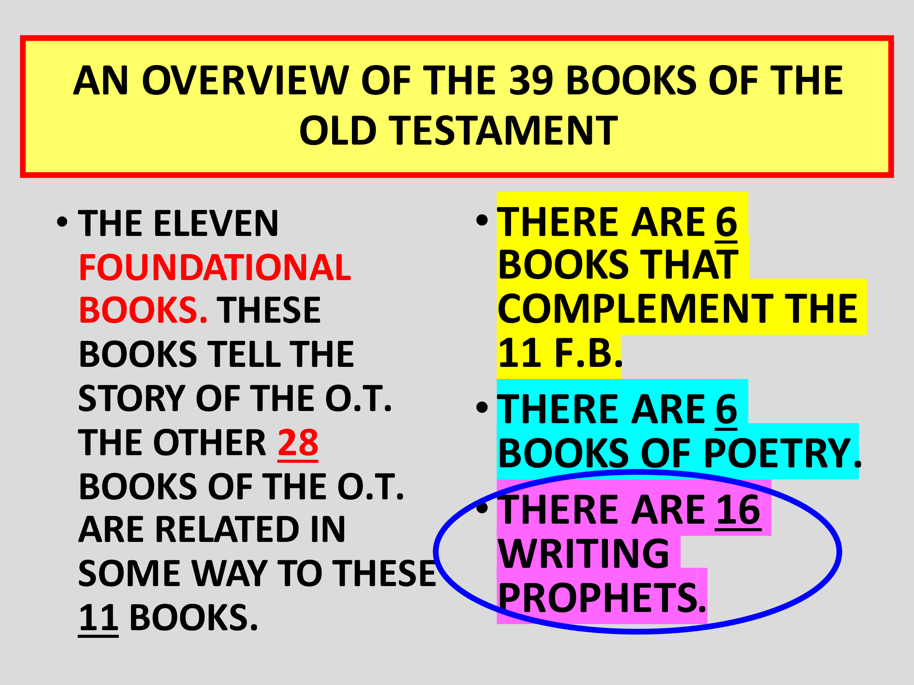



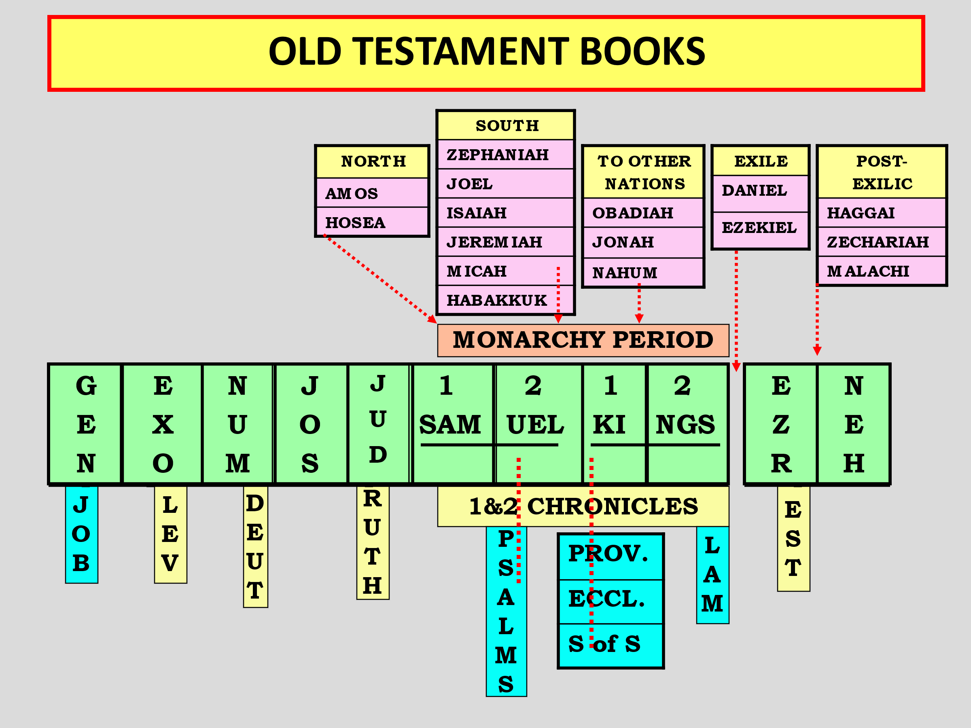



## **There were major prophets and minor prophets (our classifications)**

## **A PROPHET HAS BEEN DESIGNATED AS “MAJOR” BECAUSE:**

## **(1) VOLUME – THE BOOK IS SIMPLY LARGER, CONTAINING MORE MATERIAL.**



## **(2) SCOPE – IT INCLUDES MANY SUBJECTS AND ISSUES. “MINOR” PROPHETS USUALLY HAVE A MAIN SUBJECT OR EMPHASIS.**



# **THE PROPHETS OF ISRAEL**

## **GROUP #1:**

## **7 PROPHETS WHO MINISTERED DURING THE DIVIDED KINGDOM**



## **OBADIAH JOEL JONAH AMOS HOSEA MICAH ISAIAH**

## **Major sounds more important… NOT!**



## **Joel is three chapters and Obadiah is only one chapter. BUT There are catastrophic spiritual events in them on the last days! In Obadiah, Edom is prophesized against.**



## ***Obadiah 1:15 “For the day of the LORD upon all the nations is near; As you have done, it shall be done to you; Your reprisal shall return upon your own head.***



## ***1:13 You should not have entered the gate of My people In the day of their calamity. Indeed, you should not have gazed***

## ***on their affliction In the day of their calamity, Nor laid hands on their substance In the day of their calamity.***

## ***God does not forget.***

## **Because of Edom’s harassment of Israel, and God’s promise to Abraham, Edom, or southern Jordan will be a continual area of burning pitch and smoke throughout the Kingdom period! The only ones there, are bound demons (Isa 34!)**



## **These are events in THE DAY OF THE LORD.**



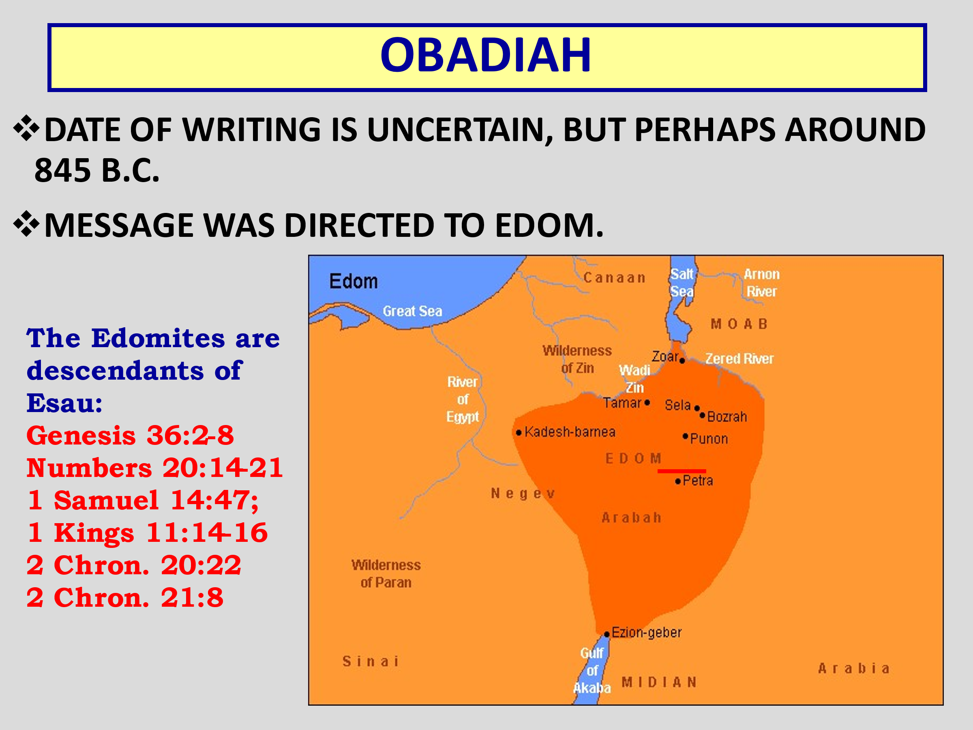



# **OBADIAH**

## **Basic Point of the Message: JUDGMENT IS COMING ON THE NATION OF EDOM AND IT WILL BE A SEVERE JUDGMENT.**



## **Reasons for God’s Judgment:**

## **(1) THE PRIDE OF EDOM**

## **(2) THE HARM DONE BY THEM TO “BROTHER” JACOB. Behind this point is Gen. 12:3…Abe. Cov.**

## **Expanding of the Message: ALL NATIONS WILL BE INVOLVED IN GOD’S JUDGMENT IN THE GREAT “DAY OF THE LORD.”**



## **THE DAY OF THE LORD**



## **= A SPECIAL TIME OF DIVINE INTERVENTION. (c. 75x in OT)**



# **JOEL**

## **THE THEME OF JOEL: THE COMING “DAY OF THE LORD.”**



## **JOEL’S MESSAGE IS BASED ON TWO RECENT EXPERIENCES OF ISRAEL:**

## **(1) A devastating plague of locusts.**

## **(2) A time of drought on the land of Israel.**

## **THESE TWO EVENTS FORESHADOWED THE GREAT AND DEVASTATING “DAY OF THE LORD” THAT WOULD COME IN THE FUTURE.**



# 



## ***Deuteronomy 28:38 “You shall carry much seed out to the field but gather little in, for the locust shall consume it. 39 “You shall plant vineyards and tend them, but you shall neither drink of the wine nor gather the grapes; for the worms shall eat them.***

## ***40“You shall have olive trees throughout all your territory, but you shall not anoint yourself with the oil; for your olives shall drop off. 42 “Locusts shall consume all your trees and the produce of your land.***



# **JOEL 2:1 – 3:21**

## **2:1-11 – Day of the Lord is unprecedented in its destruction. (cf. Matt. 24:21)**

## **2:12-17 – God wants people to repent. (cf. Exodus 34:6-7)**

## **2:18-32 – “THEN” indicates a turning point in Joel’s message.**

## **In light of Israel’s repentance, God will (1) bring vengeance on the enemies and (2) will have mercy on Israel.**

## **3:1-21 – God now calls the nations to prepare for war. Great judgment is coming (cf. Revelation 14 and 16). “ARMAGEDDON”**

## ***Joel 2:1 Blow the trumpet in Zion, And sound an alarm in My holy mountain! Let all the inhabitants of the land tremble; For the day of the LORD is coming, For it is at hand: 2 A day of darkness and gloominess, A day of clouds and thick darkness, Like the morning clouds spread over the mountains. A people come, great and strong, The like of whom has never been; Nor will there ever be any such after them, Even for many successive generations.***

## ***3 A fire devours before them, And behind them a flame burns; The land is like the Garden of Eden before them, And behind them a desolate wilderness; Surely nothing shall escape them.***

## ***4 Their appearance is like the appearance of horses; And like swift steeds, so they run. 5 With a noise like chariots Over mountaintops they leap, Like the noise of a flaming fire that devours the stubble, Like a strong people set in battle array. 6 Before them the people writhe in pain; All faces are drained of color.***

## ***7 They run like mighty men, They climb the wall like men of war; Every one marches in formation, And they do not break ranks. 8 They do not push one another; Every one marches in his own column. Though they lunge between the weapons, They are not cut down.***

## ***9 They run to and fro in the city, They run on the wall; They climb into the houses, They enter at the windows like a thief. 10 The earth quakes before them, The heavens tremble;***

## ***The sun and moon grow dark, And the stars diminish their brightness. 11 The LORD gives voice before His army, For His camp is very great; For strong is the One who executes His word. For the day of the LORD is great and very terrible; Who can endure it?***

## ***Joel 2:12 “Now, therefore,” says the LORD, “Turn to Me with all your heart, With fasting, with weeping, and with mourning.” 13 So rend your heart, and not your garments;***

## ***Return to the LORD your God, For He is gracious and merciful, Slow to anger, and of great kindness; And He relents from doing harm. 14 Who knows if He will turn and relent, And leave a blessing behind Him– A grain offering and a drink offering For the LORD your God?***

## ***15 Blow the trumpet in Zion, Consecrate a fast, Call a sacred assembly; 16 Gather the people, Sanctify the congregation, Assemble the elders, Gather the children and nursing babes;***

## ***Let the bridegroom go out from his chamber, And the bride from her dressing room. 17 Let the priests, who minister to the LORD, Weep between the porch and the altar; Let them say, “Spare Your people, O LORD, And do not give Your heritage to reproach, That the nations should rule over them. Why should they say among the peoples, ‘Where is their God?’ ”***

## ***18 Then the LORD will be zealous for His land, And pity His people.***

## Next week: The result of the repentance