Slowly trickling in
June 18, 2023
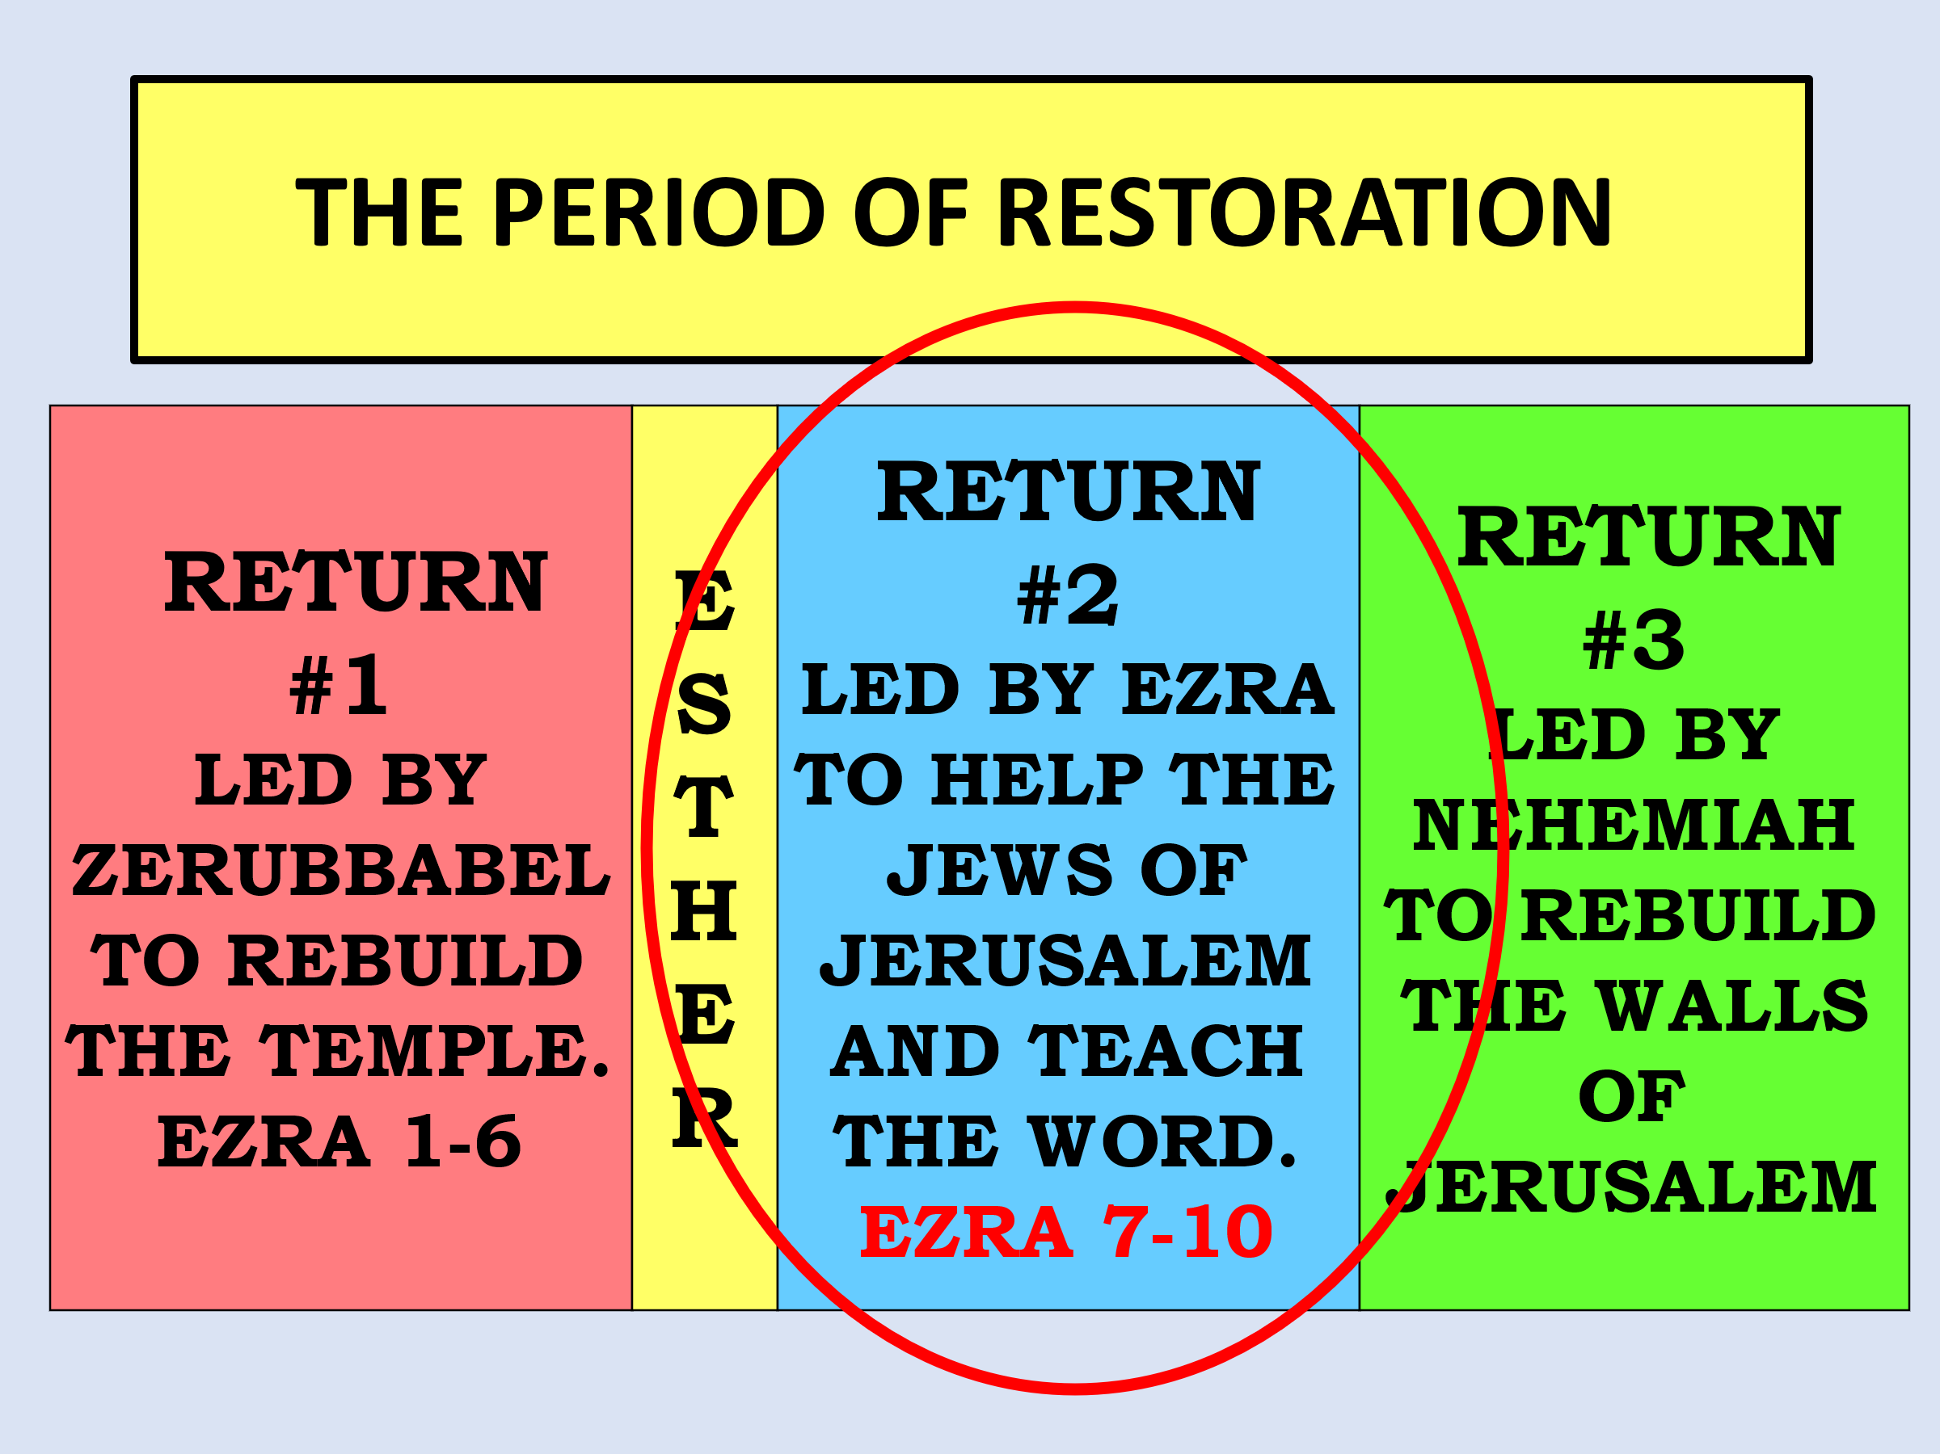

EZRA 7-10: THE 2nd RETURN

Artaxerxes is the new king (Xerxes died by the hand of an assassin in 465 BC).

It is 458 B.C., about 80 years after the 1st Return under Zerubbabel.

Ezra was a biblical scholar with a passion to teach the Scriptures in the land of Israel (7:6, 10)

Artaxerxes is favorable to Ezra and issues a decree allowing a return.

The decree (7:12-26) includes an offering from the Persians, and it allows for some rebuilding in Jerusalem (7:18).

This is how God works with giftedness: Zerubbabel, great administrator and leader.

Ezra great teacher!

Romans 12:4 For as we have many members in one body, but all the members do not have the same function, 5 so we, being many, are one body in Christ, and individually members of one another. 6 Having then gifts differing according to the grace that is given to us, let us use them: if prophecy, let us prophesy in proportion to our faith;

7 or ministry, let us use it in our ministering; he who teaches, in teaching; 8 he who exhorts, in exhortation; he who gives, with liberality; he who leads, with diligence; he who shows mercy, with cheerfulness.

1Cor 12:1 Now concerning spiritual gifts, brethren, I do not want you to be ignorant:

1 Cor 12:4 There are diversities of gifts, but the same Spirit. 5 There are differences of ministries, but the same Lord.

6 And there are diversities of activities, but it is the same God who works all in all. 7 But the manifestation of the Spirit is given to each one for the profit of all:

φανέρωσις phanerosis: Exhibition, expression, a bestowment.

φανερόω phaneroo: to render apparent,

appear, manifestly declare, manifest, show, Shine to all!

Until the Church of Christ learns this in the West, you will continue to see these:

https://www.ranker.com/list/pastors-that-fell-from-grace/genevieve-carlton

https://virtueonline.org/how-fallen-christian-leaders-have-hurt-us-all

https://www.beliefnet.com/faiths/2008/09/a-gallery-of-fallen-religious-leaders.aspx

https://vyfoqupel.krieger-urnen.de/

https://careynieuwhof.com/some-thoughts-about-the-recent-exit-of-two-megachurch-pastors/

Celebrities are what the church wants today.

Someone who leads like Patton

Someone as good looking as __________

Someone who speaks like Billy Graham

Someone who is the friendliest, most inviting person, like Mother Theresa.

Someone that everyone can say, “please come to our church, our Pastor is simply the best in town!”

I’ve literally heard this statement, “you’re the man everyone comes to see!”

I’ve had people drop 50-dollar bills in my hand so that I would be their friend, so they could have a say.

Well, Israel had all kinds of “the Men” and where did that get them?

So, Ezra begins to clean up the town with God’s Word!

EZRA 7-10 - THE 2nd RETURN

REVIVAL IN THE LAND (9, 10)

“REVIVAL” = “a new beginning of obedience to the Word of God.”

In Jerusalem, Ezra discovers many who have married foreign women.

Ezra’s anguish. He knew the Scriptures and knew what this would lead to.

Tremendous prayer of Ezra (9:6-15).

NOTE: the influence of just one godly person can affect many for good.

The meeting in Jerusalem of all who had married foreign women…..The great “divorce ceremony.”

Ezra 9:6 And I said: “O my God, I am too ashamed and humiliated to lift up my face to You, my God; for our iniquities have risen higher than our heads, and our guilt has grown up to the heavens.

7 “Since the days of our fathers to this day we have been very guilty, and for our iniquities we, our kings, and our priests have been delivered into the hand of the kings of the lands, to the sword, to captivity, to plunder, and to humiliation, as it is this day.

8 “And now for a little while grace has been shown from the LORD our God, to leave us a remnant to escape, and to give us a peg in His holy place, that our God may enlighten our eyes and give us a measure of revival in our bondage.

9 “For we were slaves. Yet our God did not forsake us in our bondage; but He extended mercy to us in the sight of the kings of Persia, to revive us, to repair the house of our God, to rebuild its ruins, and to give us a wall in Judah and Jerusalem.

10 “And now, O our God, what shall we say after this? For we have forsaken Your commandments,

11 “which You commanded by Your servants the prophets, saying, ‘The land which you are entering to possess is an unclean land, with the uncleanness of the peoples of the lands, with their abominations which have filled it

from one end to another with their impurity.

12 ‘Now therefore, do not give your daughters as wives for their sons, nor take their daughters to your sons; and never seek their peace or prosperity, that you may be strong and eat the good of the land, and leave it as an inheritance to your children forever.’

13 “And after all that has come upon us for our evil deeds and for our great guilt, since You our God have punished us less than our iniquities deserve, and have given us such deliverance as this,

14 “should we again break Your commandments, and join in marriage with the people committing these abominations? Would You not be angry with us until You had consumed us, so that there would be no remnant or survivor?

15 “O LORD God of Israel, You are righteous, for we are left as a remnant, as it is this day. Here we are before You, in our guilt, though no one can stand before You because of this!”

This is preparing your heart

Ezra 7:10 For Ezra had prepared his heart to seek the Law of the LORD and to do it, and to teach statutes and ordinances in Israel.

It MUST be in that order!

Too many do not prepare their hearts and try to teach it, without doing it themselves!

How can you teach your children if you don’t practice it yourself?

We are too flippant about this!

We drop our kids off at SS or church, we make sure they are part of a youth group, but these things do not apply to us. We act one way here and another way at home!

A very stern warning…

Mat 23:27 “Woe to you, scribes and Pharisees, hypocrites! For you are like whitewashed tombs which indeed appear beautiful outwardly, but inside are full of dead men’s bones and all uncleanness.

This is only 1 of 12 different woes.

Church, in this day we are called to this!

Rom 12:1 I beseech you therefore, brethren, by the mercies of God,

that you present your bodies a living sacrifice, holy, acceptable to God, which is your reasonable service.

2 And do not be conformed to this world, but be transformed by the renewing of your mind,

that you may prove what is that good and acceptable and perfect will of God.

Church MOVE!

MOVE!

MOVE!

