The end of the road!
7 May 2023

Last week we finished up the Northern Kingdom and their demise by Assyria, this week sees the end of the Southern Kingdom by the invasion of the Babylonians. Regardless of the Kingdom, this is the reason for destruction even with a good King Josiah!

2 Kings 23:26 Nevertheless the LORD did not turn from the fierceness of His great wrath, with which His anger was aroused against Judah, because of all the provocations with which Manasseh had provoked Him.

27 And the LORD said, “I will also remove Judah from My sight, as I have removed Israel, and will cast off this city Jerusalem which I have chosen, and the house of which I said, ‘My name shall be there.’ ”

Is God harsh and mean? NO!

They would not listen and instead…

Jer 22:1 Thus says the LORD: “Go down to the house of the king of Judah, and there speak this word, 2 “and say, ‘Hear the word of the LORD, O king of Judah, you who sit on the throne of David,

you and your servants and your people who enter these gates! 3 ‘Thus says the LORD: “Execute judgment and righteousness, and deliver the plundered out of the hand of the oppressor. Do no wrong and do no violence to the stranger, the fatherless, or the widow, nor shed innocent blood in this place.

4 “For if you indeed do this thing, then shall enter the gates of this house, riding on horses and in chariots, accompanied by servants and people, kings who sit

on the throne of David. 5 “But if you will not hear these words, I swear by Myself,” says the LORD, “that this house shall become a desolation.” ’ ”

Jehoahaz lasts 3 months does evil and is removed by Egypt!

Jehoiakim is now made king. He does evil, the people are taxed hard by Pharaoh Necho. Jehoiakim obeys Necho but than comes Nebuchadnezzar. For 3 years he is his vassal then rebels.
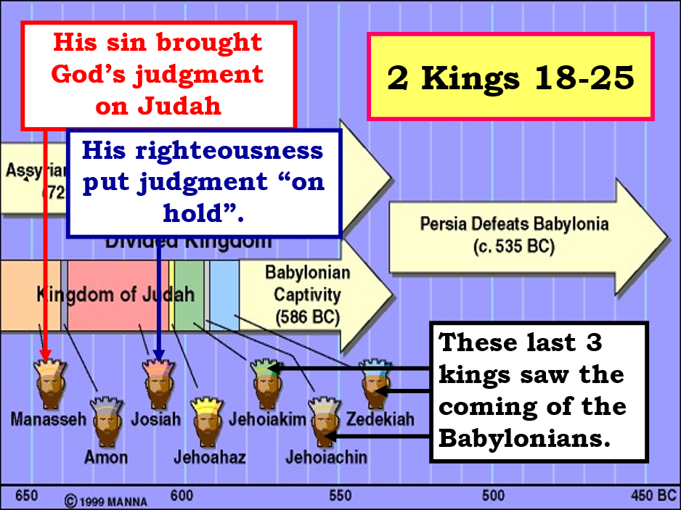

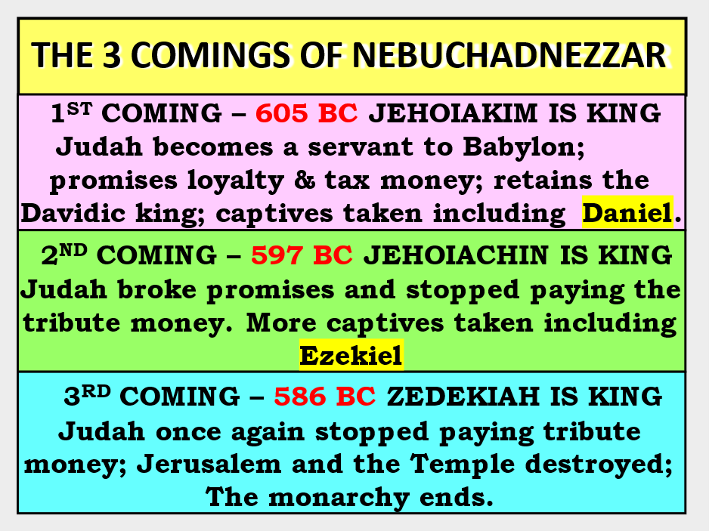
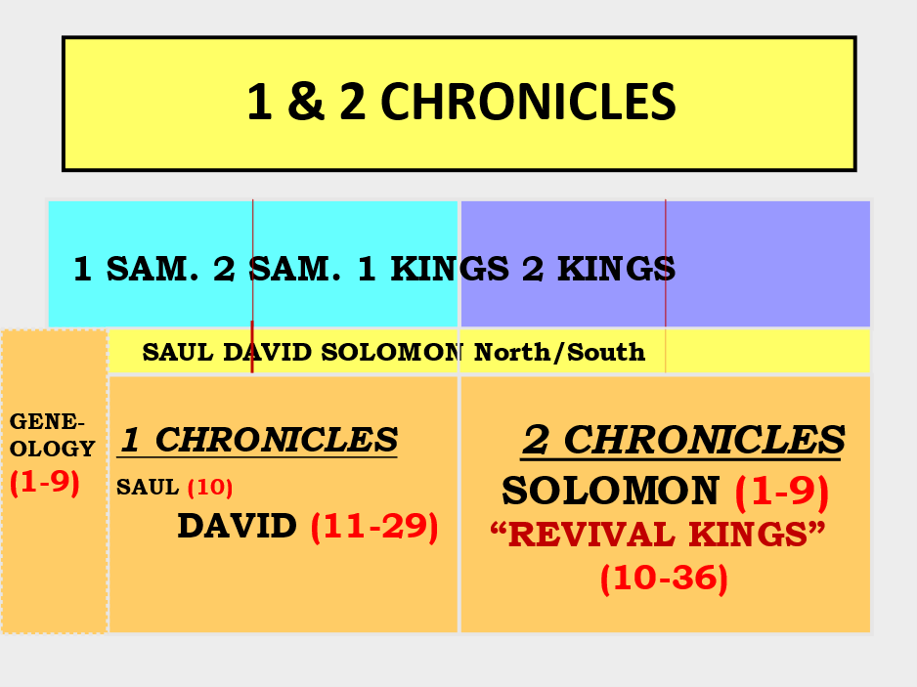

1&2 Chronicles probably written by Ezra, ends with destruction but also with hope!

2 Chr 36:15 And the LORD God of their fathers sent warnings to them by His messengers, rising up early and sending them, because He had compassion on His people and on His dwelling place.

16 But they mocked the messengers of God, despised His words, and scoffed at His prophets, until the wrath of the LORD arose against His people, till there was no remedy.

Destruction:

The destruction was massive

Many died in battle

Temple was plundered

Everything burned and razed to the ground

Those who survived were deported.

This will last 70 years

Hope:

2Chr 36:22 Now in the first year of Cyrus king of Persia,

that the word of the LORD by the mouth of Jeremiah might be fulfilled, the LORD stirred up the spirit of Cyrus king of Persia, so that he made a proclamation throughout all his kingdom, and also put it in writing, saying,

23 Thus says Cyrus king of Persia: All the kingdoms of the earth the LORD God of heaven has given me. And He has commanded me to build Him a house at Jerusalem which is in Judah. Who is among you of all His people?

May the LORD his God be with him, and let him go up!

Isaiah predicted Cyrus the Persian 140 years earlier!

Isaiah 44:28 Who says of Cyrus, ‘He is My shepherd, And he shall perform all My pleasure, Saying to Jerusalem, “You shall be built,” And to the temple, “Your foundation shall be laid.” ’

God is Sovereign over all! Who can say and do these things?

Isaiah 44:6 “Thus says the LORD, the King of Israel, And his Redeemer, the LORD of hosts: ‘I am the First and I am the Last; Besides Me there is no God. 7 And who can proclaim as I do? Then let him declare it and set it in order for Me, Since I appointed the ancient people. And the things that are coming and shall come, Let them show these to them.

8 Do not fear, nor be afraid; Have I not told you from that time, and declared it? You are My witnesses.

Is there a God besides Me? Indeed there is no other Rock; I know not one.’ ” 9 Those who make an image, all of them are useless, And their precious things shall not profit; They are their own witnesses; They neither see nor know, that they may be ashamed.

10 Who would form a god or mold an image That profits him nothing? 11 Surely all his companions would be ashamed; And the workmen, they are mere men. Let them all be gathered together, Let them stand up; Yet they shall fear, They shall be ashamed together.

12 The blacksmith with the tongs works one in the coals, Fashions it with hammers, And works it with the strength of his arms. Even so, he is hungry, and his strength fails; He drinks no water and is faint.

13 The craftsman stretches out his rule, He marks one out with chalk; He fashions it with a plane, He marks it out with the compass, And makes it like the figure of a man, According to the beauty of a man, that it may remain in the house.

14 He cuts down cedars for himself, And takes the cypress and the oak; He secures it for himself among the trees of the forest. He plants a pine, and the rain nourishes it.

15 Then it shall be for a man to burn, For he will take some of it and warm himself; Yes, he kindles it and bakes bread; Indeed he makes a god and worships it; He makes it a carved image, and falls down to it. 16 He burns half of it in the fire; With this half he eats meat; He roasts a roast, and is satisfied.

He even warms himself and says, “Ah! I am warm, I have seen the fire.”17 And the rest of it he makes into a god, His carved image. He falls down before it and worships it, Prays to it and says, “Deliver me, for you are my god!”

18 They do not know nor understand; For He has shut their eyes, so that they cannot see, And their hearts, so that they cannot understand. 19 And no one considers in his heart, Nor is there knowledge nor understanding to say, “I have burned half of it in the fire,

Yes, I have also baked bread on its coals; I have roasted meat and eaten it; And shall I make the rest of it an abomination? Shall I fall down before a block of wood?” 20 He feeds on ashes; A deceived heart has turned him aside; And he cannot deliver his soul, Nor say, “Is there not a lie in my right hand ?”

21 “Remember these, O Jacob, And Israel, for you are My servant; I have formed you, you are My servant; O Israel, you will not be forgotten by Me!

22 I have blotted out, like a thick cloud, your transgressions, And like a cloud, your sins. Return to Me, for I have redeemed you.” 23 Sing, O heavens, for the LORD has done it! Shout, you lower parts of the earth; Break forth into singing, you mountains, O forest, and every tree in it! For the LORD has redeemed Jacob, And glorified Himself in Israel.

24 Thus says the LORD, your Redeemer, And He who formed you from the womb: “I am the LORD, who makes all things, Who stretches out the heavens all alone, Who spreads abroad the earth by Myself;

25 Who frustrates the signs of the babblers, And drives diviners mad; Who turns wise men backward, And makes their knowledge foolishness; 26 Who confirms the word of His servant, And performs the counsel of His messengers;

Who says to Jerusalem, ‘You shall be inhabited,’ To the cities of Judah, ‘You shall be built,’ And I will raise up her waste places; 27 Who says to the deep, ‘Be dry! And I will dry up your rivers’;

