Adding insult to injury

The last chapters of Jeremiah are a fitting tribute to all of Israel/Judah and their unfaithfulness to God.

Remember these words from Stephan:

Acts 7:51-53

The 2 responses of Israel for the last 2000 years!

1. Acts 7:54

2. Acts 2:37

Both convicted but only one group responds.

Romans 11:5

Romans 9:27

And this is what has happened since Abraham.

They didn’t listen in the days of Jeremiah either!

In chapter 39 of Jeremiah, he is set free by Nebuchadnezzar, because he has been in prison and in a pit of mire.

Zedekiah, the last king of Judah whom Jeremiah warned not to resist Nebuchadnezzar, has all his sons killed and is blinded. Jeremiah is set free and has a final warning for the remnant of Judah.

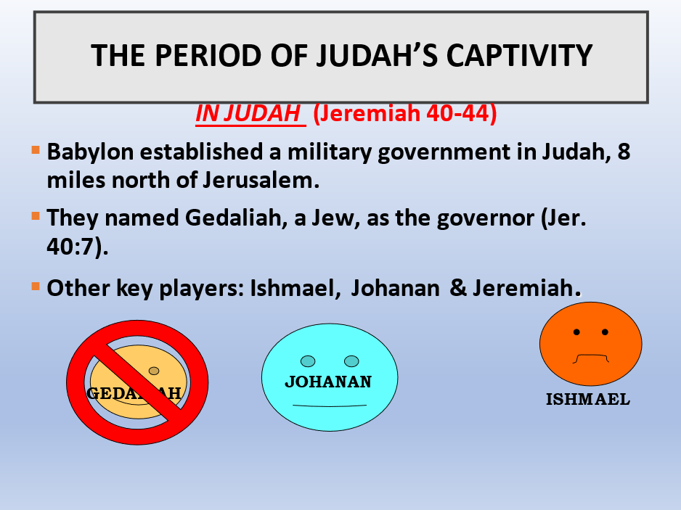

Babylon set up Gedaliah as king in Judah, but he doesn’t last long because of the Ishmael zealots.

Ismael eventually flees to the Ammonites and Johanan “Yow-Cha-nan” takes over.

*Be careful of being a zealot they have a lot of passion for their cause, but if it is not from the Lord, it will fail!

Zealots were around then defending Jerusalem, but God had issued its destruction all perished.

Zealots around during the second Temple destruction 70 AD and they all died.

Zealots during Paul’s time take an oath not to eat (Acts 23) till they kill Paul.

Be careful what camp you stand in and what you fight for!

Now because of the foolish act of Ishmael and the zealots, this will lead the Israelites into another horrible situation because they are afraid of Nebuchadnezzar and his response.

So, they “very spiritually” ask God what to do.

Jer 42:2-6, 9-21

They do not believe, and they turn it around on Jeremiah by accusing him of something ridiculous!

Sin always makes you:

Think stupid!

Believe stupid lies and

Become stupid in wisdom, discernment and spiritually.

Romans 1:21 -25

Being double minded is a terrible thing!

Psalm 119:113 I hate the double-minded, But I love Your law.

James 1:6 -8

James 4:8 Draw near to God and He will draw near to you. Cleanse your hands, you sinners; and purify your hearts, you. double-minded.

Chapter 44-45 of Jeremiah

They will not listen to Jeremiah, but they do what they want!

They will worship who they want.

And they will all die as they did not want. Except the remnant who return.

ALL THIS HAPPENED AS GOD SAID!

Next week: Even yet mercy will be shown.

