## **It was the best of times, it was the worst, Pt 2. 19 March 2023**

## **David now passes from the scene and says this:**

## ***1 Kings 2:2 “I go the way of all the earth; be strong, therefore, and prove yourself a man. 3 “And keep the charge of the LORD your God: to walk in His ways, to keep His statutes, His commandments, His judgments, and His testimonies, as it is written in the Law of Moses,***

## ***that you may prosper in all that you do and wherever you turn;***

## **2 very important statements:**

## **Outside of Enoch, (from the world before) and Elijah, (our world), all of us will go the way of all the Earth.**

## **All of us, unless the departing happens, will someday die.**

## **Are you ready? Have you passed?**

## ***John 5:21 “For as the Father raises the dead and gives life to them, even so the Son gives life to whom He will. 22 “For the Father judges no one, but has committed all judgment to the Son,***

## ***23 “that all should honor the Son just as they honor the Father. He who does not honor the Son does not honor the Father who sent Him. 24 “Most assuredly, I say to you, he who hears My word and believes in Him who sent Me has everlasting life, and shall not come into judgment, but has passed from death into life.***

## **Also, our society has many ways to define how to be a man, but David said something very different…**

## ***1 Kings 2:2 … be strong, therefore, and prove yourself a man. 3 “And keep the charge of the LORD your God: to walk in His ways, to keep His statutes, His commandments, His judgments, and His testimonies, as it is written in the Law of Moses, that you may prosper in all that you do and wherever you turn;***

## ***Colossians 2:6 As you therefore have received Christ Jesus the Lord, so walk in Him, 7 rooted and built up in Him***

## ***and established in the faith, as you have been taught, abounding in it with thanksgiving.***

## **Unfortunately, this is something Solomon did not adhere to completely.**

## **FOUNDATIONAL BOOK #8 1 KINGS**

## **KEY WORD: DIVISION**

## **KEY CHAPTER: 12 (Israel divides)**

## **KEY DATE: 931 B.C.**

## **YEARS COVERED: 125 years**

## **HISTORICAL HIGHLIGHTS:**

## **Greatest time in Israel’s history.**

## **The sin of king Solomon is the cause for the dividing up of the nation into north (Israel) and South (Judah).**

## **KING SOLOMON – 1:1-11:43**

## **He builds the Temple of God.**

## **It was the greatest time in Israel’s history**

## **But he has a flaw which plagues Israel/Judah for the next 345 years!**

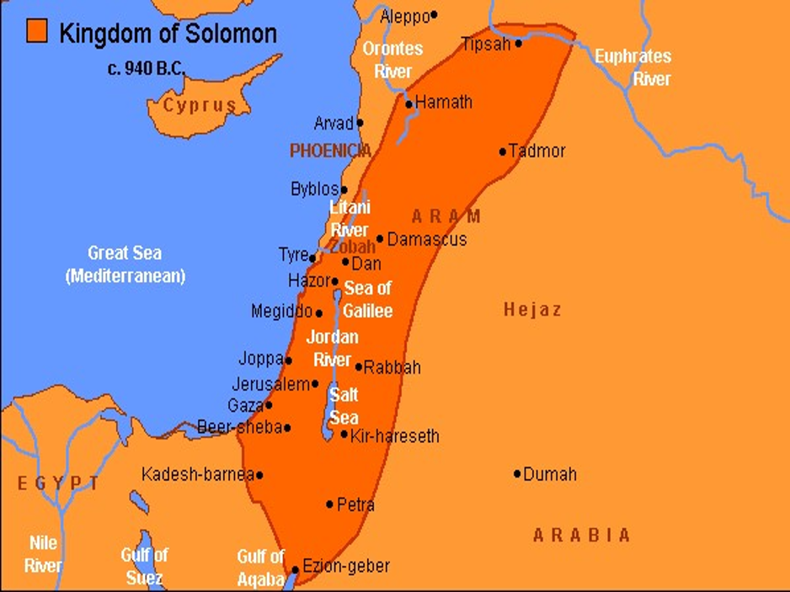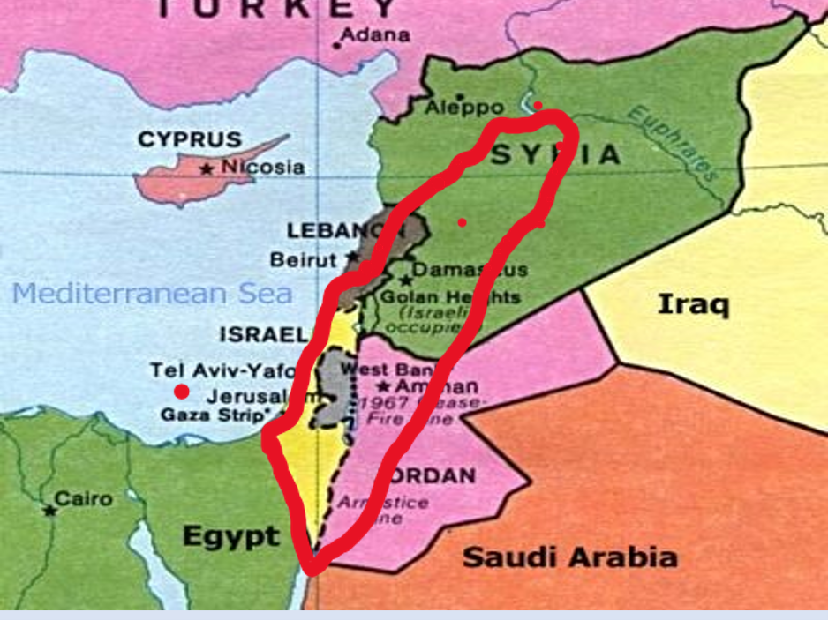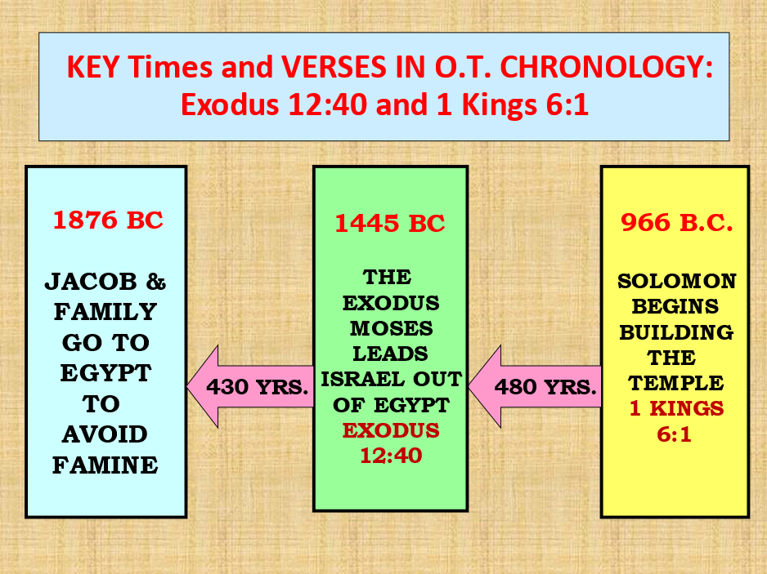

# **BUILDING THE TEMPLE 5:1-8:66**

## **Chapter 6---Temple building began in Solomon’s 4th year (c. 967/966 B.C.). This is a key verse in O.T. chronology.**

## **1 Chronicles 22:5-19 and 28:2-20.**

## **(1) David not allowed to build the temple but he did gather much material.**

## **(2) Solomon commissioned to build it.**

## **(3) David gave detailed plans of the temple to Solomon. These plans came directly from the Lord.**

# **BUILDING THE TEMPLE - 6:1-8:66**

## **SOLOMON’S OWN HOUSE**

## **It took 13 years to build it.**

## **It was a very large house of about 11,250 square feet.**

## **It was a luxurious house with costly building materials.**

## **THE LORD’S HOUSE**

## **Built with great amounts of gold, silver and precious stones.**

## **Silver = $755 million**

## **Gold - $15.3 billion**

## **Used 184,000 workers**

## **610 tons of bronze**

## **Phoenician artisans were the primary skilled workers in the temple project.**

## **God now lays a choice before Solomon and all Israel and Judah**

## ***1 Kings 9:4 “Now if you walk before Me as your father David walked, in integrity of heart and in uprightness, to do according to all that I have commanded you, and if you keep My statutes and My judgments,***

## ***5 “then I will establish the throne of your kingdom over Israel forever, as I promised David your father, saying, ‘You shall not fail to have a man on the throne of Israel.’***

## ***6 “But if you or your sons at all turn from following Me, and do not keep My commandments and My statutes which I have set before you, but go and serve other gods and worship them,***

## ***7 “then I will cut off Israel from the land which I have given them; and this house which I have consecrated for My name I will cast out of My sight. Israel will be a proverb and a byword among all peoples. 8 “And as for this house, which is exalted, everyone who passes by it will be astonished and will hiss, and say,***

## ***‘Why has the LORD done thus to this land and to this house?’ 9 “Then they will answer, ‘Because they forsook the LORD their God, who brought their fathers out of the land of Egypt, and have embraced other gods, and worshiped them and served them; therefore the LORD has brought all this calamity on them.’ ”***

## **And that is exactly what Jeremiah said many years later at the end of Judah (Jer 22:8,9)**

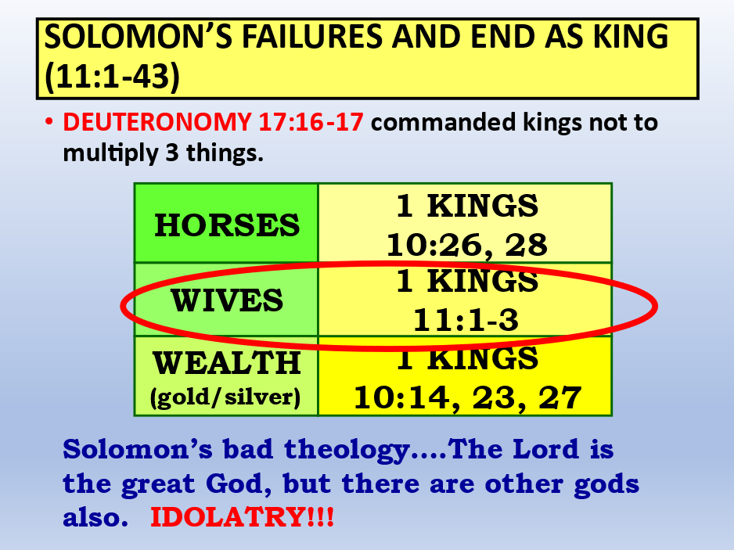

## ***1Kgs 11:1 But King Solomon loved many foreign women, as well as the daughter of Pharaoh: women of the Moabites, Ammonites, Edomites, Sidonians, and Hittites– 2 from the nations of whom the LORD had said to the children of Israel, “You shall not intermarry with them, nor they with you. Surely they will turn away your hearts after their gods.” Solomon clung to these in love.***

## ***3 And he had seven hundred wives, princesses, and three hundred concubines; and his wives turned away his heart.***

## ***4 For it was so, when Solomon was old, that his wives turned his heart after other gods; and his heart was not loyal to the LORD his God, as was the heart of his father David.***

## ***5 For Solomon went after Ashtoreth the goddess of the Sidonians, and after Milcom the abomination of the Ammonites. 6 Solomon did evil in the sight of the LORD, and did not fully follow the LORD, as did his father David.***

## **Next week:**

## **The beginning of the end… Rehoboam Solomon’s son and Jeroboam the servant of Solomon whom God chose to receive 10 tribes.**