It was the best of times and the worst of times

THE DAVIDIC COVENANT
12 March 2023
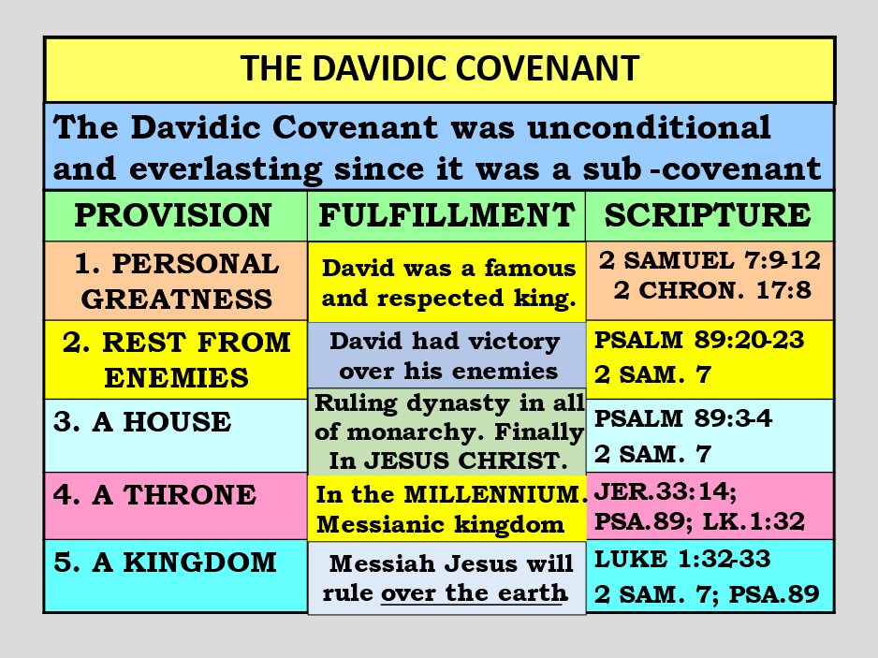

Luke 1:26 Now in the sixth month the angel Gabriel was sent by God to a city of Galilee named Nazareth, 27 to a virgin betrothed to a man whose name was Joseph, of the house of David. The virgin’s name was Mary.

28 And having come in, the angel said to her, “Rejoice, highly favored one, the Lord is with you; blessed are you among women!” 29 But when she saw him, she was troubled at his saying,

and considered what manner of greeting this was. 30 Then the angel said to her, “Do not be afraid, Mary, for you have found favor with God. 31 “And behold, you will conceive in your womb and bring forth a Son, and shall call His name JESUS.

32 “He will be great, and will be called the Son of the Highest; and the Lord God will give Him the throne of His father David. 33 “And He will reign over the house of Jacob forever, and of His kingdom there will be no end.”
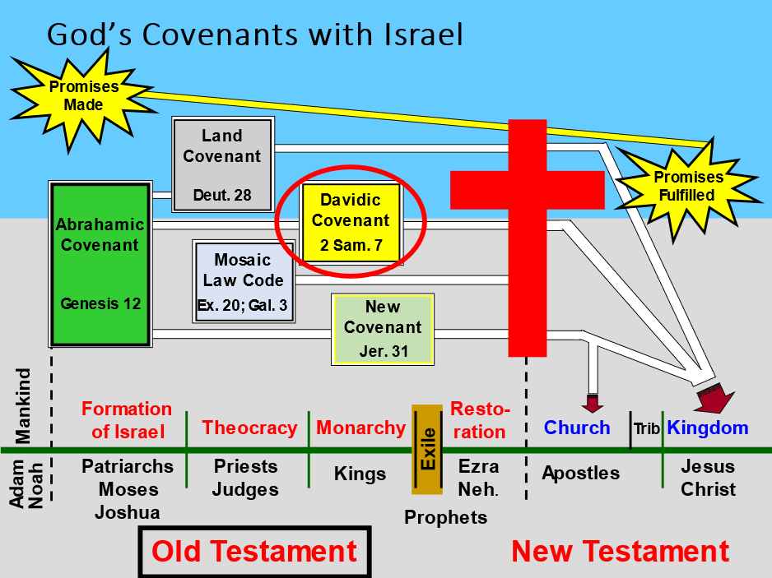

Is God done with Israel?

Has the Church replaced Israel?

Are the Promises to David all void?

Luke 1:33 And He will reign over the house of Jacob forever, and of His kingdom there will be no end.”

Does forever mean forever?

Psalm 89:28 My mercy I will keep for him forever, And My covenant shall stand firm with him.

29 His seed also I will make to endure forever, And his throne as the days of heaven. 30 “If his sons forsake My law And do not walk in My judgments,

31 If they break My statutes And do not keep My commandments, 32 Then I will punish their transgression with the rod, And their iniquity with stripes. 33 Nevertheless My lovingkindness I will not utterly take from him, Nor allow My faithfulness to fail.

34 My covenant I will not break, Nor alter the word that has gone out of My lips. 35 Once I have sworn by My holiness; I will not lie to David:

36 His seed shall endure forever, And his throne as the sun before Me; 37 It shall be established forever like the moon, Even like the faithful witness in the sky.” ​Selah

Israel Is getting ready, to act and stand alone against world opinion.

“Any attack on Iran’s nuclear sites would violate international law whether by Israel or any other country, the head of the United Nations nuclear watchdog said Monday.”

https://www.bloomberg.com/news/articles/2023-03-06/any-attack-on-iran-would-violate-law

Israel’s response:

“I think he said something totally wrong and inappropriate…There is nothing more legitimate than preventing a regime that openly calls for your destruction from having the weapons to achieve that goal.” Israeli prime minister Netanyahu
Israel will once again look like they are on the verge of annihilation, but we know better and that is a witness to the Word Of God.

Church, We hold fast to what God says!!!!!!

2 Sam 7:16 “And your house and your kingdom shall be established forever before you. Your throne shall be established forever.” ’ ”

18 Then King David went in and sat before the LORD; and he said: “Who am I, O Lord GOD? And what is my house, that You have brought me this far? 19 “And yet this was a small thing in Your sight, O Lord GOD; and You have also spoken of Your servant’s house for a great while to come.

Is this the manner of man, O Lord GOD? 20 “Now what more can David say to You? For You, Lord GOD, know Your servant. 21 “For Your word’s sake, and according to Your own heart, You have done all these great things, to make Your servant know them.

22 “Therefore You are great, O Lord GOD. For there is none like You, nor is there any God besides You, according to all that we have heard with our ears.

- No purpose of God can be thwarted!
Psalm 86:10 For You are great, and do wondrous things; You alone are God.
Deut 10:17 “For the LORD your God is God of gods and Lord of lords, the great God, mighty and awesome, who shows no partiality nor takes a bribe.

23 “And who is like Your people, like Israel, the one nation on the earth whom God went to redeem for Himself as a people, to make for Himself a name–and to do for Yourself great and awesome deeds for Your land–before Your people whom You redeemed for Yourself from Egypt, the nations, and their gods?

24 “For You have made Your people Israel Your very own people forever; and You, LORD, have become their God.

- Israel isn’t going anywhere.
Psalm 147:20 He has not dealt thus with any nation; And as for His judgments, they have not known them. Praise the LORD!
Jer 32:37 ‘Behold, I will gather them out of all countries where I have driven them in My anger, in My fury, and in great wrath; I will bring them back to this place, and I will cause them to dwell safely. 38 ‘They shall be My people, and I will be their God;

25 “Now, O LORD God, the word which You have spoken concerning Your servant and concerning his house, establish it forever and do as You have said.

26 “So let Your name be magnified forever, saying, ‘The LORD of hosts is the God over Israel.’ And let the house of Your servant David be established before You. 27 “For You, O LORD of hosts, God of Israel, have revealed this to Your servant, saying, ‘I will build you a house.’

- GOD IS IN CONTROL
Ezek 20:32 “What you have in your mind shall never be, when you say, ‘We will be like the Gentiles, like the families in other countries, serving wood and stone.’
33 “As I live,” says the Lord GOD, “surely with a mighty hand, with an outstretched arm, and with fury poured out, I will rule over you.

Therefore Your servant has found it in his heart to pray this prayer to You. 28 “And now, O Lord GOD, You are God, and Your words are true, and You have promised this goodness to Your servant.

29 “Now therefore, let it please You to bless the house of Your servant, that it may continue before You forever; for You, O Lord GOD, have spoken it, and with Your blessing let the house of Your servant be blessed forever.”

God will not fail any of His promises to David!

Psalm 89:28 My mercy I will keep for him forever, And My covenant shall stand firm with him. 29 His seed also I will make to endure forever, And his throne as the days of heaven.

33 Nevertheless My lovingkindness I will not utterly take from him, Nor allow My faithfulness to fail. 34 My covenant I will not break, Nor alter the word that has gone out of My lips.

