## **Joshua, the land, and the Kings 5 February 2023**

## **As we continue this review of the Old Testament to where we left off at Ezra, we remember these things:**



## **Joshua takes over as leader and it is a brand-new generation. All the remnants of the old generation of unbelief are dead.**



## **This is the Land part of People-Law-Land!**

## **This is a great time of obedience because Joshua is faithful like Moses, but this generation is also new!**



# **BACKGROUND TO JOSHUA**



## **JOSHUA’S JOB DESCRIPTION:**



## **#1 - He was to destroy the Canaanite fortress cities.**

## **#2 - He was to divide up the land.**

## **ISRAEL AND THE CANAANITES:**

## **Deut. 7 and 20; Lev. 18**

## **The Canaanites were totally wicked and had to be eliminated.**



## **The Canaanite deities were fertility gods and goddesses. Baal, Astartes, Asherah.**

## **Changeable, brutal, lustful and put no moral demands on the worshippers.**



## **God gave these nations time, but now time is Up!**

## ***Gen 15:16 “But in the fourth generation they shall return here, for the iniquity of the Amorites is not yet complete.”***

## ***Deut 20:16 “But of the cities of these peoples which the LORD your God gives you as an inheritance, you shall let nothing that breathes remain alive, 17 “but you shall utterly destroy them: the Hittite and the Amorite and the Canaanite and the Perizzite and the Hivite and the Jebusite,***



## ***just as the LORD your God has commanded you, 18 “lest they teach you to do according to all their abominations which they have done for their gods, and you sin against the LORD your God.***



## **How bad were they? Lev 18, 20**



## **All forms of debauchery**



## **Incest**

## **Adultery**



## **Sex with minors**

## **Child sacrifice**

## **Homosexuality**

## **Bestiality**

## **Witchcraft**

## **Paranormal**

## **Trafficking children and women**

## **Or today’s San Fernando Valley CA and Orlando FL.**

## ***Job 4:8 Even as I have seen, Those who plow iniquity And sow trouble reap the same. 9 By the blast of God they perish, And by the breath of His anger they are consumed.***



## **.**

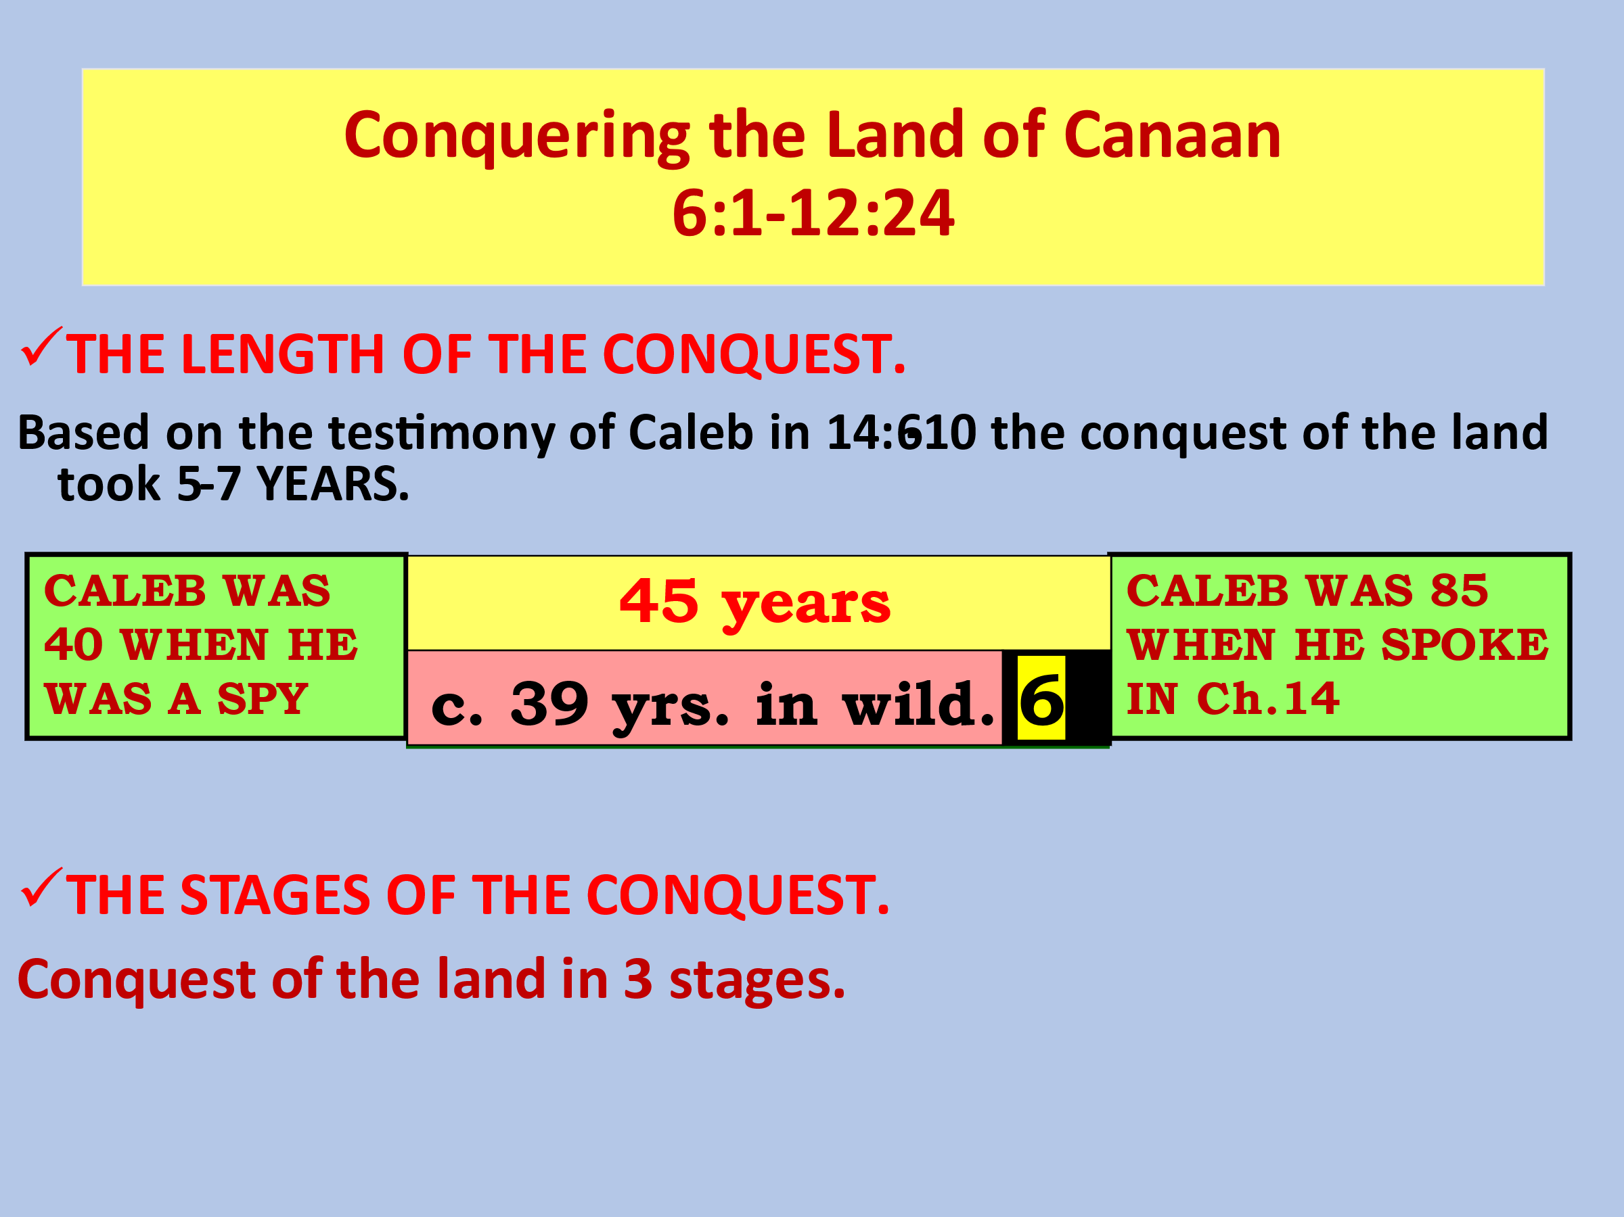

# **6:1-17 -JERICHO: THE FIRST VICTORY IN THE LAND**



## **GOD’S PLAN---March around the city once a day and 7 times on the 7th day….UNCONVENTIONAL.**

## **Normally the spoils of war were taken by the victorious army. In this case Jericho was the “firstfruits” to the Lord. All was to be destroyed except the precious metals which were given to the Lord.**

## **The plan was carried out exactly as the Lord had said. VICTORY!!!**



# **ISRAEL’S DEFEAT AT AI 7:1-26**



## **THE SIN OF ACHAN.**

## **He took that which was under the ban. Coveting (wrong desires) started it all.**

## **His sin affected the whole nation. One person’s sin always affects others.**



## **Israel would not experience victory until sin was taken care of. (Us too!)**

## **Achan put to death. Others in family died also---assumes that they were involved in concealing the stolen goods.**



# **SUMMARY AND DIVIDING THE LAND 11:16-23**

## **Joshua completely fulfilled his “job description”, yet much land still needed to be taken by Israel.**

## ***Josh 11:16 Thus Joshua took all this land: the mountain country, all the South, all the land of Goshen, the lowland, and the Jordan plain–the mountains of Israel and its lowlands, 17 from Mount Halak and the ascent to Seir, even as far as Baal Gad in the Valley of Lebanon***

## ***below Mount Hermon. He captured all their kings, and struck them down and killed them.* *18 Joshua made war a long time with all those kings. 19 There was not a city that made peace with the children of Israel, except the Hivites, the inhabitants of Gibeon. All the others they took in battle.***



## ***20 For it was of the LORD to harden their hearts, that they should come against Israel in battle, that He might utterly destroy them,***



## ***and that they might receive no mercy, but that He might destroy them, as the LORD had commanded Moses. 21 And at that time Joshua came and cut off the Anakim from the mountains: from Hebron, from Debir, from Anab, from all the mountains of Judah, and from all the mountains of Israel; Joshua utterly destroyed them with their cities.***



## ***22 None of the Anakim were left in the land of the children of Israel; they remained only in Gaza, in Gath, and in Ashdod.***



## ***23 So Joshua took the whole land, according to all that the LORD had said to Moses; and Joshua gave it as an inheritance to Israel according to their divisions by their tribes. Then the land rested from war.***



## **The land is divided up and each tribe was instructed to finish the conquering process.**

## **But instead of driving them out they left them as workers and taxpayers.**



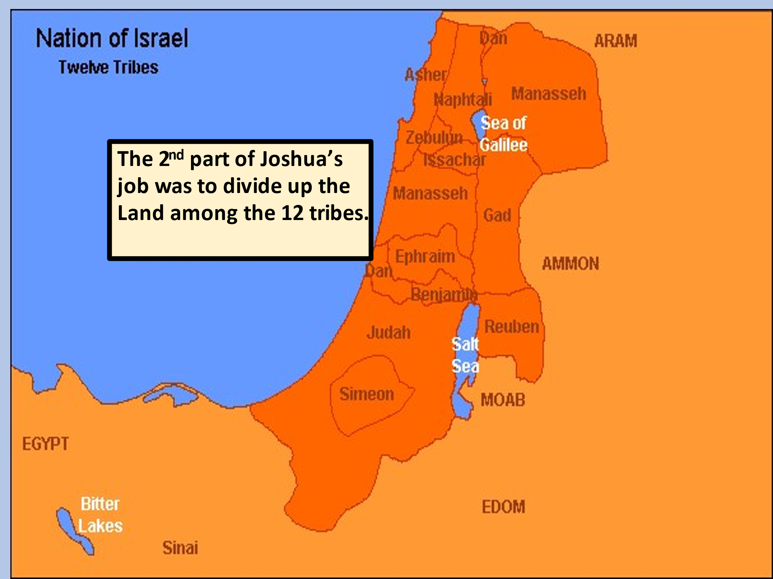

## 

## 



## 



## 

## 



## **Next week: The Kings**