New Year review (part 1)!
8 Jan 2023

We have been working our way through the Old Testament, here is where we have been over the last 14 months!

Review:

Four events Genesis 1-11

Creation

Fall

Flood

Babel

GENESIS 1 -11: THE FOUR MAJOR EVENTS

The Creation of the Earth and the Universe: Gen. 1-2

Given to tell us that GOD DID IT.

Creation was sudden, supernatural and out of nothing.

The text says that the days of creation are literal, 24 hour days.

Genesis 1 records the first 6 days of creation.

Genesis 2 records day #7; as well as one aspect of day #6, the creation of man…in the image of God.

(2) The Fall of Man: 3-5

Given to tell us that the MESS MANKIND IS IN WAS NOT PART OF THE ORIGINAL CREATION.

Man’s sin in Eden brought with it spiritual separation; physical death; mental, emotional and relational decline.

GENESIS 1 -11: THE FOUR MAJOR EVENTS

(3) The Flood of Noah: Gen 6-9

Given to tell us that this PRESENT WORLD IS NOT WHAT THE ORIGINAL EARTH LOOKED LIKE.

The flood was to deter the rampant evil in mankind; only Noah was said to be righteous.

The flood was worldwide; no place to hide; the ark needed to preserve human and animal life.

The flood brought monumental geological changes to the planet.

2 Pet 3:6 by which the world that then existed perished, being flooded with water.

The flood lasted for a little over one year.

GENESIS 1-11: THE FOUR MAJOR EVENTS

(4) The Tower of Babel: Gen 10-11

Given to tell us about our present world as to why WE HAVE DIFFERENT RACES AND SPEAK DIFFERENT LANGUAGES.

In order to keep evil from maturing in a united mankind, God suddenly, supernaturally divided mankind at the “Tower of Babel.”

Man’s languages were different, causing them to separate from one another.

This led to geographic isolation which led to certain genetic characteristics beginning to dominate these separated groups.

Every time the world unites, evil becomes rampant.

In the history of man, when the world unites, God either slows it down or wraps it up!

Four people Genesis 12-50

1. Abraham

2. Isaac

3. Jacob

4. Joseph

Gathering of a people according to this covenant:

The Abrahamic Covenant

This is the beginning of:

PEOPLE, LAW, LAND!

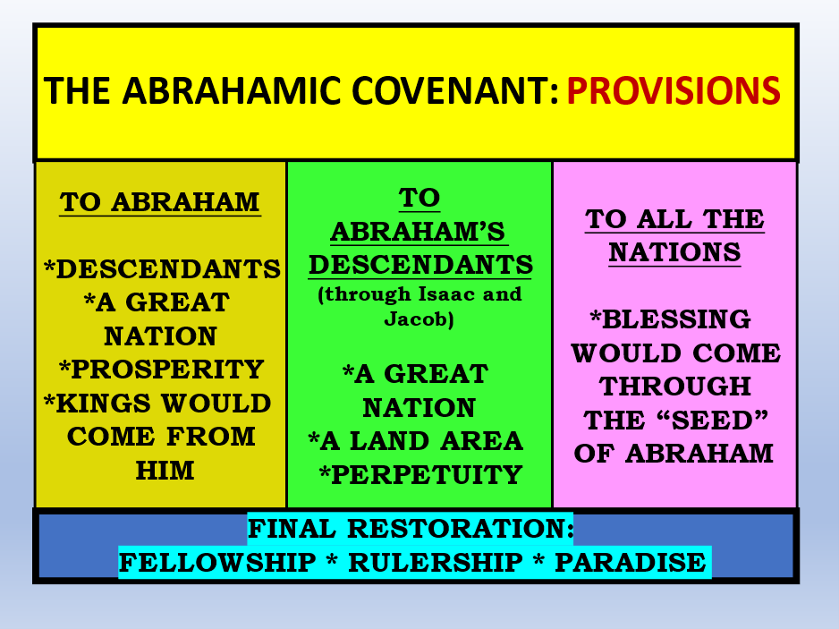

THE ABRAHAMIC COVENANT: PROVISIONS

The “Sub-covenants” of The Abrahamic Cov.

Land Covenant (aka Palestinian Cov.)

Detailed boundaries given

Israel given the “title deed” to the land and will eventually live on it forever.

(2) Davidic Covenant

Seed and King

Descendant of David will rule over Israel and the nations “forever”.

(3) New Covenant

Deals with sin/salvation; based on the Cross of Jesus Christ. Made with Israel, but the Church “partakers” of it.

4 Events

4 People

4 Covenants

These covenants are still in effect, and we literally have the playbook to this.

God has not forgotten His people, His Promises or His land.

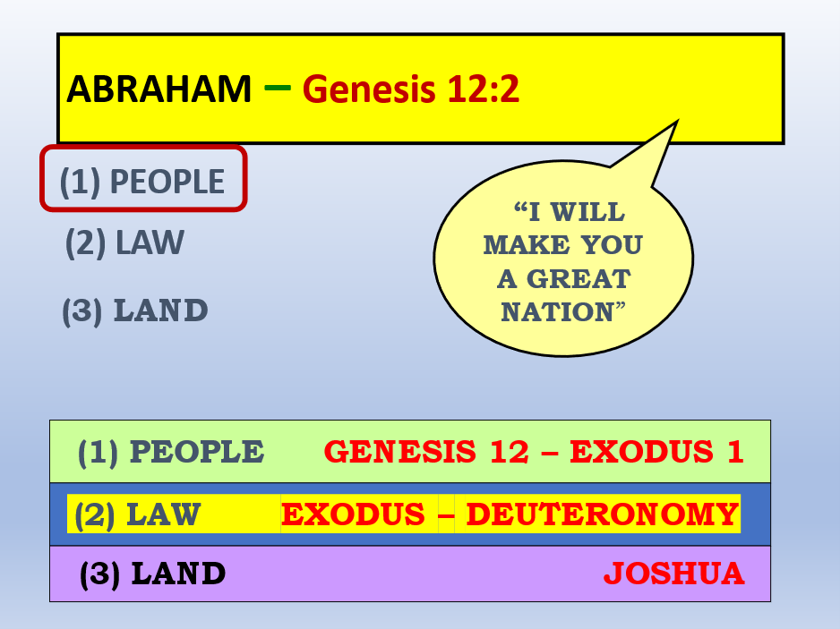

Those 3 are irrevocable

Romans 11:29 For the gifts and the calling of God are irrevocable.

Numbers 23:19 “God is not a man, that He should lie, Nor a son of man, that He should repent. Has He said, and will He not do? Or has He spoken, and will He not make it good?

Malachi 3:6 “For I am the LORD, I do not change; Therefore you are not consumed, O sons of Jacob.

Next week (Part 2)

