On with the review!!!
28 January, 2023

Why do we study so hard?

Negative:

Hosea 4:6 My people are destroyed for lack of knowledge. Because you have rejected knowledge, I also will reject you from being priest for Me; Because you have forgotten the law of your God, I also will forget your children.

Isa 1:2 Hear, O heavens, and give ear, O earth! For the LORD has spoken: “I have nourished and brought up children, And they have rebelled against Me;

3 The ox knows its owner And the donkey its master’s crib; But Israel does not know, My people do not consider.”

Positive:

Psalm 119:9 How can a young man cleanse his way? By taking heed according to Your word. 10 With my whole heart I have sought You; Oh, let me not wander from Your commandments! 11 Your word I have hidden in my heart, That I might not sin against You. 12 Blessed are You, O LORD! Teach me Your statutes.

13 With my lips I have declared All the judgments of Your mouth. 14 I have rejoiced in the way of Your testimonies, As much as in all riches. 15 I will meditate on Your precepts, And contemplate Your ways. 16 I will delight myself in Your statutes; I will not forget Your word.

2Tim 2:15 Be diligent to present yourself approved to God, a worker who does not need to be ashamed, rightly dividing the word of truth.

1 Tim 4:13 Till I come, give attention to reading, to exhortation, to doctrine.

From Egypt to Kadesh Barnea

Numbers 13:1-14:45

We focus on this because it is this issue that has hampered Israel since that time even to today!

Unbelief in what God says!!!

Numbers 14:4 So they said to one another, “Let us select a leader and return to Egypt.”

1 Samuel 8:19 Nevertheless the people refused to obey the voice of Samuel; and they said, “No, but we will have a king over us,

1 Sam 10:18 and said to the children of Israel, “Thus says the LORD God of Israel: ‘I brought up Israel out of Egypt, and delivered you from the hand of the Egyptians and from the hand of all kingdoms and from those who oppressed you.’

19 “But you have today rejected your God, who Himself saved you from all your adversities and your tribulations; and you have said to Him, ‘No, set a king over us!’ Now therefore, present yourselves before the LORD by your tribes and by your clans.”

John 19:14 Now it was the Preparation Day of the Passover, and about the sixth hour. And he said to the Jews, “Behold your King!”

15 But they cried out, “Away with Him, away with Him! Crucify Him!” Pilate said to them, “Shall I crucify your King?” The chief priests answered, “We have no king but Caesar!”

The cost to Israel

40 years wandering

Temple destroyed; 70 years captivity.

Temple destroyed 1878 years out of the land.

UNBELIEF AT KADESH
13:1-14:45

13:1-25 - SPIES CHOSEN (cf. Deut. 1:22)

13:26-33 - SPIES RETURN and REPORT

14:1-45 – RESPONSE TO THE SPIES REPORT.

The people (14:1-10)-“Back to Egypt!”

The Lord (14:10-12)-“I will destroy them”

Moses (14:13-19)-“No Lord, don’t!”

The Lord (14:20-45)- “Okay, I’ll pardon them but they will wander for 40 years.”

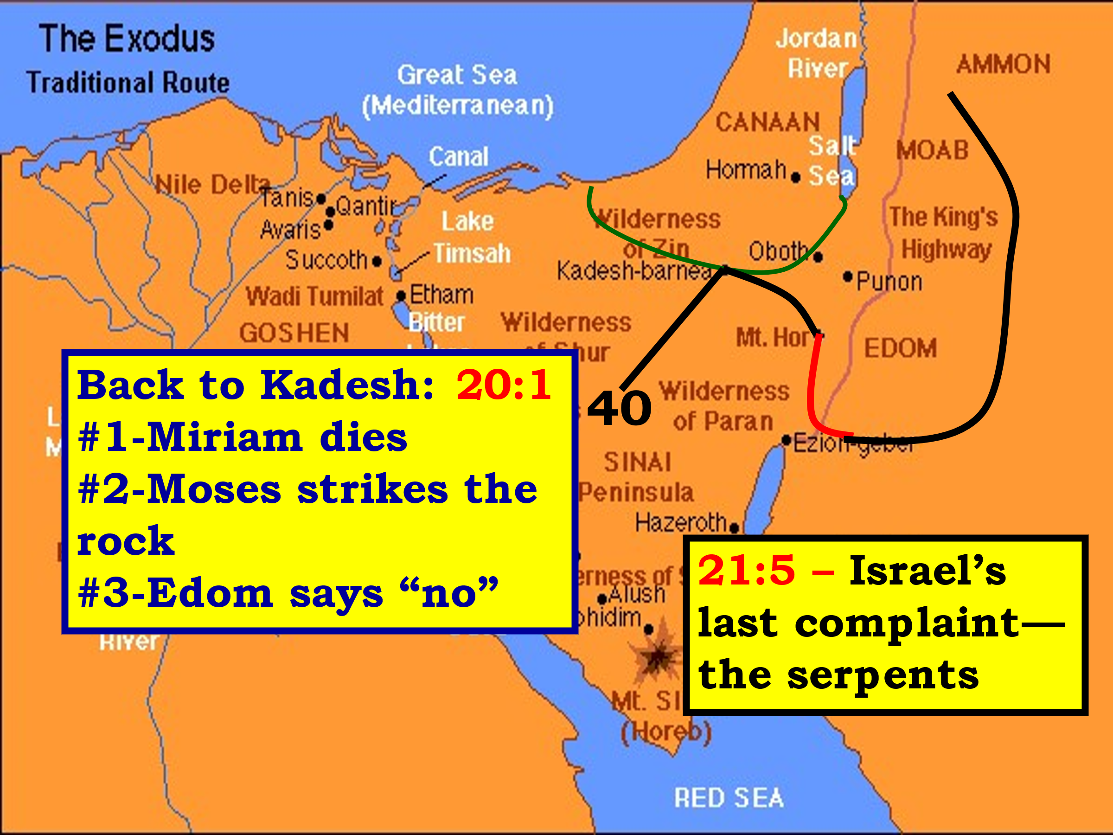

Last exhortations; Deuteronomy!

Moses exhorted Israel to:

Deuteronomy 4-6

CHAPTERS 4 & 5

A restating of the 10 commandment for the new generation.

CHAPTER 6

6:4 The great OT statement about God.

The key to the transmitting of God’s truth---the home.

Deuteronomy 7-8

CHAPTER 7

TWO WARNINGS:

1. Show no mercy to the Canaanites.

2. Do not marry a Canaanite.

CHAPTER 8

God is going to richly bless you– but in your prosperity, do not forget the Lord.

Deuteronomy 9 and 11

CHAPTER 9

WHY IS GOD GIVING ISRAEL THE LAND?

1. Because of the wickedness of the Canaanites.

2. Because of the Abe.

Covenant.

3. But not because of Israel’s righteousness

CHAPTER 11

THE LAND OF CANAAN.

1. It is different from the land of Egypt.

2. The condition of the land will reveal Israel’s spiritual condition.

Changing of the guard

Numbers 27:18 And the LORD said to Moses: “Take Joshua the son of Nun with you, a man in whom is the Spirit, and lay your hand on him; 19 “set him before Eleazar the priest and before all the congregation, and inaugurate him in their sight.

20 “And you shall give some of your authority to him, that all the congregation of the children of Israel may be obedient.

21 “He shall stand before Eleazar the priest, who shall inquire before the LORD for him by the judgment of the Urim. At his word they shall go out, and at his word they shall come in, he and all the children of Israel with him–all the congregation.”

Deut 34:4 Then the LORD said to him, “This is the land of which I swore to give Abraham, Isaac, and Jacob, saying, ‘I will give it to your descendants.’ I have caused you to see it with your eyes, but you shall not cross over there.”

5 So Moses the servant of the LORD died there in the land of Moab, according to the word of the LORD.

Next week: Joshua

