Review, where we have been part 3!
22 January 2023

Gen 12:1 Now the LORD had said to Abram: “Get out of your country, From your family And from your father’s house, To a land that I will show you. 2 I will make you a great nation; I will bless you And make your name great; And you shall be a blessing.

3 I will bless those who bless you, And I will curse him who curses you;

And in you all the families of the earth shall be blessed.”

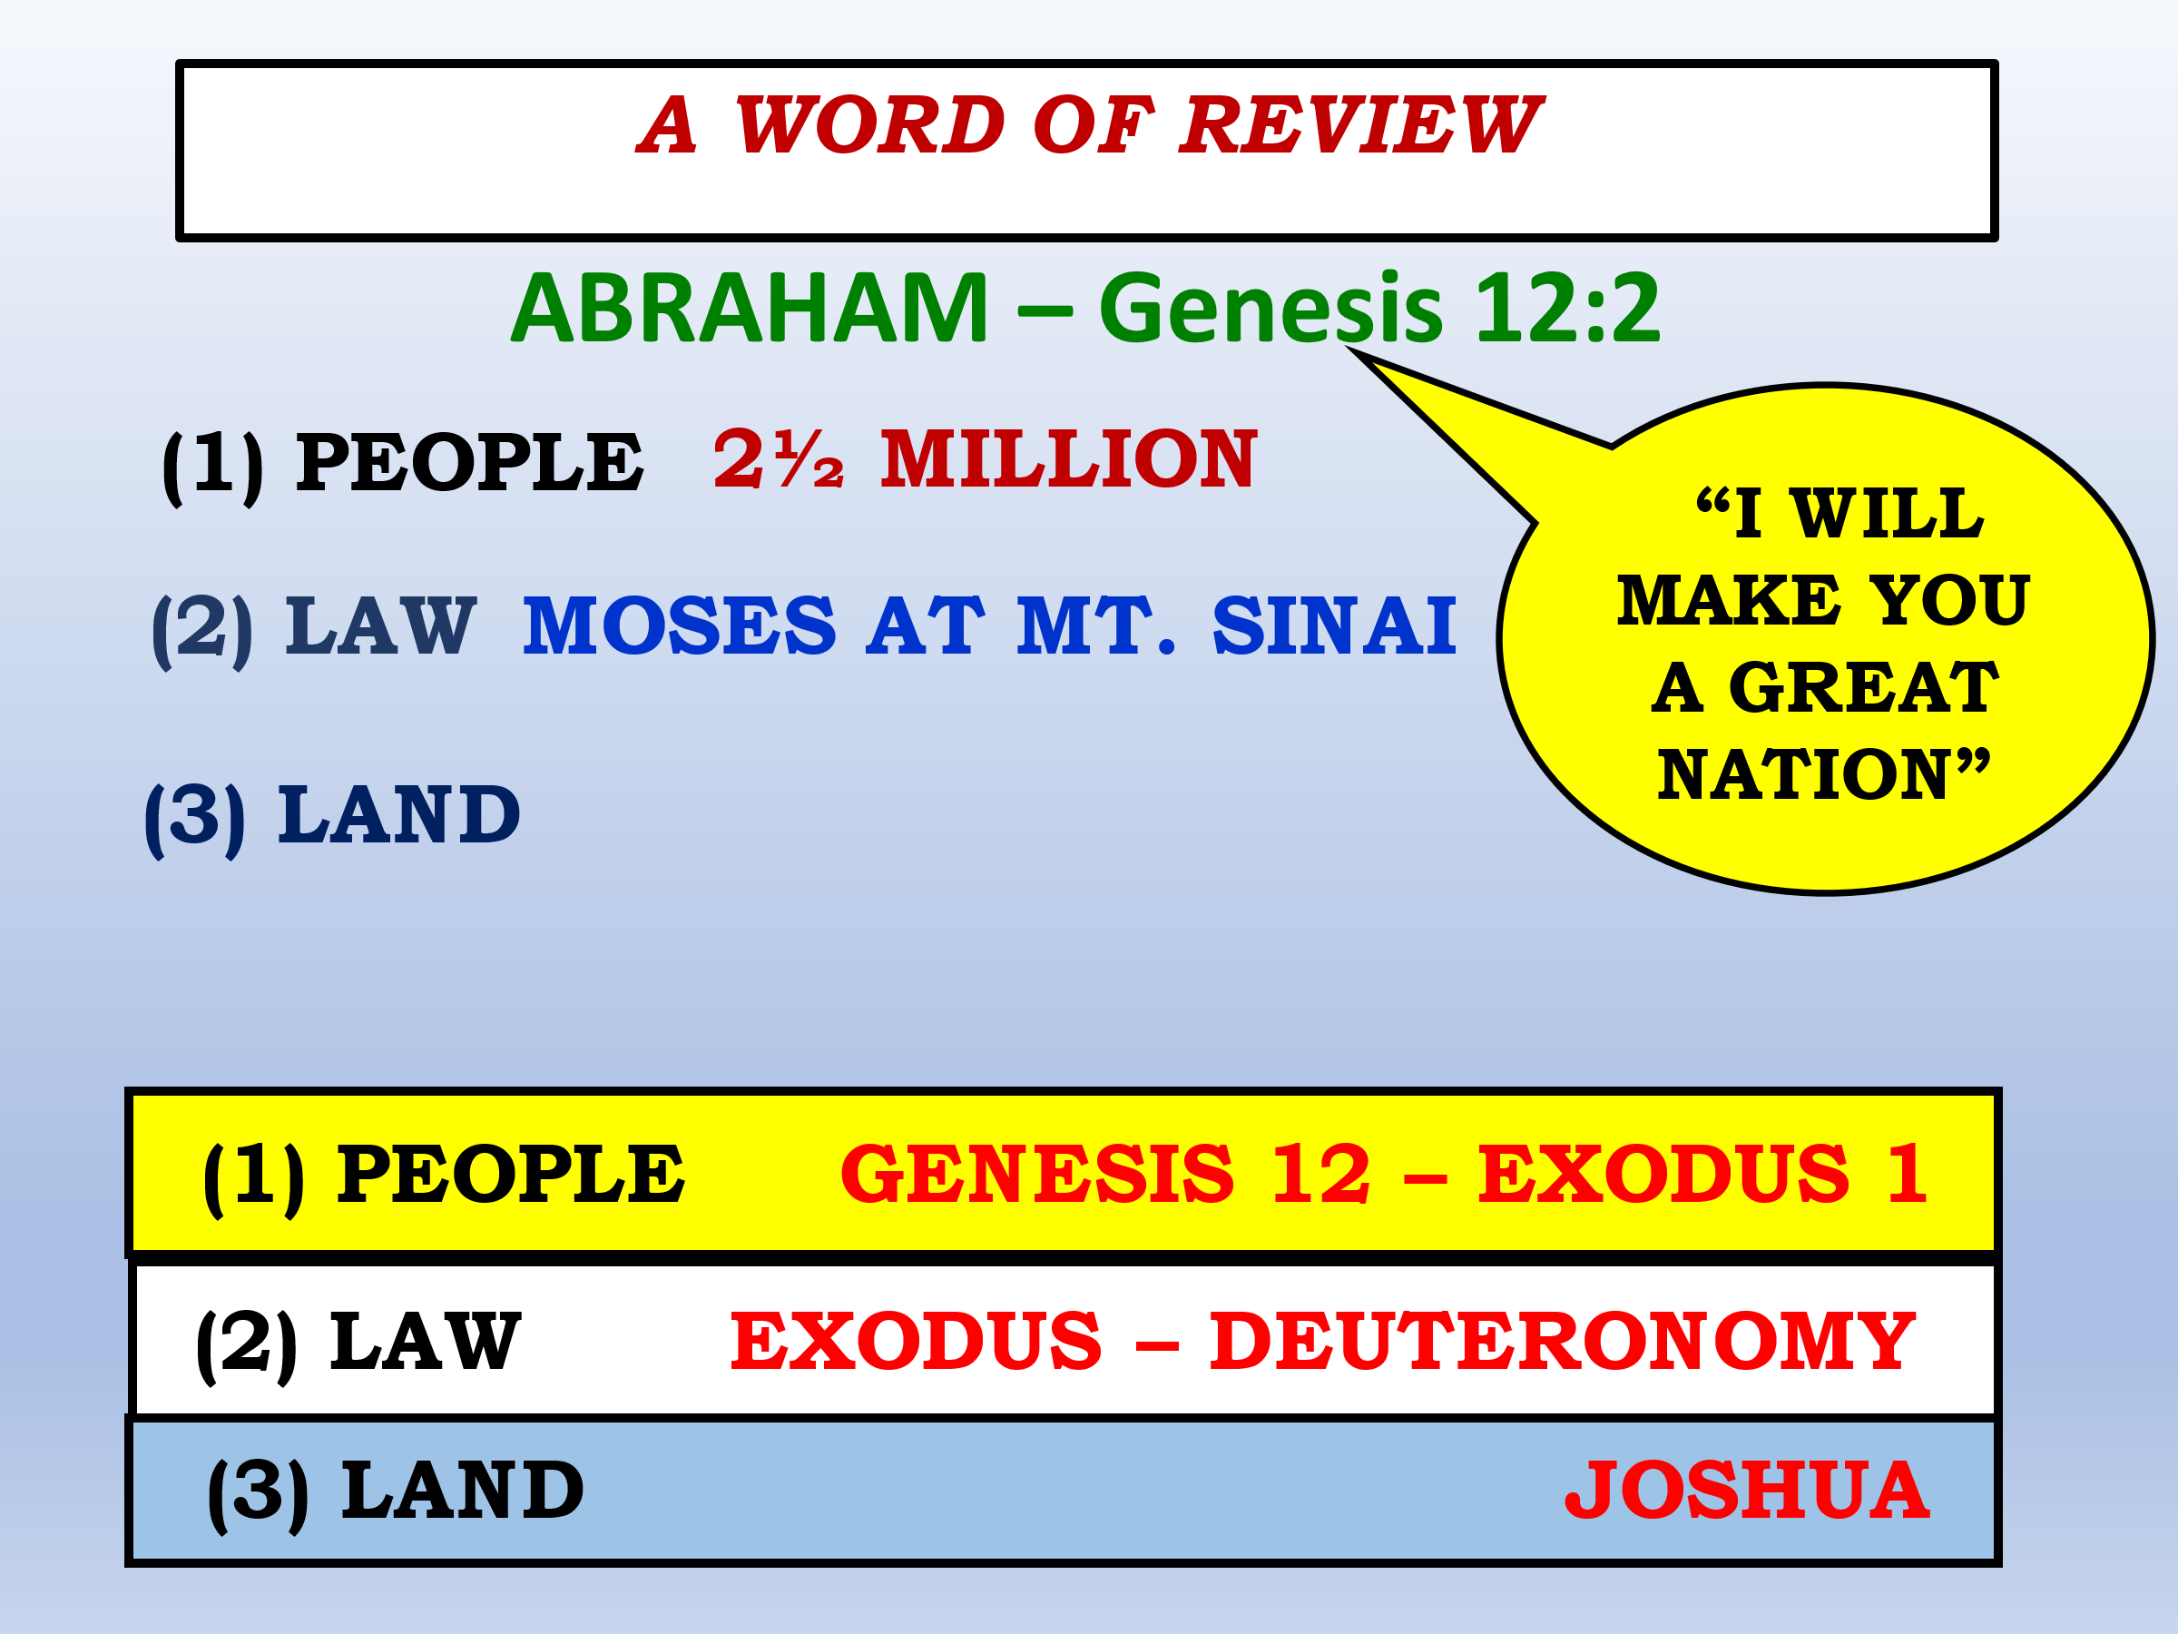

FROM EGYPT TO SINAI – Exodus 1:1-18:27

ISRAEL IN EGYPTIAN BONDAGE

Moses raised in Pharaoh’s court. He believed he was the deliverer.

Fled Egypt but called of God to return. Had ability to work 3 kinds of miracles.

THE PLAGUES ON EGYPT

Pharaoh’s foolish statement (Gen 5:2).

The “education” of Pharaoh: the plagues on the land of Egypt.

Some Facts About the Plagues on Egypt

#1 – The plagues perhaps took place over a period of 8-9 months.

#2 – The plagues were directed towards the many gods of Egypt. (cf. Exo. 12:12 and Num. 33:4).

#3 – They were supernatural even though natural, familiar objects were used.

*They were predicted ahead of time.

*Known objects and phenomena were greatly intensified.

*They discriminated between the Israelites and the Egyptians.

OUT OF EGYPT -12:1-15:21

THE PASSOVER

(1) A MALE IN ITS PRIME.

(2) NO BLEMISH ON IT.

(3) ITS BLOOD SHED HAD TO BE SHED.

(4) ITS BLOOD HAD TO BE APPLIED.

Passover breaks Pharaoh.

Israel flees/Egypt pursues.

The destruction of Egypt’s army.

“Christ our Passover” – 1 Cor. 5:7

1 Cor 5:7 Therefore purge out the old leaven, that you may be a new lump, since you truly are unleavened. For indeed Christ, our Passover, was sacrificed for us.

Christ our Passover breaks death

2 Tim 1:10 but has now been revealed by the appearing of our Savior Jesus Christ, who has abolished death and brought life and immortality to light through the gospel,

Death has been destroyed in Christ!

2 For the law of the Spirit of life in Christ Jesus has made me free from the law of sin and death.

Freedom from slavery

Heb 2:14 Inasmuch then as the children have partaken of flesh and blood, He Himself likewise shared in the same, that through death He might destroy him who had the power of death, that is, the devil, 15 and release those who through fear of death were all their lifetime subject to bondage.

THE 10 COMMANDMENTS 20:1-17

The Commandments were written on two stones. Each one probably had all 10 commandments on it.

This would follow the custom of the time; 2 copies were made; one for the king and the other for the slave

#1---No worship, dependence, loyalty to any other God.

#2---No making of carved images/idols which easily become realities and objects of worship.

THE 10 COMMANDMENTS -20:1-17

#3---God’s name is sacred and is not to be used in empty ways or in irreverent oaths.

#4---The Sabbath was sign of the Mosaic covenant (31:13) and was a day of rest from labor, which was to benefit man.

#5---Honoring parents. A lifelong obligation. Central to the health and stability of a culture. (cf. Rom. 1:30).

#6---No criminally taking of a life (murder). Different word used for “killing” as in warfare.

THE 10 COMMANDMENTS - 20:1-17

#7---No sexually taking of another person's spouse.

#8---No taking of that which belongs to another person.

#9---Giving testimony that is not true, especially in the law court.

#10---No craving desire for something or someone which belongs to another. This is something within the person.

There were a total of 613 laws. The priests were the interpreters of the law and their ruling was final. Deut. 17:8

THE MOSAIC LAW CODE GIVEN

(1) THE LAW WAS GIVEN TO ISRAEL. It is not given to the gentiles. It was made with those that God redeemed out of Egypt.

(2) THE LAW IS A UNIT. A person cannot pick and choose which of the 613 laws to keep.

(3) IT WAS DESIGNED TO BE TEMPORARY. It would last until the faith in Messiah would come. (Galatians 3)

(4) THE LAW WAS NOT GIVEN TO SAVE. It was given to protect and teach Israel.

(5) THE LAW IS MORE THAN JUST THE 10 COMMANDMENTS. It deals with every area of life for the Israelite.

(6) THE LAW REVEALED GOD’S HOLINESS AND MAN’S SINFULLNESS. The emphasis is on being “clean” and “holy.”

Galatians 3:19 What purpose then does the law serve? It was added because of transgressions, till the Seed should come to whom the promise was made; and it was appointed through angels by the hand of a mediator.

20 Now a mediator does not mediate for one only, but God is one. 21 Is the law then against the promises of God? Certainly not! For if there had been a law given which could have given life, truly righteousness would have been by the law.

22 But the Scripture has confined all under sin, that the promise by faith in Jesus Christ might be given to those who believe. 23 But before faith came, we were kept under guard by the law, kept for the faith which would afterward be revealed.

24 Therefore the law was our tutor to bring us to Christ, that we might be justified by faith. 25 But after faith has come, we are no longer under a tutor. 26 For you are all sons of God through faith in Christ Jesus.

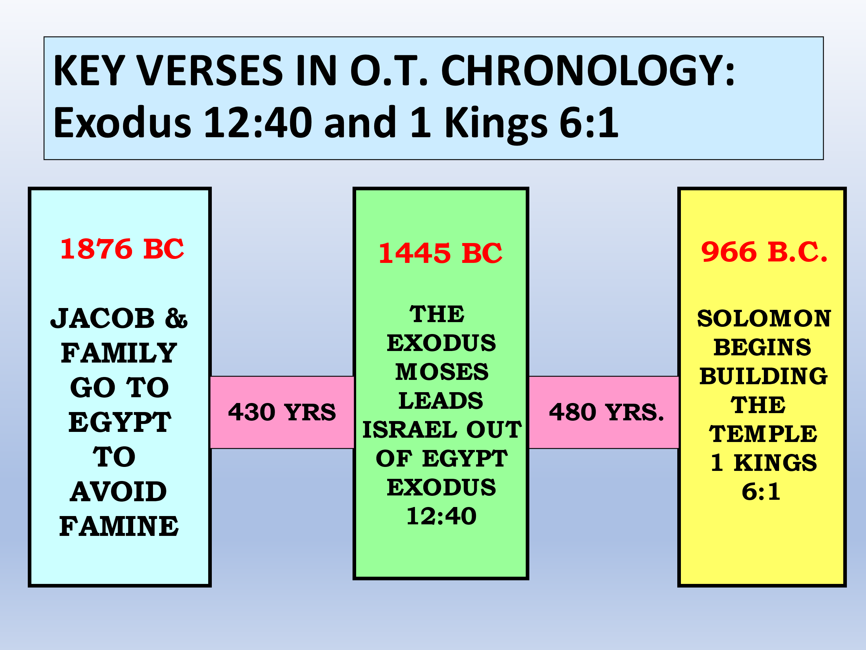

Deut 7:6 “For you are a holy people to the LORD your God; the LORD your God has chosen you to be a people for Himself, a special treasure above all the peoples on the face of the earth.

7 “The LORD did not set His love on you nor choose you because you were more in number than any other people, for you were the least of all peoples; 8 “but because the LORD loves you, and because He would keep the oath which He swore to your fathers,

the LORD has brought you out with a mighty hand, and redeemed you from the house of bondage, from the hand of Pharaoh king of Egypt.

9 “Therefore know that the LORD your God, He is God, the faithful God who keeps covenant and mercy for a thousand generations with those who love Him and keep His commandments;

