Review, where we have been part 2!
15 Jan 2023

After 14 months of study here is what we have been through.

Remember!

Jeremiah 6:16 Thus says the LORD: “Stand in the ways and see, And ask for the old paths, where the good way is, And walk in it; Then you will find rest for your souls. But they said, ‘We will not walk in it.’ 17 Also, I set watchmen over you, saying, ‘Listen to the sound of the trumpet!’ But they said, ‘We will not listen.’

18 Therefore hear, you nations, And know, O congregation, what is among them. 19 Hear, O earth! Behold, I will certainly bring calamity on this people– The fruit of their thoughts, Because they have not heeded My words Nor My law, but rejected it.

Isaiah 8:20 To the law and to the testimony! If they do not speak according to this word, it is because there is no light in them.

4 events Gen 1-11

4 People Gen 12-50

4 covenants Gen 12-50

Another significant issue in understanding the whole Old Testament is the covenant that God made with Abraham. The Abrahamic Covenant along with its three “sub-covenants” are the glue that holds the Old Testament together.

In fact, it is this covenant that really binds all of the Bible together---both Old and New Testaments. Again and again in historical events, in the Law and in the messages of the poets and prophets, God’s people Israel are reminded of the commitments and covenant promises made by God. This covenant not only draws the entire Bible together but is the basis for understanding Bible prophecy. ‘Benware’

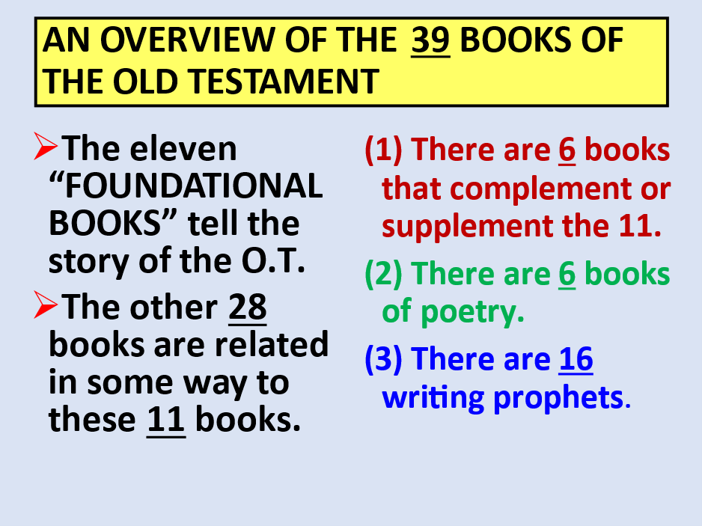

AN OVERVIEW OF THE 39 BOOKS OF THE OLD TESTAMENT

BOOKS OF THE OLD TESTAMENT

GENESIS *ISAIAH

EXODUS *JEREMIAH

LEVITICUS *LAMENTATIONS

NUMBERS *EZEKIEL

DEUTERONOMY *DANIEL

JOSHUA *HOSEA

JUDGES *JOEL

RUTH *AMOS

1 & 2 SAMUEL *OBADIAH

1 & 2 KINGS *JONAH

1 & 2 CHRONICLES *MICAH

EZRA *NAHUM

NEHEMIAH *HABAKKUK

ESTHER *ZEPHANIAH

JOB *HAGGAI

PSALMS *ZECHARIAH

PROVERBS *MALACHI

ECCLESIASTES

SONG OF SOLOMON

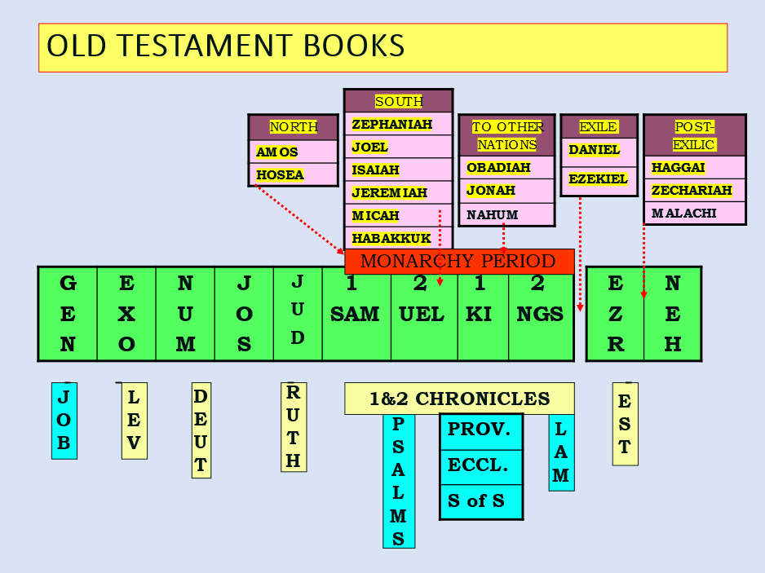

The People must be born

The law must be given

The Land must be possessed

People, Law, Land!

People formed from Gen 50-Exodus 1 about 400 years.

About 70 people turn into 2.5 million

Only God could do this:

Exodus 1:19 And the midwives said to Pharaoh, “Because the Hebrew women are not like the Egyptian women;

for they are lively and give birth before the midwives come to them.” 20 Therefore God dealt well with the midwives, and the people multiplied and grew very mighty.

The time of the EXODUS

Exodus 5:2 And Pharaoh said, “Who is the LORD, that I should obey His voice to let Israel go? I do not know the LORD, nor will I let Israel go.”

The problem of the ages with this world!

Romans 1:18 For the wrath of God is revealed from heaven against all ungodliness and unrighteousness of men, who suppress the truth in unrighteousness, 19 because what may be known of God is manifest in them, for God has shown it to them.

20 For since the creation of the world His invisible attributes are clearly seen, being understood by the things that are made, even His eternal power and Godhead, so that they are without excuse,

Pharoah and all the land the Israelites were about to possess had become just like this:

Rom 1:21 because, although they knew God, they did not glorify Him as God, nor were thankful, but became futile in their thoughts, and their foolish hearts were darkened.

22 Professing to be wise, they became fools, 23 and changed the glory of the incorruptible God into an image made like corruptible man–and birds and four-footed animals and creeping things.

24 Therefore God also gave them up to uncleanness, in the lusts of their hearts, to dishonor their bodies among themselves, 25 who exchanged the truth of God for the lie, and worshiped and served the creature rather than the Creator, who is blessed forever. Amen.

God is getting ready to punish sin and redeem a people to bless the nations!

Gen 12:3 I will bless those who bless you, And I will curse him who curses you; And in you all the families of the earth shall be blessed.”

FROM EGYPT TO SINAI - 1:1-18:27

ISRAEL IN EGYPTIAN BONDAGE

Moses raised in Pharaoh’s court. He believed he was the deliverer.

Fled Egypt but called of God to return. Had ability to work 3 kinds of miracles.

THE PLAGUES ON EGYPT

Pharaoh’s foolish statement (Gen 5:2).

The “education” of Pharaoh: the plagues on the land of Egypt.

Some Facts About the Plagues on Egypt

#1 – The plagues perhaps took place over a period of 8-9 months.

#2 – The plagues were directed towards the many gods of Egypt. (cf. Exo. 12:12 and Num. 33:4).

#3 – They were supernatural even though natural, familiar objects were used.

*They were predicted ahead of time.

*Known objects and phenomena were greatly intensified.

*They discriminated between the Israelites and the Egyptians.

THE MOSAIC LAW CODE GIVEN

(1) THE LAW WAS GIVEN TO ISRAEL. It is not given to the gentiles. It was made with those that God redeemed out of Egypt.

(2) THE LAW IS A UNIT. A person cannot pick and choose which of the 613 laws to keep.

(3) IT WAS DESIGNED TO BE TEMPORARY. It would last until the faith in Messiah would come. (Galatians 3)

(4) THE LAW WAS NOT GIVEN TO SAVE. It was given to protect and teach Israel.

(5) THE LAW IS MORE THAN JUST THE 10 COMMANDMENTS. It deals with every area of life for the Israelite.

(6) THE LAW REVEALED GOD’S HOLINESS AND MAN’S SINFULLNESS. The emphasis is on being “clean” and “holy.”

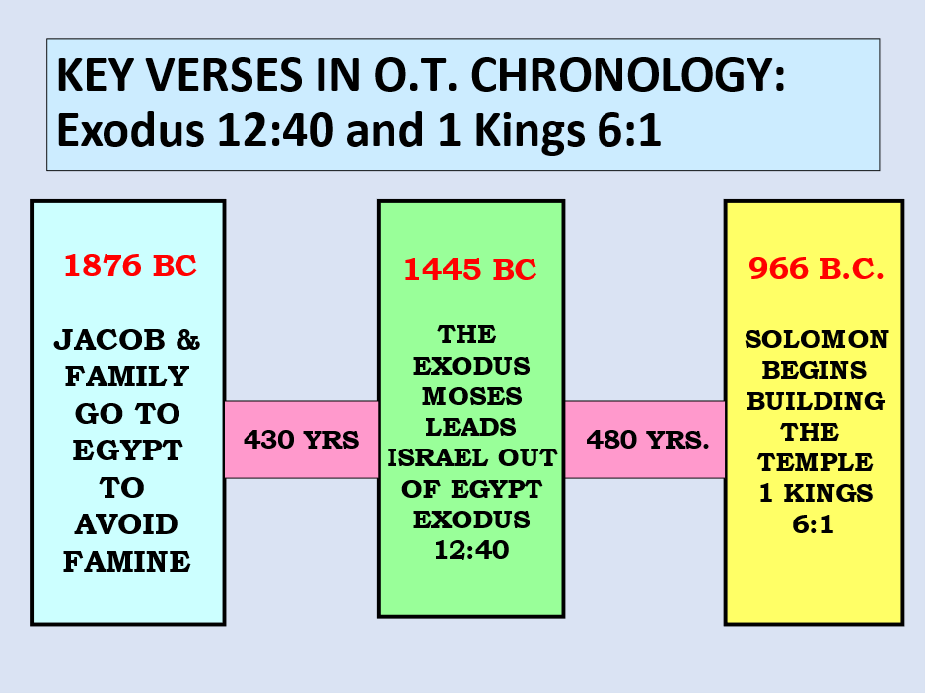

Deut 7:6 “For you are a holy people to the LORD your God; the LORD your God has chosen you to be a people for Himself, a special treasure above all the peoples on the face of the earth.

7 “The LORD did not set His love on you nor choose you because you were more in number than any other people, for you were the least of all peoples; 8 “but because the LORD loves you, and because He would keep the oath which He swore to your fathers,

the LORD has brought you out with a mighty hand, and redeemed you from the house of bondage, from the hand of Pharaoh king of Egypt.

9 “Therefore know that the LORD your God, He is God, the faithful God who keeps covenant and mercy for a thousand generations with those who love Him and keep His commandments;

