## **The fourth beast and it’s progression Dec 4 2022**

## ***Daniel 7:23 “Thus he said: ‘The fourth beast shall be A fourth kingdom on earth, Which shall be different from all other kingdoms, And shall devour the whole earth, Trample it and break it in pieces.***



## ***24 The ten horns are ten kings Who shall arise from this kingdom. And another shall rise after them; He shall be different from the first ones, And shall subdue three kings.***

## **THE 4TH KINGDOM IS THE LAST OF MAN’S KINGDOMS ON EARTH.**



## **1. Shall be A fourth kingdom on earth, It shall be different from all other kingdoms,**

## **2. And shall devour the whole earth,**



## **3. Trample it and break it in pieces.**

## **4. The ten horns are ten kings Who shall arise from this kingdom.**



## **5. And another shall rise after them; He shall be different from the first ones,**

## **6. *And shall subdue three kings.***

## **Rome never took over the whole world**



## **4. The Fourth Empire— The Empire of Imperialism (Dan 7:23-28)**

## **a. The United Stage— The Roman Empire**

## **b. The Two Division Stage— The East-West Balance of Power**

## **c. The One World Government Stage**

## **d. The Ten Division Stage— The Ten Kingdoms**

## **e. The Antichrist Stage— Absolute Imperialism**

## **5. The Messianic Kingdom**

## **Arnold G. Fruchtenbaum. The Footsteps of the Messiah (Kindle Locations 1080-1083). Ariel Ministries.**

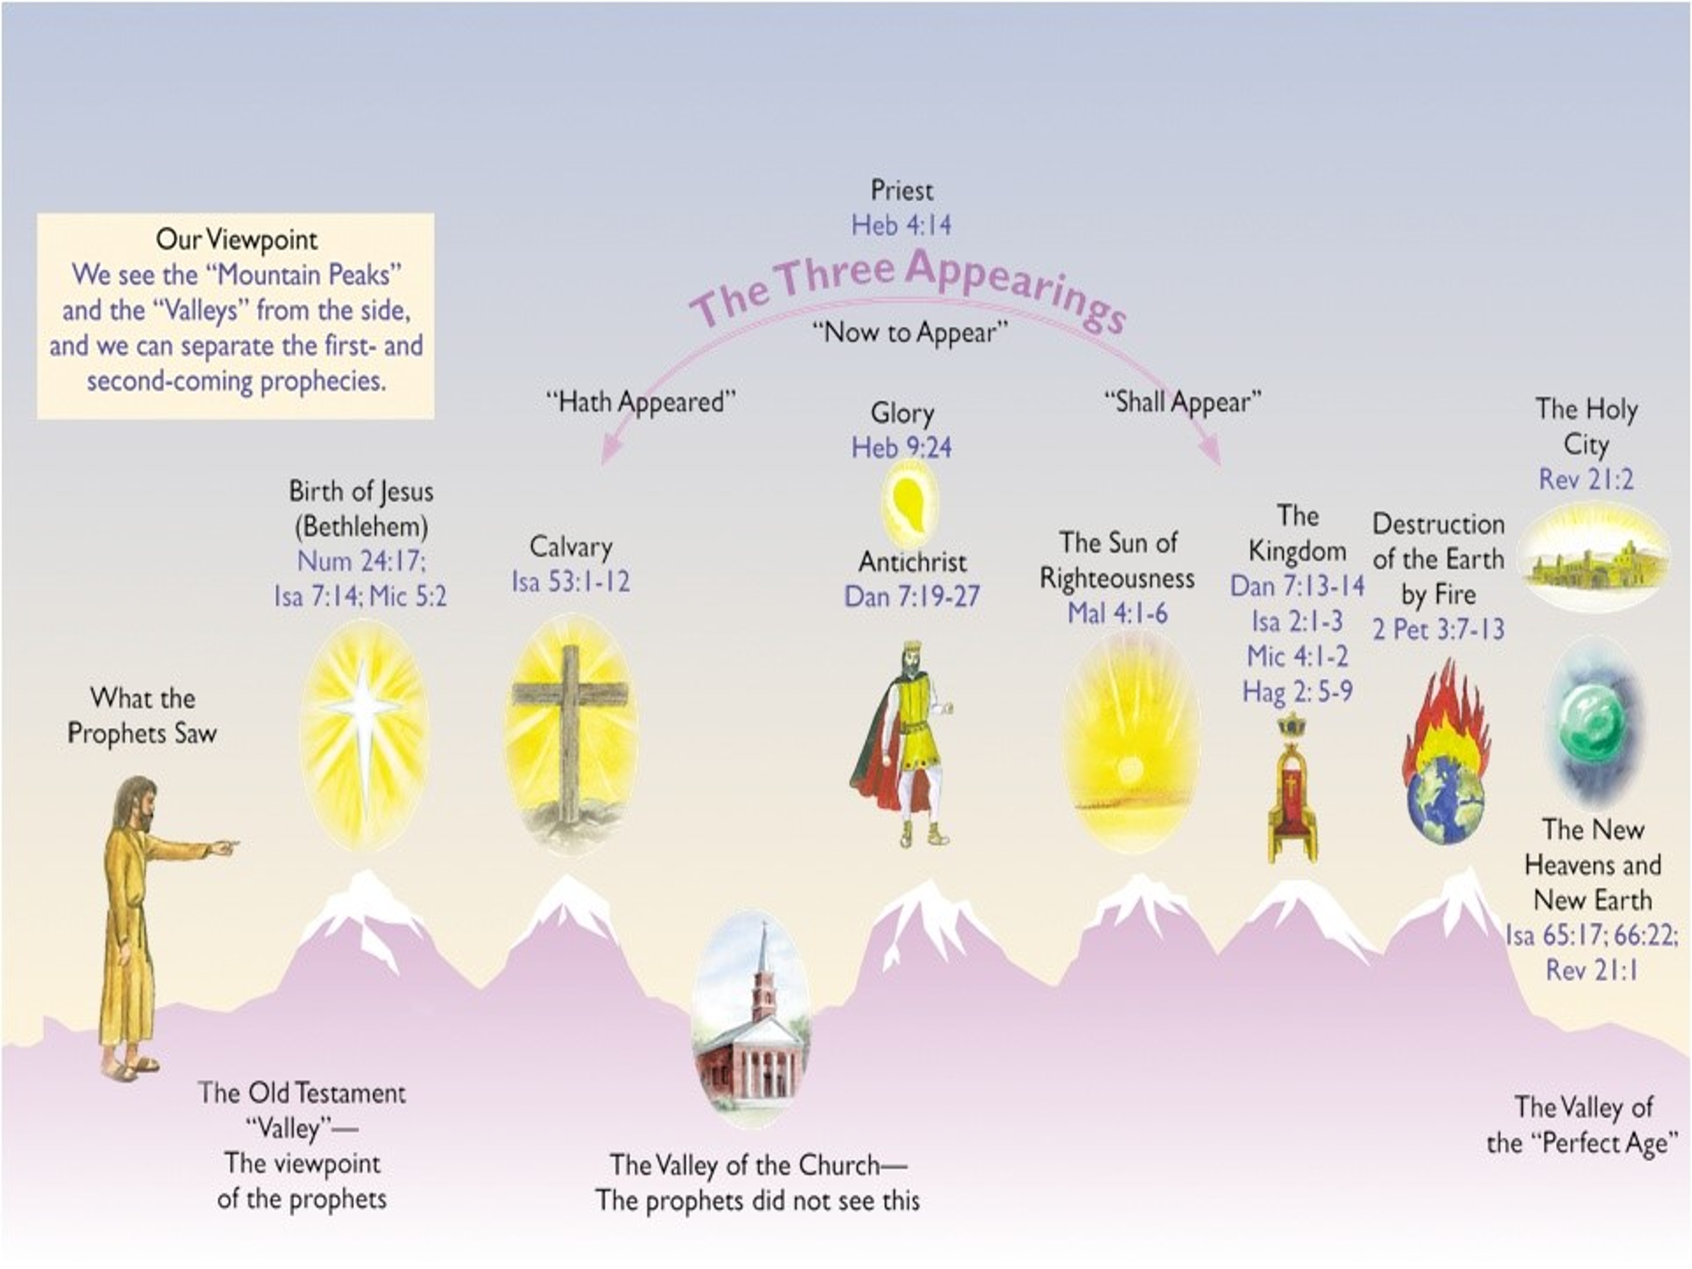

## **We have been in the two-division stage for a long time (1692 years). In 330 AD That’s when Constantine split it.**

## **God’s time frame is not our time frame!**

## ***2 Peter 3:8 But, beloved, do not forget this one thing, that with the Lord one day is as a thousand years, and a thousand years as one day.***

## **SO how does it become one world?**

## **Ezekiel 38-39 perhaps?**

## **Note the armies and who is in the center of it all?**

## ***Ezek 38:1 Now the word of the LORD came to me, saying, 2 “Son of man, set your face against Gog, of the land of Magog, the prince of Rosh, Meshech, and Tubal, and prophesy against him,***

## ***3 “and say, ‘Thus says the Lord GOD: “Behold, I am against you, O Gog, the prince of Rosh, Meshech, and Tubal. 4 “I will turn you around, put hooks into your jaws, and lead you out, with all your army, horses, and horsemen,***

## ***all splendidly clothed, a great company with bucklers and shields, all of them handling swords. 5 “Persia, Ethiopia, and Libya are with them, all of them with shield and helmet;***

## **1. These were identified as Russia, Iran, Ethiopia area, Somalia, Germany area and Armenia/Georgia/Southern Russia.**

## **2. They are from the far North vs 6,15; 39:2**

## **3. God is the one that leads them out 38:4,16,17**

## **4. The time of this invasion is significant**

## ***38:8 “After many days you will be visited. In the latter years you will come into the land of those brought back from the sword and gathered from many people on the mountains of Israel, which had long been desolate; they were brought out of the nations, and now all of them dwell safely.***

## ***16 “You will come up against My people Israel like a cloud, to cover the land. It will be in the latter days that I will bring you against My land,***



## ***so that the nations may know Me, when I am hallowed in you, O Gog, before their eyes.”***

## **5. The type of Israel then, is the type of Israel now!**



## ***38:8 “After many days you will be visited. In the latter years you will come into the land of those brought back from the sword and gathered from many people on the mountains of Israel, which had long been desolate;***

## ***they were brought out of the nations, and now all of them dwell safely.***

## ***38:11 “You will say, ‘I will go up against a land of unwalled villages; I will go to a peaceful people, who dwell safely, all of them dwelling without walls, and having neither bars nor gates’– 12 “to take plunder and to take booty, to stretch out your hand against the waste places that are again inhabited, and against a people gathered from the nations, who have acquired livestock and goods, who dwell in the midst of the land.***

## **6. The nations who protest Vs 38:13**

## **North America, South America, Central America, Western Europe, Saudi Arabia.**

## **7. Israel must be in the land; occupy the mountains and Jerusalem.**

## ***39:4 “You shall fall upon the mountains of Israel, you and all your troops and the peoples who are with you; I will give you to birds of prey of every sort and to the beasts of the field to be devoured.***

## **The Battle**

## ***38:18 “And it will come to pass at the same time, when Gog comes against the land of Israel,” says the Lord GOD, “that My fury will show in My face.***

## ***19 “For in My jealousy and in the fire of My wrath I have spoken: ‘Surely in that day there shall be a great earthquake in the land of Israel, 20 ‘so that the fish of the sea, the birds of the heavens, the beasts of the field,***

## ***all creeping things that creep on the earth, and all men who are on the face of the earth shall shake at My presence. he mountains shall be thrown down, the steep places shall fall, and every wall shall fall to the ground.’***

## ***21 “I will call for a sword against Gog throughout all My mountains,” says the Lord GOD. “Every man’s sword will be against his brother. 22 “And I will bring him to judgment with pestilence and bloodshed;***



## ***I will rain down on him, on his troops, and on the many peoples who are with him, flooding rain, great hailstones, fire, and brimstone.***

## **Questions?**

## **Next week: Pre-mid-post?????**