Ten Kings North and Ten Kings South
31 July 2022

This time period lasts from

931BC 721BC

1Kings 12 2Kings 17

It begins with sin and division and ends in captivity.

Galatians 5:14 For all the law is fulfilled in one word, even in this: “You shall love your neighbor as yourself.” 15 But if you bite and devour one another, beware lest you be consumed by one another!

16 I say then: Walk in the Spirit, ….

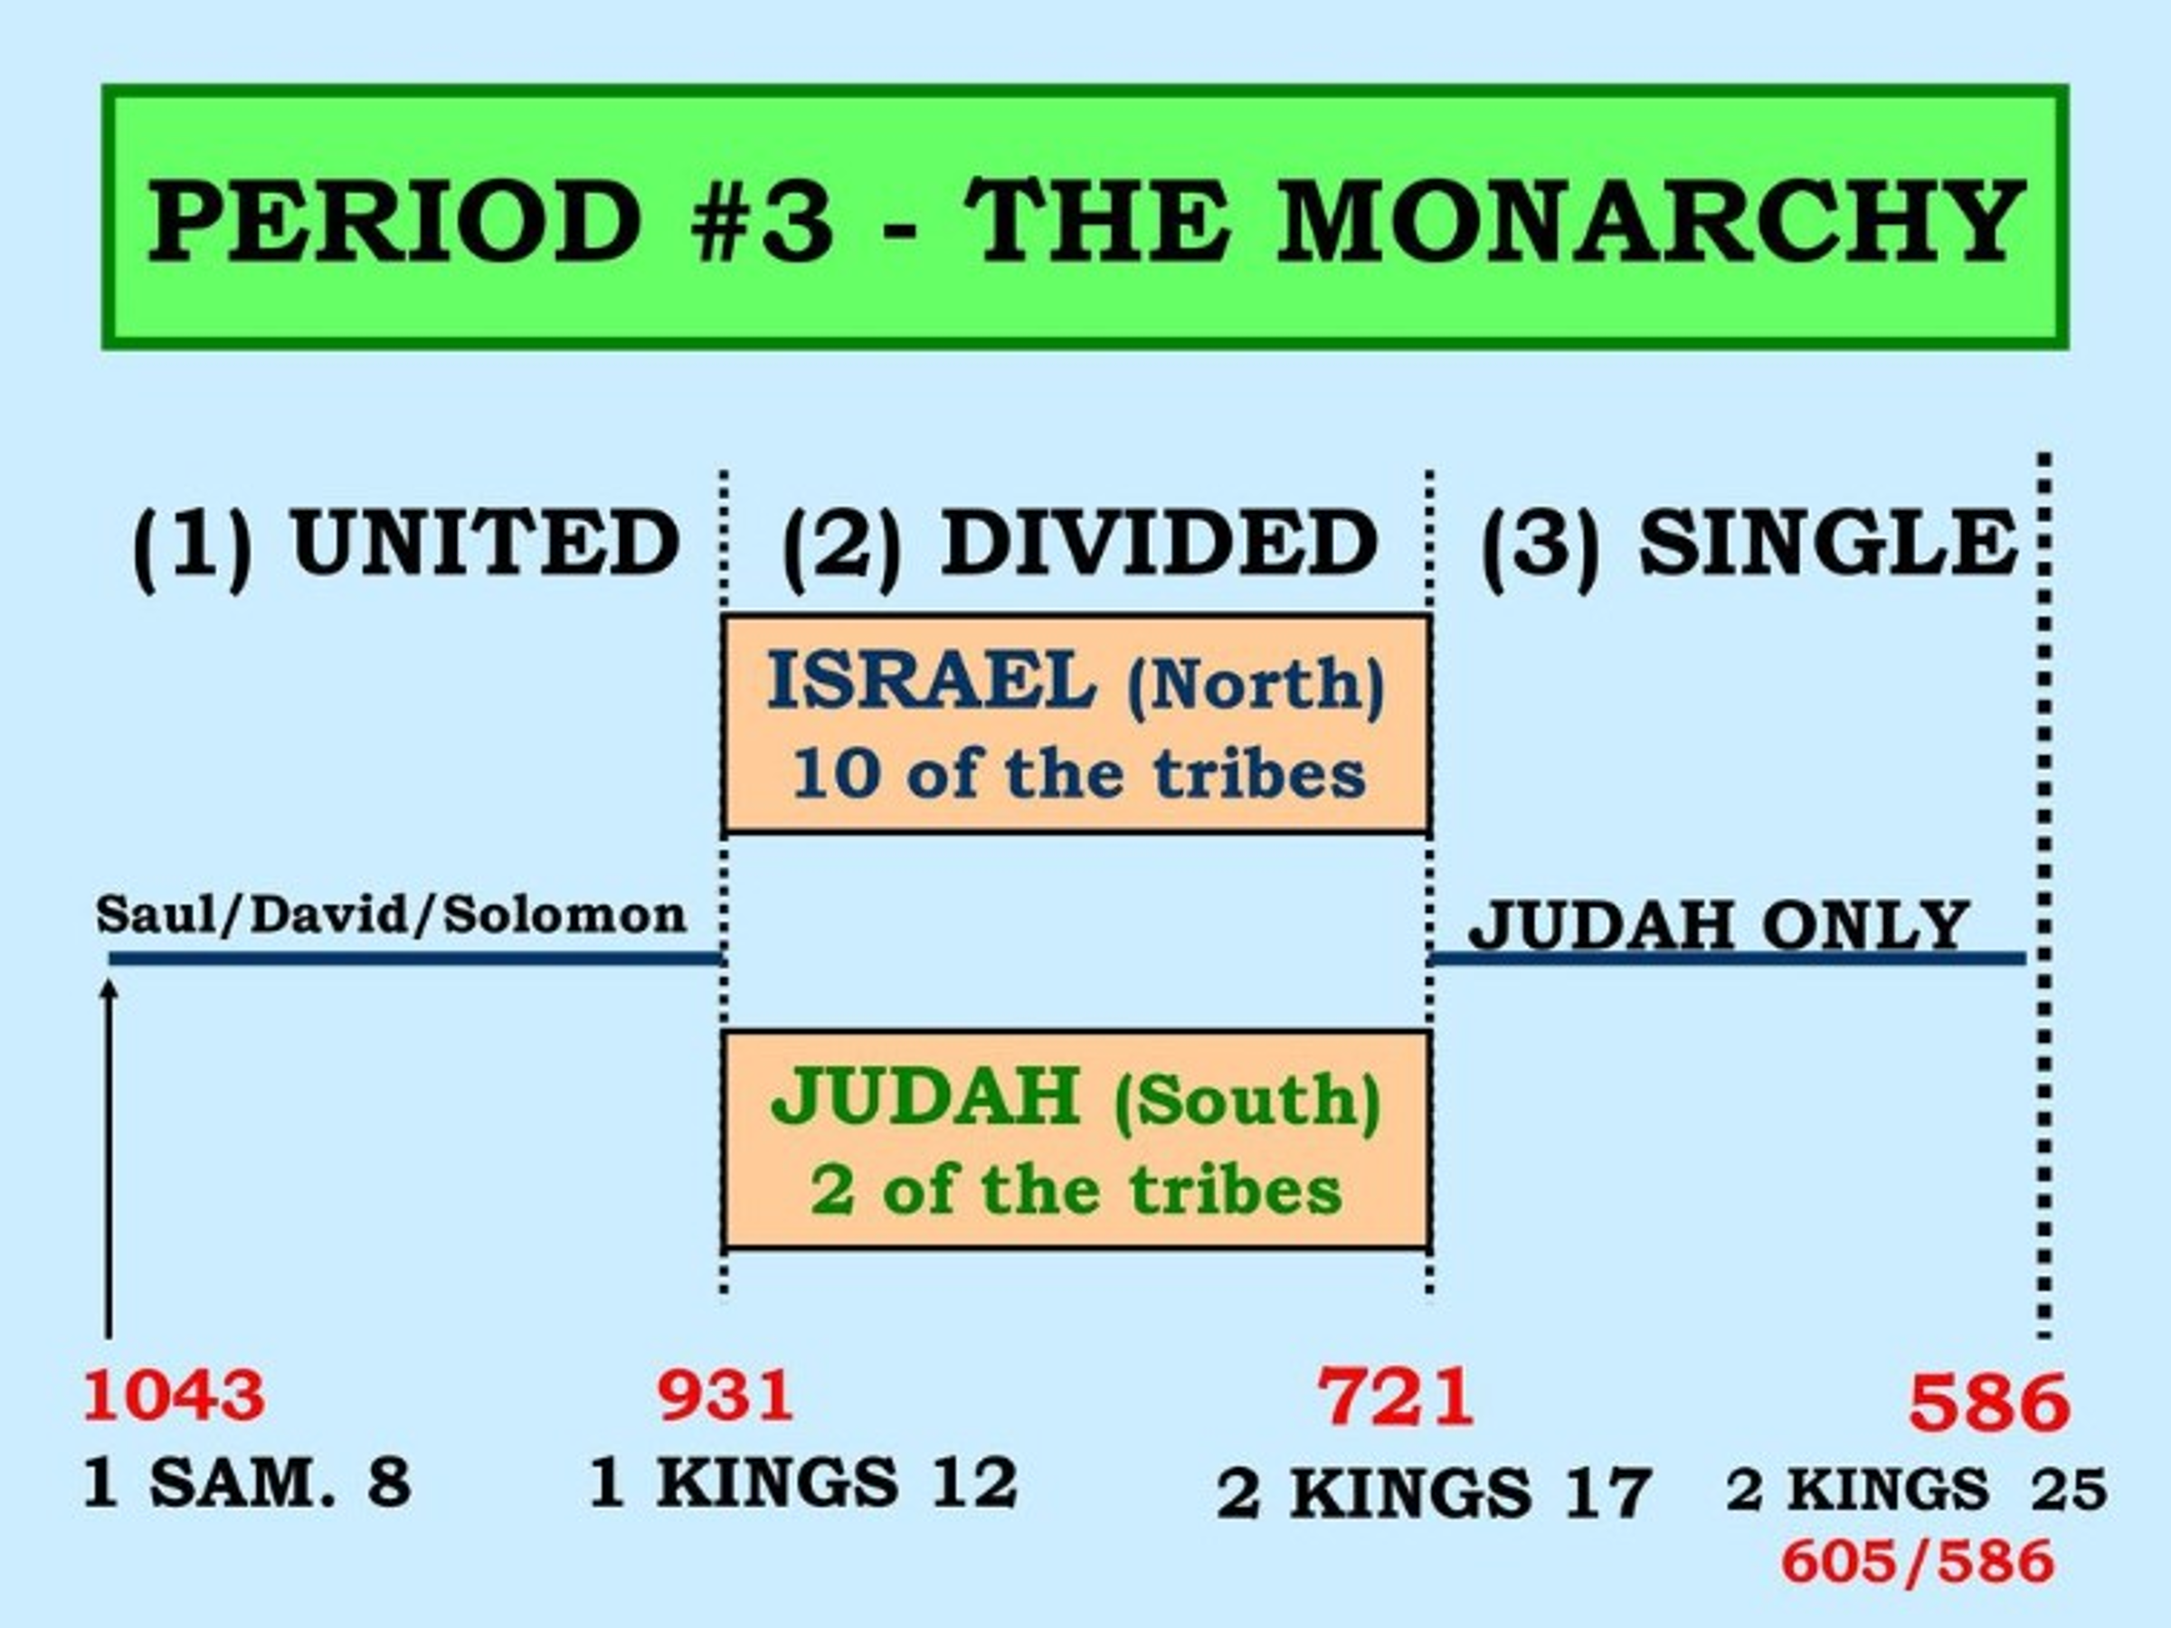

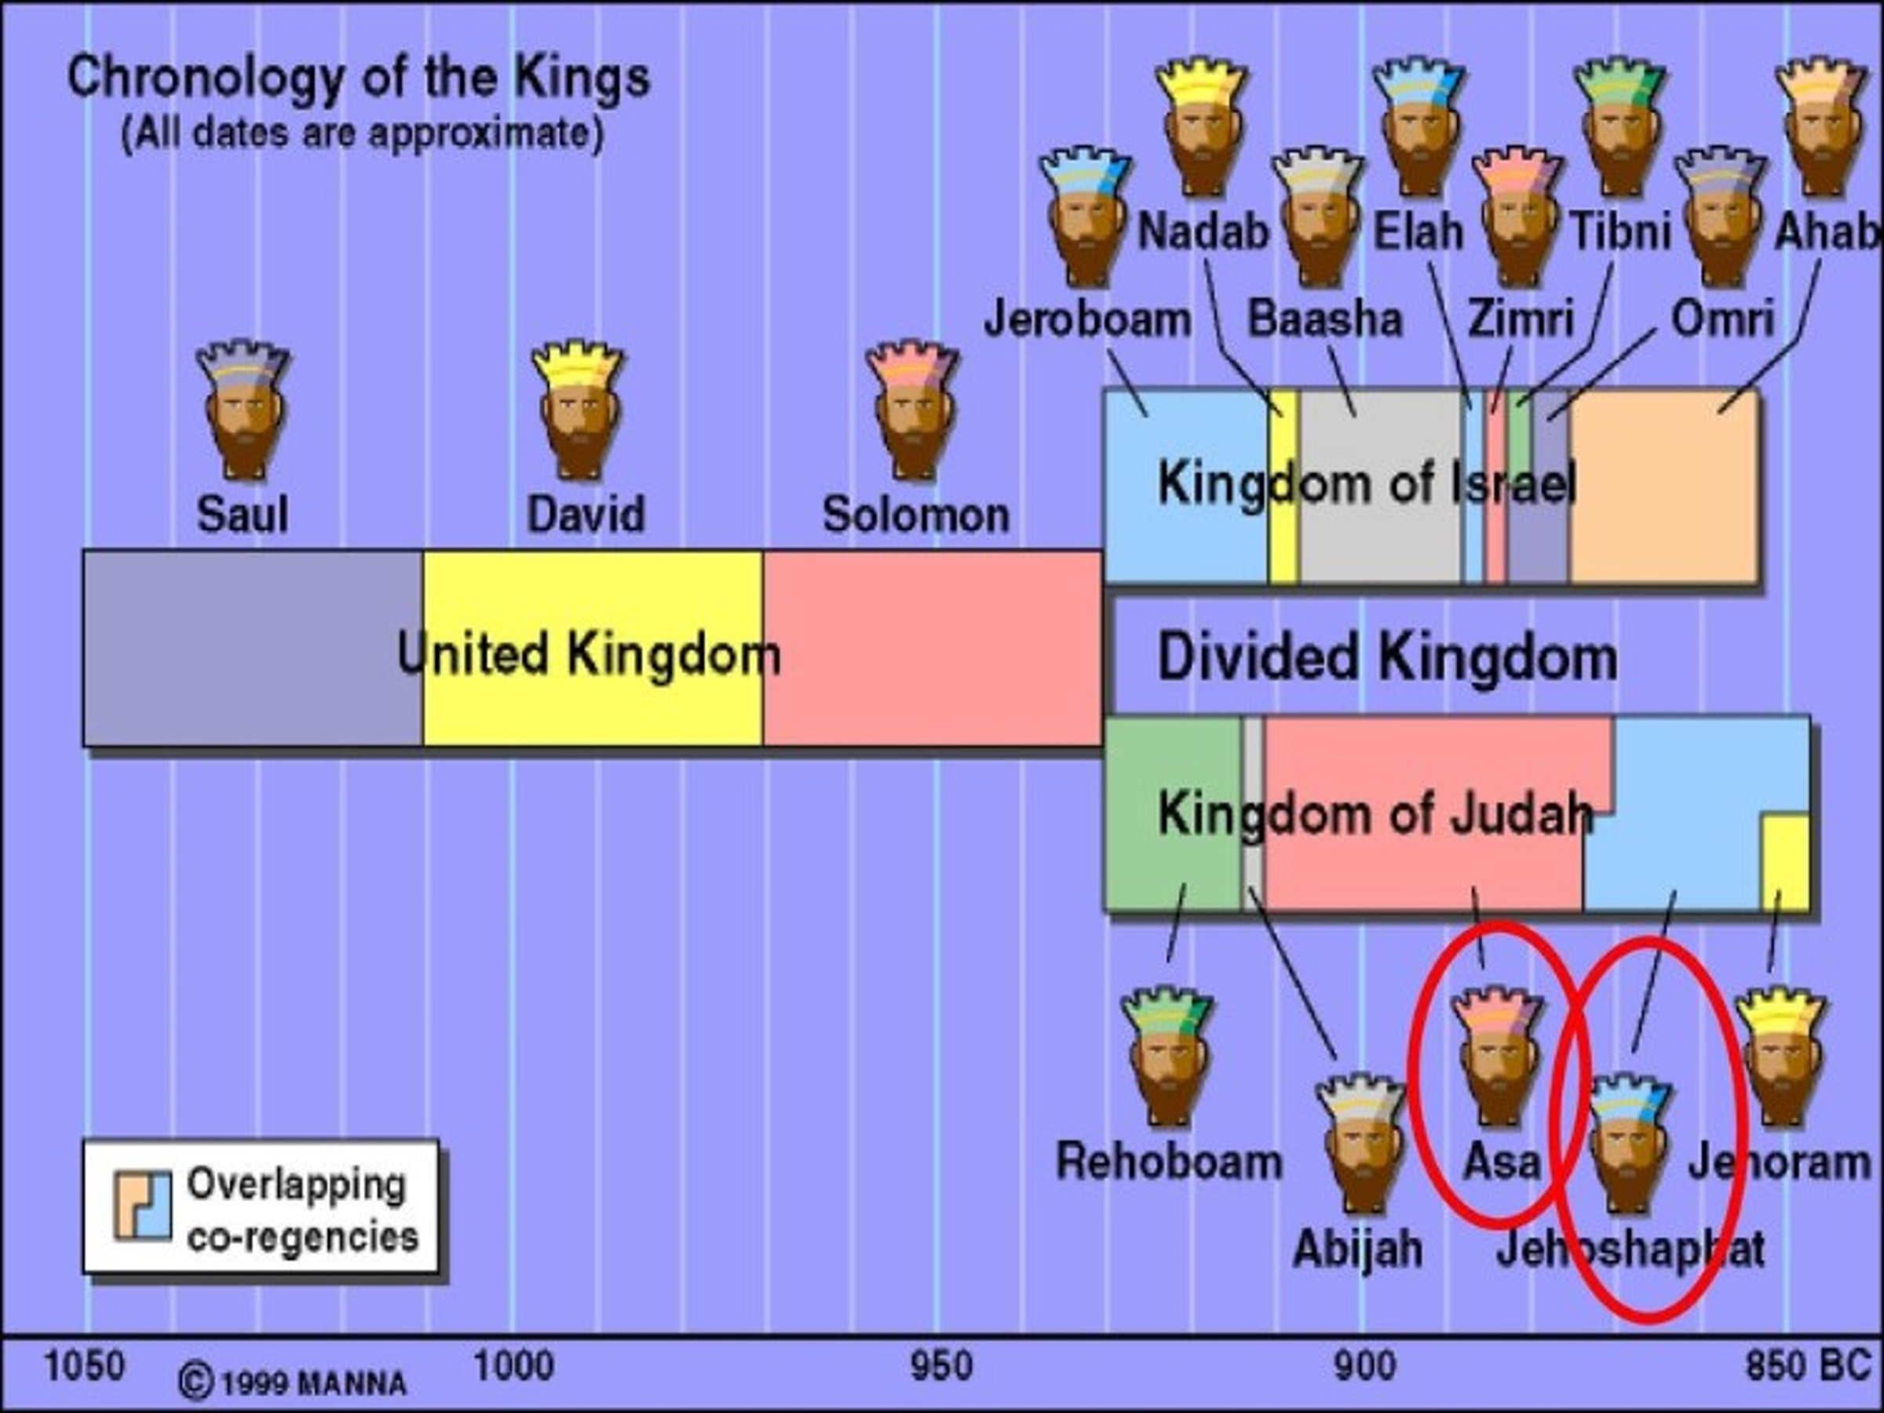

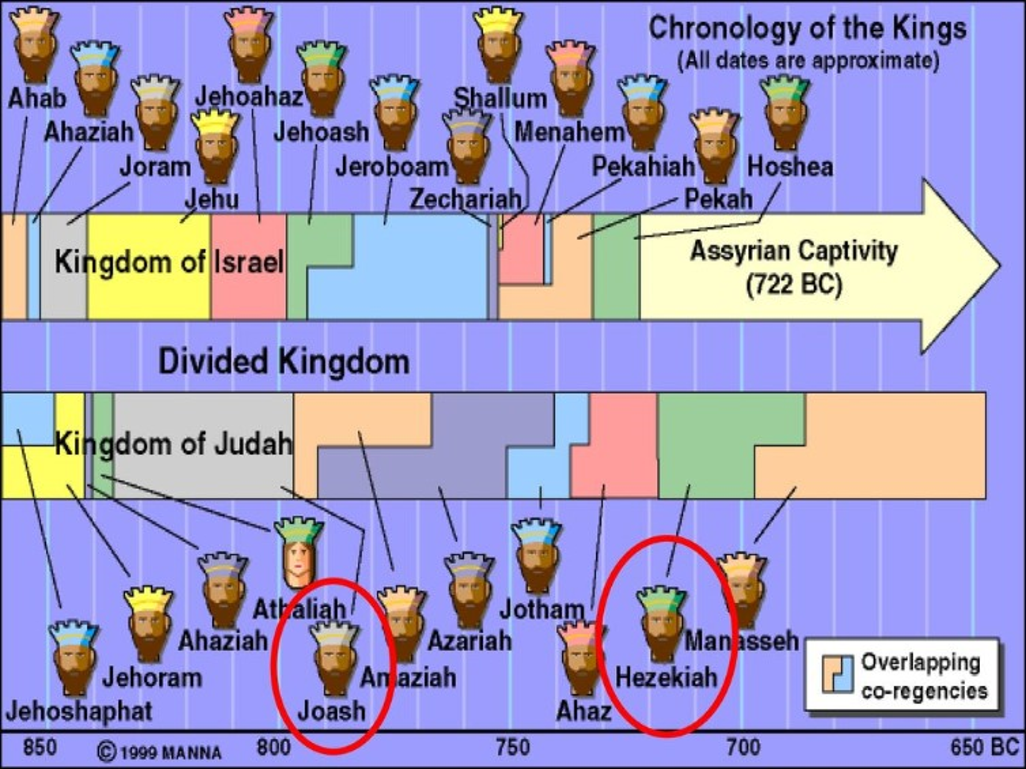

10 Kings North (Israel)

10 Kings South (Judah)

Israel:

Jeroboam: Splits the Nation into north and south. Fear of loss of power creates rival temples and rival priests. Introduces golden calves back into Israel. Gets beat in battle and eventually dies.

Nadab: Just like his daddy rules 2 years and Baasha kills him!

Baasha: Kills every single person related to Jeroboam, why? Because God’s judgment on Jeroboam. Fights with the south.

Elah: Just as wicked as daddy, provokes the Lord, reigns 2 years, then his servant Zimri kills him when he is drunk.

Zimri: Treacherous “Frienemy” to Elah and he kills everyone related to Baasha. Seven days later Comander of the Army Omri finds out and the people make him king. Zimri burns the house down on top of himself.

Tibni: tries to rule against Omri and dies

Omri: Reigns 12 years and was the worst up till that point, provokes the Lord.

Ahab: You think daddy was Bad? Wait till this guy. All the other kings before him though idol worshipers still had the mindset this was God. This King marries Jezebel who brings in baal worship.

1 Kings 16:33 And Ahab made a wooden image. Ahab did more to provoke the LORD God of Israel to anger than all the kings of Israel who were before him.

It is during this time that God raises up Elijah! So it begins…

The drought!

1Kgs 17:1 And Elijah the Tishbite, of the inhabitants of Gilead, said to Ahab, “As the LORD God of Israel lives, before whom I stand, there shall not be dew nor rain these years, except at my word.”

The battle on Mt Carmel

1 Kings 18:15 Then Elijah said, “As the LORD of hosts lives, before whom I stand, I will surely present myself to him today.” 16 So Obadiah went to meet Ahab, and told him; and Ahab went to meet Elijah.

17 Then it happened, when Ahab saw Elijah, that Ahab said to him, “Is that you, O troubler of Israel?” 18 And he answered, “I have not troubled Israel, but you and your father’s house have, in that you have forsaken the commandments of the LORD and have followed the Baals.

19 “Now therefore, send and gather all Israel to me on Mount Carmel, the four hundred and fifty prophets of Baal, and the four hundred prophets of Asherah, who eat at Jezebel’s table.”

20 So Ahab sent for all the children of Israel, and gathered the prophets together on Mount Carmel.

The real troubler is Ahab and his wife Jezebel. She is a nasty woman, she killed all the prophets of God except for the 100 hidden by this Obadiah. She is treacherous and does evil without even thinking about it.

Even near death she spews evil

2 Kings 9:31 Then, as Jehu entered at the gate, she said, “Is it peace, Zimri, murderer of your master?”

She has dressed herself up to show her royalty in this last act of defiance. Jehu doesn’t even address her but has the guys do this:

2 Kings 9:32 And he looked up at the window, and said, “Who is on my side? Who?” So two or three eunuchs looked out at him. 33 Then he said, “Throw her down.” So they threw her down, and some of her blood spattered on the wall and on the horses; and he trampled her underfoot.

34 And when he had gone in, he ate and drank. Then he said, “Go now, see to this accursed woman, and bury her, for she was a king’s daughter.” 35 So they went to bury her, but they found no more of her than the skull and the feet and the palms of her hands.

36 Therefore they came back and told him. And he said, “This is the word of the LORD, which He spoke by His servant Elijah the Tishbite, saying, ‘On the plot of ground at Jezreel dogs shall eat the flesh of Jezebel;

37 ‘and the corpse of Jezebel shall be as refuse on the surface of the field, in the plot at Jezreel, so that they shall not say, “Here lies Jezebel.” ’ ”

You don’t defy God! The wicked will be paid back in full!

Zech 14:12 And this shall be the plague with which the LORD will strike all the people who fought against Jerusalem: Their flesh shall dissolve while they stand on their feet, Their eyes shall dissolve in their sockets, And their tongues shall dissolve in their mouths.

13 It shall come to pass in that day That a great panic from the LORD will be among them. Everyone will seize the hand of his neighbor, And raise his hand against his neighbor’s hand;

15 Such also shall be the plague On the horse and the mule, On the camel and the donkey, And on all the cattle that will be in those camps. So shall this plague be.

Rev 19:11 Now I saw heaven opened, and behold, a white horse. And He who sat on him was called Faithful and True,

and in righteousness He judges and makes war.

12 His eyes were like a flame of fire, and on His head were many crowns. He had a name written that no one knew except Himself. 13 He was clothed with a robe dipped in blood, and His name is called The Word of God.

14 And the armies in heaven, clothed in fine linen, white and clean, followed Him on white horses.

15 Now out of His mouth goes a sharp sword, that with it He should strike the nations. And He Himself will rule them with a rod of iron. He Himself treads the winepress of the fierceness and wrath of Almighty God.

16 And He has on His robe and on His thigh a name written: KING OF KINGS AND LORD OF LORDS.

Isaiah 63:2 Why is Your apparel red, And Your garments like one who treads in the winepress?

3 “I have trodden the winepress alone, And from the peoples no one was with Me. For I have trodden them in My anger, And trampled them in My fury; Their blood is sprinkled upon My garments, And I have stained all My robes.

4 For the day of vengeance is in My heart, And the year of My redeemed has come.

5 I looked, but there was no one to help, And I wondered That there was no one to uphold; Therefore My own arm brought salvation for Me; And My own fury, it sustained Me.

6 I have trodden down the peoples in My anger, Made them drunk in My fury, And brought down their strength to the earth.”

Next week: The Mt Carmel battle and last 2 kings of the North.

