## **The reign Of the Kings**

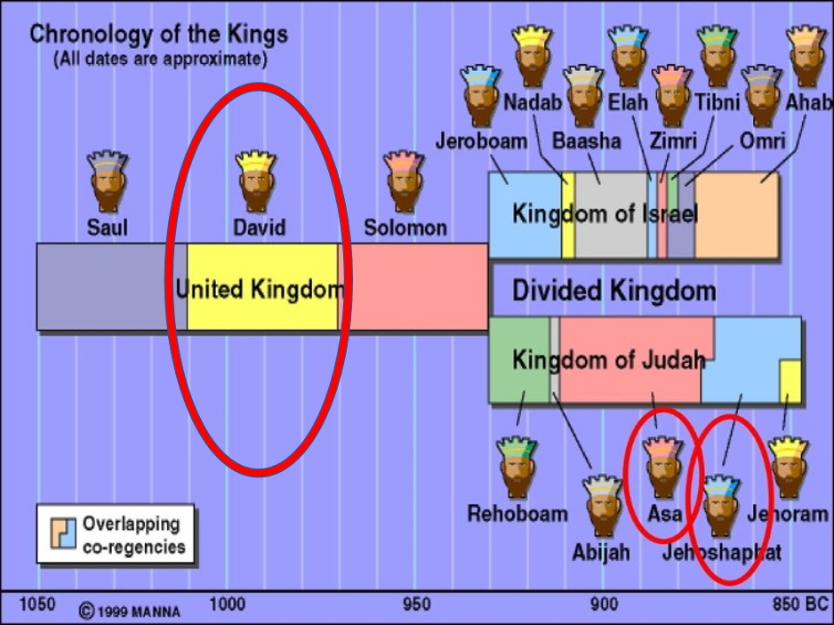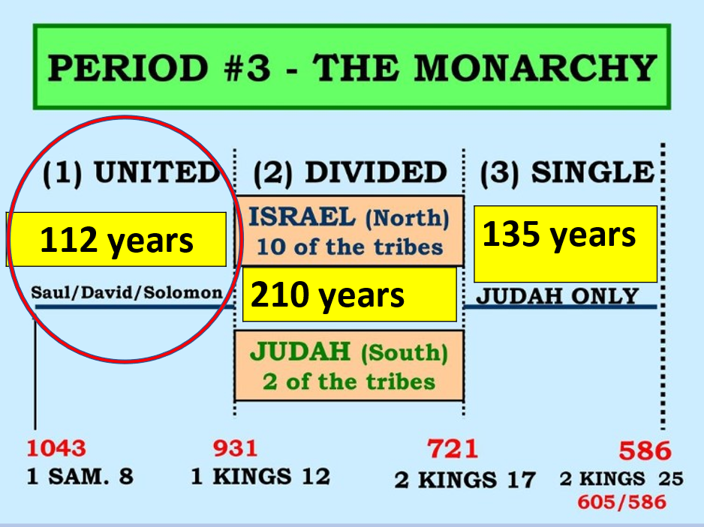

## **United kingdom lasts from 1 Samuel 8**

## **1 Kings 12.**

## **1043BC 931BC (112 years)**

## **Saul, David, Solomon**

## **For the most part it is a pinnacle time for Israel. There is expansion, wealth, strong military, a very fruitful time for the kingdom and its citizens.**

## **David’s 40-year reign stretches from**

## **2 Sam 1:1 1 Kings 2:10**

## **David is one of the more famous kings.**

## **The Lord picks him according to…**

## ***1Sam 16:7 But the LORD said to Samuel, “Do not look at his appearance or at his physical stature, because I have refused him. For the LORD does not see as man sees; for man looks at the outward appearance, but the LORD looks at the heart.”***

## **3 different lessons we can learn from David**

## **David and the Philistine**

## **Goliath was used as an example of just how weak the flesh is before God**

## **He was a warrior giant at almost 10 feet**

## **The armor he wore was 157lbs**

## **The spear was 15lbs, and if it hit, would leave a hole in you a football could pass through.**

## **God destroys him with a rock thrown by a**

## **youth not even wearing armor.**

## ***1Sam 17:45 Then David said to the Philistine, “You come to me with a sword, with a spear, and with a javelin. But I come to you in the name of the LORD of hosts, the God of the armies of Israel, whom you have defied.***

## ***1Sam 17:47 “Then all this assembly shall know that the LORD does not save with sword and spear; for the battle is the LORD’s, and He will give you into our hands.”***

## **The “great” Goliath falls on his face…BEFORE our great God and Savior!**

## ***1Sam 17:49 Then David put his hand in his bag and took out a stone; and he slung it and struck the Philistine in his forehead, so that the stone sank into his forehead, and he fell on his face to the earth.***

## **David cuts off his head with Goliath’s own sword.**

## **Important lesson here is not how big or strong our adversaries and problems are but HOW BIG IS OUR GOD!**

## **David is also not without sin and its consequences**

## **The sin: Bathsheba and Uriah 2 Samuel 11**

## **The consequence:**

## ***2Sam 12:10 ‘Now therefore, the sword shall never depart from your house, because you have despised Me, and have taken the wife of Uriah the Hittite to be your wife.’***

## ***11 “Thus says the LORD: ‘Behold, I will raise up adversity against you from your own house;***

## ***and I will take your wives before your eyes and give them to your neighbor, and he shall lie with your wives in the sight of this sun.***

## ***12 ‘For you did it secretly, but I will do this thing before all Israel, before the sun.’ ”14 “However, because by this deed you have given great occasion to the enemies of the LORD to blaspheme, the child also who is born to you shall surely die.”***

## **The baby dies, Absalom kills Amnon, who raped his sister, and Absalom dies after he takes the kingdom from David**

## **The important lesson here is:**

## ***because by this deed you have given great occasion to the enemies of the LORD to blaspheme***

## **When we sin, we have the potential to be guilty of this in varying degrees.**

## ***1Tim 5:24 Some men’s sins are clearly evident, preceding them to judgment, but those of some men follow later.***

## **“Sin will always take you farther than you wanted to go, keep you longer than you**

## **Wanted to stay and cost you more than you wanted to pay.”**

## **Alcoholism will take you farther than you want to go, keep you longer than you want to stay, and cost you more than you want to pay.**

## **Drug addiction will take you farther than you want to go, keep you longer than you want to stay, and cost you more than you want to pay.**

## **Gossip will take you farther than you want to go, keep you longer than you want to stay, and cost you more than you want to pay.**

## **Stealing will take you farther than you want to go, keep you longer than you want to stay, and cost you more than you want to pay.**

## **Pornography will take you farther than you want to go, keep you longer than you want to stay, and cost you more than you want to pay.**

## **Deception will take you farther than you want to go, keep you longer than you want to stay, and cost you more than you want to pay.**

## **And with David, adultery, and murder, with deception, took him further than he wanted to go, kept him longer than he wanted to stay, and cost him more than he wanted to pay.**

## **Lesson 3**

## **However, with God there is great forgiveness. And the end of David is better than the beginning**

## ***1Kings 2:1 Now the days of David drew near that he should die, and he charged Solomon his son, saying: 2 “I go the way of all the earth; be strong, therefore, and prove yourself a man.***

## ***3 “And keep the charge of the LORD your God: to walk in His ways,***

## ***to keep His statutes, His commandments, His judgments, and His testimonies, as it is written in the Law of Moses, that you may prosper in all that you do and wherever you turn;***

## ***4 “that the LORD may fulfill His word which He spoke concerning me, saying, ‘If your sons take heed to their way, to walk before Me in truth with all their heart and with all their soul,’ He said, ‘you shall not lack a man on the throne of Israel.’***

## ***1Kgs 2:10 So David rested with his fathers, and was buried in the City of David.1Kgs 11 The period that David reigned over Israel was forty years; seven years he reigned in Hebron, and in Jerusalem he reigned thirty-three years.***

## ***12 Then Solomon sat on the throne of his father David; and his kingdom was firmly established.***