God alone is faithful
24 July 2022
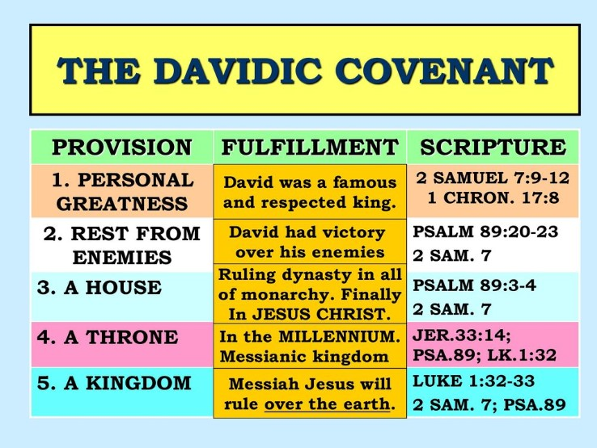

This covenant will be fulfilled because God is who He is!

Ps 89:1 I WILL sing of the mercies of the LORD forever; With my mouth will I make known Your faithfulness to all generations. 2 For I have said, “Mercy shall be built up forever; Your faithfulness You shall establish in the very heavens.”

3 “I have made a covenant with My chosen, I have sworn to My servant David: 4 ‘Your seed I will establish forever, And build up your throne to all generations.’ ” ​Selah

The Davidic line is remembered

Luke 1:31 “And behold, you will conceive in your womb and bring forth a Son, and shall call His name JESUS. 32 “He will be great, and will be called the Son of the Highest; and the Lord God will give Him the throne of His father David.

33 “And He will reign over the house of Jacob forever, and of His kingdom there will be no end.”

Luke 1:54 He has helped His servant Israel, In remembrance of His mercy,

55 As He spoke to our fathers, To Abraham and to his seed forever.”

David’s throne extends to the kingdom

Jer 30:9 But they shall serve the LORD their God, And David their king, Whom I will raise up for them.

Hos 3:4 For the children of Israel shall abide many days without king or prince, without sacrifice or sacred pillar, without ephod or teraphim.

5 Afterward the children of Israel shall return and seek the LORD their God and David their king. They shall fear the LORD and His goodness in the latter days.

Ezek 34:24 “And I, the LORD, will be their God, and My servant David a prince among them; I, the LORD, have spoken.

As we enter this next period that many of us kinda ignore, we’ll need to remember that man fails but God doesn’t.

1 King 12----2 Kings 17

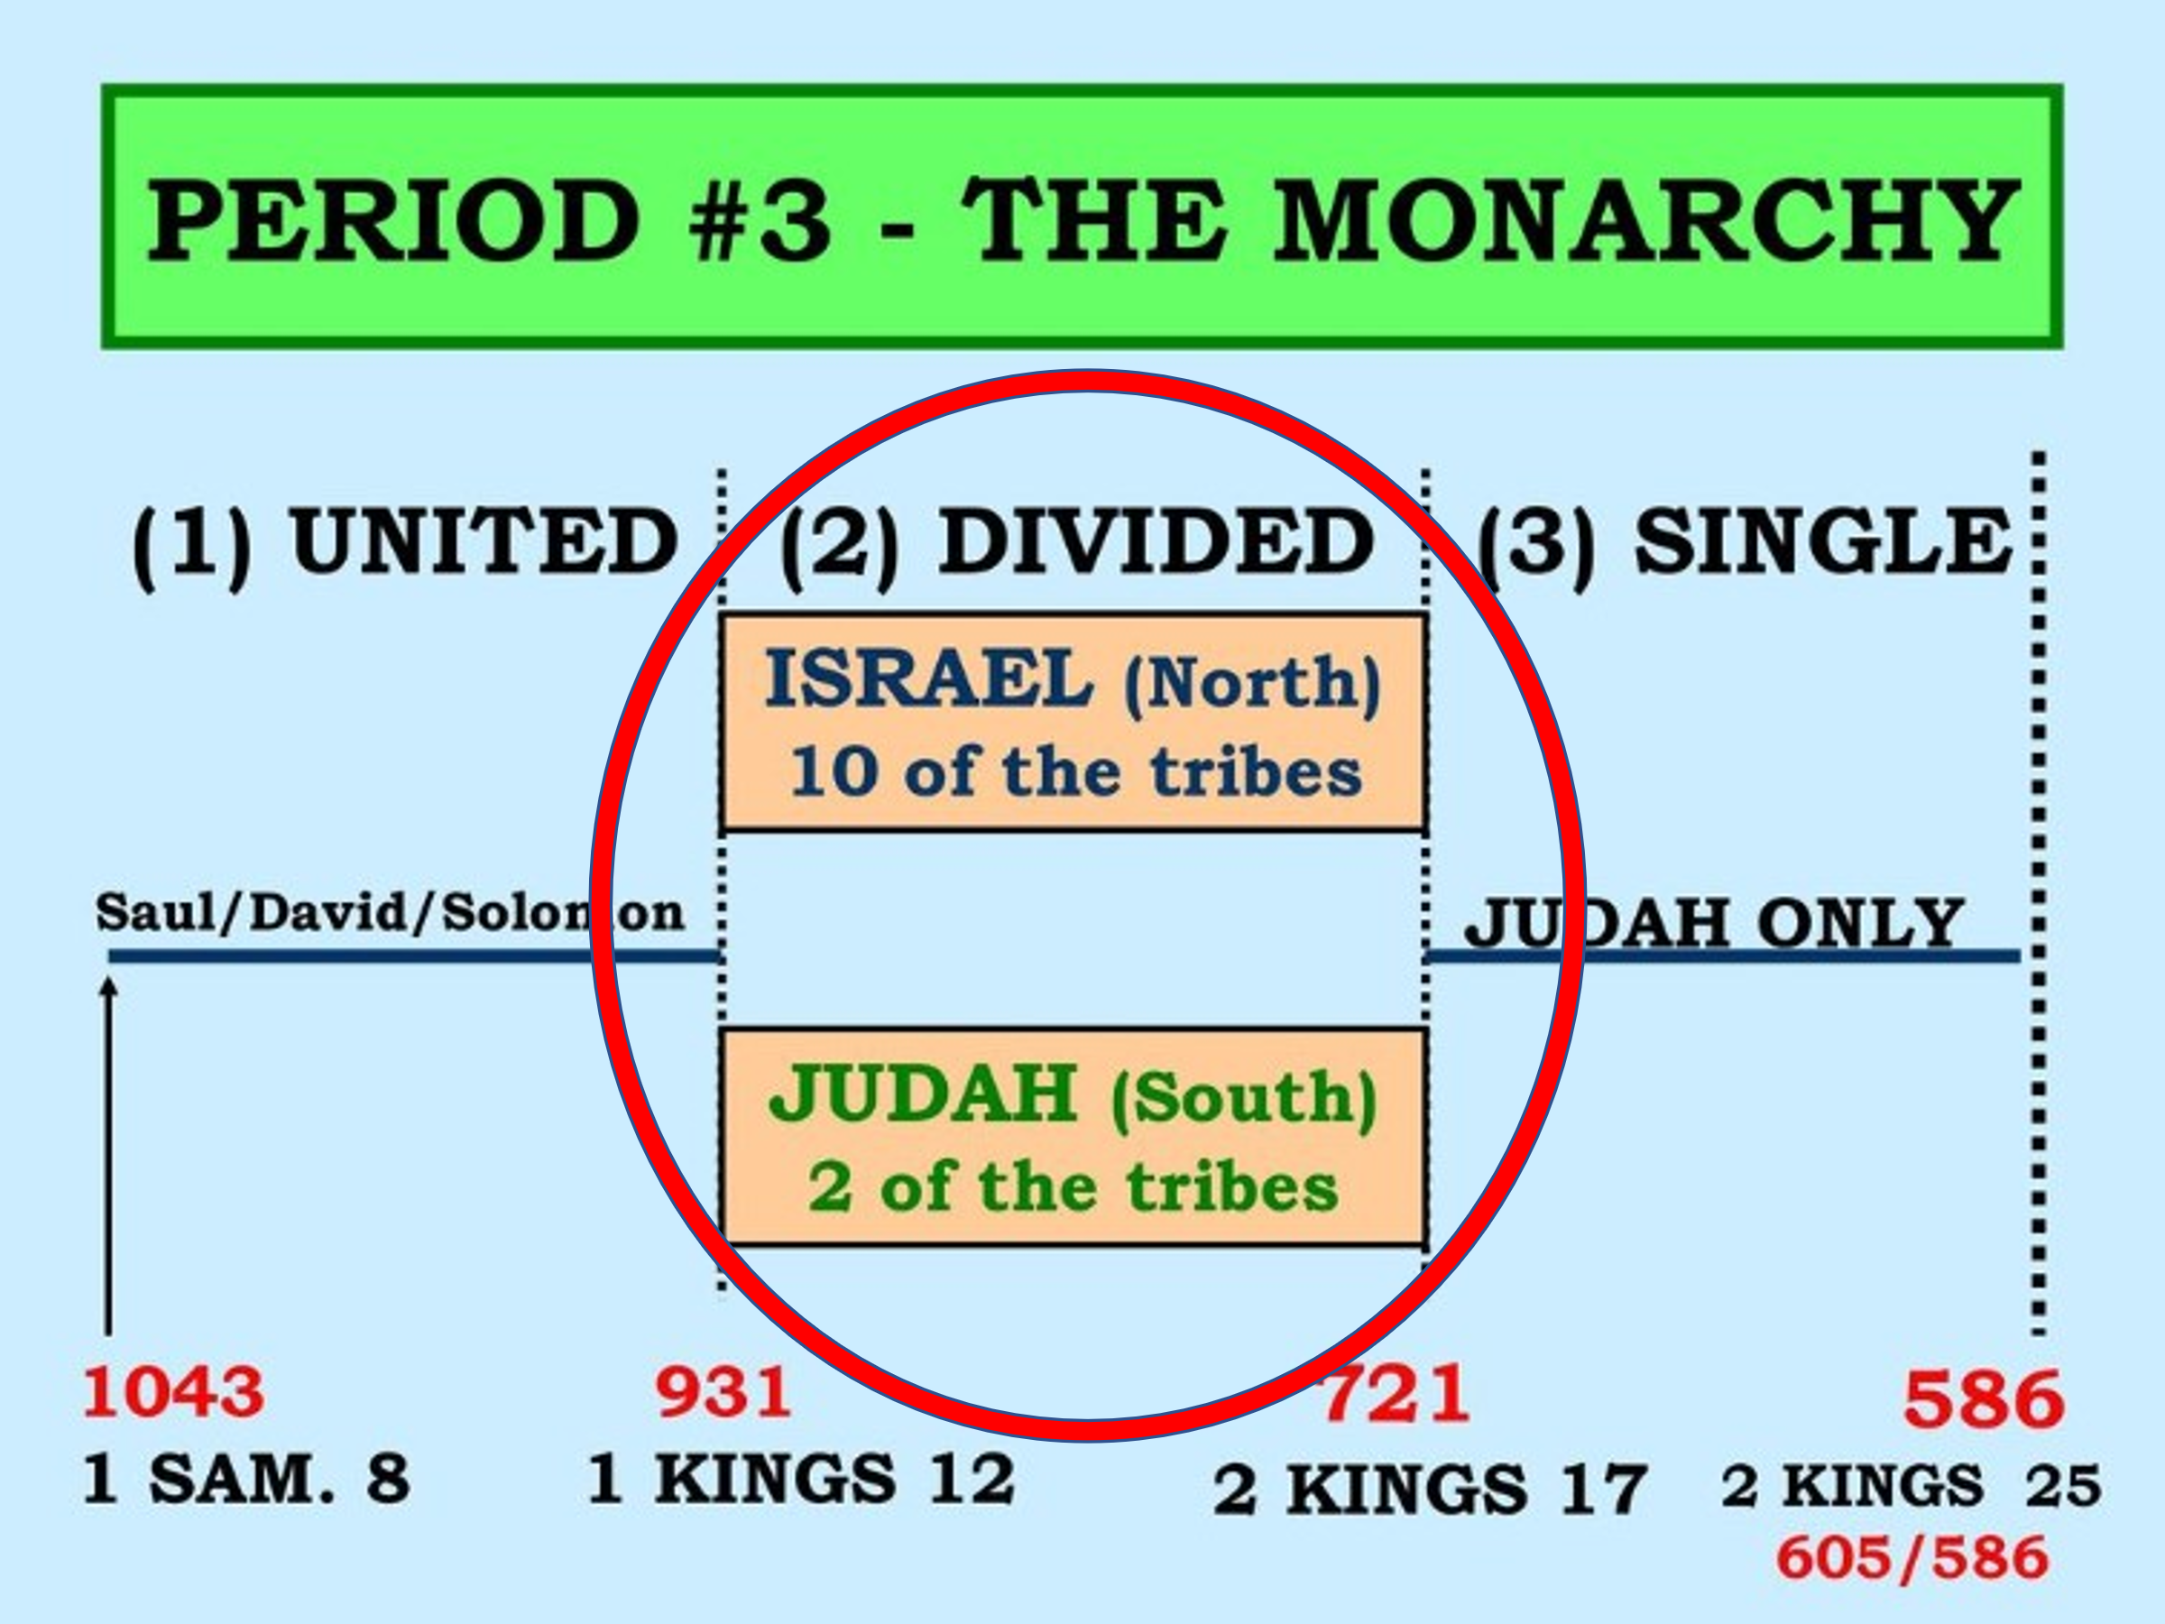

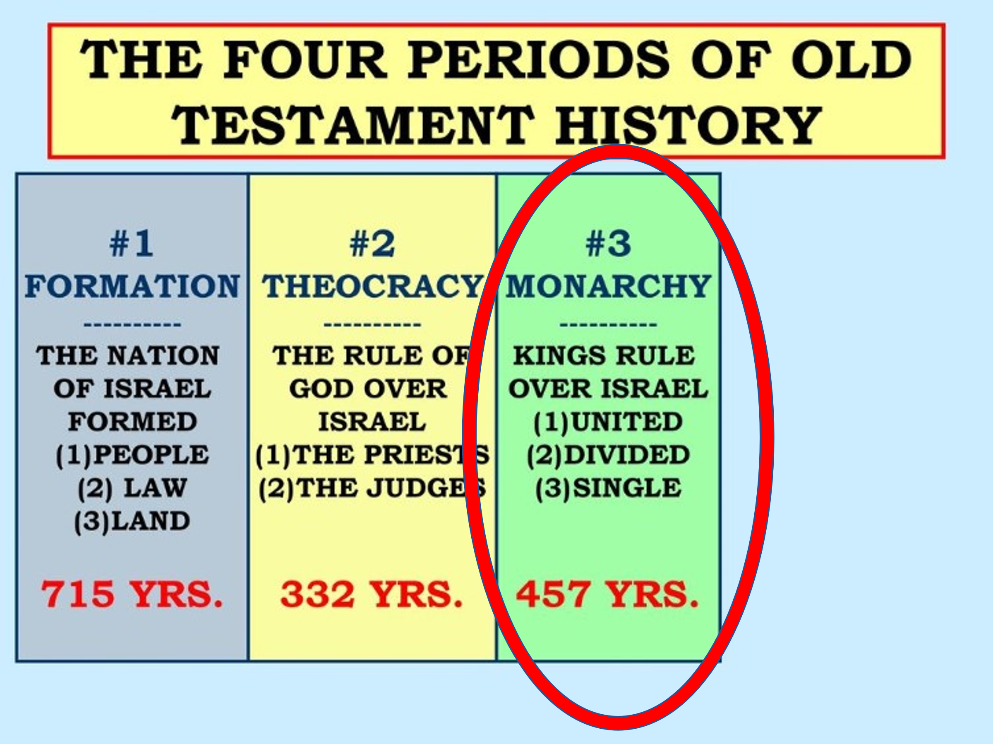

40 different kings' rule in this divided time

20 in Israel north

20 in Judah south

Israel north has no more Godly Kings and they are removed by God through Assyria in 721 BC

Judah or the Southern Kingdom lasts till 586 BC and is removed by Babylonia.

And this is how things begin to go astray:

Solomon, his servant Jeroboam and his son Rehoboam.

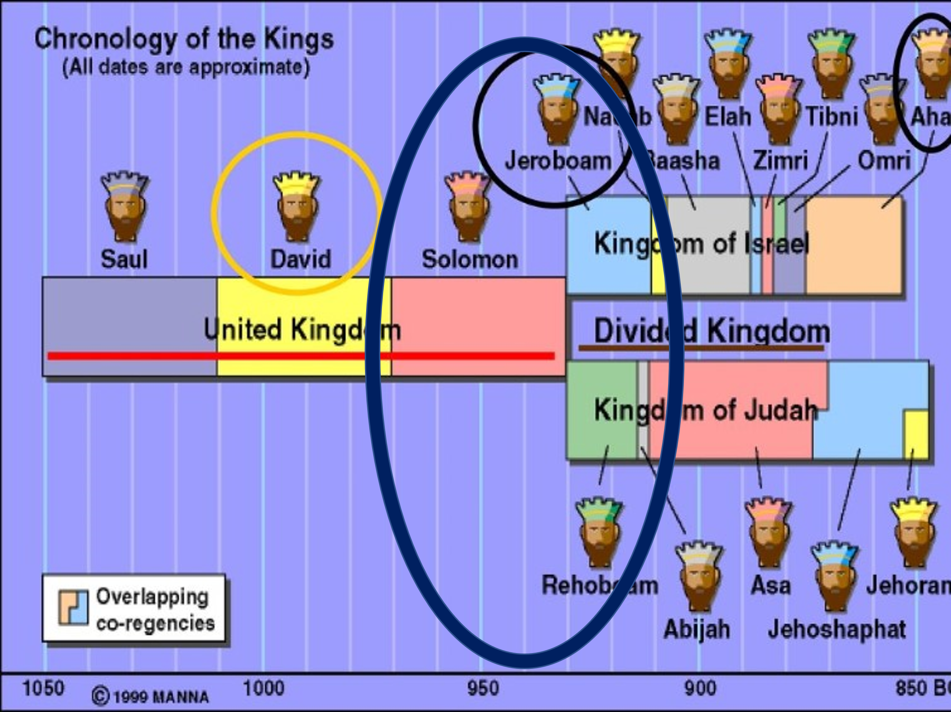

1 Kings 11:9 So the LORD became angry with Solomon, because his heart had turned from the LORD God of Israel, who had appeared to him twice, 10 and had commanded him concerning this thing, that he should not go after other gods; but he did not keep what the LORD had commanded.

11 Therefore the LORD said to Solomon, “Because you have done this, and have not kept My covenant and My statutes, which I have commanded you,

I will surely tear the kingdom away from you and give it to your servant. 12 “Nevertheless I will not do it in your days, for the sake of your father David; I will tear it out of the hand of your son.

13 “However I will not tear away the whole kingdom; I will give one tribe to your son for the sake of My servant David, and for the sake of Jerusalem which I have chosen.”

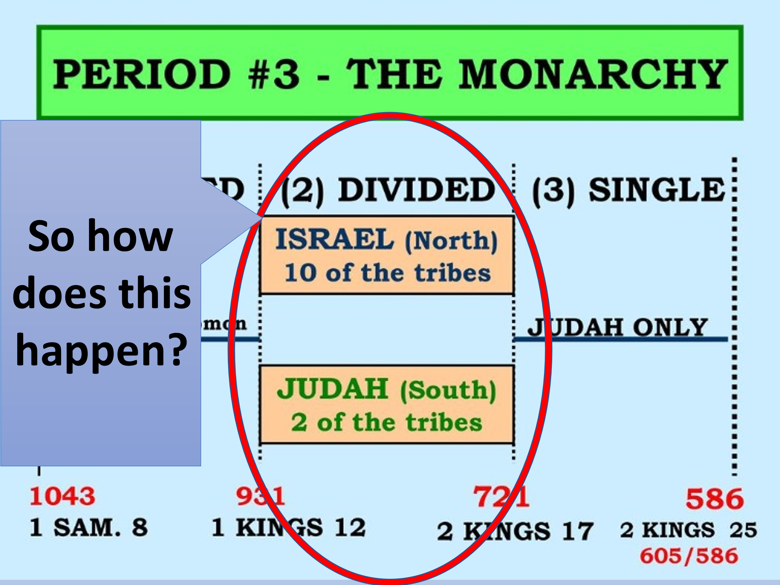

God says to Jeroboam:

1 Kings 11:31 And he said to Jeroboam, “Take for yourself ten pieces, for thus says the LORD, the God of Israel: ‘Behold, I will tear the kingdom out of the hand of Solomon and will give ten tribes to you 32 ‘(but he shall have one tribe for the sake of My servant David, and for the sake of Jerusalem, the city which I have chosen out of all the tribes of Israel),

The other tribe's defect to Solomon's servant Jeroboam in the North because of this foolish move by Solomon’s son Rehoboam.

When he takes power the Elder’s tell him reduce the taxes and they will all follow you. Instead, he listens to his foolish young friends.

1 Kings 12:8 But he rejected the advice which the elders had given him, and consulted the young men who had grown up with him, who stood before him.

9 And he said to them, “What advice do you give? How should we answer this people who have spoken to me, saying, ‘Lighten the yoke which your father put on us’?”

10 Then the young men who had grown up with him spoke to him, saying, “Thus you should speak to this people who have spoken to you, saying, ‘Your father made our yoke heavy, but you make it lighter on us’–thus you shall say to them:

‘My little finger shall be thicker than my father’s waist! 11 ‘And now, whereas my father put a heavy yoke on you, I will add to your yoke; my father chastised you with whips, but I will chastise you with scourges!’ ”

He ends up with an Israeli tea party event!

10 tribes say goodbye and join Jeroboam and there you have the split!!!!

Next week: Fear from Jeroboam leads Israel down the path of Idolatry!

