The major OT covenants
July 17, 2022

Last week we learned about the Abrahamic covenant.

To Abraham it meant

Descendants

A great nation

Prosperity

Kings would come from him and that they did!

Through those descendants namely Isaac and Jacob, came Israel the Jewish nation and eventually the Land.

To all the nations, the salvation of the race of man would come. Everything the fall of man did would be undone, through the promise…

Gal 3:8 And the scripture, foreseeing that God would justify the nations through faith, preached before the gospel to Abraham, saying, In you shall all nations be blessed.

Gal 3:14 in order that in Christ Jesus the blessing of Abraham would come to the Gentiles, so that we (the Jews) could receive the promise of the Spirit by faith.

Gal 3:29 And if you belong to Christ, then you are Abraham’s descendants, heirs according to the promise.

This covenant never went away because it is a perpetual covenant.

Many have thought the Jewish people were gone and cut off. Over the last 2000 years many have attempted to remove them, even erasing the name of Israel and Jerusalem!

Where are all those foolish people now?

Gen 17:1-9) 1 When Abram was 99 years old, the LORD appeared to him, saying, “I am God Almighty. Live in My presence and be blameless. 2 I will establish My covenant between Me and you, and I will multiply you greatly.” 3 Then Abram fell facedown and God spoke with him:

4 “As for Me, My covenant is with you: you will become the father of many nations. 5 Your name will no longer be Abram, but your name will be Abraham,

for I will make you the father of many nations. 6 I will make you extremely fruitful and will make nations and kings come from you. 7 I will keep My covenant between Me and you, and your future offspring throughout their generations, as an everlasting covenant to be your God and the God of your offspring after you.

8 And to you and your future offspring I will give the land where you are residing — all the land of Canaan — as an eternal possession, and I will be their God.”

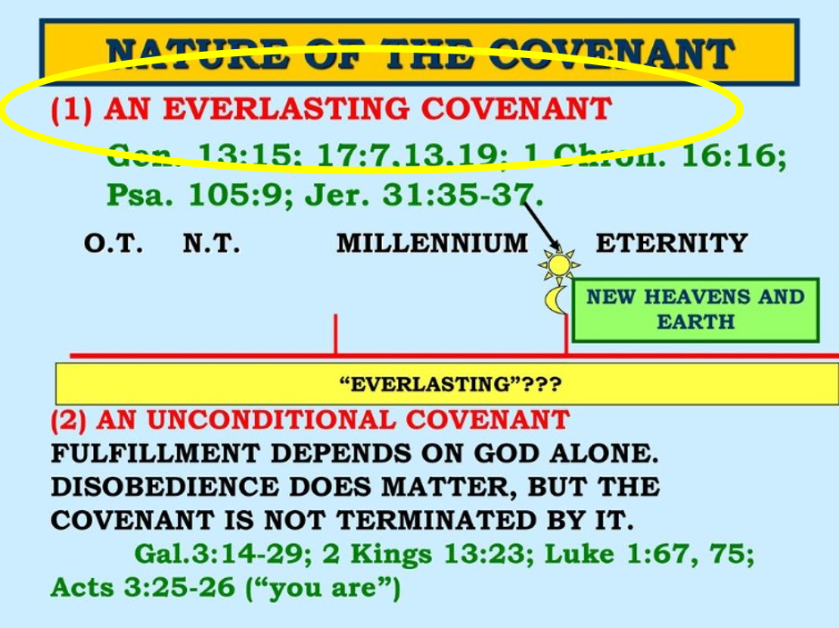

Israel remains! The fact that they remain is evidence of the power and covenant of God.

The Abrahamic covenant is forever

Genesis 13:15 for I will give you and your offspring forever all the land that you see.

Gen 17:7,13,19

7 I will keep My covenant between Me and you, and your future offspring throughout their generations, as an everlasting covenant to be your God and the God of your offspring after you.,

13 a slave born in your house, as well as one purchased with money, must be circumcised. My covenant will be marked in your flesh as an everlasting covenant. 19 But God said, “No. Your wife Sarah will bear you a son, and you will name him Isaac. I will confirm My covenant with him as an everlasting covenant for his future offspring.

1Chr 16:13-16)

13 you offspring of Israel His servant, Jacob’s descendants — His chosen ones.

14 He is the LORD our God; His judgments govern the whole earth.

15 Remember His covenant forever — the promise He ordained for a thousand generations, 16 the covenant He made with Abraham, swore to Isaac,

Ps 105:8-11) 8 He remembers His covenant forever, the promise He ordained for a thousand generations — 9 the covenant He made with Abraham, swore to Isaac,

10 and confirmed to Jacob as a decree and to Israel as an everlasting covenant: 11 “I will give the land of Canaan to you as your inherited portion.”

Gen 26:3-4) (to Isaac) stay in this land as a foreigner, and I will be with you and bless you. For I will give all these lands to you and your offspring, and I will confirm the oath that I swore to your father Abraham.

4 I will make your offspring as numerous as the stars of the sky,

I will give your offspring all these lands, and all the nations of the earth will be blessed by your offspring,

Gen 28:14-15) to Jacob

14 Your offspring will be like the dust of the earth, and you will spread out toward the west, the east, the north, and the south. All the peoples on earth will be blessed through you and your offspring. 15 Look, I am with you and will watch over you wherever you go.

I will bring you back to this land, for I will not leave you until I have done what I have promised you.”

Jer 31:35-37) 35 This is what the LORD says: The One who gives the sun for light by day, the fixed order of moon and stars for light by night, who stirs up the sea and makes its waves roar — Yahweh of Hosts is His name: 36 If this fixed order departs from My presence — this is the LORD’s declaration — then also Israel’s descendants will cease to be a nation before Me forever.

37 This is what the LORD says: If the heavens above can be measured and the foundations of the earth below explored, I will reject all of Israel’s descendants because of all they have done — this is the LORD’s declaration.

GOD SAID IT, I BELIEVE IT, THAT SETTLES IT!

It is an everlasting Covenant

It is also an unconditional covenant

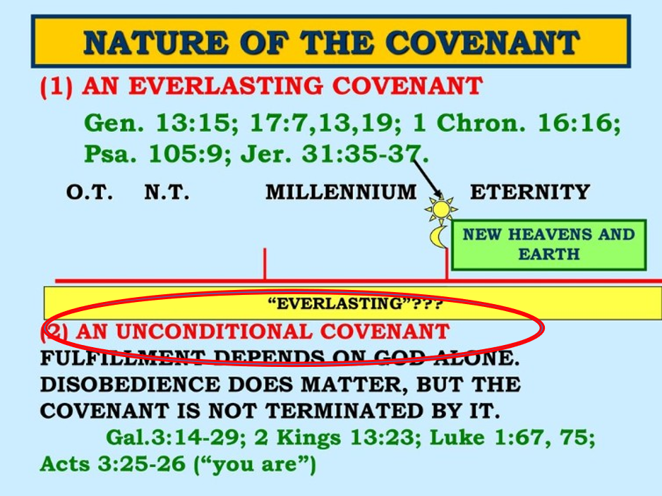

Luke 1:67-75)67 Then his father Zechariah was filled with the Holy Spirit and prophesied: 68 Praise the Lord, the God of Israel, because He has visited and provided redemption for His people. 69 He has raised up a horn of salvation for us in the house of His servant David,

70 just as He spoke by the mouth of His holy prophets in ancient times; 71 salvation from our enemies and from the clutches of those who hate us.

72 He has dealt mercifully with our fathers and remembered His holy covenant — 73 the oath that He swore to our father Abraham. He has given us the privilege,

74 since we have been rescued from our enemies’ clutches, to serve Him without fear 75 in holiness and righteousness in His presence all our days.

