## **The reign of the Kings June 12, 2022**

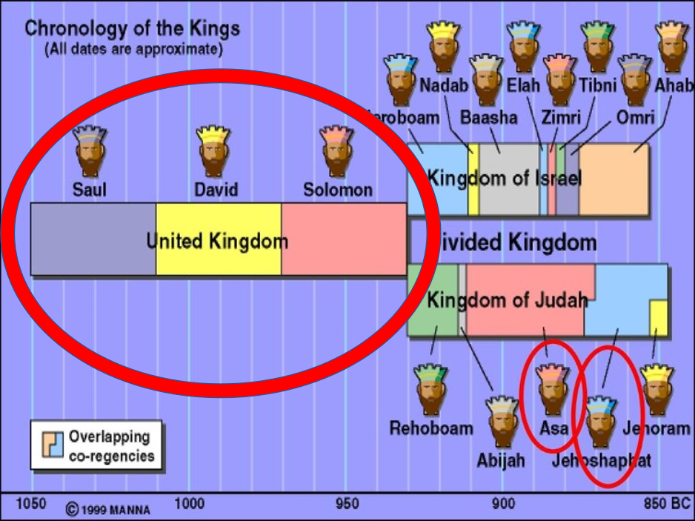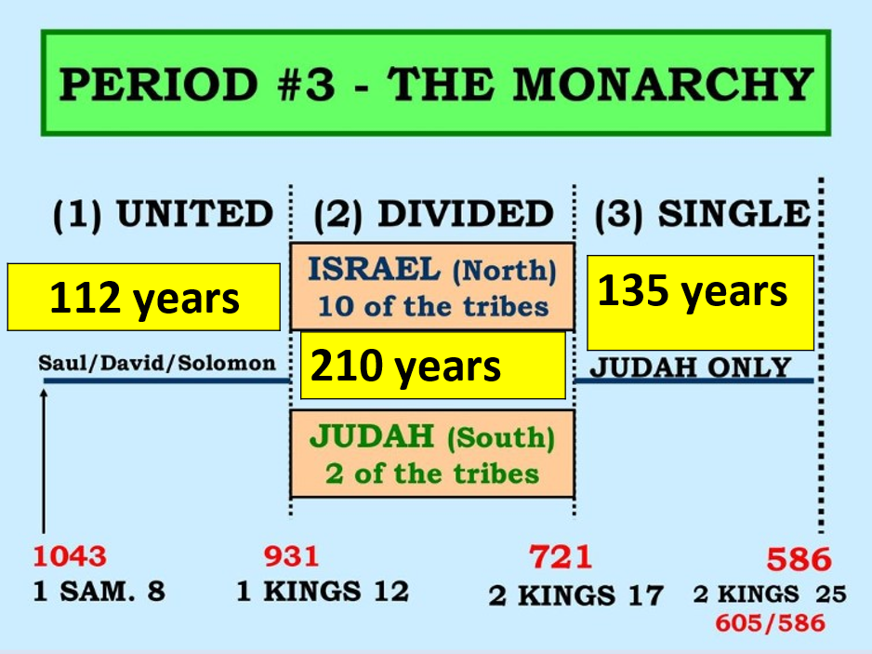

## **Things to glean from these Kings**

## **Saul starts off good but ends badly.**

## ***1Sam 10:23 So they ran and brought him from there; and when he stood among the people, he was taller than any of the people from his shoulders upward.***

## ***24 And Samuel said to all the people, “Do you see him whom the LORD has chosen, that there is no one like him among all the people?” So all the people shouted and said, “Long live the king!”***

## **He fights against the Ammonites and wins**

## ***1Sam 11:11 So it was, on the next day, that Saul put the people in three companies; and they came into the midst of the camp in the morning watch, and killed Ammonites until the heat of the day. And it happened that those who survived were scattered, so that no two of them were left together.***

## **Pardons those who wouldn’t accept his kingship 11:13**

## **But at 2 years things start to unravel.**

## ***1Sam 13:8 Then he waited seven days, according to the time set by Samuel. But Samuel did not come to Gilgal; and the people were scattered from him.9 So Saul said, “Bring a burnt offering and peace offerings here to me.” And he offered the burnt offering.***

## **God had spoken through Samuel already**

## ***1Sam 10:8 “You shall go down before me to Gilgal; and surely I will come down to you***

## ***to offer burnt offerings and make sacrifices of peace offerings. Seven days you shall wait, till I come to you and show you what you should do.”***

## **Consequence:**

## ***1Sam 13:13 And Samuel said to Saul, “You have done foolishly. You have not kept the commandment of the LORD your God, which He commanded you. For now the LORD would have established your kingdom over Israel forever.14 “But now your kingdom shall not continue.***

## ***The LORD has sought for Himself a man after His own heart, and the LORD has commanded him to be commander over His people, because you have not kept what the LORD commanded you.”***

## **God said it! I believe it! That settles it!**

## **No matter what others say, No matter what others do, You live holy!**

## ***1Thess 5:1 But concerning the times and the seasons, brethren, you have no need that I should write to you.***

## ***2 For you yourselves know perfectly that the day of the Lord so comes as a thief in the night.***

## ***1Thess 5:3 For when they say, “Peace and safety!” then sudden destruction comes upon them, as labor pains upon a pregnant woman. And they shall not escape.***

## ***4 But you, brethren, are not in darkness, so that this Day should overtake you as a thief.***

## ***5 You are all sons of light and sons of the day. We are not of the night nor of darkness. 6 Therefore let us not sleep, as others do, but let us watch and be sober.***

## ***7 For those who sleep, sleep at night, and those who get drunk are drunk at night. 8 But let us who are of the day be sober, putting on the breastplate of faith and love, and as a helmet the hope of salvation.***

## ***9 For God did not appoint us to wrath, but to obtain salvation through our Lord Jesus Christ,***

## ***11 Therefore comfort each other and edify one another, just as you also are doing.***

## **Saul’s slide into ruin #2:**

## **He leaves the king and the goods**

## **God said:**

## ***1Sam 15:3 ‘Now go and attack Amalek, and utterly destroy all that they have, and do not spare them. But kill both man and woman, infant and nursing child, ox and sheep, camel and donkey.’ ”***

## ***Deut 25:16-19***

## **But Saul…**

## ***1Sam 15:8 He also took Agag king of the Amalekites alive, and utterly destroyed all the people with the edge of the sword. 9 But Saul and the people spared Agag and the best of the sheep, the oxen,***

## ***the fatlings, the lambs, and all that was good, and were unwilling to utterly destroy them. But everything despised and worthless, that they utterly destroyed.***

## **The consequences:**

## ***1Sam 15:26 But Samuel said to Saul, “I will not return with you, for you have rejected the word of the LORD, and the LORD has rejected you from being king over Israel.”***

## ***1Sam 15:28 So Samuel said to him, “The LORD has torn the kingdom of Israel from you today, and has given it to a neighbor of yours, who is better than you.***

## ***1Sam 15:35 And Samuel went no more to see Saul until the day of his death. Nevertheless Samuel mourned for Saul, and the LORD regretted that He had made Saul king over Israel.***

## **Saul was accountable and so are we!**

## ***Rom 14:10 But why do you judge your brother? Or why do you show contempt for your brother? For we shall all stand before the judgment seat of Christ. 11 For it is written: “As I live, says the LORD, Every knee shall bow to Me, And every tongue shall confess to God.”***

## ***Rom 14:12 So then each of us shall give account of himself to God.***

## **Saul’s slide into ruin #3**

## ***1Sam 28:4 Then the Philistines gathered together, and came and encamped at Shunem. So Saul gathered all Israel together, and they encamped at Gilboa.***

## ***5 When Saul saw the army of the Philistines, he was afraid, and his heart trembled greatly. 6 And when Saul inquired of the LORD,***

## ***the LORD did not answer him, either by dreams or by Urim or by the prophets. 7 Then Saul said to his servants, “Find me a woman who is a medium, that I may go to her and inquire of her.” And his servants said to him, “In fact, there is a woman who is a medium at En Dor.”***

## **The consequence:**

## ***1Sam 28:19 “Moreover the LORD will also deliver Israel with you into the hand of the Philistines.***

## ***And tomorrow you and your sons will be with me. The LORD will also deliver the army of Israel into the hand of the Philistines.”***

## ***1Sam 31:2 Then the Philistines followed hard after Saul and his sons. And the Philistines killed Jonathan, Abinadab, and Malchishua, Saul’s sons. 3 The battle became fierce against Saul. The archers hit him, and he was severely wounded by the archers.***

## **And that’s all folks, times up, check mate!**

## **Saul’s life is done, what he has he has.**

## **There is no replay.**

## **No do over.**

## **No, “one more chance”**

## ***Gal 6:7 Do not be deceived, God is not mocked; for whatever a man sows, that he will also reap.***

## ***8 For he who sows to his flesh will of the flesh reap corruption, but he who sows to the Spirit will of the Spirit reap everlasting life.***