Samuel, and Israel’s choice to have a king
15 May 2022

Short history of Israel’s final judge:

Samuel

Elkanah; Samuel’s father…

1Sam 1:2 And he had two wives: the name of one was Hannah, and the name of the other Peninnah. Peninnah had children, but Hannah had no children.3 This man went up from his city yearly to worship and sacrifice to the LORD of hosts in Shiloh. Also the two sons of Eli, Hophni and Phinehas, the priests of the LORD, were there.

Good guys and girls in the first 7 chapters

Hanna

Samuel

Eli (mostly good but fails to rebuke his sons by removing them from their positions)

Bad guys and girls in the first 7 chapters

Peninnah

Eli’s sons Hophni and Phinehas

Philistines

Samuel is righteous before the Lord

1Sam 3:19 So Samuel grew, and the LORD was with him and let none of his words fall to the ground. 20 And all Israel from Dan to Beersheba knew that Samuel had been established as a prophet of the LORD. 21 Then the LORD appeared again in Shiloh. For the LORD revealed Himself to Samuel in Shiloh by the word of the LORD.

Israel is not righteous; still being judged. Note that they lose 2 battles to the Philistines.

1Sam 4:2 Then the Philistines put themselves in battle array against Israel. And when they joined battle, Israel was defeated by the Philistines, who killed about four thousand men of the army in the field.

Even the Ark of the Covenant doesn’t help

Though the Philistines are afraid, they destroy Israel’s army

1Sam 4:10 So the Philistines fought, and Israel was defeated, and every man fled to his tent.

There was a very great slaughter, and there fell of Israel thirty-thousand foot soldiers.

Also, Eli dies, his 2 sons and his daughter-in law giving birth. Before she dies, she names her son, "Ichabod” (the glory has departed from Israel) And the Ark is captured.

1Sam 4:21 Then she named the child Ichabod, (inglorious one) saying, “The glory has departed from Israel!”

because the ark of God had been captured and because of her father-in-law and her husband. 22 And she said, “The glory has departed from Israel, for the ark of God has been captured.”

Eli has been judged

His sons are judged

Israel is judged

God is not a cosmic genie, who is there to help you whenever you need Him no matter how you live!

As Hanna said in her prayer…

1Sam 2:2 “No one is holy like the LORD, For there is none besides You, Nor is there any rock like our God. 3 “Talk no more so very proudly; Let no arrogance come from your mouth, For the LORD is the God of knowledge; And by Him actions are weighed.

Israel is being weighed and Samuel has the prescription if they will follow it:

1Sam 7:3 Then Samuel spoke to all the house of Israel, saying, “If you return to the LORD with all your hearts, then put away the foreign gods and the Ashtoreths from among you, and prepare your hearts for the LORD, and serve Him only; and He will deliver you from the hand of the Philistines.”

Israel does so

1Sam 7:4 So the children of Israel put away the Baals and the Ashtoreths, and served the LORD only.

The result!

1Sam 7:10 Now as Samuel was offering up the burnt offering, the Philistines drew near to battle against Israel. But the LORD thundered with a loud thunder upon the Philistines that day, and so confused them that they were overcome before Israel.

1Sam 7:13 So the Philistines were subdued, and they did not come anymore into the territory of Israel. And the hand of the LORD was against the Philistines all the days of Samuel.

1Sam 7:14 Then the cities which the Philistines had taken from Israel were restored to Israel, from Ekron to Gath; and Israel recovered its territory from the hands of the Philistines. Also there was peace between Israel and the Amorites. 15 And Samuel judged Israel all the days of his life.

Things are looking up and then these happen:

1. 1Sam 8:1 Now it came to pass when Samuel was old that he made his sons judges over Israel.

2 The name of his firstborn was Joel, and the name of his second, Abijah; they were judges in Beersheba. 3 But his sons did not walk in his ways; they turned aside after dishonest gain, took bribes, and perverted justice.

2. 1 Sam 8:4 Then all the elders of Israel gathered together and came to Samuel at Ramah, 5 and said to him, “Look, you are old, and your sons do not walk in your ways. Now make us a king to judge us like all the nations.”

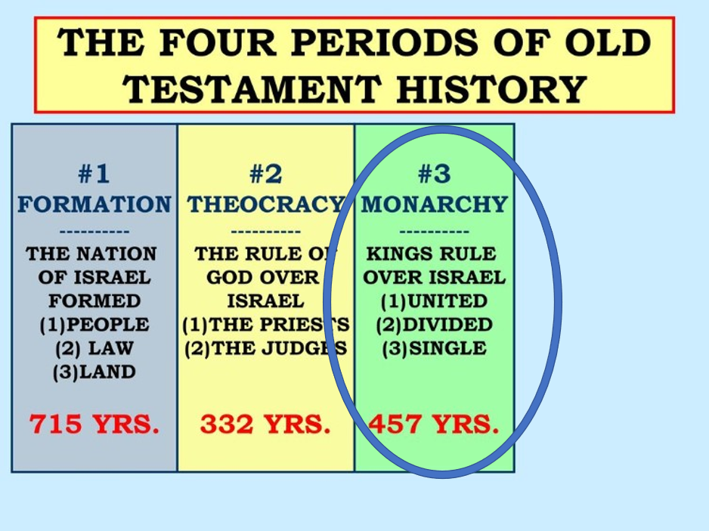

And a king they shall have…

1Sam 8:7 And the LORD said to Samuel, “Heed the voice of the people in all that they say to you; for they have not rejected you, but they have rejected Me, that I should not reign over them.

8 “According to all the works which they have done since the day that I brought them up out of Egypt, even to this day–with which they have forsaken Me and served other gods–so they are doing to you also.

9 “Now therefore, heed their voice. However, you shall solemnly forewarn them, and show them the behavior of the king who will reign over them.”

God says, okay here’s what you get!

Take your sons in a Military Draft

Take your sons as Military leaders

Take your sons as farmers

Take your daughters to be maids

Take the best lands, water ect…

6. He will tax you coming and going

7. Forget about all the best rookies because he will take them for his team

8. He will make you mourn

This is Israel’s constant problem:

1Sam 8:20 “that we also may be like all the nations, and that our king may judge us and go out before us and fight our battles.”

And this is God’s constant response:

Ezek 20:32 “What you have in your mind shall never be, when you say, ‘We will be like the Gentiles, like the families in other countries, serving wood and stone.’

33 “As I live,” says the Lord GOD, “surely with a mighty hand, with an outstretched arm, and with fury poured out, I will rule over you.

Even today where half are secular in Israel, God will rule over them.

