The end of the Theocracy
8 May 2022

People has been accomplished

Law is being accomplished

Land has yet to be accomplished

Moses’ history and calling (Exodus 1-3)

The destruction of Egypt through 10 plagues (Exodus 4-14)

Crossing the Red Sea with celebrations (Exodus 14-15.)

Complaining begins (Exodus 15)

Israel at MT Sinai and the Law being given (Exodus 19-31)

4. The golden calf incident and Moses' meeting with God (Exodus 32-33)

5. The covenant renewed and the building of the tabernacle, priests, and dress of the Priests. (Exodus 34-40)

Law accomplished

Red Sea - Wanderings

Exodus chapter 15-Numbers chapter 14:44

Red sea generation dies out

New wilderness generation under Joshua

Josh 11:23 So Joshua took the whole land, according to all that the LORD had said to Moses; and Joshua gave it as an inheritance to Israel according to their divisions by their tribes. Then the land rested from war.

By now the Land is accomplished

People

law

land

ALL ACCOMPLISHED

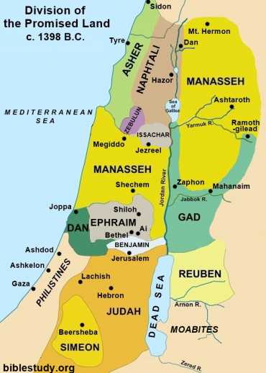

Enter the time of Judges which begins with:

Judg 2:10 When all that generation had been gathered to their fathers, another generation arose after them who did not know the LORD nor the work which He had done for Israel. 11 Then the children of Israel did evil in the sight of the LORD, and served the Baals;

12 and they forsook the LORD God of their fathers, who had brought them out of the land of Egypt;

and they followed other gods from among the gods of the people who were all around them, and they bowed down to them; and they provoked the LORD to anger. 13 They forsook the LORD and served Baal and the Ashtoreths.

And Judges ends with:

Judg 21:25 In those days there was no king in Israel; everyone did what was right in his own eyes.

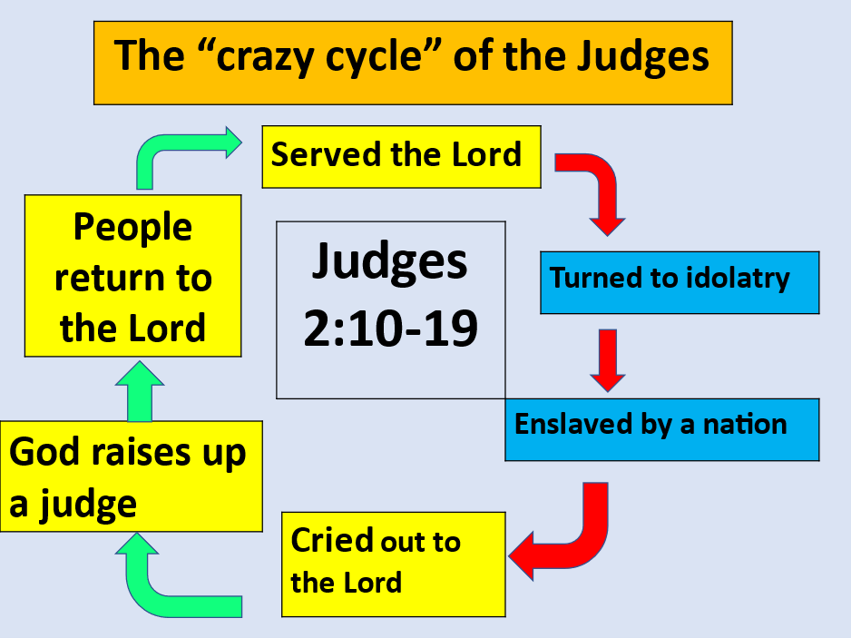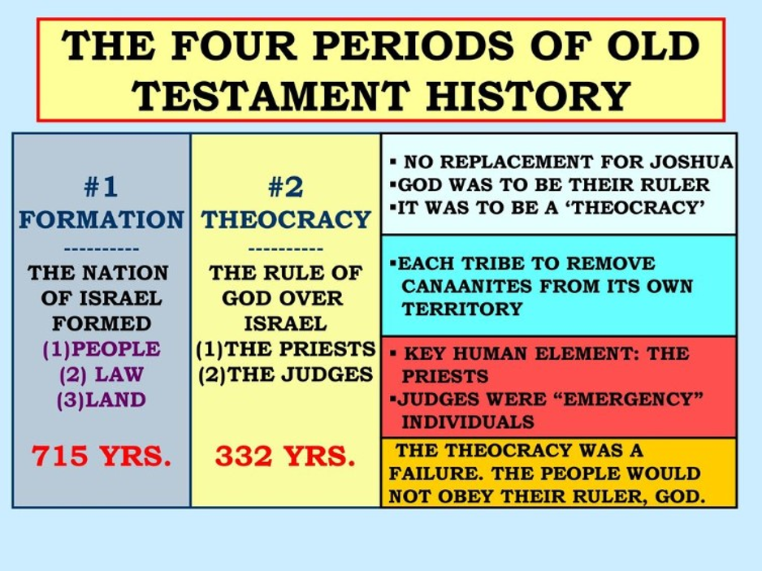

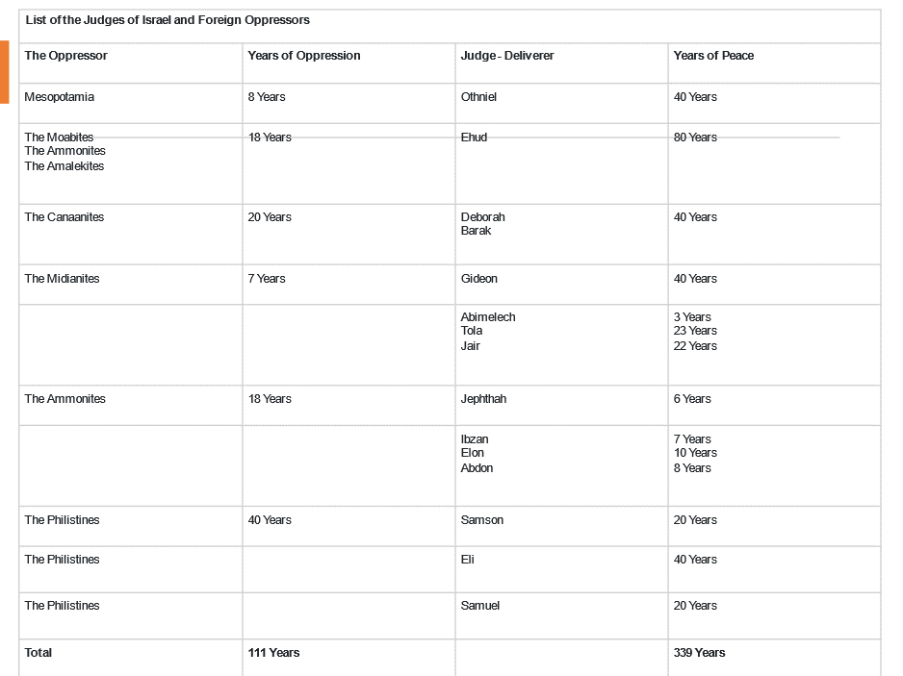

Judges/Theocracy and there are 12 of these crazy cycles or 12 cycles of Judges.

During this period of the Judges, we have the book of Ruth which is a short little book, but it is filled hope and redemption

Boaz who is the son of Salmon (Jew) whose mother was Rahab (Canaanite from Jericho). Marries Ruth (Moabite from Moab).

This is a huge, because it demonstrates the Abrahamic covenant

Gen 22:18 “In your seed all the nations of the earth shall be blessed, because you have obeyed My voice.”

Rahab- Canaanite prostitute

Responds by faith to what God said marries Salmon-Jew.

They have a child named Boaz-Jew

He marries Ruth who is a Moabite widow who has responded by faith in God.

They have a son named Obed, the father of Jesse, the father of DAVID!!

In Rahab and Ruth, we see an amazing prediction of God saving all who come to Him in faith; be it Jew or Gentile.

2 Pet 3:9 The Lord is not slack concerning His promise, as some count slackness, but is longsuffering toward us, not willing that any should perish but that all should come to repentance.

1Tim 2:4 who desires all men to be saved and to come to the knowledge of the truth.

Boaz redeemed Ruth! Salmon/Rahab

Gal 3:13 Christ has redeemed us from the curse of the law, having become a curse for us (for it is written, “Cursed is everyone who hangs on a tree”),

Gal 3:14 that the blessing of Abraham might come upon the Gentiles in Christ Jesus, that we might receive the promise of the Spirit through faith.

Gal 3:26 For you are all sons of God through faith in Christ Jesus.

Boaz was a close kinsman redeemer

So is Jesus Messiah

Heb 2:14 Inasmuch then as the children have partaken of flesh and blood, He Himself likewise shared in the same, that through death He might destroy him who had the power of death, that is, the devil,

Heb 2:15 and release those who through fear of death were all their lifetime subject to bondage.

Both Rahab and Ruth were redeemed from death and married to another! They both produced fruit from a Godly union!

Rom 7:4 Therefore, my brethren, you also have become dead to the law through the body of Christ, that you may be married to another–to Him who was raised from the dead,

that we should bear fruit to God.

Because of who you are and who you are now married to, go and produce much fruit!

