Everything He said Happened, is happening, and will happen!
April 24, 2022

From last week we saw that all Jesus talked about happened is happening and will happen.

Said He would suffer die and be resurrected

Told the future of the disciples

Talked of the beginning of the Church and baptism of the Holy spirit

Said Jerusalem and the Temple would be destroyed

5. Told the world it’s history for the next nearly 2000 years.

6. Told us the sign of the Temple destruction and the sign of the end of this age

7. Predicted that the Jewish people would be back in their land with the Temple standing and functioning. All that includes their regathering in unbelief for judgment and their rebuilding of the Temple.

And As He said…(whoever reads, let him understand),

Israel has gone from this in the middle 1800’s

To His Excellency, ... Since we have merited to these days, when such a great man as His Excellency has been appointed to Jacob, to whom every king stands at attention, perhaps the will of G-d will have success through him. And especially at a time like this, when the Land of Israel is under the dominion of the Pasha... perhaps if his most noble Excellency pays him a handsome sum and purchases for him some other country (in Africa) in exchange for the Holy Land, which is presently small in quantity but great in quality... this money would certainly not be wasted... for when the leaders of Israel are gathered from every corner of the world... and transform it into an inhabited country,

the many G-d-fearing and charitable Jews will travel there to take up their residency in the Holy Land under Jewish sovereignty... and be worthy to take up their portion in the offering upon the altar. And if the master (Ibrahim Pasha) does not desire to sell the entire land, then at least he should sell Jerusalem and its environs... or at least the Temple Mount and surrounding areas... so that we many offer to the L-rd our G-d."

Excerpts from Rabbi Kalisher's Letter to Baron Rothschild Concerning the Purchase of the Temple Mount:

To this today….

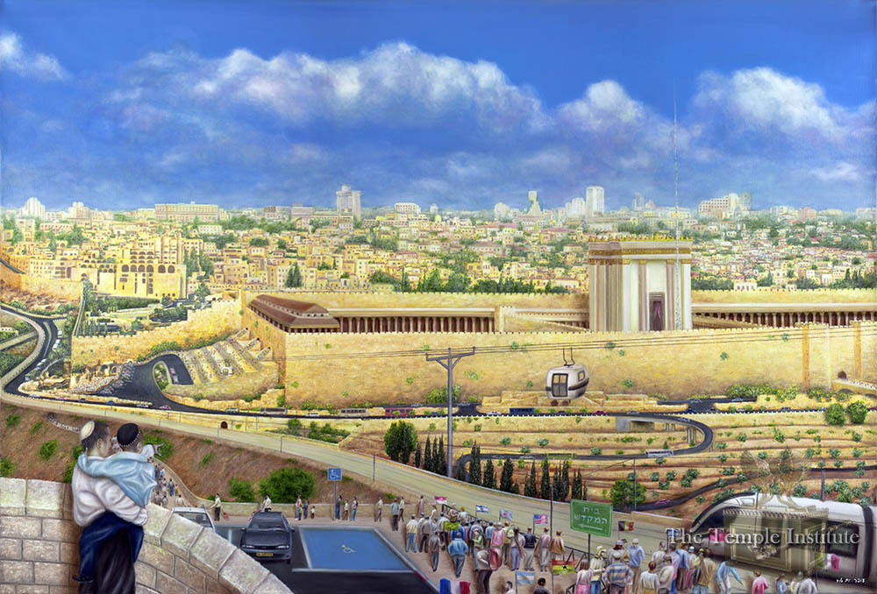

The religious leaders have everything ready to go for the rebuilding of the Temple. https://templeinstitute.org

2 things stand in that way.

Red heifer

Dome of the rock

However, Jesus said the Temple would be standing note:

2Thess 2:3 Let no one deceive you by any means; for that Day will not come unless the falling away comes first, and the man of sin is revealed, the son of perdition,

2 Thess 2:4 who opposes and exalts himself above all that is called God or that is worshiped, so that he sits as God in the temple of God, showing himself that he is God.

Matt 24:15 “Therefore when you see the ‘abomination of desolation,’ spoken of by Daniel the prophet, standing in the holy place” (whoever reads, let him understand), 16 “then let those who are in Judea flee to the mountains. 17 “Let him who is on the housetop not go down to take anything out of his house.

Matt 24:18 “And let him who is in the field not go back to get his clothes. 19 “But woe to those who are pregnant and to those who are nursing babies in those days! 20 “And pray that your flight may not be in winter or on the Sabbath.

Israel’s rainy season is Oct-April

“When the rainy season comes, great quantities of water may rush through the wadis, destroying lives and property. Most of the year, wadis are either dry or have intermittent stream flow. They can range in size from small gullies to large, deep canyons”. geography.name/wadi/

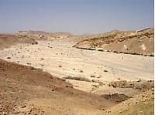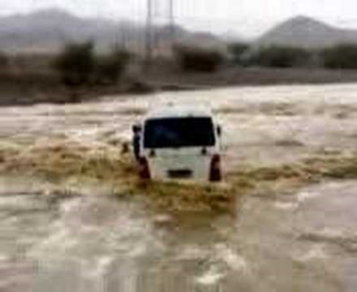

Mat 24:22 “And unless those days were shortened, no flesh would be saved; but for the elect’s sake those days will be shortened. 23 “Then if anyone says to you, ‘Look, here is the Christ!’ or ‘There!’ do not believe it.

24 “For false christs and false prophets will rise and show great signs and wonders to deceive, if possible, even the elect. 25 “See, I have told you beforehand.

Messiah predicted almost 2000 years ago that Israel would exist, the Temple would be standing, and that sabbath rules would apply. He also predicted the infrastructure that a future Israel would have, which is TODAY’S REALITY!

Jesus said know and understand Daniel 9:27

Dan 9:27 Then he shall confirm a covenant with many for one week; But in the middle of the week He shall bring an end to sacrifice and offering.

And on the wing of abominations shall be one who makes desolate, Even until the consummation, which is determined, Is poured out on the desolate.”

Dan 12:11 “And from the time that the daily sacrifice is taken away, and the abomination of desolation is set up, there shall be one thousand two hundred and ninety days.

“The word wing refers to the pinnacle of the Temple, and it is a Hebrew word that means “an overspreading influence.”

“This overspreading influence will be upon the pinnacle of the Temple. This specifically refers to the worship of the Antichrist, when he declares himself to be the one true god (II Thes. 2: 3-4).

The word abomination in Hebrew refers to “an image” or “idol,” meaning that an image or idol of the Antichrist will be set up in the Temple Compound on the pinnacle of the Temple itself. This is also spoken of in Daniel 12:11 and Matthew 24:15.

The image itself is spoken of in Revelation 13:14-15. Upon the wing of abominations [upon the overspreading influence of idol worship] shall come one that makes desolate. The one that makes desolate is the Antichrist, who will cause desolations to fall upon the Jewish people”. Arnold G. Fruchtenbaum. The Footsteps of the Messiah (Kindle Locations 3691-3695). 3688-3691). Ariel Ministries.

Jesus also said this:

Matt 24:21 “For then there will be great tribulation, such as has not been since the beginning of the world until this time, no, nor ever shall be.

Matt 24:22 “And unless those days were shortened, no flesh would be saved; but for the elect’s sake those days will be shortened.

Next week: Maybe more on this?

