Judges and more Judges
Jan 9, 2022

How in the world to break up the book of Judges???

Judges happened because of this: Key chapter is 2

Judg 2:1 Then the Angel of the LORD came up from Gilgal to Bochim, and said: “I led you up from Egypt and brought you to the land of which I swore to your fathers; and I said, ‘I will never break My covenant with you. 2 ‘And you shall make no covenant with the inhabitants of this land; you shall tear down their altars.’

But you have not obeyed My voice. Why have you done this? 3 “Therefore I also said, ‘I will not drive them out before you; but they shall be thorns in your side, and their gods shall be a snare to you.’ ” 4 So it was, when the Angel of the LORD spoke these words to all the children of Israel, that the people lifted up their voices and wept.

Judges 2:11 Then the children of Israel did evil in the sight of the LORD, and served the Baals; 12 and they forsook the LORD God of their fathers, who had brought them out of the land of Egypt; and they followed other gods from among the gods of the people who were all around them, and they bowed down to them; and they provoked the LORD to anger.

15 Wherever they went out, the hand of the LORD was against them for calamity, as the LORD had said, and as the LORD had sworn to them.

And they were greatly distressed.

The entire book is made up of the crazy cycle.

There are 12 crazy cycles in the book of judges.

The Crazy Cycle

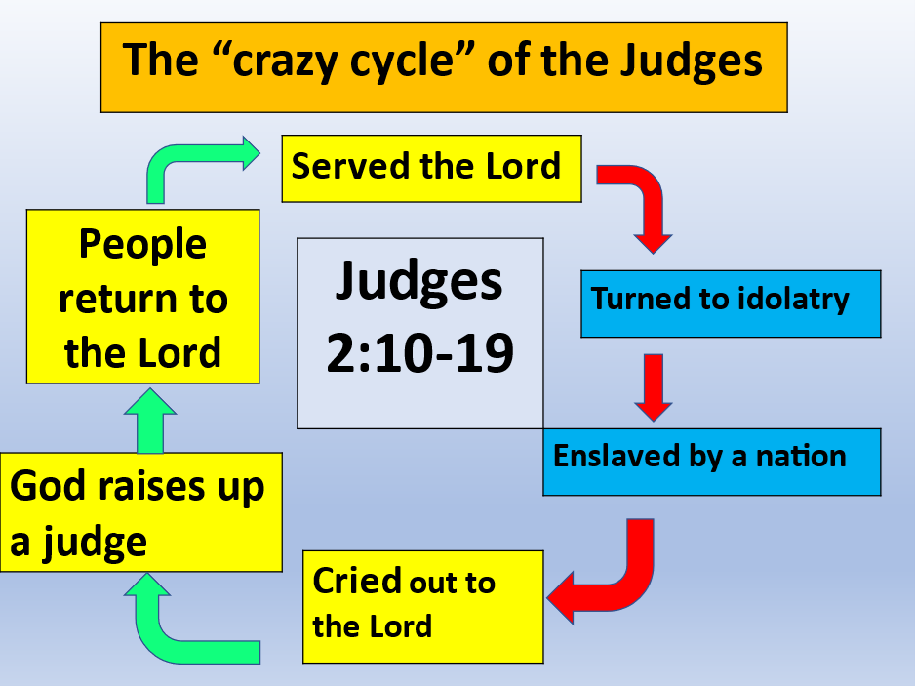

“Courtesy of Ariel Ministries”

Cycle 1: Oth-ni-el

1. The Sin - 3:7

2. The Oppression: king of Mesopotamia - 3:8

3. The Cry - 3:9a

4. The Deliverance - 3:9b-10

5. The Rest - 3:11

Cycle 2: Ehud 3:12-30

The Sin - 3:12a

The Oppression: Eglon of Moab - 3:12b-14

The Cry - 3:15a

The Deliverance - 3:15b-29

The Rest - 3:30

Cycle 3: Shamgar 3:31

Cycle 4: Barak and Deborah - 4:1 - 5:31

The Sin - 4:1

2. Oppression: Jabin the King of Hazor-4:2

3. The Cry - 4:3

4. The Deliverance - 4:4-24

a. The Calling of Deborah and Barak - 4:4-10

b. The Movement of Heber the Kenite - 4:11

c. The Defeat of the Canaanites - 4:12-16

d. The Flight and Death of Sisera - 4:17-22

e. The Defeat of Jabin - 4:23-24

5. The Song of Deliverance - 5:1-31a

a. The Singers - 5:1

b. The First Stanza: The Praising of God - 5:2-3

c. The Second Stanza: Jehovah - The Commander in Chief - 5:4-5

d. The Third Stanza: The Emergence of Deborah - 5:6-8

e. The Fourth Stanza: The Praise of God - 5:9-11

f. The Fifth Stanza: The Response of the Tribes - 5:12-18

g. The Sixth Stanza: The Defeat of the Canaanites - 5:19-23

h. The Seventh Stanza: The Praise of Jael - 5:24- 27

I. The Eighth Stanza: The Mother of Sisera - 5:28-30

j. The Ninth Stanza: The Conclusion - 5:31a

6. The rest 5:31b

Next week: Gideon, Jephthah, Samson

