## **Is there any peace now? Jan 2, 2022**

## **These studies of the WORD OF GOD address several areas of confusion that many struggle to answer.**

## **Why is there no peace on earth when Jesus came to bring peace?**

## **Does real peace eventually happen?**

## **Why does God let this world continue in war?**

## **Is there any peace now?**

## **Is there any real peace now?**

## **We long for peace**

## **We strive for peace**

## **Yet peace is elusive**

## **The world is constantly aflame with war.**

## **Right now, we have over 40 conflicts around the world.**

## **The USA has been at war for about 20 years now.**

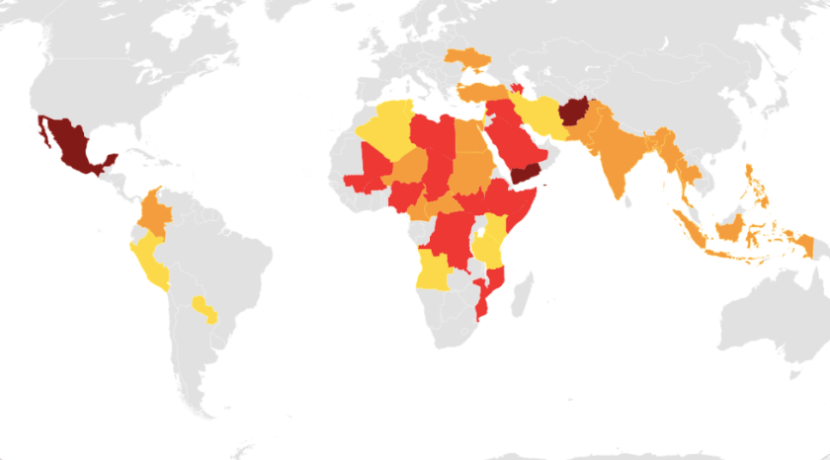

**Detailed map of ongoing armed conflicts   Major wars, 10,000+ deaths in current or past calendar year. Wars, 1,000–9,999 deaths in current or past calendar year. Minor conflicts, 100–999 deaths in current or past calendar year.   Skirmishes and clashes, 10–99 deaths in current or past calendar year.**

Wki

## **The world offers no lasting peace**

## ***John 14:27 “Peace I leave with you, My peace I give to you; not as the world gives do I give to you. Let not your heart be troubled, neither let it be afraid.***

## **In fact, all the world can offer is turmoil!**

## ***John 16:33 “These things I have spoken to you, that in Me you may have peace.***

## ***In the world you will have tribulation; (anguish, burdened, persecution, tribulation, trouble)***

## ***but be of good cheer, I have overcome the world.”***

## **Jesus said that the only true peace is in Him. Peace is really a big issue because ever since the fall we have been at war.**

## **The peace promised In Luke…**

## ***Luke 2:14 “Glory to God in the highest, And on earth peace, goodwill toward men!”***

## **Has been put on hold with the earth…**

## ***Luke 19:42 saying, “If you had known, even you, especially in this your day, the things that make for your peace! But now they are hidden from your eyes.***

## **It has now shifted to the individual**

## **First to the Jews**

## ***Acts 2:40 And with many other words he testified and exhorted them, saying, “Be saved from this perverse generation.” 41 Then those who gladly received his word were baptized; and that day about three thousand souls were added to them.***

## **Then to the Gentiles:**

## **Acts 10:43 “To Him all the prophets witness that, through His name, whoever believes in Him will receive remission of sins.”**

## **44 While Peter was still speaking these words, the Holy Spirit fell upon all those who heard the word. 48 And he commanded them to be baptized in the name of the Lord. Then they asked him to stay a few days.**

## **Through Christ there is peace**

## **Peace with God**

## ***Rom 5:1 Therefore, having been justified by faith, we have peace with God through our Lord Jesus Christ, 2 through whom also we have access by faith into this grace in which we stand, and rejoice in hope of the glory of God.***

## ***10 For if when we were enemies we were reconciled to God through the death of His Son, much more, having been reconciled, we shall be saved by His life.***

## **Peace in death and life by assurance**

## ***1Cor 15:55 “O Death, where is your sting? O Hades, where is your victory?” 56 The sting of death is sin, and the strength of sin is the law. 57 But thanks be to God, who gives us the victory through our Lord Jesus Christ.***

## ***Hebrews 2:14 Inasmuch then as the children have partaken of flesh and blood, He Himself likewise shared in the same, that through death He might destroy him who had the power of death, that is, the devil,***

## ***15 and release those who through fear of death were all their lifetime subject to bondage.***

## **There is no greater cruelty then to tell Saints, who fully believe in a Hell, that unfortunately assurance is something that is elusive at best and impossible to attain in this life.**

## **The bible says Christ is supposed to give you release from fear of Hell**

## **The Bible also says we are to be fully assured of our destiny…**

## ***Romans 4:20 He did not waver at the promise of God through unbelief, but was strengthened in faith, giving glory to God, 21 and being fully convinced that what He had promised He was also able to perform. 22 And therefore “it was accounted to him for righteousness.”***

## **What was “IT”?**

## **Being fully convinced that what God promised is certain!!!!**

## ***23 Now it was not written for his sake alone that it was imputed to him,***

## ***24 but also for us. It shall be imputed to us who believe in Him***

## ***who raised up Jesus our Lord from the dead,***

## ***25 who was delivered up because of our offenses,***

## ***and was raised because of our justification.***

## **You will never have 100% PEACE when YOU are in the equation somewhere.**

## **Have I done ______________enough?**

## **Paul a Pharisee of Pharisees wrote this also:**

## ***Gal 3:21 Is the law then against the promises of God? Certainly not! For if there had been a law given which could have given life, truly righteousness would have been by the law.***

## ***22 But the Scripture has confined all under sin, that the promise by faith in Jesus Christ might be given to those who believe.***

## **Peace can only truly be had, by having full assurance in where you are heading after this life; 99% or less will not do.**

## **How does this apply in day to day living?**

## **When you have peace, you have joy**

## ***Luke 2:10 Then the angel said to them, “Do not be afraid, for behold,***

## ***I bring you good tidings of great joy which will be to all people.***

## **2. When you have JOY Your spiritual life reaches a new level!**

## ***When you're under the burden of, “Have I done enough,” you are a bit miserable and not rejoicing. As we say the Joy of the Lord is our strength, we could also say the misery of the devil is our weakness. When we are rejoicing in the free gift of our salvation, it puts a power in us to really live the Christian life.***

## ***We know God really loves us and has done a great thing. We also begin to love others and we don’t want to quarrel anymore***

## ***We want to pray for our enemies we want to pray, love and live that sermon on the mount. When you're not miserable your free to have joy.***

## ***Michael Eaton, Gracelife 2009***

## **3. When you have these things people want what you have and you become like Jesus**

## ***Heb 2:10 For it was fitting for Him, for whom are all things and by whom are all things, in bringing many sons to glory, to make the captain of their salvation perfect through sufferings.***

## **We begin to draw many sons to glory!**

## **Next week: Judges in the hall of Faith???**